**FOR IMMEDIATE RELEASE**

 

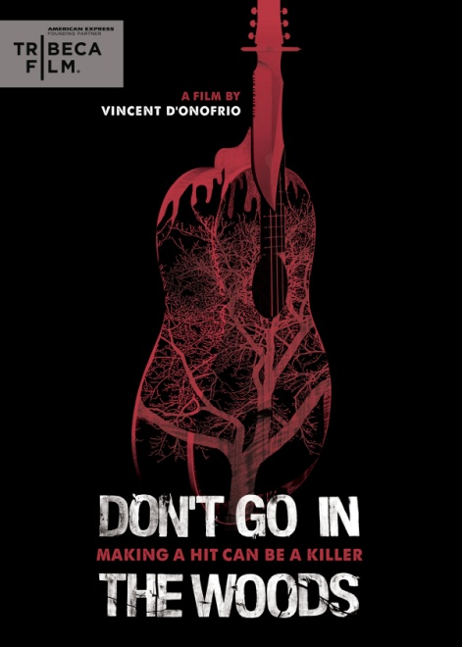

“**DON’T GO IN THE WOODS,” DIRECTED BY VINCENT D’ONOFRIO,**

**DEBUTS JUNE 12 ON DVD & DIGITAL**

**Hybrid Slasher-Musical Co-Written By Veteran Singer-Songwriter Sam Bisbee**

*May 14, 2012 – New York, New York* – ***DON’T GO IN THE WOODS***. Sound advice, especially when there’s a killer on the loose. Veteran film and television actor **Vincent D’Onofrio** (*Full Metal Jacket*, *Law & Order: Criminal Intent*) explores love, greed and ruthlessness in his directorial debut: a twisted musical/horror hybrid film, featuring original music by acclaimed singer-songwriter **Sam Bisbee**.

***DON’T GO IN THE WOODS*** is the story of an indie rock band who takes a weekend getaway from their everyday lives to focus on writing new songs. Hoping to return from their trip with tunes that will score them their first big break, the band instead finds themselves in a nightmare beyond comprehension. The film – starring a gifted ensemble cast of mostly non-actor musicians – cleverly walks an unusual line, maintaining genuine suspense alongside a sinister sense of dread as it explores the lengths to which people will go in order to make their ambitions a reality.

D’Onofrio on the film’s unusual hybrid genre: “We have grown accustomed to referring to the film as a ‘slasher-musical.’ *Once* meets *Friday the 13th*. At times, the music is directly involved in the story that’s playing out on the film. Other times, it’s there to just scream out.”

Bo Boddie stars as bandleader Carson. A Grammy Award winner for his engineering work on Norman Brown’s record, *Just Chillin’*, Boddie is currently working with Merge artist Imperial Teen, as well as playing with and producing Patty Schemel’s (Hole) new band, Psychic Friend. The cast also includes: Gwynn Galitzer, Jorgen Jorgensen, Tim Lajcik, Soomin Lee, Kate O’Malley, Matt Sbeglia, Casey Smith, Nick Thorp, Ali Tobia and Cassandra Walker, with a cameo appearance by Eric Bogosian.

Story by Vincent D’Onofrio; screenplay by Sam Bisbee and Joe Vinciguerra; songs by Sam Bisbee; Original score by Sam Bisbee and Bo Boddie; Michael J. Latino, cinematography; Jennifer Lee, editor; Ken Christmas and Erika Hampson, producers; Sam Bisbee and Vinciguerra, executive producers.

***DON’T GO IN THE WOODS***

Pricing: $26.95 US/ $29.95 CAN

Runtime: 83 mins. + extras

Rating: NR

Catalog #: NNVG268710

Language: English

Color: Color

Audio Format: Dolby Digital 5.1 Stereo

Genre: Horror

**About Tribeca Film**  
Tribeca Film is a comprehensive distribution label dedicated to acquiring and marketing independent films across multiple platforms, including video-on-demand, theatrical and home video.  It is an initiative from Tribeca Enterprises designed to provide new platforms for how film can be experienced, while supporting filmmakers and introducing audiences to films they might not otherwise see. American Express continues its support of Tribeca and the independent film community by serving as the Founding Partner of Tribeca Film.

**About New Video**

New Video is a leading entertainment distributor and the largest aggregator of independent digital content worldwide. Headquartered in New York City, with an international presence in 45 territories, the company delivers feature films, TV programs and web originals via digital download, streaming, video-on-demand, Blu-ray, DVD, and theatrical release. In 2011, New Video bowed Oscar®-nominated Hell and Back Again and South American blockbuster Elite Squad: The Enemy Within in US theaters. Through a new partnership with digital exhibitor Cinedigm Entertainment Group, New Video is poised to bring more independent films to theaters nationwide. New Video streamlines distribution and marketing for filmmakers and partners, bringing a wide variety of fresh content to new audiences. The company’s library includes original TV series and movies from A+E® Home Entertainment, HISTORY™, and Lifetime®, unforgettable games and trophy sets from Major League Baseball®, storybook treasures from Scholastic®, award-winning documentaries from Docurama Films®, next-gen indies from Flatiron Film Company®, and acclaimed independent films and festival picks through partnerships with the Sundance Institute and Tribeca Film. New Video is proud to distribute many Oscar®-nominated films including GasLand, Waste Land, Chico & Rita and Hell and Back Again.

**For more information, please contact:**

Luis Garza; 646-259-4144; lgarza@newvideo.com

For Box Art:

<http://www.newvideo.com/new-video-digital/dont-go-in-the-woods/>