**FOR IMMEDIATE RELEASE**



presents

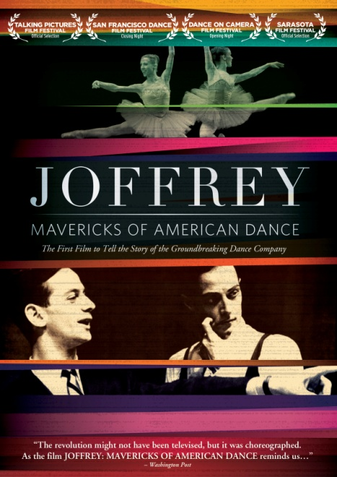

***Joffrey: Mavericks of American Dance*, Available June 12 on DVD & Digital**

**Feature-Length Documentary About America’s Cultural Treasure Narrated by Tony® and Emmy® Award winner Mandy Patinkin**

“The revolution might not have been televised, but it was choreographed.  As the film *Joffrey: Mavericks of American Dance* reminds us.”—*The Washington Post*

*May 10, 2012 – New York, New York* – Co-founded in 1956 by visionary teacher Robert Joffrey and dancer Gerald Arpino, who would become their principal choreographer, The Joffrey Ballet began as a DIY dance company of six dancers touring the United States in a borrowed station wagon. What started as a childhood dream quickly grew into one of the world’s most exciting and prominent ballet companies. Together, Joffrey and Arpino transformed the face of dance with bold new perspectives for edgy ballets that challenged conventions.

Directed by **Bob Hercules** (*Bill T. Jones: A Good Man*), ***Joffrey: Mavericks of American Dance*** will debut on DVD and standard digital platforms on June 12, following a festival premiere and nationwide theatrical release. The feature-length documentary is the first film to tell the story of how the legendary Joffrey Ballet revolutionized American ballet by daringly combining modern dance with traditional ballet at a time when it was not routinely accepted. The Company broke other barriers by accepting and cultivating a diverse group of talented dancers regardless of race and body type, by resurrecting nearly lost early 20th Century masterpieces, and by commissioning daring new works by cutting-edge choreographers.

The film weaves together a wealth of archival footage, behind-the-scene photos and interviews with luminaries in the dance work and features rare excerpts from many seminal Joffrey works, including *Astarte*, *Trinity* and *Billboards*, as well as its breakthrough collaborations with choreographers Twyla Tharp, Leonid Massine, Laura Dean and Kurt Jooss. Founders Robert Joffrey and Gerald Arpino and a host of ballet notables including Gary Chryst, Trinette Singleton, Helgi Tomasson, Kevin McKenzie are featured in the film.

***Joffrey: Mavericks of American Dance*** had its world premiere in New York City in January 2012 at Lincoln Center’s “Dance on Camera” film festival and was the closing night film of the 2012 San Francisco Dance Film Festival. The film has screened in theaters across the country. Written and directed by Bob Hercules; Michael Swanson and Keith Walker, photography; Melissa Sterne, editor; Una Jackman and Erica Mann Ramis, producers; Jay Alix and Harold Ramis, executive producers; narrated by Mandy Patinkin. Bonus materials include a full dress rehearsal of Jooss’s *The Green Table*, a “making of” featurette, and deleted scenes (including one from the making of Robert Altman’s film, *The Company*). The DVD release includes a 12-page collectible booklet.

***Joffrey: Mavericks of American Dance***

Pricing: $29.95 US/$34.95 CAN

Runtime: 82 mins. + extras

Rating: PG

Catalog #: NNVG270780

Language: English, with French, Spanish and German subtitles

Color: Color

Audio Format: Dolby Digital 2.0 Stereo

Genre: Documentary

**About Docurama Films**

In 1999, **NEW VIDEO** launched **Docurama Films**® with the first feature documentary ever available on DVD: D.A. Pennebaker’s *Bob Dylan: Dont Look Back.* Twelve years and 300 award-winning, highly-acclaimed titles later, Docurama continues to discover and release the greatest non-fiction films of our time while spreading the word about filmmakers who are taking the form to new heights.  Docurama’s catalog features the performing and visual arts, history, politics, the environment, ethnic and gender interests, and all-time favorites including *The Wild Parrots of Telegraph Hill*, *Andy Goldsworthy:* *Rivers and Tides* and *King Corn.* Recent titles include the Oscar®-nominated films *Gasland* and *Hell and Back Again*. [www.docuramafilms.com](http://www.docuramafilms.com)

**About New Video**

Now a division of Cinedigm Digital Cinema, New Video is a leading entertainment distributor and the largest aggregator of independent digital content worldwide. Headquartered in New York City, with an international presence in 45 territories, the company delivers feature films, TV programs and web originals via digital download, streaming, video-on-demand, Blu-ray, DVD, and theatrical release. In 2011, New Video bowed Oscar®-nominated Hell and Back Again and South American blockbuster Elite Squad: The Enemy Within in US theaters. As Cinedigm’s new Entertainment Group, New Video is poised to bring more independent films to theaters nationwide. The company’s library includes original TV series and movies from A+E® Home Entertainment, HISTORY™, and Lifetime®, unforgettable games and trophy sets from Major League Baseball®, storybook treasures from Scholastic®, award-winning documentaries from Docurama Films®, next-gen indies from Flatiron Film Company®, and acclaimed independent films and festival picks through partnerships with the Sundance Institute and Tribeca Film. New Video is proud to distribute many Oscar®-nominated films including GasLand, Waste Land, Chico & Rita and Hell and Back Again. [www.newvideo.com](http://www.newvideo.com).

**For more information, please contact:**

Luis Garza

646-259-4144

lgarza@newvideo.com

For Box Art:

<http://www.newvideo.com/docurama/joffrey-american-dance/>