**FOR IMMEDIATE RELEASE**

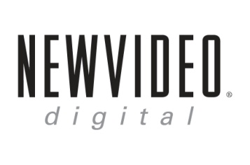 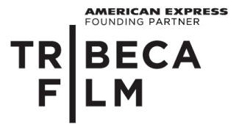

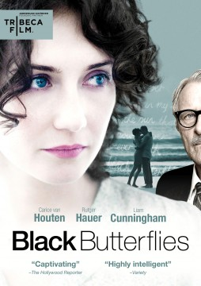

**“BLACK BUTTERFLIES,” THE STORY OF SOUTH AFRICA’S ICONIC POET**

**INGRID JONKER, DEBUTS JULY 17 ON DVD & DIGITAL**

“Highly intelligent, brilliantly thesped” – *Variety*

*June 9, 2012 – New York, New York* –In 1960s Cape Town, as apartheid steals the expressive rights of blacks and whites alike, young Ingrid Jonker (**Carice van Houten**, *Black Book*, *Valkyrie*) finds her freedom writing poetry while frittering through a series of stormy affairs. Amid escalating quarrels with her lovers and her rigid father, a parliament censorship minister (**Rutger Hauer**, *Sin City*, *Batman Begins*), Jonker wit­nesses an unconscionable event that will alter the course of both her artistic and personal lives.

***BLACK BUTTERFLIES***, a narrative feature based on the life of “South Africa’s Sylvia Plath,” releases July 17 on standard digital platforms and DVD. The film premiered at the 2011 Tribeca Film Festival, where van Houten received the Best Actress in a Narrative Feature Award. At the 2011 Netherlands Film Festival, ***BLACK BUTTERFLIES*** received the Best Film Award, van Houten received the Best Actress Award and Sander Vos received the Best Editing Award. The film received rave reviews and was a *New York Times* Critics’ Pick.

Jonker gained worldwide recognition in 1994 after Nelson Mandela read her poem, “The Child Who Was Shot Dead by Soldiers in Nyanga” during his opening address to the first South African democratic parliament. While living in Cape Town, Jonker became involved with Jack Cope and led a free-spirited life, despite her inner turmoil. Many of her poems and writings reflected on the destruction created by apartheid, including the poem made famous by Mandela.

After learning more about Jonker and watching Mandela’s address, Dutch producer Arry Voorsmit was inspired to create a feature film about the troubled poet. Much of the research for the film revolved around documentaries, books, and Jonker’s poems as well as Cope’s journals, which were donated after his death, to the National English Literary Museum in Grahamstown, South Africa.

“The core of the story became this idea that as a human being you have to have a reason to live. There is a need for everybody to express themselves and apartheid is just the background in front of which our story unfolds,” Voorsmit said.

***BLACK BUTTERFLIES*** is directed by Paula van der Oest (*The Domino Effect*, *Tiramisu*); executive produced by Arnold Heslenfeld; produced by Frans van Gestel, Richard Claus, Michael Auret and Arry Voorsmit, written by Greg Latter; edited by Sander Vos; cinematography by Giulio Biccari. The DVD includes an interview with van der Oest and van Houten, presented by American Express.

Pricing: $26.95 US/ $29.95 CAN

Runtime: 96 mins. + extras

Rating: NR

Catalog #: NNVG272447

Language: English

Color: Color

Audio Format: Dolby Digital 5.1 Stereo

Genre: Drama

**About Tribeca Film**  
Tribeca Film is a comprehensive distribution label dedicated to acquiring and marketing independent films across multiple platforms, including video-on-demand, theatrical and home video.  It is an initiative from Tribeca Enterprises designed to provide new platforms for how film can be experienced, while supporting filmmakers and introducing audiences to films they might not otherwise see. American Express continues its support of Tribeca and the independent film community by serving as the Founding Partner of Tribeca Film.

**About New Video**

New Video is a leading entertainment distributor and the largest aggregator of independent digital content worldwide. Headquartered in New York City, with an international presence in 45 territories, the company delivers feature films, TV programs and web originals via digital download, streaming, video-on-demand, Blu-ray, DVD, and theatrical release. In 2011, New Video bowed Oscar®-nominated Hell and Back Again and South American blockbuster Elite Squad: The Enemy Within in US theaters. Through a new partnership with digital exhibitor Cinedigm Entertainment Group, New Video is poised to bring more independent films to theaters nationwide. New Video streamlines distribution and marketing for filmmakers and partners, bringing a wide variety of fresh content to new audiences. The company’s library includes original TV series and movies from A+E® Home Entertainment, HISTORY™, and Lifetime®, unforgettable games and trophy sets from Major League Baseball®, storybook treasures from Scholastic®, award-winning documentaries from Docurama Films®, next-gen indies from Flatiron Film Company®, and acclaimed independent films and festival picks through partnerships with the Sundance Institute and Tribeca Film. New Video is proud to distribute many Oscar®-nominated films including GasLand, Waste Land, Chico & Rita and Hell and Back Again.

**For more information, please contact:**

Luis Garza; 646-259-4144; lgarza@newvideo.com

For Box Art:

<http://www.newvideo.com/featured-releases/black-butterflies/>