**For Immediate Release**



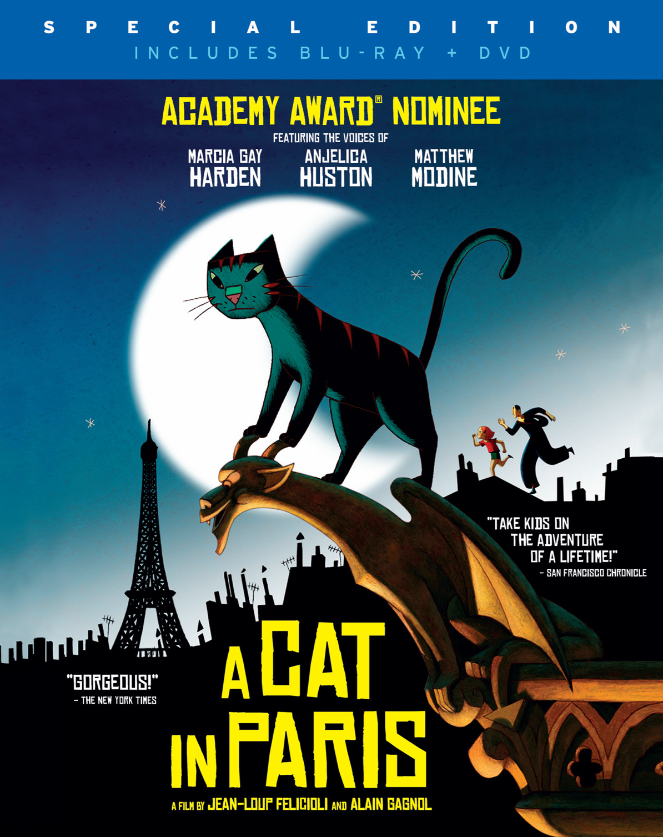

**CINEDIGM TO RELEASE GKIDS’ 2012 ACADEMY AWARD**®**-****NOMINATED ANIMATED FILM,**

**“A CAT IN PARIS,” ACROSS ON-DEMAND, DIGITAL, DVD AND BLU-RAY ON OCTOBER 9**

**Visually-Stunning Family Adventure Featuring the Voices of Academy Award**® **Winners   
Marcia Gay Harden and Anjelica Huston and Golden Globe**® **Nominee Matthew Modine**

**“SUBLIME…BREATHTAKING…** **A STYLISH CELEBRATION OF STORYTELLING.”** *- Boston Globe*

**“WONDERFUL, SOPHISTICATED FUN.”** *-San Francisco Chronicle*

**“REFRESHING… EXHILERATING…** **FANTASTIC.”** -*Time Out Chicago*

***CRITICS’ PICK –* “A NIFTY LITTLE CAPER”** “A refreshing reminder, at a time of large-scale, highly polished cinematic spectacle, of the essential, elemental sources of movie-watching pleasure.” *-The New York Times*

August 13, 2012 – [***A CAT IN PARIS***](http://www.catinparis.com), the 2012 Academy Award®-nominated animated film from GKIDS that has been captivating critics and audiences since its U.S. theatrical release in June, makes its cable VOD, digital, DVD and Blu-ray debut on October 9 from Cinedigm Entertainment Group, a division of Cinedigm Digital Cinema Corp. (NASDAQ: CIDM).

From directors Jean-Loup Felicioli and Alain Gagnol and France’s renowned Folimage animation studio, ***A CAT IN PARIS*** is a beautifully hand-drawn caper set in the shadow-drenched alleyways of Paris. Dino is a cat that leads a double life. By day he lives with Zoë, a little girl whose mother is a detective in the Parisian police force. But at night Dino sneaks out the window to work with Nico – a slinky cat burglar with a big heart, whose fluid movements are poetry in motion as he evades captors and slips and swishes from rooftop to rooftop across the city skyline.



With the voices of Academy Award®-winner Marcia Gay Harden (“Mystic River”), Academy Award®-winner Anjelica Huston (“The Royal Tenenbaums”) and Matthew Modine (“The Dark Knight Rises”), ***A CAT IN PARIS*** is a delightful animated adventure, perfect for both adults and children – a witty and stylish “animated noir” with a jazzy soundtrack featuring Billie Holiday and a thrilling climax on top of Notre Dame cathedral.

**“A GEM…A TREAT… NOT TO BE MISSED BY CHILDREN OR THEIR PARENTS.”** -*Seattle Weekly*

**“A DELIGHTFUL, JAZZY ANIMATED FILM.”** *-The Seattle Times*

**“AN ELEGANT THRILLER.”** “*A Cat in Paris* glories in striking silhouettes, a slinky '50s beat, a bright storybook palette and an entrancing brand of make-believe that grown-ups can believe in.” *-The Chicago Tribune*

***A CAT IN PARIS*** was an official selection at the Berlin, Annecy, San Francisco and Seattle film festivals, prior to its nationwide U.S. theatrical release in June 2012. The original French-language version of ***A CAT IN PARIS*** was nominated for a 2011 César Award (French Oscar®).



Special bonus features on the DVD and DVD/Blu-ray discs include: “The Many Lives of a Cat” Video Flipbook; “Extinction of the Saber-Toothed Housecat”, an animated short distributed in U.S. theaters with ***A CAT IN PARIS***; U.S. film trailer; and the original French-language version of the film with English subtitles. For more information, visit <http://www.newvideo.com/new-video-digital/a-cat-in-paris/>.

Pricing: $29.95 DVD; $39.95 BD/DVD

Runtime: 62 mins. + extras

MPAA Rating: PG

DVD Catalog #: NNVG277041

DVD/BD Catalog #: NNVG277050

Language: English; bonus includes French-language version with English subtitles

Color: Color

Audio Format: Dolby Digital 5.1 Stereo

Genre: Animation

**About GKIDS**

GKIDS is a distributor of award-winning filmed entertainment specializing in animation for both adult and family audiences. The company has scored three Best Animated Feature Oscar® nominations in the past three years, with “The Secret of Kells” in 2010 and both “A Cat in Paris” and “Chico & Rita” in 2012 – marking the first time an independent distributor has had two simultaneous nominations in the category. GKIDS also handles North American theatrical distribution for Oscar® winner Hayao Miyazaki's famed Studio Ghibli library of films, one of the world’s most coveted animation collections with titles “Spirited Away*,”* My Neighbor Totoro*,” “*Princess Mononoke” and others. GKIDS is longtime producer of the New York Int’l Children’s Film Festival, an Oscar®-qualifying event and North America’s largest festival of film for children and teens. NYICFF jury members include Uma Thurman, Susan Sarandon, Matthew Modine, Jeffrey Wright, Gus van Sant, Christine Vachon, John Canemaker and James Schamus. www.gkids.com

**About Cinedigm Entertainment Group**

Cinedigm Entertainment Group, a division of Cinedigm Digital Cinema Corpis a state of the art digital distributor of award-winning independent films and alternative content. CEG has released close to 200 independent films and alternative content events over the last few years, with past releases ranging up to 1,000 screens based on content and audience footprint. Films released by Cinedigm include: “Life In A Day.” directed by Kevin McDonald; “The Ward,” directed by John Carpenter; “Smell of Success,” featuring Billy Bob Thornton, Téa Leoni and Ed Helms; Foo Fighters documentary, “Back & Forth,” directed by Oscar® winner James Moll; and Peter Bogdanovich's “Runnin' Down A Dream,” with Tom Petty and the Heartbreakers. Current and upcoming CEG films include "No Room For Rockstars," Parris Patton's documentary chronicling the Vans Warped Tour; "Like Water," directed by Pablo Croce; "The Invisible War," directed by Kirby Dick; “Citadel,” directed by Ciaran Foy; “In Our Nature,” starring John Slattery; and “22 Bullets,” starring Jean Reno and produced by Luc Besson.

Additionally, Cinedigm delivers feature films, TV programs and web originals via digital download, streaming, video-on-demand, Blu-ray, and DVD. The company’s library includes award-winning documentaries from Docurama Films®, next-gen indies from Flatiron Film Company®, including international blockbuster “Elite Squad: The Enemy Within,” and acclaimed independent films and festival picks through partnerships with the Sundance Institute and Tribeca Film. Cinedigm is proud to distribute many Oscar®-nominated films including “Hell and Back Again*,” “*GasLand,” “Waste Land*,” “*The Secret of Kells*,” “*Paradise Lost 3: Purgatory” and *“*Chico & Rita*.”*

# # #

Press contacts:  
Grand Communications (for Cinedigm):

Alison Grand Jaymie Presberg Gabrielle Torello

212-584-1133 212-584-1133 201-678-2824

[alison@grandcommunications.com](mailto:alison@grandcommunications.com) [jaymie@grandcommunications.com](mailto:jaymie@grandcommunications.com) [gab@grandcommunications.com](mailto:gab@grandcommunications.com)