**FOR IMMEDIATE RELEASE**



**CINEDIGM ENTERTAINMENT GROUP’S FLATIRON FILM COMPANY**

**CELEBRATES 10 YEARS OF RED VS. BLUE WITH 3 NEW DVD RELEASES**

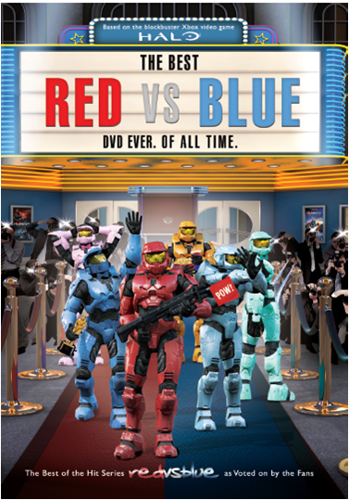 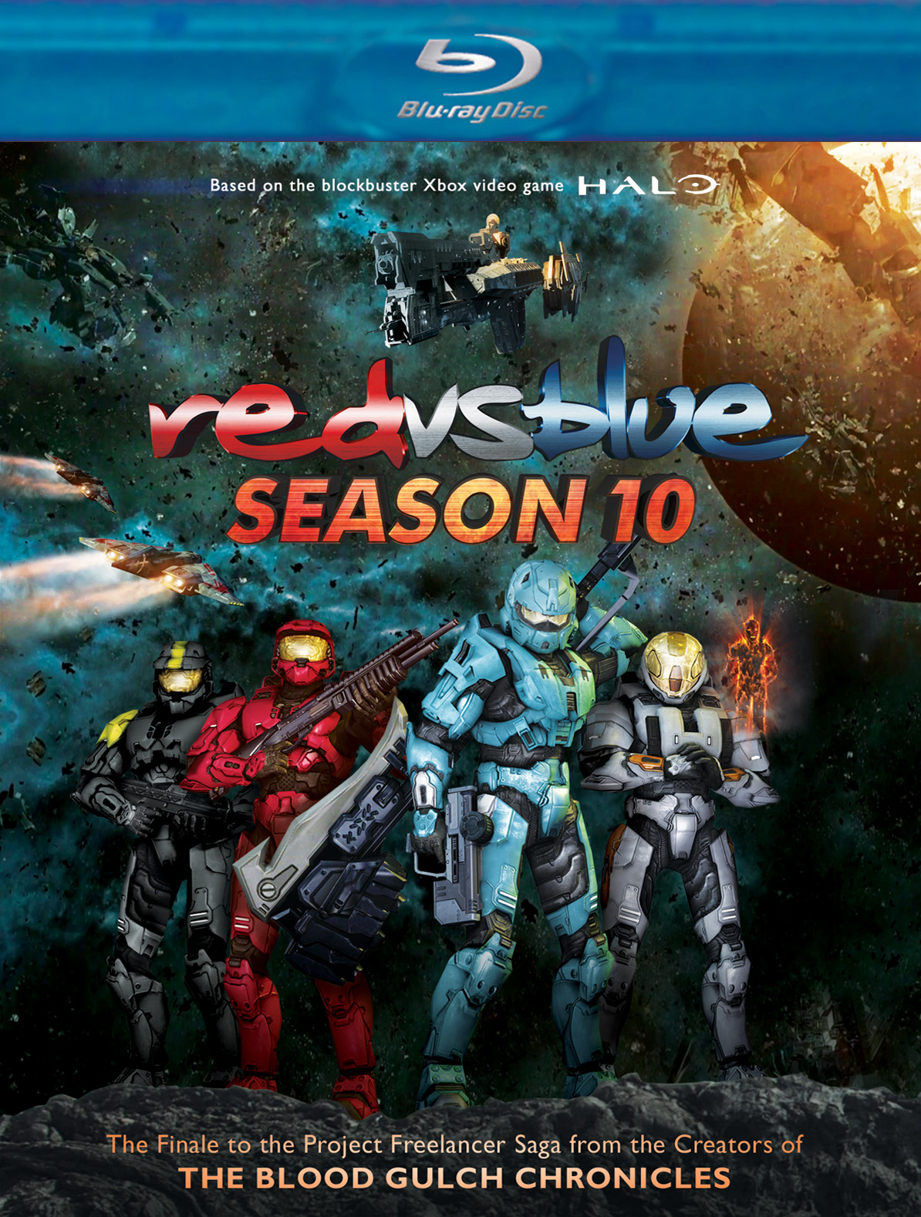 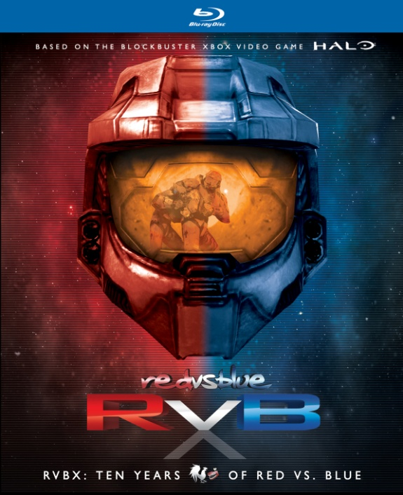

**“The Best Red vs. Blue DVD Ever. Of All Time” Releases October 1; First-Ever Blu-Ray Releases of “RVBX: Ten Years of Red vs. Blue” 14-Disc Set and “Red vs. Blue Season 10” on November 6**

“An instant runaway hit”—*The New York Times*

September 10, 2012 – New York, New York – In April 2003, the first episode of *Red vs. Blue* took the internet by storm, heralding the dawn of a new era of online viral video. Based on the explosively popular video game franchise Halo® and created with a new form of animation called “machinima,” *Red vs. Blue* was unlike anything online audiences had ever seen before.

In 10 years, *Red vs. Blue* has become what could be considered the most loved, watched and quoted web series ever. From tank romances to alien offspring, buddy clubs, knock-knock jokes and laser faces, this is the sci-fi comedy that paved the way for an entire generation of online video, while audiences around the world joined in the laughter.

On October 1, Flatiron Film Company, a label of Cinedigm Digital Cinema Corp. (NASDAQ: CIDM)’s Entertainment Group, will release ***THE BEST RED VS. BLUE DVD EVER. OF ALL TIME***, compiled from a fan survey conducted by *Red vs. Blue* creators, Rooster Teeth. Presented in an award-show format, ***THE BEST RED VS. BLUE DVD EVER. OF ALL TIME*** is a salute to the show's most ridiculous, explosive, jaw-dropping and sidesplitting moments.

On November 6, Flatiron Film Company will release ***RED VS. BLUE SEASON 10*** and ***RVBX: TEN YEARS OF RED VS. BLUE*** on DVD and Blu-ray. Season 10 will be premiering on digital platforms day-and-date with the DVD and Blu-ray release.

* ***RVBX: TEN YEARS OF RED VS. BLUE*** marks the first time the entire series has been available on Blu-ray. The 14-disc boxed set is a collection of the full first 10 seasons of Red vs. Blue, with newly re-mastered surround sound audio, plus additional videos and miniseries, hours of special features, interviews and behind-the-scenes footage.
* ***RED VS. BLUE SEASON 10*** is the gripping and hilarious finale to the Project Freelancer saga, featuring the debut of Elijah Wood (*Lord of the Rings*, *Wilfred*) as the voice of the artificial intelligence program, “Sigma.” The film includes newly animated battle sequences – including never-before-seen footage from Halo 4®. Bonus content includes: PSAs, Trailers, Outtakes and Deleted Scenes.

With the release of the “Best of” collection, the first-ever Blu-Ray release for Season 10 and the culmination of the decade-long saga in the RVBX set, fans of the series are sure to be entertained for hours by the world's longest-running web series ever. Of all time.

**THE BEST RED VS. BLUE DVD EVER. OF ALL TIME**

Pricing: $5.00 US/$8.99 CAN

Runtime: 149 minutes + extras

Rating: NA

Catalog #: NNVG276801

Language: English

Color: Color

Audio Format: Dolby Digital 2.0 Stereo

Genre: Comedy, Gaming

**RED VS. BLUE SEASON 10**

DVD Pricing: $19.95 US/$22.95 CAN

BD Pricing: $24.95 US/$29.95 CAN

Runtime: 165 minutes + extras

Rating: NA

Catalog #: NNVG279231

BD Catalog #: NNVG279240

Language: English

Color: Color

Audio Format: Dolby Digital 5.1 Surround

Genre: Comedy, Gaming

**RVBX: TEN YEARS OF RED VS. BLUE**

DVD Pricing: $139.95 US/$154.95 CAN

BD Pricing: $179.95 US/$199.95 CAN

Runtime: 18 hours, 42 minutes + extras

Rating: NA

Catalog #: NNVG279260

BD Catalog #: NNVG279280

Language: English

Color: Color

Audio Format: Dolby Digital 5.1 Surround

Genre: Comedy, Gaming

**About Cinedigm Entertainment Group**

Cinedigm Entertainment Group, a division of Cinedigm Digital Cinema Corp. is a state of the art digital distributor of award-winning independent films and alternative content. CEG has released close to 200 independent films and alternative content events over the last few years, with past releases ranging up to 1,000 screens based on content and audience footprint. Films released by Cinedigm include: “Life In A Day.” directed by Kevin McDonald; “The Ward,” directed by John Carpenter; “Smell of Success,” featuring Billy Bob Thornton, Téa Leoni and Ed Helms; Foo Fighters documentary, “Back & Forth,” directed by Oscar® winner James Moll; and Peter Bogdanovich's “Runnin' Down A Dream,” with Tom Petty and the Heartbreakers. Current and upcoming CEG films include "No Room For Rockstars," Parris Patton's documentary chronicling the Vans Warped Tour; "Like Water," directed by Pablo Croce; "The Invisible War," directed by Kirby Dick; “Citadel,” directed by Ciaran Foy; “In Our Nature,” starring John Slattery; and “22 Bullets,” starring Jean Reno and produced by Luc Besson.

Additionally, Cinedigm delivers feature films, TV programs and web originals via digital download, streaming, video-on-demand, Blu-ray, and DVD. The company’s library includes award-winning documentaries from Docurama Films®, next-gen indies from Flatiron Film Company®, including international blockbuster “Elite Squad: The Enemy Within,” and acclaimed independent films and festival picks through partnerships with the Sundance Institute and Tribeca Film. Cinedigm is proud to distribute many Oscar®-nominated films including “Hell and Back Again*,” “*GasLand,” “Waste Land*,” “*The Secret of Kells*,” “*Paradise Lost 3: Purgatory” and *“*Chico & Rita*.”* Cinedigm™ and Cinedigm Digital Cinema Corp™ are trademarks of Cinedigm Digital Cinema Corp. [CIDM-G] [www.cinedigm.com](http://ctt.marketwire.com/?release=877084&id=1508824&type=1&url=http%3a%2f%2fwww.cinedigm.com%2f).

**About Rooster Teeth**

* Creators of one of the most popular and longest running web series of all-time, Red vs. Blue, now in its tenth season.
* Over 1 million DVDs sold
* Over 1 billion total video views.
* 8th most viewed YouTube channel in the world (non-music).
* 2 million YouTube subscribers.
* 5 million monthly unique visitors to RoosterTeeth.com.
* 1.4 million registered community members.
* Most downloaded gaming podcast on iTunes.
* 3 million monthly podcast downloads.
* Created the first machinima broadcast on commercial television.
* Winners of multiple awards, including the 2011 Best Animated Series from the IAWTV.
* Featured by hundreds of major publications and networks including MTV, G4, the New York Times, the Wall Street Journal, Rolling Stone Magazine, Wired Magazine, and many more.

**About “Halo”**

The “Halo” franchise is an award-winning collection of properties that has grown into a global entertainment phenomenon. Beginning with the original “Halo: Combat Evolved” (2001), the critically acclaimed and record-shattering series of games has since inspired multiple New York Times bestselling novels, comic books, action figures, apparel and more.

Published by Microsoft Studios, the “Halo” franchise of games is exclusive to the Xbox 360 video game and entertainment system and the Xbox LIVE online entertainment network. To date, more than 43 million copies of “Halo” games have been sold worldwide, driving more than 3.3 billion hours of gameplay by people connected to Xbox LIVE.

**For more information, please contact:**

Luis Garza; 646-259-4144;

lgarza@newvideo.com

For box art:

**The Best Red vs. Blue DVD Ever. Of All Time:**

<http://www.newvideo.com/flatiron-film-company/the-best-red-vs-blue-dvd-ever-of-all-time/>

**RVBX Ten Years of Red vs. Blue:**

<http://www.newvideo.com/new-video-digital/rvbx-ten-years-of-red-vs-blue/>

**Red vs. Blue Season 10:**