**FOR IMMEDIATE RELEASE**

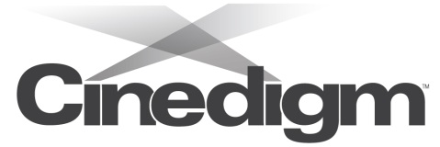 

present

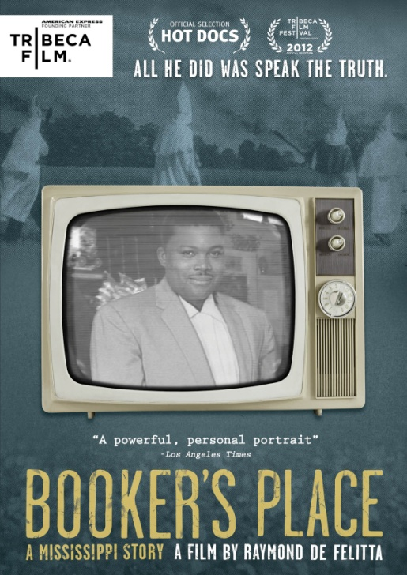

**THE STORY OF A MAN’S COURAGEOUS ACT TO SPEAK THE TRUTH**

**“BOOKER’S PLACE: A MISSISSIPPI STORY” RELEASES**

**NOVEMBER 6 ON DVD AND DIGITAL**

“A powerful, personal portrait” – *Los Angeles Times*

***October 16, 2012*** – *New York, New York* -- In 1965, filmmaker Frank De Felitta made a documentary film for NBC News about the changing times in the American South and the tensions of life in the Mississippi Delta during the civil rights struggle. The film was broadcast in May 1966 and outraged many Southern viewers, in part, because it included an extraordinary scene featuring a local African-American waiter named Booker Wright.

Wright, who worked at a local "whites only" restaurant in Greenwood MS, went on record to deliver a stunning, heartfelt and inflammatory monologue exploding the myth about who he was and how he felt about his position serving the local white community. The fallout for Booker Wright was extreme: He lost his job and was beaten and ostracized by those that considered him “one of their own.”

Directed by Frank De Felitta’s son, Oscar®-nominated director Raymond De Felitta (*City Island*), ***BOOKER’S PLACE: A MISSISSIPPI STORY*** releases November 6 on standard digital platforms and DVD from Cinedigm Entertainment Group, a division of Cinedigm Digital Cinema Corp. (NASDAQ: CIDM), and Tribeca Film.

***BOOKER’S PLACE*** paints a moving and inspiring portrait of Wright’s life as witnessed by his family and friends. In the film, De Felitta travels to Mississippi to uncover the details surrounding Wright’s life and death and the impact his father’s documentary had on the community.

With the help of Wright’s granddaughter, Yvette Johnson, De Felitta gives a behind-the-scenes account of the controversial event through interviews with Wright’s family, friends and elected officials, including former Governor William Winter, former Senator David Jordan, Representative Willie Bailey, Judges Grey Evans and Johnnie E. Walls. Both De Felitta and his father are interviewed in the film as they discuss the NBC broadcast of *Mississippi: A Portrait* and the consequences of including Wright in the 1965 film.

Through archival footage and photos, ***BOOKER’S PLACE*** revisits the tenuous time of the civil rights movement. Along with sharing what life was like during the ‘60s, the film serves as a testament to a courageous individual who was unafraid to speak the truth. ***BOOKER’S PLACE*** premiered at this year’s Tribeca Film Festival, was an official selection at the 2012 HotDocs Film Festival and was the subject of a full NBC *Dateline* episode that aired in July 2012.

***BOOKER’S PLACE*** is directed by Raymond De Felitta ; executive produced by Lynn Roer and Steven C. Beer; produced by Yvette Johnson and David Zellerford; edited by George Gross. Bonus features include: an interview with director Raymond De Felitta, presented by American Express, additional scenes and the “The Streets of Greenwood” documentary.

Pricing: $26.95 US/$29.95

Runtime: 92 mins. + extras

Rating: NR

Catalog #: NNVG276581

Language: English

Color: Black and White

Audio Format: Dolby Digital 5.1 Stereo

Genre: Documentary

**About Tribeca Film**

Tribeca Film is a comprehensive distribution label dedicated to acquiring and marketing independent films across multiple platforms, including video-on-demand, theatrical and home video. It is an initiative from Tribeca Enterprises designed to provide new platforms for how film can be experienced, while supporting filmmakers and introducing audiences to films they might not otherwise see. American Express continues its support of Tribeca and the independent film community by serving as the Founding Partner of Tribeca Film.

**Cinedigm Entertainment Group:**

Cinedigm Entertainment Group (CEG), a division of Cinedigm Digital Cinema Corp., is an end-to-end digital distribution company delivering content in theaters, across digital and on-demand platforms, and on DVD/Blu-ray. CEG reaches a global digital audience through partnerships with iTunes, Netflix, Amazon, Google, Hulu, Vudu, Xbox, Playstation, and others. The company’s library of over 5,000 titles includes award-winning documentaries from Docurama Films®, next-gen indies from Flatiron Film Company® and acclaimed independent films and festival picks through partnerships with the Sundance Institute and Tribeca Film. CEG is proud to distribute many Oscar®-nominated films including *Hell and Back Again*, GasLand, Waste Land, *Paradise Lost 3: Purgatory, A Cat in Paris* and Chico & Rita*.* Current and upcoming CEG multi-platform releases include *The Invisible War*, *Citadel*, *In* *Our Nature*, *22 Bullets* and *Don’t Stop Believin’: Everyman’s Journey*. [CIDM-G] [www.cinedigm.com](http://ctt.marketwire.com/?release=877084&id=1508824&type=1&url=http%3a%2f%2fwww.cinedigm.com%2f).

**For more information, please contact:**

Luis Garza; 646-259-4144;

lgarza@newvideo.com

For Box Art:

<http://www.newvideo.com/new-video-digital/bookers-place-a-mississippi-story/>