**FOR IMMEDIATE RELEASE**



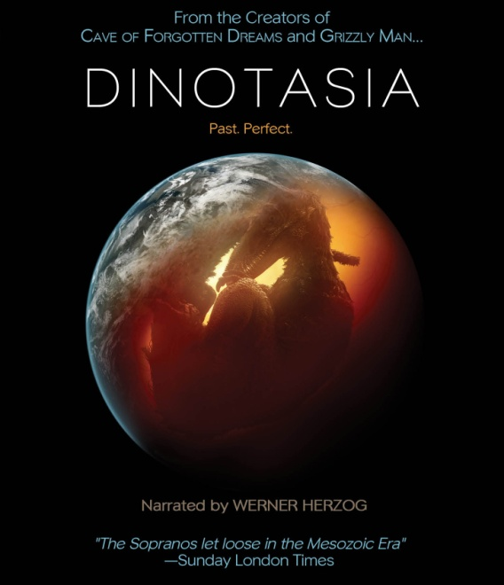

**“DINOTASIA,” AN ANIMATED FEATURE FILM NARRATED BY CINEMA LEGEND**

**WERNER HERZOG, RELEASES NOVEMBER 6 ON DIGITAL AND DVD/BLU-RAY**

*October 10, 2012* – *New York, New York* –One of our favorite natural history subjects, the dinosaur, gets a makeover like never before in the fantastically ambitious and groundbreaking animated feature film, ***DINOTASIA***, narrated by legendary director **Werner Herzog** (*Fitzcarraldo*, *Grizzly Man*). On November 6, **Flatiron Film Company**, a label of **Cinedigm Entertainment Group** (NASDAQ: CIDM), will release ***DINOTASIA*** on DVD/Blu-ray and digital platforms. A marriage between classic visual storytelling and CGI dinosaurs, the film is an anthology of prehistoric stories created in the cartoon-style of the Golden Age of animation. The DVD/Blu-ray includes the 83-minute feature film plus an extended scene, a mating rites extra story, and a stunning hand-drawn version of the final story.

The film is co-directed by long-time Herzog collaborator **Erik Nelson** and Disney character designer **David Krentz**. “*The Sunday Times* said it best,” says Nelson, “when they called ***DINOTASIA*** the ‘*Sopranos* of the Mesozoic.’”

***DINTOTASIA*** is not a documentary or nature film, but a love letter to fans of bizarre, graphic novel-style film vignettes and classic film animation. Werner Herzog, an early fan of the project, lends his inimitable style as narrator, serving as a tour guide to ***DINOTASIA***’s strange world. Audiences can feast their eyes on mind-blowing vignettes including: the saga of a dinosaur family under siege from a rogue T-Rex; a post-apocalyptic narrative set in the aftermath of THE asteroid that destroys most of the earth; and the adventures of a dinosaur that ingests the Jurassic equivalent of a psychedelic mushroom. The fact that all of the stories are based on hard science and the fossil record makes the end product even more amazing.   
  
The animated stories are told in a purely visual style not seen since the classic era of silent filmmaking and the pioneering early work of Walt Disney Studios. Aside from brief “Herzogian” narration to introduce each sequence, the film has no character dialogue, just music and imagery. Based on current research findings from recent paleontology studies, *Dinotasia* uses CGI to bring to life many creatures that have been discovered in the past 10 years. The back plates for the animated action were primarily shot in Tenerife, in the Canary Islands, and in the old-growth forests of Humboldt County in Northern California.

***DINOTASIA*** was co-directed by Erik Nelson, best known for his work with Herzog on his documentary features including *Grizzly Man* and *Cave of Forgotten Dreams*, with David Krentz, the lead character designer for a number of Disney films, including *John Carter* and *Dinosaur*.

**Credits**: Narrator, Werner Herzog; Directors, David Krentz and Erik Nelson; Producer, Erik Nelson; Executive Producers, Dave Harding and Amy Briamonte; Music, Mark Leggett; VFX Supervisor, Douglas Martin; Supervising Director, Ricardo Delgado; VFX Producer, Chad Nixon.

**DINOTASIA:**

DVD: $29.95 U.S./$34.95 CAN

Catalog #: NNVG279290  
Blu-ray: $34.95 U.S./$39.95 CAN

Catalog #: NNVG279310

Runtime: 83 minutes, plus extras

Language: English

Color: Color

Audio Format: 5.1

Genre: Animation

Bonus: Single DVD and Blu-ray include extended scenes, a dinosaur mating rites extra story, and stunning hand-drawn version of the final story.

**Erik Nelson, Co-Director & Producer:**  
Erik Nelson is the President of Creative Differences and the co-director/producer of *Dinotasia*. Other recent projects produced and directed by Nelson include *9-11: Science and Conspiracy*, National Geographic Channel’s *Dark Secrets Of The Lusitania,* and The History Channel’s *Engineering Evil*, a two-hour documentary on the logistics of the Holocaust. Nelson also produced Werner Herzog’s 2005 feature *Grizzly Man*, Oscar-nominated *Encounters at the End of the World*, *Into The Abyss* and *Cave Of Forgotten Dreams* (the highest grossing feature documentary of 2011). <http://www.imdb.com/name/nm0625356/> **David Krentz, Co-Director**:  
David Krentz is one of the world’s leading dinosaur artists. Krentz was lead character designer for the benchmark Disney CG film *Dinosaur*, and has contributed to such movies as *John Carter*, *Fantasia 2000, Treasure Planet, Spiderman 2, Valiant, The Ant Bully, Spiderwick,* and *Outlander,* as well as many other live-action and animated films currently in production. <http://www.davidkrentz.com/davidkrentz/David_Krentz.html>

**Werner Herzog, Narrator**:  
High-stakes German filmmaker Werner Herzog, known for exploring dark and dramatic material, was born in Munich and grew up removed from technology in a remote Bavarian village. He worked as a welder to fund production of his first film at age nineteen and has since directed more than fifty features. He has also published more than a dozen books of prose and directed as many operas. His films have won numerous awards, including the special grand jury prize at the Cannes Film Festival for *The Enigma of Kaspar Hauser* (1974) and best director at the Cannes Film Festival for *Fitzcarraldo* (1982). His other films include: *Aguirre*: *The Wrath of God* (1972), *Nosferatu* (1978), *Little Dieter Needs to Fly* (1997), *Grizzly Man* (2005), *Rescue Dawn* (2006), *Bad Lieutenant: Port of Call New Orleans* (2009), *Cave of Forgotten Dreams* (2010), and *Into the Abyss* (2011). <http://www.wernerherzog.com/>

**Creative Differences**:Creative Differences is a Los Angeles- and Vancouver-based production company. Over the past fifteen years, Creative Differences has produced a wide range of programming for an even wider range of television networks, including: HISTORY, A+E, Animal Planet, Discovery, National Geographic, Fox, CBS, MTV, and PBS. The company has produced notable series such as *Unsolved History*, *Time Warp*, *Blood Dolphins*, and *Megadisasters* as well as the feature documentaries *Grizzly Man,* and the Oscar-nominated *Encounters at the End of the World*. <http://www.creatvdiff.com/>

**Cinedigm Entertainment Group:**

Cinedigm Entertainment Group (CEG), a division of Cinedigm Digital Cinema Corp., is an end-to-end digital distribution company delivering content in theaters, across digital and on-demand platforms, and on DVD/Blu-ray. CEG reaches a global digital audience through partnerships with iTunes, Netflix, Amazon, Google, Hulu, Vudu, Xbox, Playstation, and others. The company’s library of over 5,000 titles includes award-winning documentaries from Docurama Films®, next-gen indies from Flatiron Film Company® and acclaimed independent films and festival picks through partnerships with the Sundance Institute and Tribeca Film. CEG is proud to distribute many Oscar®-nominated films including *Hell and Back Again*, GasLand, Waste Land, *Paradise Lost 3: Purgatory, A Cat in Paris* and Chico & Rita*.* Current and upcoming CEG multi-platform releases include *The Invisible War*, *Citadel*, *In* *Our Nature*, *22 Bullets* and *Don’t Stop Believin’: Everyman’s Journey*. [CIDM-G] [www.cinedigm.com](http://ctt.marketwire.com/?release=877084&id=1508824&type=1&url=http%3a%2f%2fwww.cinedigm.com%2f).

**For more information, please contact:**

Luis Garza; 646-259-4144; lgarza@newvideo.com

For box art and promotional stills:

<http://www.newvideo.com/flatiron-film-company/dinotasia/>