

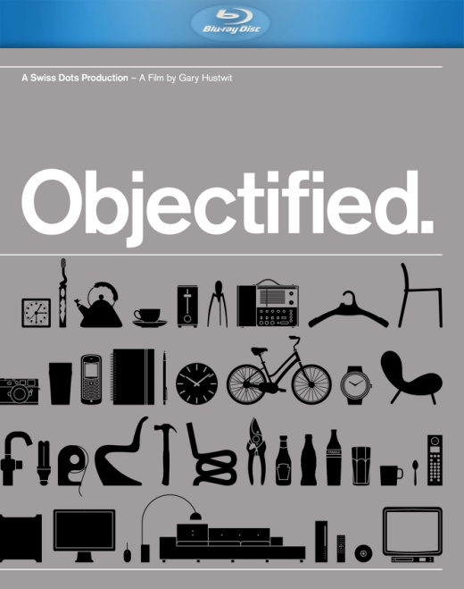

**CINEDIGM ENTERTAINMENT GROUP RELEASES BLU-RAY EDITION OF “OBJECTIFIED”**

**“**As sleek and handsome as any of the new and improved household items it exhibits.”

– *The New York Times*

**“**You'll never look at your next toothbrush (or your next any product) in quite the same way after watching this astute, elegant inquiry into the purpose and process of industrial design.” – *Entertainment Weekly*

“You may not ever think about what kind of planning goes into designing simple, everyday things like toothbrushes, wastebaskets or hedge trimmers, but after seeing ***OBJECTIFIED***, you will never look at any one of those objects the same way again.” – *Wired*

October 12, 2012 – New York, NY – On November 6, Cinedigm Entertainment Group will release director Gary Hustwit’s ode to industrial design, ***OBJECTIFIED***, on Blu-ray.

Objectified is a feature-length documentary about our complex relationship with manufactured objects and, by extension, the people who design them. It’s a look at the creativity at work behind everything from toothbrushes to tech gadgets. It’s about the designers who re-examine, re-evaluate and re-invent our manufactured environment on a daily basis. It’s about personal expression, identity, consumerism, and sustainability.

Through vérité footage and in-depth conversations, the film documents the creative processes of some of the world’s most influential product designers, and looks at how the things they make impact our lives. What can we learn about who we are, and who we want to be, from the objects with which we surround ourselves?

Says Hustwit on ***OBJECTIFIED***: “I’m interested in industrial designers because their work influences so many aspects of our world yet most of the time it’s taken for granted. And I think that, especially today, it’s crucial for us to re-examine how we make and use consumer products at every level.”

***OBJECTIFIED*** features interviews with some of the world’s most influential designers and design experts, including:

**Paola Antonelli, Senior Curator of the Department of Architecture and Design at the** Museum of Modern Art (MOMA); **Andrew Blauvelt, Head of the** Walker Art Center’s Design Studio; **Jonathan Ive, Senior Vice President of Industrial Design at** Apple, Inc.;award-winning designer **Karim Rashid; Alice Rawsthorn, design critic for the** *International Herald Tribune*; **Davin Stowell, founder and CEO of** Smart Design; **Rob Walker, former “Consumed” columnist for *The*** *New York Times* Magazine and blogger for Design Observer; many other world renowned designers.

***OBJECTIFIED*** is the second documentary in Gary Hustwit’s beloved design film trilogy that also includes *Helvetica* (2008) and *Urbanized* (2011). The film world premiered at the 2009 SXSW Film Festival and screened at the Full Frame and Hot Docs film festivals before its national theatrical release and PBS debut in 2010. ***OBJECTIFIED*** is produced and directed by Gary Hustwit, with cinematography by Luke Geissbühler and film editing by Joe Beshenkovsky.

Pricing: $34.95 US

Runtime: 75 minutes, plus extras

Rating: Not rated

Catalog #: NNVG400502

Language: English

Color: Color

Sound: Dolby Digital 5.1

Genre: Documentary

**Cinedigm Entertainment Group:**

Cinedigm Entertainment Group (CEG), a division of Cinedigm Digital Cinema Corp., is an end-to-end digital distribution company delivering content in theaters, across digital and on-demand platforms, and on DVD/Blu-ray. CEG reaches a global digital audience through partnerships with iTunes, Netflix, Amazon, Google, Hulu, Vudu, Xbox, Playstation, and others. The company’s library of over 5,000 titles includes award-winning documentaries from Docurama Films®, next-gen indies from Flatiron Film Company® and acclaimed independent films and festival picks through partnerships with the Sundance Institute and Tribeca Film. CEG is proud to distribute many Oscar®-nominated films including *Hell and Back Again*, GasLand, Waste Land, *Paradise Lost 3: Purgatory, A Cat in Paris* and Chico & Rita*.* Current and upcoming CEG multi-platform releases include *The Invisible War*, *Citadel*, *In* *Our Nature*, *22 Bullets* and *Don’t Stop Believin’: Everyman’s Journey*.

[CIDM-G] [www.cinedigm.com](http://ctt.marketwire.com/?release=877084&id=1508824&type=1&url=http%3a%2f%2fwww.cinedigm.com%2f).

**For more information, please contact:**

Luis Garza; 646-259-4144; [lgarza@newvideo.com](mailto:lgarza@newvideo.com)

For box art and promotional stills: http://www.newvideo.com/plexifilm/objectified-2/