**FOR IMMEDIATE RELEASE**



**CINEDIGM ENTERTAINMENT GROUP’S FLATIRON FILM COMPANY**

**CELEBRATES 10 YEARS OF RED VS. BLUE WITH FIRST EVER BLU-RAY RELEASES**

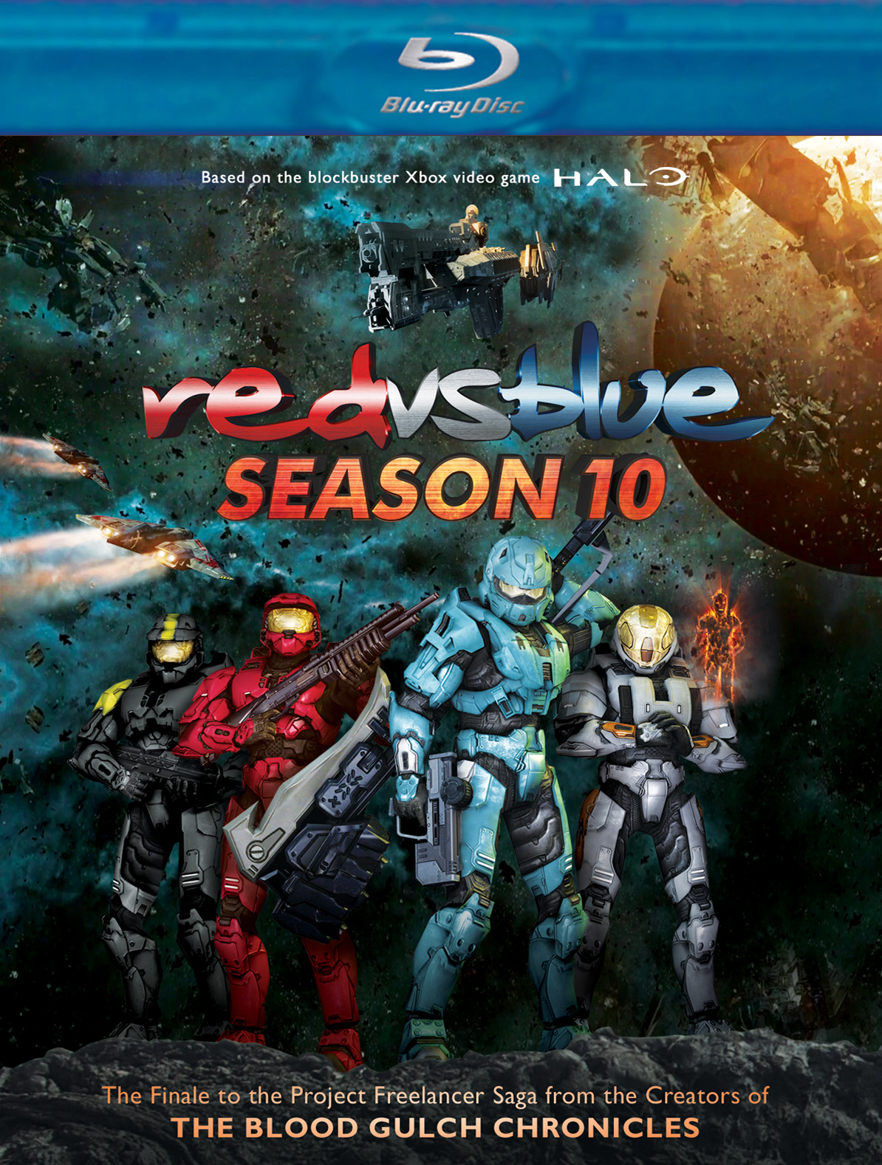 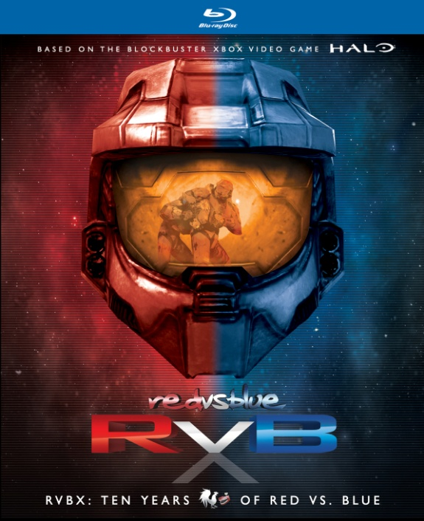

**“RVBX: Ten Years of Red vs. Blue” 14-Disc Set and “Red vs. Blue Season 10”**

**Hit Stores November 6, Day and Date with Release of Halo 4**

“An instant runaway hit”—*The New York Times*

October 19, 2012 – New York, New York – In April 2003, the first episode of *Red vs. Blue* took the internet by storm, heralding the dawn of a new era of online viral video. Based on the explosively popular video game franchise Halo® and created with a new form of animation called “machinima,” *Red vs. Blue* was unlike anything online audiences had ever seen before.

In 10 years, *Red vs. Blue* has become what could be considered the most loved, watched and quoted web series ever. From tank romances to alien offspring, buddy clubs, knock-knock jokes and laser faces, this is the sci-fi comedy that paved the way for an entire generation of online video, while audiences around the world joined in the laughter.

On November 6, Flatiron Film Company, a label of Cinedigm Entertainment Group (NASDAQ: CIDM), will release ***RED VS. BLUE SEASON 10*** and ***RVBX: TEN YEARS OF RED VS. BLUE*** on Blu-ray, for the first time ever, and on DVD. Season 10 will premiere on digital platforms day-and-date.

* ***RVBX: TEN YEARS OF RED VS. BLUE*** marks the first time the entire series to date has been available on Blu-ray. The 14-disc boxed set is a collection of the full first 10 seasons of *Red vs. Blue*, with newly re-mastered surround sound audio, and includes a collectible booklet plus additional videos and miniseries, hours of special features, interviews and behind-the-scenes footage.
* ***RED VS. BLUE SEASON 10*** is the gripping and hilarious finale to the Project Freelancer saga, featuring the debut of Elijah Wood (*Lord of the Rings*, *Wilfred*) as the voice of the artificial intelligence program, Sigma. The film includes newly animated battle sequences – including never-before-seen footage from Halo 4®. Bonus content includes: PSAs, Trailers, Outtakes and Deleted Scenes.

*The Best Red vs. Blue DVD Ever. Of All Time* released October 1 on DVD. With its release alongside the first-ever Blu-Ray release for Season 10 and the culmination of the decade-long saga in the RVBX set, fans of the series are sure to be entertained for hours by the world's longest-running web series ever. Of all time.

**RED VS. BLUE SEASON 10**

DVD Pricing: $19.95 US/$22.95 CAN

BD Pricing: $24.95 US/$29.95 CAN

Runtime: 165 minutes + extras

Rating: NA

Catalog #: NNVG279231

BD Catalog #: NNVG279240

Language: English

Color: Color

Audio Format: Dolby Digital 5.1 Surround

Genre: Comedy, Gaming

**RVBX: TEN YEARS OF RED VS. BLUE**

DVD Pricing: $139.95 US/$154.95 CAN

BD Pricing: $179.95 US/$199.95 CAN

Runtime: 18 hours, 42 minutes + extras

Rating: NA

Catalog #: NNVG279260

BD Catalog #: NNVG279280

Language: English

Color: Color

Audio Format: Dolby Digital 5.1 Surround

Genre: Comedy, Gaming

**Cinedigm Entertainment Group:**

Cinedigm Entertainment Group (CEG), a division of Cinedigm Digital Cinema Corp., is an end-to-end digital distribution company delivering content in theaters, across digital and on-demand platforms, and on DVD/Blu-ray. CEG reaches a global digital audience through partnerships with iTunes, Netflix, Amazon, Google, Hulu, Vudu, Xbox, Playstation, and others. The company’s library of over 5,000 titles includes award-winning documentaries from Docurama Films®, next-gen indies from Flatiron Film Company® and acclaimed independent films and festival picks through partnerships with the Sundance Institute and Tribeca Film. CEG is proud to distribute many Oscar®-nominated films including *Hell and Back Again*, GasLand, Waste Land, *Paradise Lost 3: Purgatory, A Cat in Paris* and Chico & Rita*.* Current and upcoming CEG multi-platform releases include *The Invisible War*, *Citadel*, *In* *Our Nature*, *22 Bullets* and *Don’t Stop Believin’: Everyman’s Journey*. [CIDM-G] [www.cinedigm.com](http://ctt.marketwire.com/?release=877084&id=1508824&type=1&url=http%3a%2f%2fwww.cinedigm.com%2f).

**About Rooster Teeth**

* Creators of one of the most popular and longest running web series of all-time, Red vs. Blue, now in its tenth season.
* Over 1 million DVDs sold
* Over 1 billion total video views.
* 8th most viewed YouTube channel in the world (non-music).
* 2 million YouTube subscribers.
* 5 million monthly unique visitors to RoosterTeeth.com.
* 1.4 million registered community members.
* Most downloaded gaming podcast on iTunes.
* 3 million monthly podcast downloads.
* Created the first machinima broadcast on commercial television.
* Winners of multiple awards, including the 2011 Best Animated Series from the IAWTV.
* Featured by hundreds of major publications and networks including MTV, G4, the New York Times, the Wall Street Journal, Rolling Stone Magazine, Wired Magazine, and many more.

**About “Halo”**

The “Halo” franchise is an award-winning collection of properties that has grown into a global entertainment phenomenon. Beginning with the original “Halo: Combat Evolved” (2001), the critically acclaimed and record-shattering series of games has since inspired multiple New York Times bestselling novels, comic books, action figures, apparel and more.

Published by Microsoft Studios, the “Halo” franchise of games is exclusive to the Xbox 360 video game and entertainment system and the Xbox LIVE online entertainment network. To date, more than 43 million copies of “Halo” games have been sold worldwide, driving more than 3.3 billion hours of gameplay by people connected to Xbox LIVE.

**For more information, please contact:**

Luis Garza; 646-259-4144; lgarza@newvideo.com

**For box art:**

Red vs. Blue Season 10: <http://www.newvideo.com/new-video-digital/red-vs-blue-season-10/>

RVBX Ten Years of Red vs. Blue: <http://www.newvideo.com/new-video-digital/rvbx-ten-years-of-red-vs-blue/>