**FOR IMMEDIATE RELEASE**

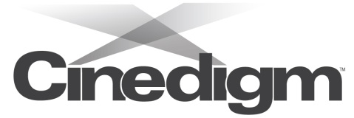



present

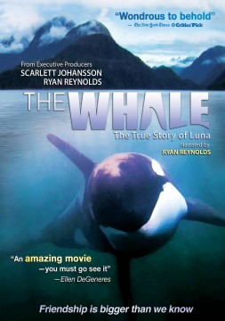

**FROM EXECUTIVE PRODUCERS SCARLETT JOHANSSON AND RYAN REYNOLDS,**

**“THE WHALE” RELEASES DECEMBER 4 ON DIGITAL AND DVD**

“Wondrous to behold”—*The New York Times*

“Visually stunning”—*Washington Post*

***November 15, 2012*** – *New York, New York* -- Narrated by Ryan Reynolds (*Green Lantern*, *The Proposal*), ***THE WHALE*** tells the remarkable true story of a young killer whale who lost contact with his family on the coast of British Columbia and became famous worldwide when he tried to befriend humans.

The film describes how the little whale, nicknamed Luna, finds himself alone in Nootka Sound, a fjord on the west coast of Vancouver Island. But killer whales are as social as humans, so, though Luna has plenty of fish to eat, he starts popping up beside boats and docks to make friendly contact with surprised fishermen, loggers, and townspeople. Like a gregarious visiting extraterrestrial doing zany things to get attention, Luna generates laughter, love and controversy as scientists, government officials, a Native American tribe and the people Luna befriends all try to figure out what to do about him, and debate whether his connection with humans is wonderful and amazing or dangerous and wrong.

Releasing on December 4 from Docurama Films, a label of Cinedigm Entertainment Group (NASDAQ: CIDM), ***THE WHALE*** is a narrative that covers four true but almost unbelievable years of the young whale’s life. Filmed as it happened by the people of Nootka Sound and by a husband and wife team that spent years following every twist and turn of the drama, the movie is a luminous, intimate portrait of a whale in need and the people who love him.

Luna’s life among humans challenges preconceptions about both science and the spirit, making us rethink our most fundamental ideas about the nature of love and friendship. The film celebrates the life of a smart, friendly and transcendent being who appeared among us like a promise out of the blue: that the greatest secrets in life are still to be discovered.

***THE WHALE*** was named Critics Pick by *The New York Times* and the *Washington Post*. It is the winner of the Outstanding Achievement in Filmmaking (Environmental) Award at the 2012 Newport Beach Film Festival and the Audience Choice at the Environmental Film Festival at Yale and was an official selection at the Beijing International Film Festival.

“An amazing movie—you must go see it.”—Ellen DeGeneres

***THE WHALE*** is directed Suzanne Chisholm and Michael Parfit; executive produced by Ryan Reynolds, Scarlett Johansson and Eric Desatnik; produced by Suzanne Chisholm; written and edited by Michael Parfit; narrated by Ryan Reynolds; with music by David Partfit and Tobin Stokes. Bonus features include exclusive interviews about Luna’s family, Luna’s birth drama, deleted scenes, and four “songs for Luna” music videos.

Pricing: $29.95 US

Runtime: 84 mins. + extras

Rating: G

Catalog #: NNVG281050

Language: English

Color: Color

Audio Format: Dolby Digital 5.1 Stereo

Genre: Documentary

**About Docurama Films**

In 1999, Docurama Films® launched with the first feature documentary available on DVD: D.A. Pennebaker’s iconic film on Bob Dylan, “Dont Look Back*.”* Twelve years and 300 award-winning, highly-acclaimed documentary titles later, Docurama continues to discover and release the greatest non-fiction films of our time while spreading the word about filmmakers who are taking the form to new heights.  Docurama’s catalog features an array of topics including the performing and visual arts, history, politics, the environment, ethnic and gender interests, and all-time favorites including “The Wild Parrots of Telegraph Hill,” “Andy Goldsworthy: Rivers and Tides”and *“*King Corn*.”* Recent titles include the Oscar®-nominated films “Gasland,”“Hell and Back Again” and “Paradise Lost 3: Purgatory.” [www.docuramafilms.com](http://www.docuramafilms.com)

**Cinedigm Entertainment Group**

Cinedigm Entertainment Group (CEG), a division of Cinedigm Digital Cinema Corp., is an end-to-end digital distribution company delivering content in theaters, across digital and on-demand platforms, and on DVD/Blu-ray. CEG reaches a global digital audience through partnerships with iTunes, Netflix, Amazon, Google, Hulu, Vudu, Xbox, Playstation, and others. The company’s library of over 5,000 titles includes award-winning documentaries from Docurama Films®, next-gen indies from Flatiron Film Company® and acclaimed independent films and festival picks through partnerships with the Sundance Institute and Tribeca Film. CEG is proud to distribute many Oscar®-nominated films including *Hell and Back Again*, GasLand, Waste Land, *Paradise Lost 3: Purgatory, A Cat in Paris* and Chico & Rita*.* Current and upcoming CEG multi-platform releases include *The Invisible War*, *Citadel*, *In* *Our Nature*, *22 Bullets* and *Don’t Stop Believin’: Everyman’s Journey*. [CIDM-G] [www.cinedigm.com](http://ctt.marketwire.com/?release=877084&id=1508824&type=1&url=http%3a%2f%2fwww.cinedigm.com%2f).

**For more information, please contact:**

Luis Garza; 646-259-4144; lgarza@newvideo.com

For Box Art:

<http://www.newvideo.com/docurama/the-whale/>