**FOR IMMEDIATE RELEASE**

Cinedigm_Logo_72dpi.jpg



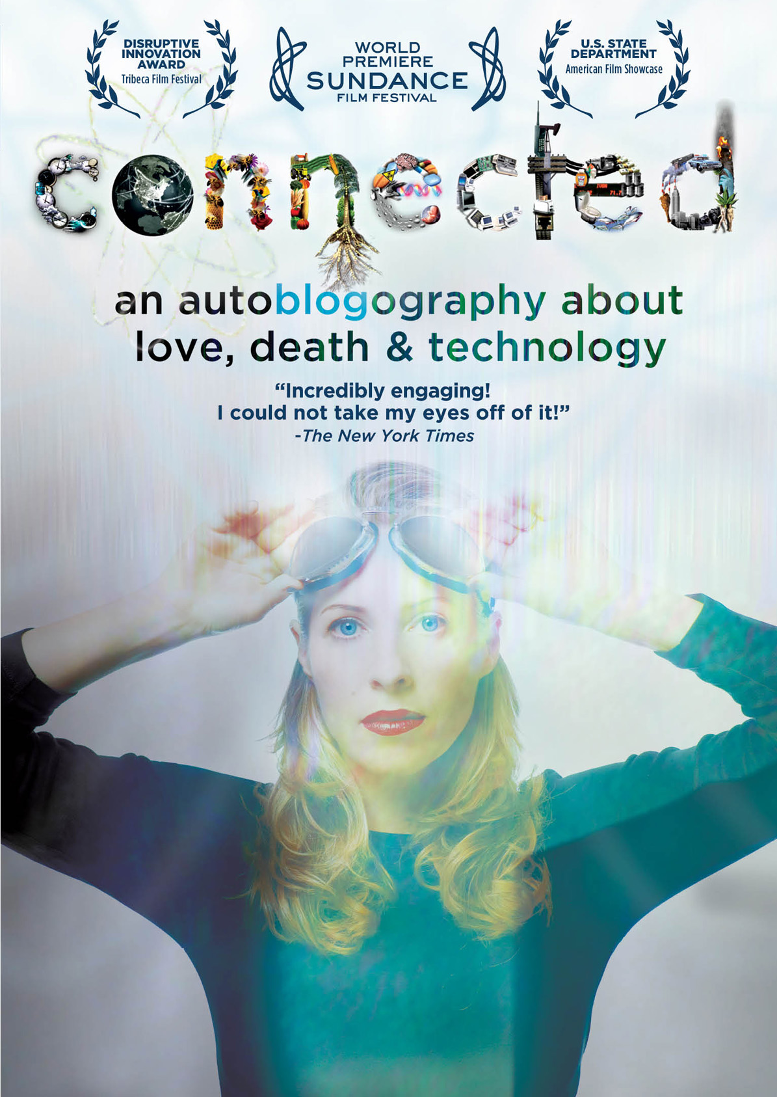

**CINEDIGM ENTERTAINMENT GROUP’S DOCURAMA FILMS RELEASES**

**INTERNET PIONEER TIFFANY SHLAIN’S “CONNECTED: AN AUTOBLOGRAPHY ABOUT LOVE, DEATH AND TECHNOLOGY”**

**Personal and Provocative Documentary Releases February 5**

**on Cable VOD and Digital; March 12 on DVD**

“Touching…examining everything from the big bang to twitter.” – *The New York Times*

“…An intensely personal exploration of what human connection means in our modern technology-obsessed world.” – *The Atlantic*

*December 11, 2012 – New York, New York* *–* Have you ever faked a restroom trip to check your email? Slept with your laptop? Become so overwhelmed that you just unplugged from it all? In her feature directorial debut, *CONNECTED*, internet pioneer and Webby Award founder Tiffany Shlain’s love-hate relationship with technology serves as the springboard for a thrilling exploration of modern life and our interconnected future. Blending a healthy dose of humor and irony with an imaginative combination of animation and archival footage, the film is equal parts documentary and memoir. Now available to a wide audience, *CONNECTED* is a chronological tour of Western modernization inspired by the work of Tiffany’s father, Leonard Shlain, a surgeon and best-selling author of *Art and Physics* and *The Alphabet Versus the Goddess*, interwoven with a deeply personal story about a year in the Shlain’s life in which technology and science literally become a matter of life and death.

On February 5, 2013, Docurama Films, a label of Cinedigm Entertainment Group (NASDAQ: CIDM), will release *CONNECTED* on cable VOD (on-demand) and digital and on DVD on March 12.

Just as Tiffany’s film-to-be was underway, two things happened: her father was diagnosed with brain cancer and given only nine months to live, and Tiffany learned that she was expecting a child. What started as a film about connectedness on a global level, turned into something much deeper.

“It was always an exciting moment when I could use an intimate revelation to illuminate a larger one about the world. Or when my personal story intersected with something I was exploring on a global scale,” said Shlain. “’Autoblogography’ is a word I made up in order to convey that the film is autobiographical and that it has to do with technology. It also conveys the humor which became a major thread in the movie.”

Tiffany Shlain has been busy since *CONNECTED* world premiered at the 2011 Sundance Film Festival: Her film has released theatrically in the U.S. in 11 cities (held over in 5), has screened more than 1,000 times around the globe – including at more than 200 educational institutions worldwide, and has been selected by the U.S. State Department to represent the States at U.S. embassies around the world as part of its 2012 American Film Showcase. The February 5 release coincides with a special screening of *CONNECTED* at YouTube’s new Venice, CA-based studio.

She has also released three short films that pick up where *CONNECTED* leaves off, putting the ideas explored in the film into action with a new way of making films she calls “Cloud Filmmaking,” an experiment in making films through global collaboration. These films include “A Declaration of Interdependence,” “Engage,” and “Brain Power: From Neurons to Networks,” which also includes an accompanying TEDBook. Shlain explains her new process in her “Cloud Filmmaking Manifesto,” which debuted in the 2012 Tribeca Film Festival’s “Future of Film” blog. *CONNECTED* won a Disruptive Innovation Award at the 2012 Tribeca Film Festival.

Honored by *Newsweek* as one of the “Women Shaping the 21st Century,” Tiffany Shlain is a filmmaker, artist, director of the Moxie Institute, founder of The Webby Awards, co-founder of the International Academy of Digital Arts and Sciences and has advised Secretary Hillary Clinton on the internet and society. Her 8 films – the last four of which, including *CONNECTED*, have premiered at the Sundance Film Festival – have won more than 50 awards, including 45 film awards and distinctions including Audience and Grand Jury Prizes. A celebrated thinker and catalyst, Tiffany is known for her ability to illuminate complex ideas in culture, science, technology and life through her unique films, dynamic talks, and innovative projects. She delivered the campus-wide keynote commencement address at UCBerkeley

Narrated by Peter Coyote, *CONNECTED* is a film by Tiffany Shlain; written by Shlain, Ken Goldberg, Carlton Evans and Sawyer Steele; Shlain and Dalan McNabola, editors. Original animations are by Stefan Nadelman; original music composed by Gunnard Doboze.

Catalogue: NNVG286241

Price:     $29.95

Bonus:  Two Bonus Short Films: *A Declaration of Interdependence; Yelp: Apologies to Allen Ginsberg's* Howl

**About Docurama Films**  
In 1999, **NEW VIDEO** launched **Docurama Films**® with the first feature documentary ever available on DVD: D.A. Pennebaker’s “Bob Dylan: Dont Look Back.” Twelve years and 300 award-winning, highly-acclaimed titles later, Docurama continues to discover and release the greatest non-fiction films of our time while spreading the word about filmmakers who are taking the form to new heights.  Docurama’s catalog features the performing and visual arts, history, politics, the environment, ethnic and gender interests, and all-time favorites including “The Wild Parrots of Telegraph Hill,” “Andy Goldsworthy:Rivers and Tides” and “King Corn.”Recent titles include the 2011 Oscar®-nominated films “Gasland” and “Hell and Back Again.” [www.docuramafilms.com](http://www.docuramafilms.com/)

**About Cinedigm Entertainment Group**  
Cinedigm Entertainment Group (CEG), a division of Cinedigm Digital Cinema Corp., is an end-to-end digital distribution company delivering content in theaters, across digital and on-demand platforms, and on DVD/Blu-ray. CEG reaches a global digital audience through partnerships with iTunes, Netflix, Amazon, Google, Hulu, Vudu, Xbox, Playstation, and others. The company’s library of over 5,000 titles includes award-winning documentaries from Docurama Films®, next-gen indies from Flatiron Film Company® and acclaimed independent films and festival picks through partnerships with the Sundance Institute and Tribeca Film. CEG is proud to distribute many Oscar®-nominated films including “Hell and Back Again,” “GasLand,” “Waste Land,” “Paradise Lost 3: Purgatory,” “A Cat in Paris” and “Chico & Rita.” Current and upcoming CEG multi-platform releases include “The Invisible War,” “Citadel,” “In Our Nature,” “22 Bullets”and “Don’t Stop Believin’: Everyman’s Journey.” [CIDM-G] [www.cinedigm.com](http://www.cinedigm.com).

**For more information, please contact:**  
Luis Garza; 646-259-4144; [lgarza@newvideo.com](mailto:lgarza@newvideo.com)