**FOR IMMEDIATE RELEASE**

Cinedigm_Logo_72dpi.jpg



**CINEDIGM ENTERTAINMENT GROUP’S DOCURAMA FILMS RELEASES “DETROPIA” JANUARY 15 ON CABLE VOD AND DVD**

**Award-Winning, Critically Acclaimed Documentary Chronicling the Rise and Fall of America’s Motor City Releases January 15 on Digital Platforms via**

**Sundance Institute’s Artist Services Program**

**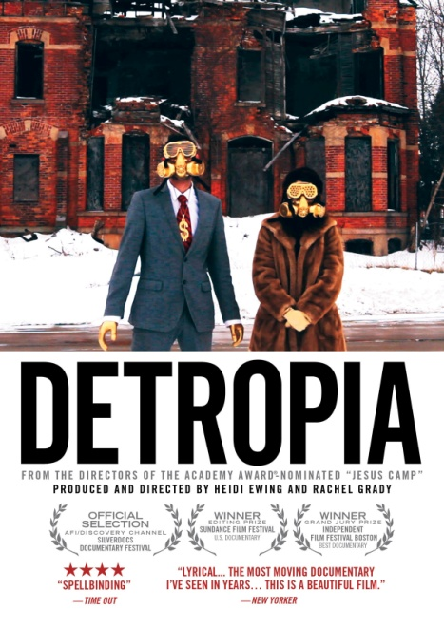**

"The most moving documentary I've seen in years. Both an ardent love letter to past vitality and a grateful salute to those who remain in place…I was amazed by the handsomeness of what I was seeing."

– *The New Yorker*

"Of all the Sundance films tackling the gap between the richest 1% and the rest of the nation, the documentary ‘Detropia’ stands out for how it encapsulates the causes and potential solutions." – *Los Angeles Times*

*December 4, 2012 – New York, New York* – Detroit was the birthplace of the middle class, an industrial utopia where anyone who worked hard enough could experience the American Dream. Today, Detroit is on the brink of bankruptcy. In the past 10 years this iconic Midwestern city has lost 25% of its population and 50% of its manufacturing jobs. Local officials are in the midst of the most dramatic “downsizing” of an American city ever seen - demolishing thousands of homes, reconsolidating massive tracts of excess land, cutting basic services and even encouraging Detroiters in the most marginal neighborhoods to move. Detroiters who have stuck with the city are at the breaking point. Despite these desperate conditions, artists and curious outsiders flock to the city in search of inspiration… and opportunity.

“In this visual caress of postindustrial blight, disintegration has never looked so gorgeous.” – *The New York Times*

On January 15, 2013, Docurama Films, a label of Cinedigm Entertainment Group (NASDAQ: CIDM), will release ***DETROPIA*** on cable VOD and DVD. Through Sundance Institute’s Artist Services program, the film will launch the same day across 10 leading digital platforms. Visit [www.sundance.org/nowplaying](http://www.sundance.org/nowplaying) for more information.

Produced and directed by **Heidi Ewing** and **Rachel Grady** (*12th & Delaware*, *Jesus Camp*), ***DETROPIA*** is a cinematic tapestry that chronicles the lives of several Detroiters trying to survive and make sense of what is happening to their city: an owner of a blues bar, a young blogger, an auto union rep, a group of young artists, an opera impresario and a gang of illegal “scrappers” – an unlikely chorus that illuminates the tale of both a city and a country in a soul-searching mood, desperate for a new identity.

“Our film – part love letter, part cautionary tale – enters the world of Detroiters who could leave if they wanted but have chosen to stick with a city that so desperately needs them,” said Ewing and Grady. “They represent the resilience of Americans who are facing a quickly changing world. We are thrilled to share their story with the rest of the country.”

How Detroit reboots itself will set the example for countless other post-industrial cities with similar fates. Today the entire country is watching to see if this storied metropolis has the courage, creativity and grit to reinvent itself.

***Facts about Detroit:***

* In 1930, Detroit was the fastest growing city in the world. (*The Guardian*)
* Detroit's population shrank by more than 25% in the last decade. The city's population has fallen from over [1.85 million in 1950](http://www.census.gov/population/www/documentation/twps0027/tab18.txt) to 713,777 in 2010; a drop of almost 240,000 residents in ten years - 100,000 more than Katrina-ravaged New Orleans. (*The New York Times*)
* In the last 10 years Detroit experienced a 59 percent increase in the number of college-educated residents under the age of 35 moving to its downtown. (*The New York Times*)
* Detroit has about 40,000 abandoned homes and 100,000 vacant residential lots. (*The New York Times*)
* The average price for a home in Detroit is $9,000, down from $73,000 three years earlier. (*The Wall Street Journal*)
* With more than 20 percent of the lots in the 139-square-mile city vacant, the mayor is in the midst of a program to demolish 10,000 empty residential buildings (*The New York Times*)

***Updates since the film’s release:***

* Facing a $12 billion dollar deficit (partly due to a dwindled tax base) Detroit narrowly averted bankruptcy in April 2012 by entering into a consent agreement, or a power sharing deal with the state of Michigan.
* After stalling for several months, Mayor Bing’s “Detroit Works Project” has re-launched and is currently holding “community conversations” to get feedback from residents on the best uses of excess land. There is no longer talk of an official relocation of residents.
* Real estate developer John Hantz is currently attempting to buy 1,956 lots (177 acres) owned by the city of Detroit for 8ȼ a square foot. He claims he wants to establish a [giant urban tree farm](http://www.hantzfarmsdetroit.com/) on the empty land.
* After years of stagnation,home prices in Metro Detroit have risen for the past 15 months. The average price of a home in Detroit has gone from $7,100 to $9,000.

***DETROPIA*** world premiered in January 2012 at the Sundance Film Festival, where it won the award for Best Documentary Editing. Additional awards include Grand Jury Prize at Independent Film Festival Boston, the **Grand Jury Award at Indianapolis Film Festival, Festival,** the Naples International Film Festival and the Flagstaff Mountain Film Festival**. The film was also awarded** Special Jury Award at DocAviv Festival and **at Traverse City Film Festival. *DETROPIA* recently received nominations for a Gotham Award and Cinema Eye Award. The film premiered theatrically in September 2012 and has screened nationally in over 100 markets. It is among the top ten highest grossing documentaries of 2012.**

***DETROPIA*** is produced and directed by Heidi Ewing and Rachel Grady (Loki Films); Enat Sidi, editor; Tony Hardmon and Craig Atkinson, cinematographers; Craig Atkinson, Producer; Dan Cogan and David Menschel, executive producers; Dial.81, composer, written and performed by Blair French.

Catalogue: NNVG281611

Price: $29.95 US

Bonus: 90+ minutes of deleted and extended scenes

**About Docurama Films**  
In 1999, **NEW VIDEO** launched **Docurama Films**® with the first feature documentary ever available on DVD: D.A. Pennebaker’s “Bob Dylan: Dont Look Back.” Twelve years and 300 award-winning, highly-acclaimed titles later, Docurama continues to discover and release the greatest non-fiction films of our time while spreading the word about filmmakers who are taking the form to new heights.  Docurama’s catalog features the performing and visual arts, history, politics, the environment, ethnic and gender interests, and all-time favorites including “The Wild Parrots of Telegraph Hill,” “Andy Goldsworthy:Rivers and Tides” and “King Corn.”Recent titles include the 2011 Oscar®-nominated films “Gasland” and “Hell and Back Again.” [www.docuramafilms.com](http://www.docuramafilms.com/)

**About Cinedigm Entertainment Group**  
Cinedigm Entertainment Group (CEG), a division of Cinedigm Digital Cinema Corp., is an end-to-end digital distribution company delivering content in theaters, across digital and on-demand platforms, and on DVD/Blu-ray. CEG reaches a global digital audience through partnerships with iTunes, Netflix, Amazon, Google, Hulu, Vudu, Xbox, Playstation, and others. The company’s library of over 5,000 titles includes award-winning documentaries from Docurama Films®, next-gen indies from Flatiron Film Company® and acclaimed independent films and festival picks through partnerships with the Sundance Institute and Tribeca Film. CEG is proud to distribute many Oscar®-nominated films including “Hell and Back Again,” “GasLand,” “Waste Land,” “Paradise Lost 3: Purgatory,” “A Cat in Paris” and “Chico & Rita.” Current and upcoming CEG multi-platform releases include “The Invisible War,” “Citadel,” “In Our Nature,” “22 Bullets”and “Don’t Stop Believin’: Everyman’s Journey.” [CIDM-G] [www.cinedigm.com](http://www.cinedigm.com).

**For more information, please contact:**  
Luis Garza; 646-259-4144; [lgarza@newvideo.com](mailto:lgarza@newvideo.com)