**Cinedigm_Logo_72dpi.jpg** 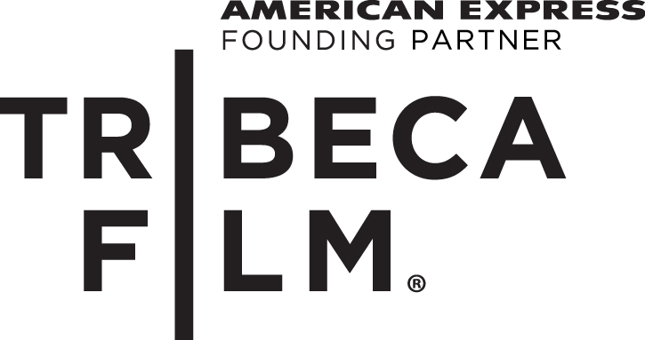

**CINEDIGM AND TRIBECA FILM TEAM TO ACQUIRE ALL U.S. RIGHTS TO**

**“THE ENGLISH TEACHER,”** **STARRING JULIANNE MOORE, NATHAN LANE AND GREG KINNEAR**

**Veteran Television Director Craig Zisk’s Feature Directorial Debut**

**Also Stars Lily Collins and Michael Angarano**

**(Los Angeles, CA, February 12, 2013)** Cinedigm Entertainment Group, a division of Cinedigm Digital Cinema Corp. (NASDAQ: CIDM) and Tribeca Film have teamed up to acquire U.S. distribution rights to director Craig Zisk’s (“Nurse Jackie,” “Weeds”) feature directorial debut, THE ENGLISH TEACHER. The film will release in spring 2013 with an ultra VOD and digital window, followed by theatrical release, DVD and broadcast.

THE ENGLISH TEACHER stars four-time Oscar® nominee Julianne Moore (“Boogie Nights,” “The Hours”) who most recently won Golden Globe® and Emmy® Awards for her lead role in the HBO movie “Game Change.” Moore plays a beloved English teacher whose repressed personal life exists in stark contrast to the passion she brings to the classroom. Her routine is upended when a former star pupil returns to her small town after failing miserably as a playwright.  Co-written by Dan and Stacy Chariton, THE ENGLISH TEACHER also stars two-time Tony Award® winner Nathan Lane (“The Producers,” “The Good Wife”), Oscar® nominee Greg Kinnear (“As Good As It Gets,” “Little Miss Sunshine”), Lily Collins (“Mirror Mirror”) and Michael Angarano (“Ceremony”). The film is produced by Matthew E. Chausse, Naomi Despres, Ben LeClair and Robert Salerno.

“THE ENGLISH TEACHER has everything audiences want in an independent film. It cleverly tells an honest, relatable and extremely funny story of self-discovery and reinvention that pops with great performances,” said Vincent Scordino, Vice President of Acquisitions, Theatrical, for Cinedigm. “We’re excited to be working with Tribeca and look forward to getting this film in front of as many people as possible. They’re going to love it.”

"We feel very fortunate to have had such wonderful collaborators in the making of this film, from our talented director and screenwriters to our wonderful cast,” said Robert Salerno. “We are now excited to bring the film to its audience, and are thrilled to be partnering with Cinedigm and Tribeca. Their enthusiasm and energy for this film is amazing."

“THE ENGLISH TEACHER is a film about life lessons, taking risks and fulfilling one’s dreams, no matter how old you are. In a performance that is at once dynamic, funny and moving, Julianne Moore leads a superb cast in this sparkling debut feature by Craig Zisk,” said Geoffrey Gilmore, Chief Creative Officer of Tribeca Enterprises.

Scordino negotiated the deal on behalf of Cinedigm with Tribeca Film’s Nick Savva, Director of Acquisitions.

**About Cinedigm**

Cinedigm is leading adigital entertainment revolution.  Cinedigm's pioneering digital cinema deployment and servicing efforts, and our state of the art distribution and exhibition software, are cornerstones of the digital cinema transformation. Cinedigm's is also the leading digital aggregator of independent content in the world, providing end-to-end digital content delivery to theaters, across digital and on-demand platforms, and on DVD/Blu-ray. Through partnerships with iTunes, Netflix, Amazon, Google, Hulu, Vudu, Xbox, Playstation, and others, Cinedigm reaches a global digital audience. The company’s library of over 5,000 titles includes award-winning documentaries from Docurama Films®, next-gen indies from Flatiron Film Company® and acclaimed independent films and festival picks through partnerships with the Sundance Institute and Tribeca Film. Cinedigm is proud to distribute many Oscar®-nominated films including “The Invisible War,” “Hell and Back Again,” “GasLand,” “Waste Land” and “Paradise Lost 3: Purgatory.” Current and upcoming CEG multi-platform releases include “Citadel,” “In Our Nature” and “Don’t Stop Believin’: Everyman’s Journey.” Cinedigm™ and Cinedigm Digital Cinema Corp™ are trademarks of Cinedigm Digital Cinema Corp [www.cinedigm.com](http://www.cinedigm.com). [CIDM-G]

**About Tribeca Film**

Tribeca Film is a comprehensive distribution label dedicated to acquiring and marketing independent films across multiple platforms, including video-on-demand, theatrical, digital, home video and television.  It is an initiative from Tribeca Enterprises designed to provide new platforms for how film can be experienced, while supporting filmmakers and introducing audiences to films they might not otherwise see. Current and upcoming Tribeca Film releases include award winning and Oscar®-nominated “War Witch,” “Struck By Lightning,” directed by Brian Dannelly and written by/starring Chris Colfer, Bob Byington’s “Somebody Up There Likes Me,” starring Nick Offerman, “Greetings from Tim Buckley,” and “How to Make Money Selling Drugs.”

###

Media Contacts:

Cinedigm Entertainment Group;

Sommer Hixson; shixson@newvideo.com; 646-259-4138

Cinedigm Corporate:

Maggie Begley, Maggie@mbcprinc.com; 310-301-1785

Tribeca Film:

Tammie Rosen; [trosen@tribecaenterprises.com](mailto:trosen@tribecaenterprises.com); 212-941-2003