**FOR IMMEDIATE RELEASE**

** **

present

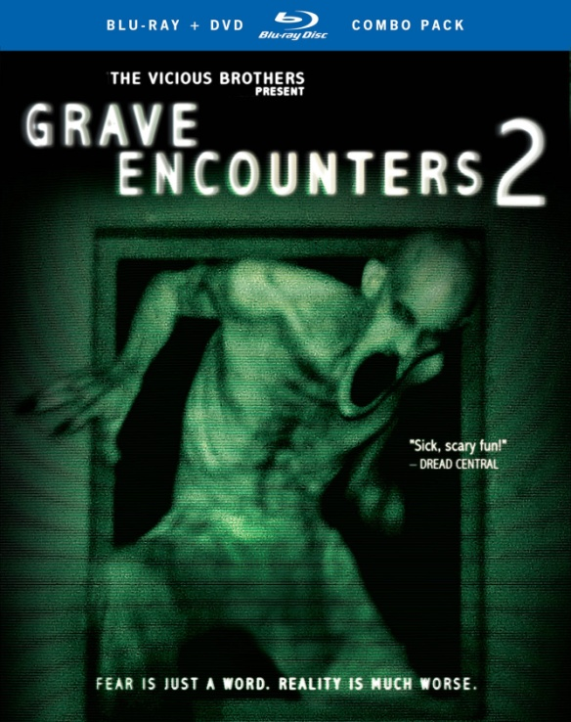

**“GRAVE ENCOUNTERS 2” RELEASES MARCH 5**

**ON DVD AND IN A BLU-RAY/DVD COMBO PACK**

"Sick, Scary Fun!" – *Dread Central*

***February 20, 2013*** – *New York, New York* – Two years ago, Lance Preston and his crew traveled to Canada to shoot an episode of the ghost-hunting reality show, *Grave Encounters*, inside an abandoned psychiatric hospital. After voluntarily locking themselves inside the building overnight with cameras placed in every corner of the building, they found themselves lost in a labyrinth of endless hallways and terrorized by the ghosts of former patients. The found footage was later released as a full-feature film, a horror phenomenon that many people believed was just a movie.

In ***GRAVE ENCOUNTERS 2***, film student Alex Wright (Richard Harmon, The Killing) is obsessed with the first film and after receiving a message from a mysterious blogger with the screen name, “Death Awaits 666,” decides to visit the real psychiatric hospital from the original film with his friends. Convinced that the events in *Grave Encounters* are true and that Sean Rogerson from the first film is still alive, Alex and his friends begin their own paranormal investigation. After breaking into the building, they find themselves face-to-face with unspeakable evil, banking on the hope that their knowledge of the original film will help them survive the sequel.

Directed by John Poliquin and written by The Vicious Brothers, ***GRAVE ENCOUNTERS*** ***2*** releases March 5 on DVD and Blu-ray/DVD combo pack from Cinedigm (NASDAQ: CIDM) and Tribeca Film. The film released on Cable VOD and digital platforms in October 2012.

***GRAVE ENCOUNTERS 2*** is directed by John Poliquin; executive produced by Richard Harmon, Sean Rogerson, Leanne Lapp, Dylan Playfair, Stephanie Bennett and Howard Lai; produced by Shawn Angelski and Martin Fisher; written by The Vicious Brothers; edited by John Poliquin. Bonus features include an Interview with the Vicious Brothers, Presented by American Express.

Pricing: $26.95 US

BD Pricing: $29.95 US

Runtime: 98 mins. + extras

Rating: NR

Catalog #: NNVG283470

BD Catalog #: NNVG287031

Language: English

Color: Color

Audio Format: Dolby Digital 5.1 Surround

Genre: Horror

**About Tribeca Film**

Tribeca Film is a comprehensive distribution label dedicated to acquiring and marketing independent films across multiple platforms, including video-on-demand, theatrical and home video. It is an initiative from Tribeca Enterprises designed to provide new platforms for how film can be experienced, while supporting filmmakers and introducing audiences to films they might not otherwise see. American Express continues its support of Tribeca and the independent film community by serving as the Founding Partner of Tribeca Film.

**About Cinedigm**

Cinedigm is leading adigital entertainment revolution.  Cinedigm's pioneering digital cinema deployment and servicing efforts, and our state of the art distribution and exhibition software, are cornerstones of the digital cinema transformation. Cinedigm's is also the leading digital aggregator of independent content in the world, providing end-to-end digital content delivery to theaters, across digital and on-demand platforms, and on DVD/Blu-ray. Through partnerships with iTunes, Netflix, Amazon, Google, Hulu, Vudu, Xbox, Playstation, and others, Cinedigm reaches a global digital audience. The company’s library of over 5,000 titles includes award-winning documentaries from Docurama Films®, next-gen indies from Flatiron Film Company® and acclaimed independent films and festival picks through partnerships with the Sundance Institute and Tribeca Film. Cinedigm is proud to distribute many Oscar®-nominated films including “The Invisible War,” “Hell and Back Again,” “GasLand,” “Waste Land” and “Paradise Lost 3: Purgatory.” Current and upcoming CEG multi-platform releases include “Citadel,” “In Our Nature” and “Don’t Stop Believin’: Everyman’s Journey.” Cinedigm™ and Cinedigm Digital Cinema Corp™ are trademarks of Cinedigm Digital Cinema Corp [www.cinedigm.com](http://www.cinedigm.com). [CIDM-G]

**For more information, please contact:**

Luis Garza; 646-259-4144;

[lgarza@newvideo.com](mailto:lgarza@newvideo.com)

For Box Art:

<http://www.newvideo.com/new-video-digital/grave-encounters-2/>