**FOR IMMEDIATE RELEASE**





Present

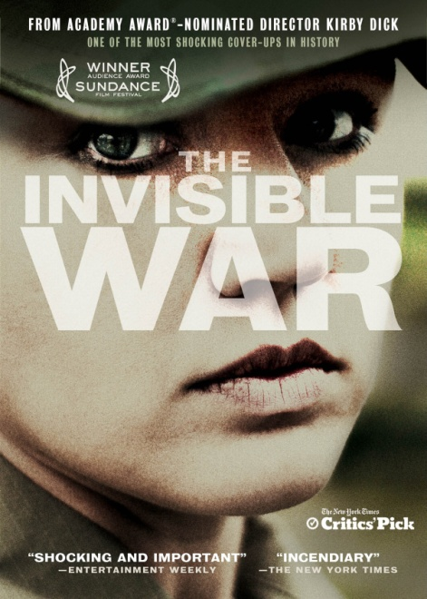

**2013 ACADEMY AWARD®-NOMINATED DOCUMENTARY, “THE INVISIBLE WAR,” FROM DIRECTOR KIRBY DICK AND PRODUCER AMY ZIERING, AVAILABLE NOW ON ITUNES, CABLE VOD AND DVD**

"CRITICS’ PICK: This is not a movie that can be ignored...the candor and bravery displayed in the telling is admirable." – The New York Times

"A poignant, powerful documentary that just might change the system.” –*TIME*

Winner, Audience Award, 2012 Sundance Film Festival

100% Fresh – *Rotten Tomatoes*

*January 10, 2013 – New York, NY* – From Oscar®- and Emmy®-nominated filmmaker Kirby Dick (“This Film Is Not Yet Rated;” “Twist of Faith”) comes ***THE INVISIBLE WAR***, a groundbreaking investigation about one of America’s most shameful and best kept secrets: the epidemic of rape within the U.S. military. Following its U.S. theatrical release in June from Cinedigm Entertainment Group, a division of Cinedigm Digital Cinema Corp. (NASDAQ: CIDM), and Docurama Films, ***THE INVISIBLE WAR*** made its iTunes ([www.iTunes.com](http://www.iTunes.com/)) debut on September 25 for sale or rent in HD, and is also available on Cable VOD and DVD.

***THE INVISIBLE WAR*** paints a startling picture: today, a female soldier in combat zones is more likely to be raped by a fellow soldier than killed by enemy fire. The Department of Defense estimates there were a staggering 19,300 service members sexually assaulted in 2010 alone.

Focusing on the powerfully emotional stories of rape victims, the film is a moving indictment of the systemic cover-up of military sex crimes, chronicling the women’s struggles to rebuild their lives and fight for justice. It also features hard-hitting interviews with high-ranking military officials and members of Congress that reveal the perfect storm of conditions that exist for rape in the military, its long-hidden history, and what can be done to bring about much-needed change.

At the core of the film are often heart-rending interviews with the rape survivors themselves—people like Kori Cioca, who was beaten and raped by her supervisor in the U.S. Coast Guard; Ariana Klay, a Marine who served in Iraq before being raped by a senior officer and his friend, then threatened with death; and Trina McDonald who was drugged and raped repeatedly by military policemen on her remote Naval station in Adak, Alaska. And it isn’t just women; according to one study's estimate, one percent of men in the military— nearly 20,000 men —were reportedly sexually assaulted in 2009.

Says Dick: “We were extremely surprised by the extent of the problem, how psychologically damaging it was, and the extent of the cover-up. More than half a million service men and women have been sexually assaulted since World War II. That comes as a shock to everyone we’ve spoken to. This is my 10th film and its subject matter is the least known to the public of any of my films, even though it most widely affects our society.”

“Many of the victims have been unable to move forward because they’ve been disbelieved, exiled and discarded,” Ziering adds. “Our hope is that the film will be a healing tool for all the survivors who have felt abandoned despite all they have sacrificed for our country.”

Both a rallying cry for the hundreds of thousands of men and women who've been assaulted and a hopeful road map for change, ***THE INVISIBLE WAR*** is one of those rare films so powerful it has already helped change military policy.

***THE INVISIBLE WAR*** won the 2013 Independent Spirit Award for Best Documentary and was nominated for a 2013 Academy Award**®** for Best Documentary. Additional 2012 nominations included Best Feature from the International Documentary Association (IDA), the Gotham Audience Award, and the Cinema Eye Honors Audience Choice Prize.  ***THE INVISIBLE WAR*** is the recipient of the 2012 Sundance Film Festival Audience Award for U.S. Documentary, the 2012 Human Rights Watch Festival’s Nestor Almendros Award for Courage in Filmmaking, the HBO Audience Award for Best Documentary Feature from the 2012 Provincetown Film Festival, the Silver Heart Award from the Dallas International Film Festival, and was an official entry at Full Frame Film Festival and HotDocs.

“Heartbreaking…what makes this savage indictment of the epidemic of rape in the U.S. military so unforgettable are not numbers but the devastating personal stories of the victims.” – *Los Angeles Times*

“An incendiary expose…a real game-changer.” *The Boston Globe*

***THE INVISIBLE WAR*** is a film by Kirby Dick and Amy Ziering; written and directed by Kirby Dick; produced by Amy Ziering and Tanner King Barklow; executive producers: Regina Kulik Scully, Jennifer Siebel Newsom, Geralyn White Dreyfous, Abigail Disney, Maria Cuomo Cole, Sarah Johnson Redlich, Women Donors Network, Teddy Leifer, Sally Jo Fifer, and Nicole Boxer-Keegan.

Bonus material exclusive to the DVD include: audio commentary with director Kirby Dick and producer Amy Ziering; extended interviews; Sundance Film Festival Post-Screening Speak-Out; footage from the VetWOW Survivor Retreat; “Cowboy Up: Equine PTSD Therapy” featurette.

***THE INVISIBLE WAR:***

DVD: $29.95 US/$34.95 CAN

Catalog #: NNVG277171

Runtime: 97 minutes, plus bonus

Digital #: NNVG10001224

Rating: N/A

Language: English

Color: Color

Audio Format: Dolby 5.1

Genre: Documentary

**About Docurama Films**

In 1999, Docurama Films® launched with the first feature documentary available on DVD: D.A. Pennebaker’s iconic film on Bob Dylan, “Dont Look Back*.”* Twelve years and 300 award-winning, highly-acclaimed documentary titles later, Docurama continues to discover and release the greatest non-fiction films of our time while spreading the word about filmmakers who are taking the form to new heights.  Docurama’s catalog features an array of topics including the performing and visual arts, history, politics, the environment, ethnic and gender interests, and all-time favorites including “The Wild Parrots of Telegraph Hill,” “Andy Goldsworthy: Rivers and Tides”and *“*King Corn*.”* Recent titles include the Oscar®-nominated films “Gasland,”“Hell and Back Again” and “Paradise Lost 3: Purgatory.” [www.docuramafilms.com](http://www.docuramafilms.com)

**About New Video – Cinedigm Entertainment Group**

New Video, a Cinedigm company, is a leading entertainment distributor and the largest aggregator of independent digital content worldwide. Headquartered in New York City, with an international presence in 45 territories, the company delivers feature films, TV programs and web originals via digital download, streaming, video-on-demand, Blu-ray, DVD, and theatrical release. In 2011, New Video bowed Oscar®-nominated “Hell and Back Again” and international blockbuster “Elite Squad: The Enemy Within” in U.S. theaters, and in 2012, “The Invisible War,” “Citadel*,*” and “In Our Nature” with John Slattery, Jena Malone and Gabrielle Union. The company’s library includes original TV series and movies, storybook treasures from Scholastic®, award-winning documentaries from Docurama Films®, next-gen indies from Flatiron Film Company®, and acclaimed independent films and festival picks through partnerships with the Sundance Institute and Tribeca Film. New Video is proud to distribute many Oscar®-nominated films including “GasLand,” “Waste Land,” “The Secret of Kells”and “Chico & Rita.” Cinedigm Digital Cinema Corp. (CIDM) is a leader in providing the services, expertise and technology that are critical to transforming movie theaters into digital entertainment centers. Its deployment entity, state-of-the-art distributor and exhibition software, and marketing and distribution platforms are cornerstones of the digital cinema revolution. The company recently acquired New Video to form a full-service, end-to-end digital studio that acquires content for theatrical distribution and across digital, mobile and home media platforms. Initial releases for 2013 will include “Dead Man’s Burden” with Nashville’s Clare Bowen, “Don’t Stop Believin’: Everyman’s Journey,” “Come Out and Play,” “Arthur Newman” with Colin Firth and Emily Blunt, and “Violet and Daisy,” with Saoirse Ronan, Danny Trejo and Alexis Bledel.

**For more information, please contact:**

Luis Garza

646-259-4138

[lgarza@newvideo.com](mailto:lgarza@newvideo.com)

New Video product page:

<http://www.newvideo.com/docurama/invisible-war/>

Official film site:

<http://invisiblewarmovie.com/>