 

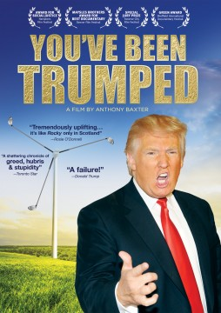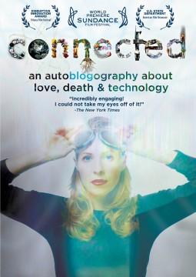

**“YOU’VE BEEN TRUMPED” and “CONNECTED” RELEASE MARCH 12 ON DVD**

**YOU’VE BEEN TRUMPED**

In ***YOU’VE BEEN TRUMPED***, a group of proud Scottish homeowners take on Donald Trump as he gets set to destroy the crown jewels of Scotland’s national heritage in order to build a luxury golf resort. The local residents make their last stand in the face of police harassment, constant legal threats and interruption of their water and electricity. Director Anthony Baxter himself becomes international news after being thrown in jail.

The film releases on March 12 from Cinedigm’s Docurama Films after its theatrical release in August 2012 and Cable VOD and digital release in February 2013. ***YOU’VE BEEN TRUMPED,*** directed by Anthony Baxter and produced by Richard Phinney, won the Award for Social Justice at the Hamptons Film Festival, the Maysles Brothers Award for Best Documentary at the Denver Film Festival, the Special Jury Prize at the Traverse City Film Festical, and the Green Award at the Sheffield International Documentary Festival.

**Bonus Features**

* Extra footage: the opening of Trump Golf course, Trump in Scottish Parliament; Occupy Wall Street projects *You’ve Been Trumped* on Trump Tower and Filmmaker Anthony Baxter on *Moyers & Company*.

**Program Information**

Pricing: $29.95 US/$34.95 CA

Runtime: 100 mins. + extras

Rating: NR

Catalog #: NNVG287231

Language: English

Color: Color

Audio Format: Dolby Digital 2.0 Stereo

Genre: Documentary

Product page:

<http://www.newvideo.com/docurama/youve-been-trumped/>

**CONNECTED**

Have you ever faked a restroom trip to check your email? Slept with your laptop? Become so overwhelmed that you just unplugged from it all? In her feature directorial debut, ***CONNECTED***, internet pioneer and Webby Award founder Tiffany Shlain’s love-hate relationship with technology serves as the springboard for a thrilling exploration of modern life and our interconnected future. Blending a healthy dose of humor and irony with an imaginative combination of animation and archival footage, the film is equal parts documentary and memoir. Narrated by Peter Coyote, ***CONNECTED***is a chronological tour of Western modernization inspired by the work of Tiffany’s father, Leonard Shlain, a surgeon and best-selling author of *Art and Physics* and *The Alphabet Versus the Goddess*, interwoven with a deeply personal story about a year in the Shlain’s life in which technology and science literally become a matter of life and death.

**Bonus Features**

* Two Bonus Short Films: *A Declaration of Interdependence* and *Yelp Apologies to Allen Ginsberg’s* Howl

**Program Information**

Pricing: $29.95 US/$34.95 CA

Runtime: 80 mins. + extras

Rating: NR

Catalog #: NNVG286241

Language: English

Color: Color

Audio Format: Dolby Digital 2.0 Stereo

Genre: Documentary

Product page:

<http://www.newvideo.com/featured-releases/connected/>

For artwork or more info, contact Luis Garza at lgarza@newvideo.com or (646) 259-4144