**FOR IMMEDIATE RELEASE**





Present

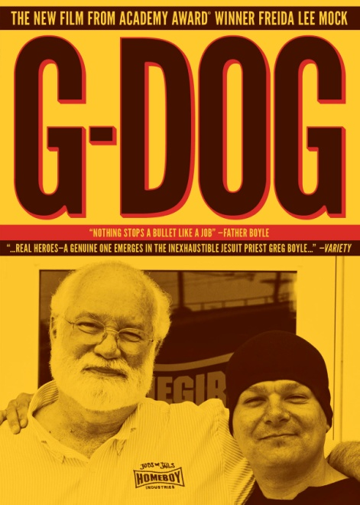

**“G-DOG,” THE REMARKABLE STORY OF HOMEBOY INDUSTRY’S FATHER GREG BOYLE, RELEASES APRIL 23 ON CABLE VOD AND APRIL 30 ON DVD & DIGITAL, TIMED TO THEATRICAL RELEASE WEEK OF APRIL 22**

“In an era with a paucity of real heroes, a genuine one emerges in ‘G-DOG’.” — *Variety*

“Easily one of the most inspirational and uplifting documentaries of the year” —*Hot Doc*s

*March 28, 2013 – New York, New York* – “Nothing stops a bullet like a job.” This is the story of a remarkable odd couple. There’s “G-Dog,” aka Father Greg Boyle or Father G, a white Jesuit priest who’s spent some 25 years in the toughest part of East LA, and then there’s the tough, street-smart, and amazingly sweet young people – all former gang members – whom G-Dog loves and helps, and who love him in turn. For Father Greg’s remedy for what he calls "a global sense of failure" for kids at-risk is radical and simple: boundless, restorative love.

Cinedigm is debuting Oscar®-winning director Freida Mock’s award-winning ***G-DOG*** in conjunction with the company’s new 7-film, 7-week theatrical DOCURAMA film series, launching April 22 in theaters nationwide. The film opens the series on April 22, followed by its cable VOD premiere on April 23 and DVD/Digital release on April 30. The film, which has become an audience favorite at film festivals around the world, first premiered in April 2012 at Toronto's Hots Docs Canadian International Documentary Festival, followed by its U.S. premiere in June at the Los Angeles Film Festival. G-DOG has been selected by the U.S. State Department to represent the States at U.S. embassies around the world as part of its 2013 American Film Showcase.

Gang violence rocked Los Angeles in the 90s, dubbed the “Decade of Death,” and Father Greg was astonished to find teenagers planning their funerals and not the future. He founded Homeboy Industries in 1992 as home to social enterprises that provide job training and comprehensive free services for those seeking employment and a path out of gang life. It is now the nation’s largest and most successful gang intervention and rehab program and an international model, with a 70% success rate in turning kids away from gang life and toward a productive future.

Father Greg Boyle is the author of the *New York Times* Bestselling book, *Tattoos on the Heart: The Power of Boundless Compassion* and has received numerous honorary degrees, awards and recognitions including the Civic Medal of Honor, the California Peace Prize, and Humanitarian of the Year from *Bon Appetit* Magazine. He was inducted into the California Hall of Fame in 2011.

***G-DOG*** chronicles atough yearatHomeboy Industries.2010wasrife withtumult,change andpain.The company faceda bruising battle with the bottom line: we watch as one day FatherGreg makes the difficult decision to shut down parts of business. It’s a crushing blow but it gets worse. Two people we’ve seen early in the movie are killed by the time the credits roll. The question is: will the homies and Homeboy itself survive?

***G-DOG*** is written, produced and directed by Freida Mock; Greg Byers, associate producer and editor; Erik Daarstad And Hirokyi Miyano, directors of photography; Pedro Bromfman, composer; Skip Lievsay, re-recording mixer.

DVD Catalogue#: NNVG288541

Runtime: 92 minutes

DVD Price:     $29.95

**About Docurama Films**

In 1999, **NEW VIDEO** launched **Docurama Films**® with the first feature documentary ever available on DVD: D.A. Pennebaker’s “Bob Dylan: Dont Look Back.” Twelve years and 300 award-winning, highly-acclaimed titles later, Docurama continues to discover and release the greatest non-fiction films of our time while spreading the word about filmmakers who are taking the form to new heights.  Docurama’s catalog features the performing and visual arts, history, politics, the environment, ethnic and gender interests, and all-time favorites including “The Wild Parrots of Telegraph Hill,” “Andy Goldsworthy:Rivers and Tides” and “King Corn.”Recent titles include the 2011 Oscar®-nominated films “Gasland” and “Hell and Back Again.” [www.docuramafilms.com](http://www.docuramafilms.com/)

**About Cinedigm Entertainment Group**

Cinedigm is a leader in the digital entertainment revolution.  Cinedigm's pioneering digital cinema deployment and servicing efforts, and our state-of-the-art distribution and exhibition software, are cornerstones of the digital cinema transformation. Cinedigm is also the leading digital aggregator of independent content in the world, providing end-to-end digital content delivery to theaters, across digital and on-demand platforms, and on DVD/Blu-ray. Through partnerships with iTunes, Netflix, Amazon, Google, Hulu, Vudu, Xbox, Playstation, and others, Cinedigm reaches a global digital audience. The company’s library of over 5,000 titles includes award-winning documentaries from Docurama Films®, next-gen indies from Flatiron Film Company® and acclaimed independent films and festival picks through partnerships with the Sundance Institute and Tribeca Film. CEG is proud to distribute many Oscar®-nominated films including “The Invisible War,” “Hell and Back Again,” “GasLand,” “Waste Land” and “Paradise Lost 3: Purgatory.” Current an upcoming multi-platform releases include “Don’t Stop Believin’: Everyman’s Journey,” “Come Out And Play,” “The English Teacher,” “Arthur Newman,” and “Violet and Daisy.” Cinedigm™ and Cinedigm Digital Cinema Corp™ are trademarks of Cinedigm Digital Cinema Corp [www.cinedigm.com](http://www.cinedigm.com). [CIDM-G]

**For more information, please contact:**

Luis Garza

646-259-4138

[lgarza@newvideo.com](mailto:lgarza@newvideo.com)

For more information:

<http://www.newvideo.com/docurama/g-dog/>