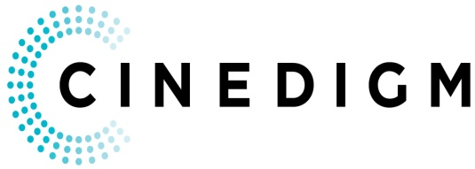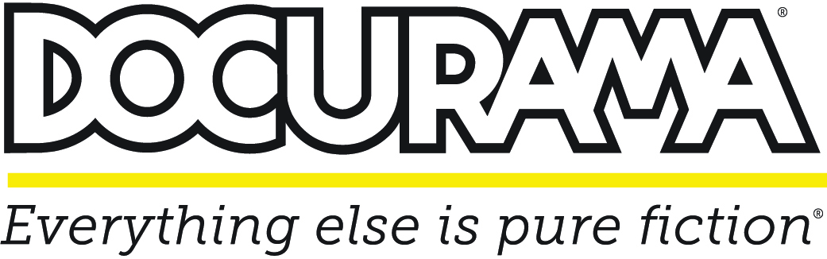

**CINEDIGM’S DOCURAMA LAUNCHES NEW YOUTUBE CHANNEL**

**Branded Channel Launches Today with Curated Selection from Cinedigm’s Extensive Documentary Film Library**

*May 9, 2013 – New York/California* – Cinedigm’s (NASDAQ: CIDM) DOCURAMA, the world’s only multi-platform brand dedicated to documentary film, is launching a paid channel on YouTube today. The announcement closely follows the launch of the company’s inaugural DOCURAMA series of film screening events currently booked in theaters across the country through June 16.

The fully-branded DOCURAMA YouTube paid channel is launching with a curated playlist of feature-length documentary films, one-quarter of which are new or recent releases. An introductory monthly subscription price of $2.99 is being offered. Content will be refreshed weekly, including films from the now-running DOCURAMA theatrical series.

Cinedigm is shifting the paradigm of the distribution business to an alternative model that merges traditional theatrical releases with new digital platforms and aggressive windowing strategies, with a focus on exclusive content and early access to new films. The new channel was developed by Cinedigm to further leverage DOCURAMA’s brand imprimatur in the market place, the company’s 20-plus years of content management experience, and its filmmaker-centric business practices.

"This is the start of our foray into the curated channel business," said Chris McGurk, Chairman & CEO of Cinedigm. "Leveraging our library of independent digital rights – the largest in the world – makes this a natural evolution for us and we expect to launch additional curated channels in the near future."

Docurama’s YouTube Channel:

<http://www.youtube.com/docurama>

Cinedigm manages a total of over 1250 documentary films through its partnerships with producers and aggregation partners. The YouTube paid channel draws from this vast library, including more than 300 award-winning and highly acclaimed films cultivated over the past 15 years under the Docurama Films proprietary label, including Oscar nominee *Hell and Back Again* and recent hits *Happy*, *Transcendent Man, Woody Allen: A Documentary, Hungry For Change, King Corn*, and *Sing Your Song: Harry Belafonte*. In addition to the feature presentation, the YouTube channel will provide access to bonus content, including filmmaker interviews, behind-the-scenes footage and other short-form material not offered in theaters.

On April 22, DOCURAMA launched its first theatrical series, with seven new documentary films premiering over seven weeks: **G-DOG**, Oscar®-winner Freida Mock’s profile of Jesuit Father Gregory Boyle, founder of Homeboy Industries in East Los Angeles and author of *Tattoos of the Heart*;**¡Vivan Las Antipodas**!, a cinematic innovation by Russian directorVictor Kossakovsky; **The Fruit Hunters**, by Yung Chang (*Up The Yangtze*) and featuring actor Bill Pullman; **The World Before Her**, Nisha Pahuja’s Tribeca Film Festival and Hot Docs award-winning film about two competing visions for young women in India; **Charge,** from the director of *Faster* and *Fastest* (Mark Neale), and narrated by actor and motorcycleenthusiast Ewan McGregor; **Ping Pong,** following eight senior citizens as they compete for table tennis gold**,** and **London: The Modern Babylon**,by Julien Temple (*Joe Strummer: The Future is Unwritten*).

**About Docurama Films**

In 1999, Docurama Films® launched with the first feature documentary ever available on DVD: D.A. Pennebaker’s iconic film on Bob Dylan, “Dont Look Back*.”* The Docurama Films catalog now includes more than 300 films, including Oscar®-nominated films “Gasland,”“Hell and Back Again,” “Paradise Lost 3: Purgatory” and “The Invisible War,” and festival favorites including “Detropia,” “Beauty is Embarrassing,” “Last Call at the Oasis” and “Revenge of the Electric Car.” Several hundred more documentary films and programs are available through Cinedigm’s aggregation partnerships, with topics ranging from history, biography, politics, the environment, ethnic and gender interests to pop culture, music and the arts*.* Including Pennebaker, esteemed filmmakers on the Docurama Films roster include Robert Drew, Frederick Wiseman, Davis Guggenheim, Joe Berlinger, Liz Garbus, Anne Sundberg and Josh Fox, among many others.

**About Cinedigm**

Over the past decade, Cinedigm has led the digital distribution revolution that continues to transform the media landscape. In addition to its pioneering role in transitioning movie theatres from traditional film prints to digital distribution, Cinedigm continues to advance worldwide cinema modernization with its suite of software products allowing exhibitors and distributors to manage their newly digital businesses with efficiency, insight and certainty. And, as the leading distributor of independent content in the world, Cinedigm collaborates with producers and the exhibition community with unequalled transparency to market, source, curate and distribute quality content across all digital platforms to targeted and profitable audiences. The company’s library includes award-winning documentaries from Docurama Films®, next-gen indies from Flatiron Film Company® and acclaimed independent films and festival picks through partnerships with the Sundance Institute and Tribeca Film. Cinedigm is proud to distribute many Oscar®-nominated films including “The Invisible War,” “Hell and Back Again,” “GasLand,” “Waste Land” and “Paradise Lost 3: Purgatory.”

Upcoming and recent CEG multi-platform releases include Dante Ariola’s ARTHUR NEWMAN, Craig Zisk’s THE ENGLISH TEACHER, Jared Moshe’s DEAD MAN’S BURDEN, Geoffrey Fletcher’s VIOLET & DAISY, MalikaZouhali-Worrall and Katherine Fairfax Wright’s CALL ME KUCHU, Jimmy Loweree’s ABSENCE, and Shaul Schwarz’s NARCO CULTURA.

Cinedigm™ and Cinedigm Digital Cinema Corp™ are trademarks of Cinedigm Digital Cinema Corp [www.cinedigm.com](http://www.cinedigm.com). [CIDM-G]

Media Contact:

Maggie Begley

310.301.1785; [Maggie@mbcprinc.com](mailto:Maggie@mbcprinc.com)