**FOR IMMEDIATE RELEASE**

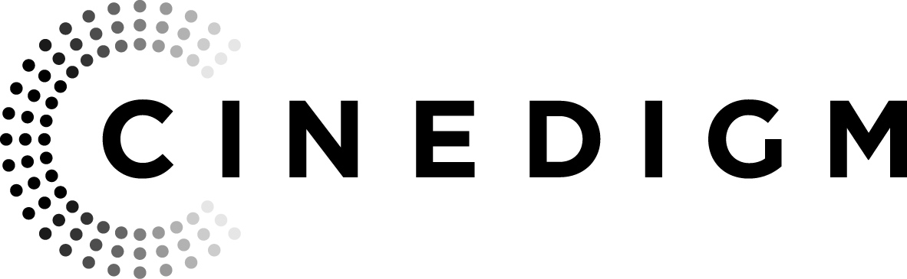

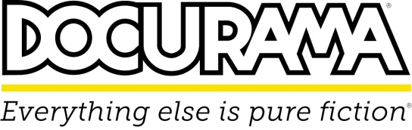

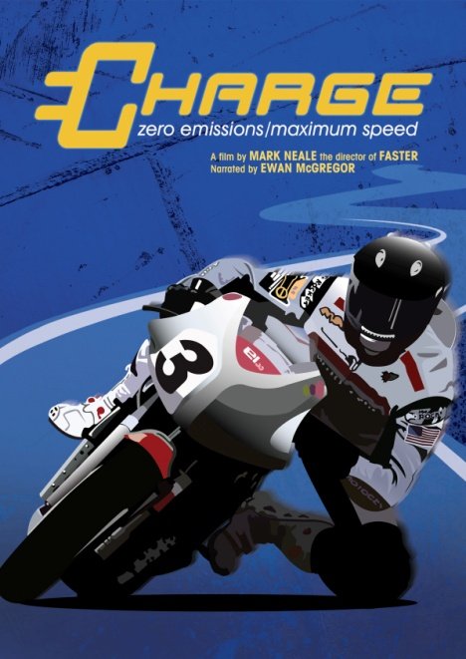 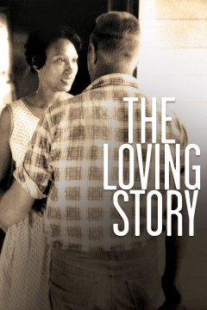

**CINEDIGM’S DOCURAMA FILMS RELEASES**

**“CHARGE” AND “THE LOVING STORY” ON MAY 28**

**CHARGE**

Director Mark Neale’s (*Faster*, *Fastest*) ***CHARGE*** is proof that maniacs on motorcycles can be a force for global good. Narrated by Ewan McGregor, the feature-length documentary follows several teams to the world’s first zero-emissions grand prix on the Isle of Man–the most demanding and deadly circuit on the planet– in 2009 and on their return in 2010, 2011, and 2012. For the visionaries, it’s history. For the petrol-heads, it’s blasphemy. What’s racing without the sound and fury of internal combustion engines? ***CHARGE*** is about the future. It’s about change. It’s about the dream of a clean, green world. It’s about the dream of winning.

Cinedigm’s (NASDAQ: CIDM) Docurama Films will release ***CHARGE*** on May 28 on cable VOD, DVD and digital download following its theatrical debut at the DOCURAMA Film Festival on May 20. The film won the Best Documentary Award at the 2012 Las Vegas Film Festival.

***CHARGE*** is written and directed by Mark Neale; executive produced by Chris Paine, John O’Grady, Chuck Ryant, Dominic Saville; produced by Paul Kewley and Mark Neale; edited by Rochelle Watson. Bonus features include footage from the 2011 and 2012 races; extended interviews; deleted scenes and the theatrical trailer.

“A must-see motorcycle film,”—*Motorcycle News*

U.S./Canada DVD SRP: $29.95/$34.95

Runtime: 90 mins. + extras

Rating: NR

Catalog #: NNVG287270

Language: English

Color: Color

Genre: Documentary

For Box Art:

<http://www.newvideo.com/docurama/charge/>

**THE LOVING STORY**

On June 2, 1958, a white man named Richard Loving and his part-black, part-Cherokee fiancée Mildred Jeter traveled from Caroline County, VA, to Washington, D.C. to be married. At the time, interracial marriage was illegal in 24 states, including Virginia. Back home five weeks later, the newlyweds were arrested in the dark of night. They were tried and convicted of the felony crime of “miscegenation.” Two young ACLU lawyers took on the Lovings’ case, fully aware of the challenges posed. Nine years later, the U.S. Supreme Court ruled unanimously in favor of the Lovings on June 12, 1967. This precedent-setting decision resulted in 16 states being ordered to overturn their bans on interracial marriage.

On May 28, ***THE LOVING STORY*** releaseson DVD and digital download following its premiere at the 2011 Full Frame Documentary Film Festival and its broadcast premiere on HBO in February 2012. The film won the 2013 George Foster Peabody Award, the 2013 Gabriel Award, the Best Use of Footage in a Factual Production at the 2012 Focal International Awards, the WGA Screenplay Award at the 2011 Silverdocs Documentary Festival, and the 2012 John E. O’Connor Film Award at the American Historical Association. ***THE LOVING STORY*** was shortlisted for an Academy Award and is nominated for a 2013 NAMIC Vision Award.

***THE LOVING STORY*** is directed by Nancy Buirski; executive produced by Scott Berrie and Marshall Sonenshine; produced by Nancy Buirski and Elisabeth Haviland James; edited by Elisabeth Haviland James. The film is co-produced by HBO Documentaries and Augusta Films and is supported in part by the National Endowment for the Humanities.

“A perfect time capsulethat illuminates the racist past of our country with a uniquely personal and poignant emphasis,”—*Hollywood Reporter*

“Documenting many pivotal moments in the case, it adds a dash of something rarely seen in the grand narrative of the American Civil Rights struggle: romance." —*Chicago Sun-Times*

U.S./Canada DVD SRP: $29.95/$34.95

Runtime: 77 mins.

Rating: NR

Catalog #: NNVG288700

Language: English

Color: Color

Genre: Documentary

For Box Art:

<http://www.newvideo.com/docurama/the-loving-story/>

**About Docurama Films**

In 1999, **NEW VIDEO** launched **Docurama Films**® with the first feature documentary ever available on DVD: D.A. Pennebaker’s “Bob Dylan: Dont Look Back.” Twelve years and 300 award-winning, highly-acclaimed titles later, Docurama continues to discover and release the greatest non-fiction films of our time while spreading the word about filmmakers who are taking the form to new heights.  Docurama’s catalog features the performing and visual arts, history, politics, the environment, ethnic and gender interests, and all-time favorites including “The Wild Parrots of Telegraph Hill,” “Andy Goldsworthy:Rivers and Tides” and “King Corn.”Recent titles include the 2011 Oscar®-nominated films “Gasland” and “Hell and Back Again.” [www.docuramafilms.com](http://www.docuramafilms.com/)

**About Cinedigm**

Over the past decade, Cinedigm has led the digital distribution revolution that continues to transform the media landscape. In addition to its pioneering role in transitioning movie theatres from traditional film prints to digital distribution, Cinedigm continues to advance worldwide cinema modernization with its suite of software products allowing exhibitors and distributors to manage their newly digital businesses with efficiency, insight and certainty. And, as the leading distributor of independent content in the world, Cinedigm collaborates with producers and the exhibition community with unequalled transparency to market, source, curate and distribute quality content across all digital platforms to targeted and profitable audiences. The company’s library of over 5,000 titles includes award-winning documentaries from Docurama Films®, next-gen indies from Flatiron Film Company® and acclaimed independent films and festival picks through partnerships with the Sundance Institute and Tribeca Film. Cinedigm is proud to distribute many Oscar®-nominated films including “The Invisible War,” “Hell and Back Again,” “Gasland,” “Waste Land” and “Paradise Lost 3: Purgatory.”

Upcoming and recent CEG multi-platform releases include Dante Ariola’s “Arthur Newman,” Craig Zisk’s “The English Teacher,” Jared Moshe’s “Dead Man’s Burden,” Geoffrey Fletcher’s “Violet & Daisy,” Malika Zouhali-Worrall and Katherine Fairfax Wright’s “Call Me Kuchu,” Jimmy Loweree’s “Absence,” and Shaul Schwarz’s “Narco Cultura.” Cinedigm™ and Cinedigm Digital Cinema Corp™ are trademarks of Cinedigm Digital Cinema Corp [www.cinedigm.com](http://www.cinedigm.com). [CIDM-G]

**For more information, please contact:**

Luis Garza

646-259-4138

[lgarza@newvideo.com](mailto:lgarza@newvideo.com)