**FOR IMMEDIATE RELEASE**

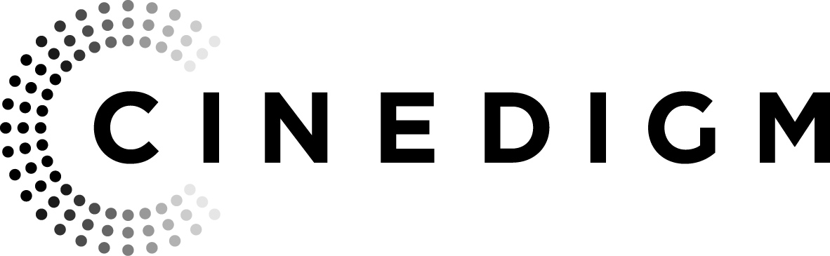

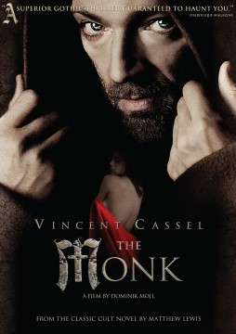

**CINEDIGM’S FLATIRON FILM COMPANY RELEASES “THE MONK,” STARRING VINCENT CASSEL, JUNE 4 ON DVD**

**From the Classic Cult Novel by Matthew Lewis**

“A superior gothic thriller guaranteed to haunt you.” – *Diabolique Magazine*

*May 28, 2013 – New York, New York* – French superstar Vincent Cassel (Black Swan, A Dangerous Method) stars as an unassailable monk who struggles with temptation in director Domink Moll’s (With a Friend Like Harry) sexy French thriller adapted from Matthew Lewis’ cult classic gothic novel, The Monk.

***THE MONK*** releases June 4 on DVD from Cinedigm’s Flatiron Film Company following a theatrical, cable VOD and digital release in March 2013. The film follows the rise and fall of Ambrosio (Vincent Cassel), a Capuchin Monk in 17th century Madrid. Abandoned as a baby on the steps of a monastery and raised in strict Capuchin fashion, Ambrosio has become the most famous preacher in the country. Large crowds from near and far come to hear his mesmerizing sermons and he has earned the admiration of all.

Convinced of his virtue and righteousness, Brother Ambrosio thinks he is immune to temptation until obscure events start terrorizing the monastery. Could they be connected to the unexpected arrival of Valerio (Déborah François, Unmade Beds, The Child), a masked apprentice monk, or to Ambrosio’s confused attraction to a woman who openly admires him? ***THE MONK*** explores seduction, secrets and dark deceits as Ambrosio gradually falls into depravity and sin.

***THE MONK*** is directed by Dominik Moll; produced by Michel Saint-Jean; screenplay by Dominik Moll and Anne-Louise Trividic; edited by François Gédigier and Sylvie Lager; music by Alberto Iglesias; cinematography by Patrick Blossier. Bonus features include: the Making of ***THE MONK***.

Pricing: $29.95 US

Runtime: 101 mins. + extras

Rating: R

Catalog #: NNVG270790

Language: French with English Subtitles

Color: Color

Audio Format: Dolby Digital 5.1 Surround

Genre: Thriller

**About Cinedigm**

Over the past decade, Cinedigm has led the digital distribution revolution that continues to transform the media landscape. In addition to its pioneering role in transitioning movie theatres from traditional film prints to digital distribution, Cinedigm continues to advance worldwide cinema modernization with its suite of software products allowing exhibitors and distributors to manage their newly digital businesses with efficiency, insight and certainty. And, as the leading distributor of independent content in the world, Cinedigm collaborates with producers and the exhibition community with unequalled transparency to market, source, curate and distribute quality content across all digital platforms to targeted and profitable audiences. The company’s library of over 5,000 titles includes award-winning documentaries from Docurama Films®, next-gen indies from Flatiron Film Company® and acclaimed independent films and festival picks through partnerships with the Sundance Institute and Tribeca Film. Cinedigm is proud to distribute many Oscar®-nominated films including “The Invisible War,” “Hell and Back Again,” “Gasland,” “Waste Land” and “Paradise Lost 3: Purgatory.”

Upcoming and recent CEG multi-platform releases include Dante Ariola’s “Arthur Newman,” Craig Zisk’s “The English Teacher,” Jared Moshe’s “Dead Man’s Burden,” Geoffrey Fletcher’s “Violet & Daisy,” Malika Zouhali-Worrall and Katherine Fairfax Wright’s “Call Me Kuchu,” Jimmy Loweree’s “Absence,” Shaul Schwarz’s “Narco Cultura,” and Destin Daniel Cretton’s “Short Term 12.” Cinedigm™ and Cinedigm Digital Cinema Corp™ are trademarks of Cinedigm Digital Cinema Corp [www.cinedigm.com](http://www.cinedigm.com). [CIDM-G]

**For more information, please contact:**

Luis Garza; 646-259-4144;

[lgarza@cinedigm.com](mailto:lgarza@cinedigm.com)

For box art: <http://www.newvideo.com/new-video-digital/the-monk/>