**FOR IMMEDIATE RELEASE**

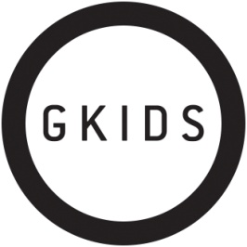

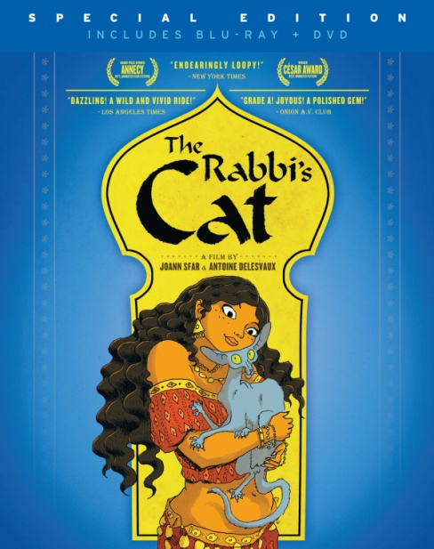

**CINEDIGM RELEASES GKIDS’ AWARD-WINNING ANIMATED FILM, “THE RABBI’S CAT,” MAY 7 ON DVD, BLU-RAY/DVD COMBO PACK AND DIGITAL PLATFORMS**

**Based on Joann Sfar’s Best-Selling Graphic Novel**

“Endearingly Loopy…Lush” *– The New York Times*

“Colorful, witty and inspired” – *Variety*

***NEW YORK, NY*** *(April 23, 2013)* – Based on the best-selling graphic novel by Joann Sfar, award-winning filmmaker (Gainsbourg: A Heroic Life) and one of France’s most celebrated comic artists, ***THE RABBI’S CAT*** tells the story of a rabbi and his talking cat – a sharp-tongued feline philosopher brimming with scathing humor.

Algeria in the 1930s is an intersection of Jewish, Arab and French culture. A cat belonging to a widowed rabbi and his beautiful daughter eats the family parrot and miraculously gains the ability to speak. Along with the power of speech comes unparalleled sardonic wit, and the cat spares no group or individual as it skewers faith, tradition and authority in a provocative exploration of God, death, lust and the search for truth. Rich with the colors, textures, flavors and music of Mediterranean Africa, ***THE RABBI’S CAT*** embarks on a cross-continent comedic adventure through colonial Algiers and under vast Saharan skies in search of a lost Ethiopian city.

Cinedigm Entertainment Group (NASDAQ:CIDM) will release ***THE RABBI’S CAT*** on May 7 on DVD, Special Edition Blu-ray/DVD combo pack and digital platforms. ***THE RABBI’S CAT*** is directed by Antoine Delesvaux and [Sfar](http://www.imdb.com/name/nm2677924/) and features the voices of French cinema stars Maurice Bénichou (*[Amélie](http://www.imdb.com/title/tt0211915/)***)** and Mathieu Amalric (*Quantum of Solace*, *The Diving Bell and the Butterfly*). Other animated films released in partnership with GKIDS include Academy Award® nominees *The Secret of Kells*, *Chico & Rita* and *A Cat in Paris*.



***THE RABBI’S CAT*** released in U.S. theaters in 3D in December 2012 to rave reviews. The film was the winner of the 2011 César Award (French Oscar®) for Best Animated Feature and was a two-time 2012 Annie Award Nominee for Best Animated Feature and Best Directing in an Animated Feature Production. The graphic novel is an Eisner Award winner and has been translated into 17 languages around the world.

DVD and Blu-ray bonus features include: Bonus Documentary on the Filmmaker: Joann Sfar Draws from Memory; 12-Page Excerpt from the Bestselling Graphic Novel (Only on DVD/Blu-ray Combo Pack); Making of ***THE RABBI’S CAT*** Featurette; and U.S. film trailer.

Pricing: $29.95 DVD; $34.95 BD/DVD

Runtime: 89 mins. + extras

Rating: N/A

DVD Catalog #: NNVG282831

BD Catalog #: NNVG285030

Language: In French with English Subtitles

Color: Color

Audio Format: Dolby Digital 5.1 Stereo

Genre: Animation

**About GKIDS**

GKIDS is a distributor of award-winning filmed entertainment specializing in animation for both adult and family audiences. The company has scored three Best Animated Feature Oscar® nominations in the past three years, with “The Secret of Kells” in 2010 and both “A Cat in Paris” and “Chico & Rita” in 2012 – marking the first time an independent distributor has had two simultaneous nominations in the category. GKIDS also handles North American theatrical distribution for Oscar® winner Hayao Miyazaki's famed Studio Ghibli library of films, one of the world’s most coveted animation collections with titles “Spirited Away*,”* My Neighbor Totoro*,” “*Princess Mononoke” and others. GKIDS is longtime producer of the New York Int’l Children’s Film Festival, an Oscar®-qualifying event and North America’s largest festival of film for children and teens. NYICFF jury members include Uma Thurman, Susan Sarandon, Matthew Modine, Jeffrey Wright, Gus van Sant, Christine Vachon, John Canemaker, Evan Shapiro and James Schamus. [www.gkids.com](http://www.gkids.com)

**About Cinedigm Entertainment Group**  
Cinedigm is a leader in the digital entertainment revolution.  Cinedigm's pioneering digital cinema deployment and servicing efforts, and our state-of-the-art distribution and exhibition software, are cornerstones of the digital cinema transformation. Cinedigm is also the leading digital aggregator of independent content in the world, providing end-to-end digital content delivery to theaters, across digital and on-demand platforms, and on DVD/Blu-ray. Through partnerships with iTunes, Netflix, Amazon, Google, Hulu, Vudu, Xbox, Playstation, and others, Cinedigm reaches a global digital audience. The company’s library of over 5,000 titles includes award-winning documentaries from Docurama Films®, next-gen indies from Flatiron Film Company® and acclaimed independent films and festival picks through partnerships with the Sundance Institute and Tribeca Film. CEG is proud to distribute many Oscar®-nominated films including “The Invisible War,” “Hell and Back Again,” “GasLand,” “Waste Land” and “Paradise Lost 3: Purgatory.” Current an upcoming multi-platform releases include “Don’t Stop Believin’: Everyman’s Journey,” “Come Out And Play,” “The English Teacher,” “Arthur Newman,” and “Violet and Daisy.” Cinedigm™ and Cinedigm Digital Cinema Corp™ are trademarks of Cinedigm Digital Cinema Corp [www.cinedigm.com](http://www.cinedigm.com). [CIDM-G]

Product page:

<http://www.newvideo.com/new-video-digital/the-rabbis-cat/>

# # #

For more information, contact:

Luis Garza, [lgarza@newvideo.com](mailto:lgarza@newvideo.com), 646.259.4144