 

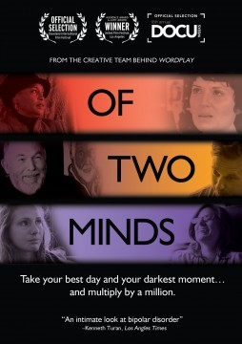

**“OF TWO MINDS,” AN INTIMATE LOOK AT LIVING WITH BIPOLAR DISORDER,**

**RELEASES MAY 14 ON CABLE VOD, DIGITAL AND DVD**

**Take your Best Day and Your Darkest Moment… and Multiply by a Million.**

“…Intelligent [and] Compassionate” – *Variety*

Directed by Doug Blush and Lisa Klein (*Cult Culture*), ***OF TWO MINDS*** is an award-winning feature documentary from the creative team behind Wordplay, The Invisible War, Superheroes and *These Amazing Shadows* that explores the extraordinary lives, struggles and successes of a few of the over five million Americans living with bipolar disorder. Personal stories of harrowing events, medical mazes, discrimination and the effects of social stigma blend together to create a compelling look at a generation coming out of the “bipolar closet.” ***OF TWO MINDS*** puts an authentic human face on bipolar disorder, providing an intimate, sometimes painful, sometimes painfully funny look at those who live in its shadows: our parents and children, our friends and lovers… and ourselves.

Cinedigm’s Docurama Films will release ***OF TWO MINDS*** on May 14 on cable VOD, digital and DVD following its theatrical release through IDA’s Docuweeks last fall. The film is the winner of the 2013 Prism Award for Best Documentary Feature, the Audience and Jury Awards at the 2012 Los Angeles United Film Festival and was an official selection at the 2012 DocuWeeks, the Newport Beach Film Festival, and the Cleveland International Film Festival. ***OF TWO MINDS*** has played in many festivals and special events screenings across the country and continues to tour in the U.S. and Canada.

**BONUS PROGRAMMING**

* Bonus Short Film “The Mad Parade;” Interviews with Experts and Advocates; Voices of Bipolar Interviews; Theatrical Trailer

**PROGRAM INFORMATION**

Pricing: $29.95 US/$34.95 CA

Runtime: 89 mins. + extras

Rating: NR

Catalog #: NNVG10003519

Language: English

Color: Color

Audio Format: Dolby Digital 2.0 Stereo

Genre: Documentary

For Box Art: <http://www.newvideo.com/docurama/of-two-minds/>

For artwork or more info, contact **Luis Garza** at **lgarza@cinedigm.com** or (646) 259-4144