**FOR IMMEDIATE RELEASE**

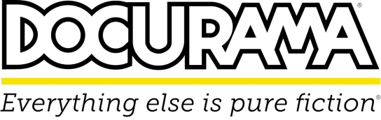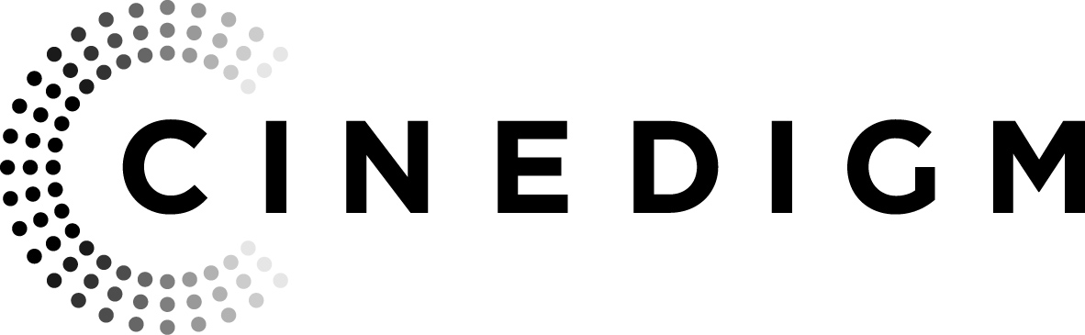

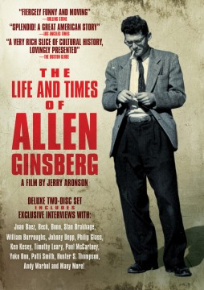 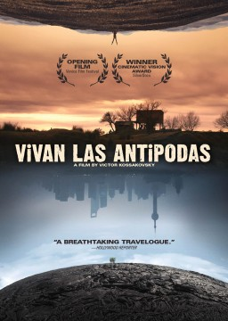

**CINEDIGM’S DOCURAMA FILMS RELEASES**

**“THE LIFE AND TIMES OF ALLEN GINSBERG” AND “VIVAN LAS ANTIPODAS” JUNE 11 ON DVD AND DIGITAL DOWNLOAD**

**“THE LIFE AND TIMES OF ALLEN GINSBERG”**

Iconic poet, visionary, outspoken champion of human rights, radical, spiritual seeker, renowned poet, founding member of a major literary movement, Buddhist, political activist and teacher—Allen Ginsberg’s remarkable life shaped the very soul of American counterculture. For 30 years, Academy Award®-nominated producer and director Jerry Aronson (*Chasing Ice*, *The Divided Trail*) accumulated more than 200 hours of film on Allen Ginsberg, resulting in this comprehensive portrait of one of America’s greatest poets, author of “Howl” and other groundbreaking poems.

Cinedigm’s (NASDAQ: CIDM) Docurama Films will release ***THE LIFE AND TIMES OF ALLEN GINSBERG*** on June 11 on DVD and digital download. The film is 30 years in the making and the collector’s deluxe two-disc set includes revealing interviews with Ginsberg’s friends, family and contemporaries and over six hours of bonus material. The original film premiered and was nominated for the Grand Jury Prize at the 1993 Sundance Film Festival and won the IDA Award at the International Documentary Association the same year. The director’s DVD cut was completed in 2007, 10 years after Ginsberg’s passing in 1997.

***THE LIFE AND TIMES OF ALLEN GINSBERG*** unveils the last 60 years of American culture beginning with the Beat era in the post-war Forties and Fifties, continuing through the revolutionary Sixties and concluding with the uncertainty and possibility of current times.

Bonus features include: Interviews; Featurette: The Making of *The Life and Times of Allen Ginsberg;* Ginsbergreading selected poems; Bob Dylan and Allen Ginsberg at Jack Kerouac’s grave; William Burroughs and Allen Ginsberg at Naropa University; Neal Cassady and Allen Ginsberg at City Lights bookstore; The Making of the Music Video: *A Ballad of the Skeletons*; Ginsberg guides us through an exhibition of his photographs; excerpts from *Scenes From* *Allen’s* *Last Three Days on Earth as a Spirit* by Jonas Mekas; Ginsberg photo gallery; director’s photo gallery; and the New York City memorial for Allen Ginsberg.

***THE LIFE AND TIMES OF ALLEN GINSBERG*** is produced and directed by Jerry Aronson; associate produced by Karen Littman; edited by Nathaniel Dorsky and Jerry Aronson.

“Splendid! A Great American Story.” – *Los Angeles Times*

“A very rich slice of cultural history, lovingly presented.” – *Boston Globe*

“Fiercely funny and moving” - *Rolling Stone*

U.S./Canada DVD SRP: $29.95/$34.95

Runtime: 84 mins. + extras

Rating: NR

Catalog #: NNVG288550

Language: English

Color: Color

Genre: Documentary

Official Website: <http://www.allenginsbergmovie.com/>

For Box Art: <http://www.newvideo.com/docurama/the-life-and-times-of-allen-ginsberg/>

**“VIVAN LAS ANTIPODAS”**

What is the shortest route between Entre Ríos in Argentina and the Chinese metropolis Shanghai? Simply a straight line through the center of the earth, since the two places are antipodes: they are located diametrically opposite to each other on the earth’s surface.

During his visits to four such antipodal pairs, the award-winning documentary filmmaker Victor Kossakovsky (*Hush!*, *Belovy*) captured images that turn our view of the world upside down. A beautiful, peaceful sunset in Entre Ríos is contrasted with the bustling streets in rainy Shanghai. People who live in a wasteland are connected to people dwelling next to a volcano. Landscapes whose splendor touches the soul are juxtaposed with the clamor of a vast city. These antipodes seem mythically connected, somehow united by their oppositeness.

On June 11, ***VIVAN LAS ANTIPODAS*** releaseson DVD and digital download following its U.S. theatrical premiere at the Docurama Film Series in April 2013. The film world premiered at the 2011 Venice Film Festival and won the Cinematic Vision Award at AFI’s Silverdocs in 2012 and the True Vision Award at the True/False Film Festival.

***VIVAN LAS ANTIPODAS*** is edited and directed by Victor Kossakovsky; executive produced by Alexander Rodnyansky, Eva-Maria Weerts, Gema Juarez Allen, Christian Angermayer and Achim Pfeffer; produced by Heino Deckert .

“A breathtaking travelogue that views the world upside down” – *Hollywood Reporter*

“Constructed around an elegantly simple idea but executed with grace and ingenuity” – *Variety*

U.S./Canada DVD SRP: $29.95/$34.95

Runtime: 108 mins.

Rating: NR

Catalog #: NNVG289432

Language: English, Spanish, Russian, Shanghainese, Setsuana with English Subtitles

Color: Color

Genre: Documentary

For Box Art: <http://www.newvideo.com/featured-releases/vivan-las-antipodas/>

**About Docurama Films**

In 1999, **NEW VIDEO** launched **Docurama Films**® with the first feature documentary ever available on DVD: D.A. Pennebaker’s “Bob Dylan: Dont Look Back.” Twelve years and 300 award-winning, highly-acclaimed titles later, Docurama continues to discover and release the greatest non-fiction films of our time while spreading the word about filmmakers who are taking the form to new heights.  Docurama’s catalog features the performing and visual arts, history, politics, the environment, ethnic and gender interests, and all-time favorites including “The Wild Parrots of Telegraph Hill,” “Andy Goldsworthy:Rivers and Tides” and “King Corn.”Recent titles include the 2011 Oscar®-nominated films “Gasland” and “Hell and Back Again.” [www.docuramafilms.com](http://www.docuramafilms.com/)

**About Cinedigm**

Over the past decade, Cinedigm has led the digital distribution revolution that continues to transform the media landscape. In addition to its pioneering role in transitioning movie theatres from traditional film prints to digital distribution, Cinedigm continues to advance worldwide cinema modernization with its suite of software products allowing exhibitors and distributors to manage their newly digital businesses with efficiency, insight and certainty. And, as the leading distributor of independent content in the world, Cinedigm collaborates with producers and the exhibition community with unequalled transparency to market, source, curate and distribute quality content across all digital platforms to targeted and profitable audiences. The company’s library of over 5,000 titles includes award-winning documentaries from Docurama Films®, next-gen indies from Flatiron Film Company® and acclaimed independent films and festival picks through partnerships with the Sundance Institute and Tribeca Film. Cinedigm is proud to distribute many Oscar®-nominated films including “The Invisible War,” “Hell and Back Again,” “Gasland,” “Waste Land” and “Paradise Lost 3: Purgatory.”

Upcoming and recent CEG multi-platform releases include Dante Ariola’s “Arthur Newman,” Craig Zisk’s “The English Teacher,” Jared Moshe’s “Dead Man’s Burden,” Geoffrey Fletcher’s “Violet & Daisy,” Malika Zouhali-Worrall and Katherine Fairfax Wright’s “Call Me Kuchu,” Jimmy Loweree’s “Absence,” Shaul Schwarz’s “Narco Cultura,” and Destin Daniel Cretton’s “Short Term 12.” Cinedigm™ and Cinedigm Digital Cinema Corp™ are trademarks of Cinedigm Digital Cinema Corp [www.cinedigm.com](http://www.cinedigm.com). [CIDM-G]

**For more information, please contact:**

Luis Garza

646-259-4144

[lgarza@cinedigm.com](mailto:lgarza@cinedigm.com)