

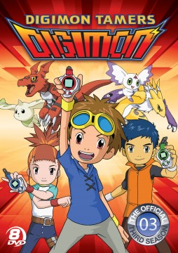

**“DIGIMON TAMERS” RELEASES JUNE 11 ON DVD AND DIGITAL DOWNLOAD**

**Season 3 is Available in an 8-Disc Set For the First Time in the U.S.**

In a separate universe from the first two seasons of Digimon Adventure, ***DIGIMON TAMERS*** follows the lives of Takato, Henry and Rika, three normal kids who are mega fans of the Digimon card game. One by one the Digimon drawings on their cards start coming to life in different ways and the kids soon realize there is a Digital World plagued by evil that needs their help.

The three tamers and their Digimon quest through the Digital World meeting new tamers on a similar journey to defeat the evil Digimon Gods. But once they all begin to battle one Digimon God, D-Reaper, an even greater evil reveals itself as the biggest threat the Digital World has ever seen. On June 11, Flatiron Film Company, a label of Cinedigm (NASDAQ: CIDM), will release all 51 episodes of ***DIGIMON TAMERS*** in an 8-disc official collector’s set and on digital download.

**Bonus Features**

* 32-page Character Guide Booklet; Gallery featuring more than 40 Villain Digimon Sketches

**Program Information**

U.S./Canada SRP:$79.95/$89.95

Runtime: 17h 51m + extras

Rating: NR

Catalog #: NNVG291031

Language: English

Color: Color

Genre: Anime

For Box Art: <http://www.newvideo.com/flatiron-film-company/digimon-tamers/>

Contact:

Luis Garza

[lgarza@cinedigm.com](mailto:lgarza@cinedigm.com)

646-259-4144