**FOR IMMEDIATE RELEASE**

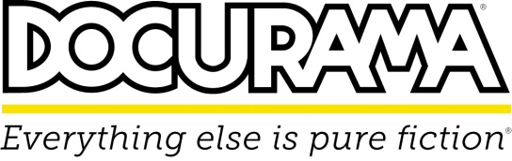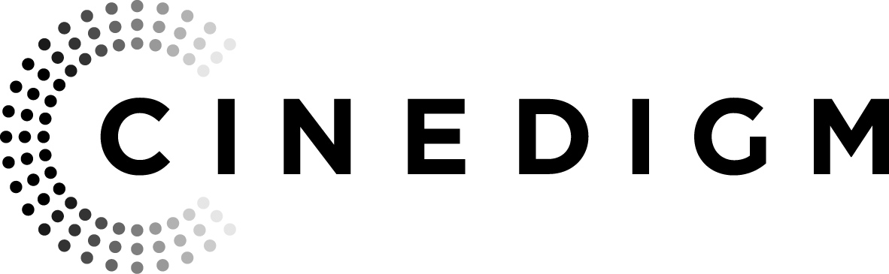

 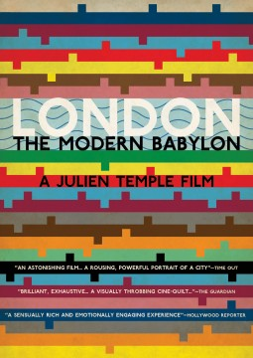

**“THE FRUIT HUNTERS” AND “LONDON: THE MODERN BABYLON” RELEASE JULY 16 ON DVD AND DIGITAL DOWNLOAD**

**Two Critically Acclaimed Documentaries Fresh Off**

**Cinedigm’s First-Ever Docurama Film Series**

**THE FRUIT HUNTERS**

Award-winning director Yung Chang’s (*Up the Yangtze*) ***THE FRUIT HUNTERS*** follows acclaimed actor and community activist Bill Pullman (*Independence Day*, *1600 Penn*) as well as adventurers, scientists and fruit detectives as they survey culture, history and geography, dedicating themselves to searching for and saving rare and exotic fruit. The passionate fruit fanatics aspire to create a Garden of Eden in a world increasingly dominated by industrialized monoculture.

Following a successful theatrical run in the Docurama Film Series in May 2013, Cinedigm (NASDAQ: CIDM) will release ***THE FRUIT HUNTERS*** on July 16 on DVD and digital download. The film is the winner of the Grand Prize Award at the 2013 Paris Environmental International Film Festival and was an official selection at IDFA and the Palm Springs International Film Festival.

A cinematic odyssey through nature and commerce, ***THE FRUIT HUNTERS***will change not only the way we look at what we eat but how we view our relationship to the natural world.

The film is inspired by the best-selling book, *The Fruit Hunters: A Story of Nature, Adventure, Commerce and Obsession* by Adam Leith Gollner, which released on June 11, 2013.

***THE FRUIT HUNTERS*** is directed by Yung Chang; executive produced by Daniel Cross, Ravida Din and Robin Smith; produced by Bob Moore, Mila Aung-Thwin and Kat Baulu; written by Yung Chang, Mark Slutsky and Mila Aung-Thwin; edited by Hannelle Halm, Iar Majeed, and Mila Aung-Thwin. Bonus features include the theatrical trailer.

“Finger-Licking Fantastic” – *The Montreal Gazette*

“The Fruit Hunters is a fascinating and thoroughly enjoyable documentary” – *Screendaily.com*

U.S. DVD SRP: $29.95

Runtime: 95 mins. + extras

Rating: NR

Catalog #: NNVG292770

Language: English

Color: Color

Genre: Documentary

For Box Art:

<http://www.newvideo.com/docurama/the-fruit-hunters/>

For an interview with Adam Leith Gollner, the author of *The Fruit Hunters,* please contact:

Leah Sikora

212-698-2358

[leah.sikora@simonandschuster.com](mailto:leah.sikora@simonandschuster.com).

**LONDON: THE MODERN BABYLON**

***LONDON: THE MODERN BABYLON*** is legendary director Julien Temple’s (Joe Strummer: The Future is Unwritten) epic time-traveling voyage to the heart of his hometown. From musicians, writers and artists to dangerous thinkers, political radicals and, above all, ordinary people, this is the story of London’s immigrants, its bohemians and how together they changed the city forever.

Reaching back to the dawn of film in London at the start of the 20th century, the story unfolds through archival film and TV clips, photos and voices of Londoners past and present, powered by the flow of popular music across the century—a stream of urban consciousness, like the river which flows through its heart. It ends in present day, as London prepares to welcome the world to the 2012 Olympics.

On July 16, ***LONDON:*** ***THE MODERN BABYLON*** releaseson DVD and digital download following its U.S. theatrical premiere at the Docurama Film Series in June 2013. The film was nominated for the Best Documentary Award at the 2012 British Independent Film Awards and the European Film Awards.

The film features the voices of Andy Serkis (*The Lord of the Rings* and *Hobbit* films), Bill Nighy (*Love Actually*), Michael Gambon (*Harry Potter* series), Juno Temple (*The Dark Knight Rises*), Imelda Staunton (*Vera Drake*), Keith Allen (*Trainspotting*), Steve Jones (*Goodfellas*) and Julien Temple.

***LONDON: THE MODERN BABYLON*** is written and directed by Julien Temple; executive produced by Christine Langan, Jonty Claypole, Alan Yentob; produced by Julien Temple, Amanda Temple, Stephen Malit; edited by Caroline Richards. Stephen Organ is the director of photography. Featuring music from The Rolling Stones, The Clash, Pink Floyd, Underworld, The Kinks, X-Ray Spex, Madness, Small Faces, Siouxsie and the Banshees, Duke Ellington, Marie Lloyd, David Bowies, The Shadows, Bob Dylan, T-Rex, Dire Straits, Bob Marley, Pet Shop Boys, Adam and the Ants, 808 State, The Shamen, Roxy Music, M.I.A, Lily Allen, Public Image LTD, Rolf Harris, Sex Pistols. Bonus features include a conversation with Julien Temple and the trailer.

“An Astonishing Film… A Rousing, Powerful Portrait for a City” – *Time Out*

“A Sensually Rich and Emotionally Engaging Experience” – *Hollywood Reporter*

U.S. DVD SRP: $29.95

Runtime: 125 mins. + extras

Rating: NR

Catalog #: NNVG291871

Language: English

Color: Color

Genre: Documentary

For Box Art:

<http://www.newvideo.com/docurama/london-the-modern-babylon/>

**About Docurama Films**

In 1999, **NEW VIDEO** launched **Docurama Films**® with the first feature documentary ever available on DVD: D.A. Pennebaker’s “Bob Dylan: Dont Look Back.” Twelve years and 300 award-winning, highly-acclaimed titles later, Docurama continues to discover and release the greatest non-fiction films of our time while spreading the word about filmmakers who are taking the form to new heights.  Docurama’s catalog features the performing and visual arts, history, politics, the environment, ethnic and gender interests, and all-time favorites including “The Wild Parrots of Telegraph Hill,” “Andy Goldsworthy:Rivers and Tides” and “King Corn.”Recent titles include the 2011 Oscar®-nominated films “Gasland” and “Hell and Back Again.” [www.docuramafilms.com](http://www.docuramafilms.com/)

**About Cinedigm**

Over the past decade, Cinedigm has led the digital distribution revolution that continues to transform the media landscape. In addition to its pioneering role in transitioning movie theatres from traditional film prints to digital distribution, Cinedigm continues to advance worldwide cinema modernization with its suite of software products allowing exhibitors and distributors to manage their newly digital businesses with efficiency, insight and certainty. And, as the leading distributor of independent content in the world, Cinedigm collaborates with producers and the exhibition community with unequalled transparency to market, source, curate and distribute quality content across all digital platforms to targeted and profitable audiences. The company’s library of over 5,000 titles includes award-winning documentaries from Docurama Films®, next-gen indies from Flatiron Film Company® and acclaimed independent films and festival picks through partnerships with the Sundance Institute and Tribeca Film. Cinedigm is proud to distribute many Oscar®-nominated films including “The Invisible War,” “Hell and Back Again,” “Gasland,” “Waste Land” and “Paradise Lost 3: Purgatory.”

Upcoming and recent CEG multi-platform releases include Dante Ariola’s “Arthur Newman,” Craig Zisk’s “The English Teacher,” Jared Moshe’s “Dead Man’s Burden,” Geoffrey Fletcher’s “Violet & Daisy,” Malika Zouhali-Worrall and Katherine Fairfax Wright’s “Call Me Kuchu,” Jimmy Loweree’s “Absence,” Shaul Schwarz’s “Narco Cultura,” and Destin Daniel Cretton’s “Short Term 12.” Cinedigm™ and Cinedigm Digital Cinema Corp™ are trademarks of Cinedigm Digital Cinema Corp [www.cinedigm.com](http://www.cinedigm.com). [CIDM-G]

**For more information, please contact:**

Luis Garza

646-259-4144

[lgarza@cinedigm.com](mailto:lgarza@cinedigm.com)