Start time: 0.0000 End time: 1354.727617
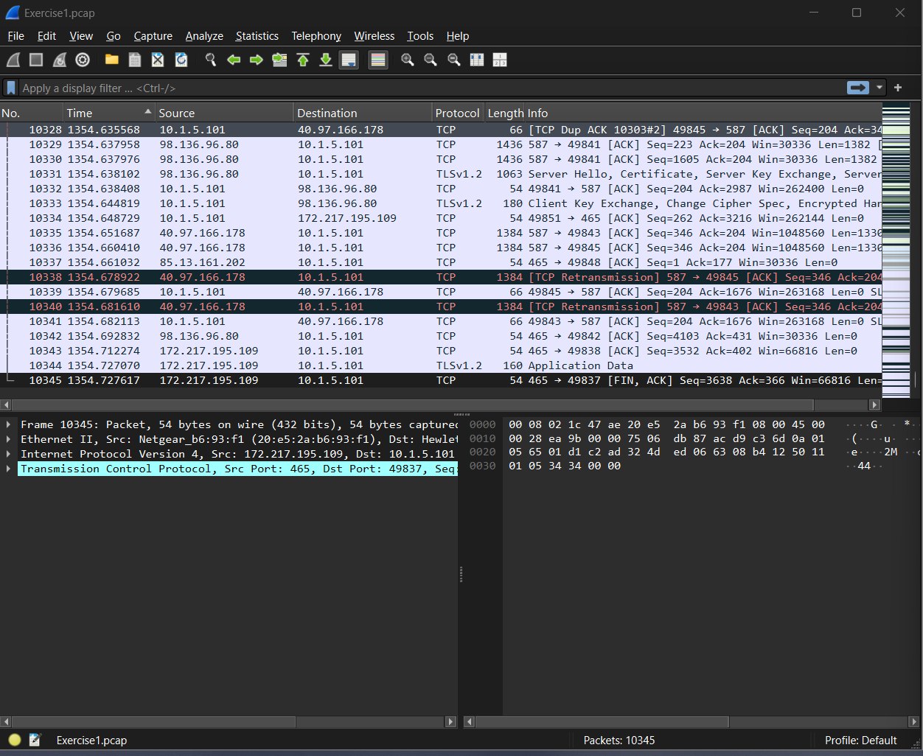

First 3 protocols: TCP, TLS, HTTP
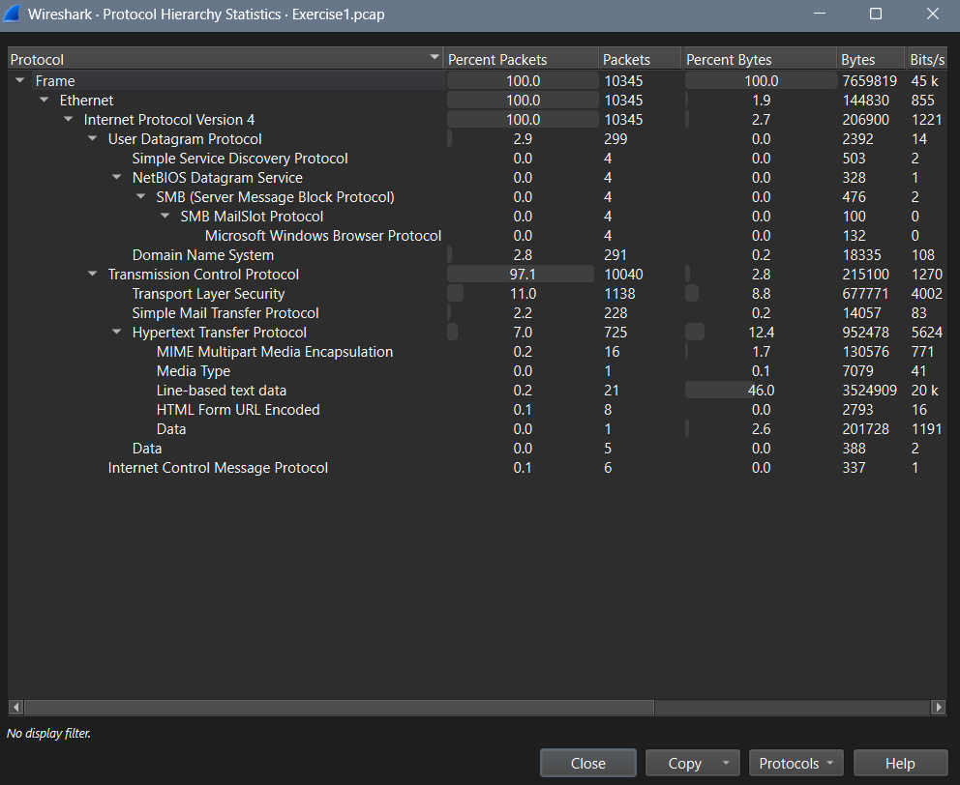
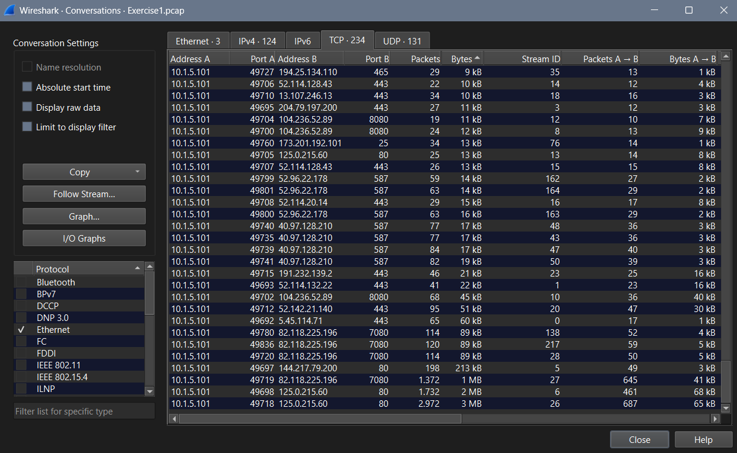

The private ip 10.1.5.101 is the internal host comunicating with tens of different public IPs, some of them having a heavy traffic volume, so it’s the most likely internal infected host IP address.

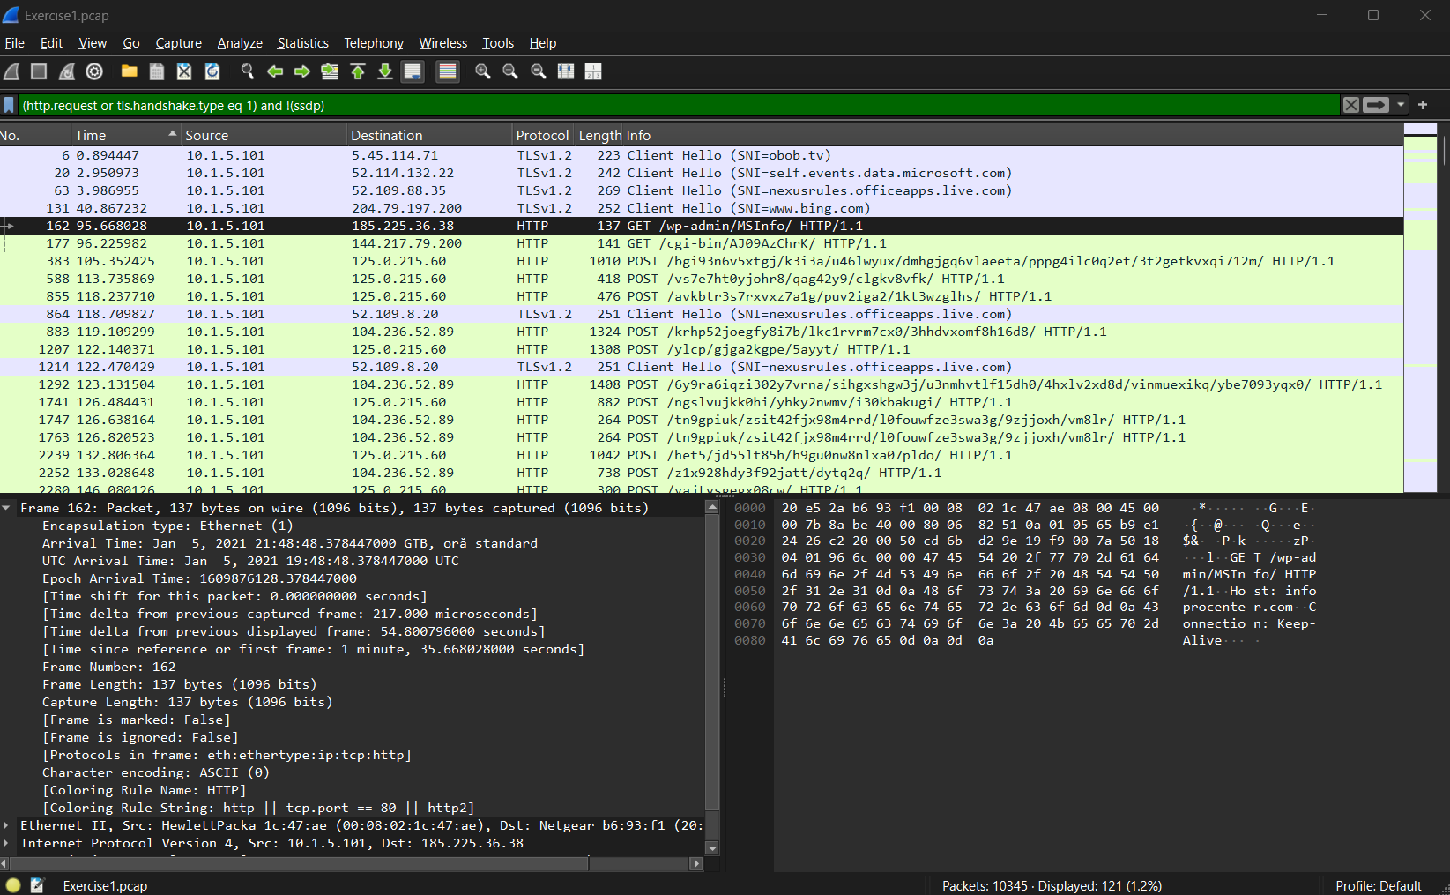
(http.request or tls.handshake.type eq 1) and !(ssdp)
- Destination 185.225.36.38 port: 80 protocol: HTTP time: 95.668028
- Destination 144.217.79.200 port: 80 protocol HTTP time 96.225982
- Destination: 125.0.215.60 port: 80 protocol HTTP time: 105.352425

(http.request or http.response or tls.handshake.type eq 1) and !(ssdp)

- Destination 10.1.5.101 dest port: 49696 HTTP time 96.005316
- Destination 125.0.215.60 port 80 HTTP time 113.735869
- Destination 125.0.215.60 port 80 HTTP time 118.237710

http.request.method == "GET"
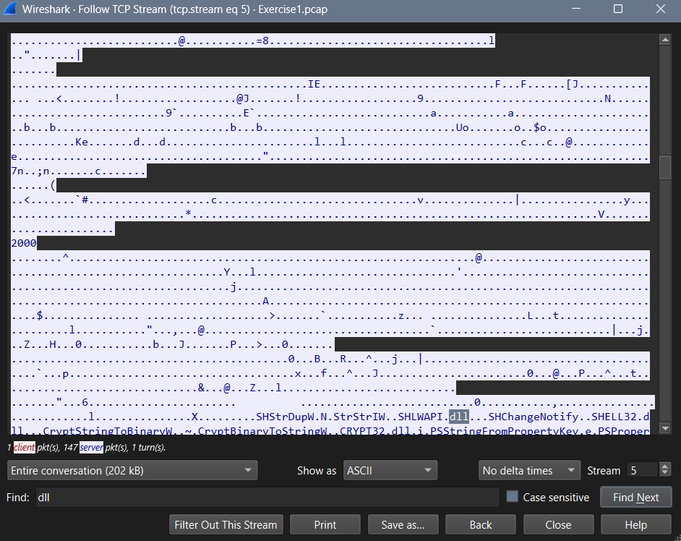
It looks like an executable, filename="GP0YDWjjyouW.dll", it is a weird looking file with the dll extension.

C: post conversations
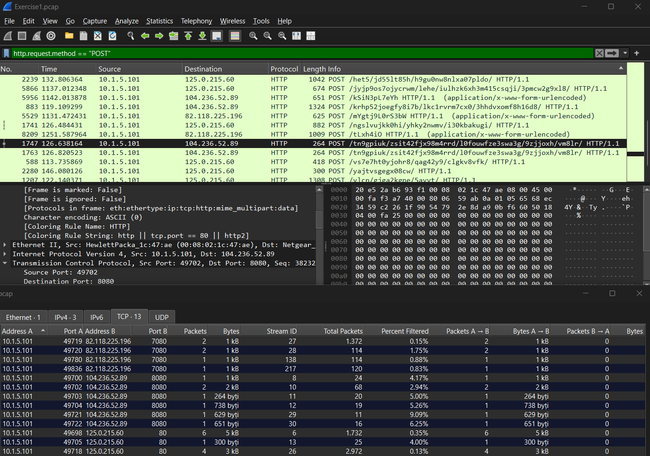
- Source 10.1.5.101 destination 104.236.52.89 port 8080 time 126.638164 /tn9gpiuk/zsit42fjx98m4rrd/l0fouwfze3swa3g/9zjjoxh/vm8lr/ HTTP/1.1
Text is unreadable, traffic is repeated.

- 588 113.735869 10.1.5.101 125.0.215.60 HTTP 418 POST /vs7e7ht0yjohr8/qag42y9/clgkv8vfk/ HTTP/1.1
text is encrypted, destination port is 80.

Is looks like C2 because there is repetetive periodical requests between the same servers.
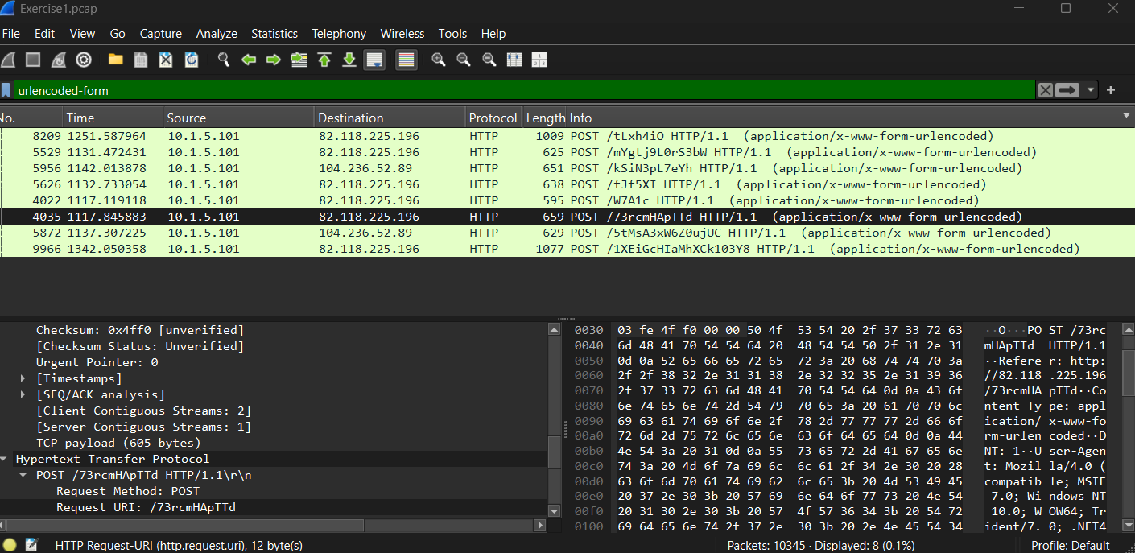
D. mail
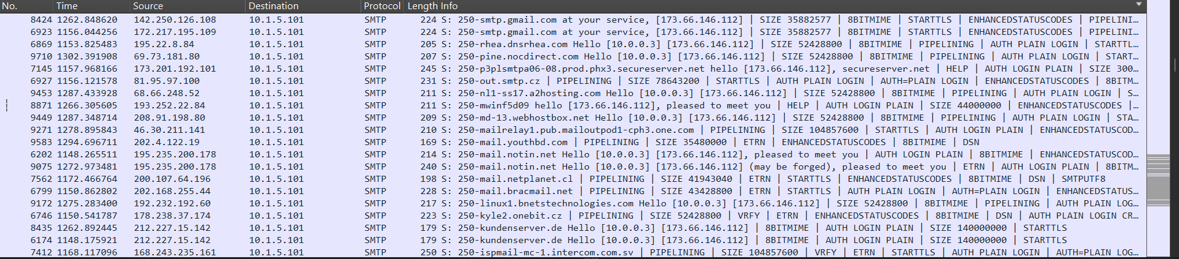
- There is mail related traffic
- It is mostly encrypted tls, but there is also smtp
- The only mail related destination is 10.1.5.101
- An infected host generating mail related traffic can cause spam and mass mail, it can be involved in data exfiltration...

