Security Appliance
  - Authoritative architecture and OVA deployment design
Document ID: SEC-ARCH | Version: 1.71

Document authority
This document defines the deployable appliance architecture, security boundaries and acceptance requirements. Release evidence, environment settings and operational records are maintained separately.
The baseline is a single Ubuntu Server 24.04 LTS virtual machine running Docker Engine with Compose. It contains the management application, Nginx reverse proxy, optional Squid forward proxy, Keycloak with PostgreSQL, and a KMIP key-management service. The release manifest pins operating-system media, packages and container images. Initial sizing is 4 vCPU, 8 GiB RAM, a 32 GiB OS disk and a 64 GiB persistent-data disk; resize from measured load and retention needs.

1 Logical topology
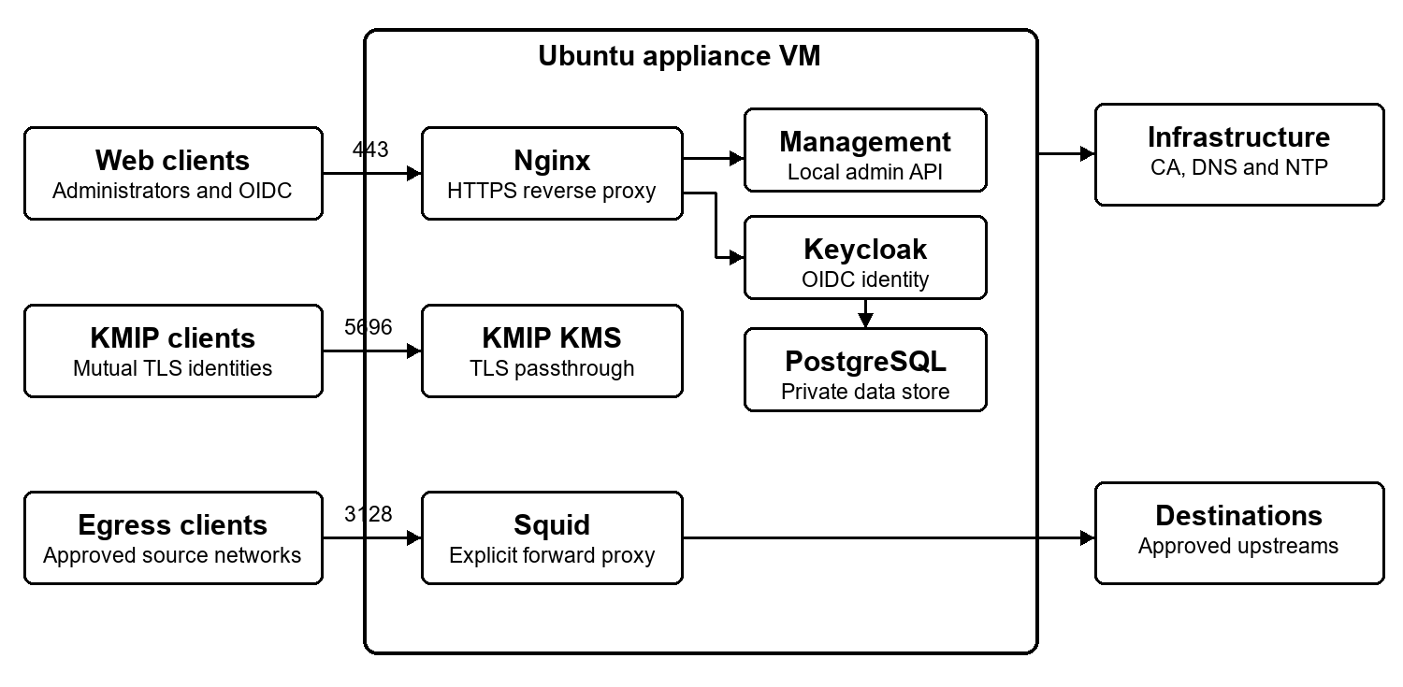
Figure 1. Logical service and trust boundaries
A single management and service NIC carries the approved listeners. Nginx terminates HTTPS for management and OIDC, and passes KMIP TLS through without decrypting the client session. Squid uses a separate explicit egress listener. PostgreSQL, the Keycloak backend, management backend and service health endpoints have no independently published host ports. The VM is one failure domain; containers alone do not provide high availability.
The deployment supplies its own hostname, stable service DNS names, network settings and certificate authority. Static IPv4 is the default. DHCP is supported only with a permanent reservation and matching DNS records so certificate names and OIDC issuer URLs remain stable.

2 Isolation and host security
Docker Engine and Compose run under systemd with separate management, proxy, identity and KMIP networks. The management application has no Docker socket, terminal, arbitrary command API or unrestricted filesystem browser. A root-owned host helper accepts only validated, bounded operations over a local authenticated Unix socket. Service containers receive only the files, capabilities and networks needed for their roles.
Routine administrators do not receive an Ubuntu login. Disable and mask SSH, ordinary and serial shell getty units, and alternate unattended consoles; lock root and operator OS-login accounts. A fixed-function VM console provides status and web-administrator recovery without a shell. Hypervisor and datastore administrators remain outside this appliance boundary and require separate infrastructure controls.
The host firewall is active before external listeners start and defaults to deny for inbound and forwarded traffic. Permit HTTP only for redirect, HTTPS for intended service clients, TCP 5696 only from enrolled KMIP client networks, and TCP 3128 only from approved forward-proxy clients when enabled. Restrict /admin/ by its own management source allowlist. Reconcile firewall and Docker forwarding rules after container changes; a firewall failure keeps external listeners closed. Never publish PostgreSQL, Keycloak backend or management backend ports.

3 Identity and access
Keycloak runs in production mode with PostgreSQL persistence, a stable HTTPS issuer hostname and proxy headers overwritten by Nginx. Keep its administrative backend private. Reserve the master realm for administration and create separate application realms or clients with explicit redirect URIs, audiences and role mappings. Browser clients use Authorization Code with PKCE; human administrators use multifactor authentication after enrollment. Machine clients receive individual least-privilege credentials. Configure an upstream OIDC provider from its exact discovery metadata, including the normalized issuer, authorization, token, user-information, logout and JWKS endpoints. Validate TLS chains and signed tokens; install additional private CA roots as root-owned read-only trust anchors and never disable certificate validation. Define required claims before onboarding. A username-only profile is acceptable only when every relying application has been qualified without email or personal-name claims.
The appliance web administrator is local to the management application and remains usable if Keycloak, DNS or KMIP is unavailable. New OVA deployments default the local web-administrator username to admin. The local web-administrator password accepts 15 to 256 characters without control characters; the console recovery and Keycloak administrator passwords remain separate 16 to 256 character secrets, and all three deployment passwords must be distinct. OVA deployment supplies separate credentials for the local web administrator, the fixed-function console recovery verifier and the Keycloak administrator. Generate database credentials per deployment; keep passwords out of Compose files, images, process arguments and logs. Protected APIs authorize each request; server-side sessions use Secure, HttpOnly and SameSite cookies scoped to /admin/, CSRF protection, session expiry and login throttling. Local administrator management shows enabled state, last successful login and active-session count. Authenticated administrators may enable or disable other accounts and revoke sessions after reauthentication; the final enabled account cannot be disabled or deleted. The idle timeout is configurable from five to sixty minutes, with an eight-hour absolute session limit. Audit every account and session-policy action.
The restricted console may reset an existing web administrator after verifying its independent recovery credential. It applies persistent failed-attempt delays, requires password confirmation, invalidates active GUI sessions and records an audit event. If the local account store is missing or corrupt, it fails visibly rather than creating a default account.

4 Management interface
The management entry point is https://<appliance-fqdn>/admin/. Redirect plain HTTP to HTTPS, the appliance root to /admin/, and /admin to /admin/. Keep the management API under /admin/api/ and reachable only through Nginx. Before authentication, display only a centered sign-in card; do not expose workspace navigation, configuration or service state. Provide a light and dark theme switch on login and authenticated pages, save the choice locally and apply it before first paint.
The authenticated header shows Prepare Appliance while first deployment is incomplete, plus KMIP, Keycloak, Proxy and Health Status.
The signed-in username opens a menu for Appliance Management, Certificates and Trust, Appliance Updates, Admin User Management, Change Password, Activity History, Help and Sign Out; administration does not appear as a primary-header link. Admin User Management owns local accounts and session controls. Change Password contains only the current web-administrator password workflow. Activity History presents bounded administrative actions and recorded outcomes. Each service page owns its service controls, readiness badge, operation summary and redacted activity view. There is no aggregate service-management or connection-logs page. Activity queries select exactly one allowlisted service, bound records and remove query strings and credential-related values. Each owning service page shows a bounded history of functional tests with the test time, appliance version, result and sanitized failure category.
Appliance Management presents Identity, Timezone, Management Network, and DNS and Time panels. Network-affecting changes require a preview, interruption acknowledgment, current-administrator reauthentication, a timed rollback and reconnection confirmation. Health Status presents identity, active network, DNS, NTP, storage, service state, certificate expiry, firewall and alerts. It provides a support bundle and refresh, with audited reboot and shutdown actions that require confirmation and reauthentication. A disabled optional forward proxy is an expected state rather than a health alert. Certificates and Trust shows bounded public metadata for management, identity, KMIP CA and server certificates, plus enrolled KMIP clients: subject, issuer, DNS names, SHA-256 fingerprint, expiry and trust status. Public CA chains are downloadable; private keys are never returned. Guide renewal, rotation and revocation according to each issuing authority and the qualified KMIP trust model. Appliance Updates shows a bounded signed-update history, signature and bundle digests, installation time, post-install health and prior-release availability. A guarded restore requires reauthentication and runs the same health checks, retaining the current release if restoration fails. Health Status can deliver only allowlisted sanitized alerts to an explicitly configured syslog, generic HTTPS webhook or Mattermost incoming webhook and shows the latest delivery outcome; delivery is disabled by default. HTTPS webhook secrets are stored with restricted permissions and are never returned by the management API or displayed after saving. Certificate validation uses the operating-system trust store plus the enrolled appliance management CA chain. Mattermost delivery uses the required text payload, and both configuration and test delivery require administrator reauthentication. A compact header indicator links to Health Status and displays the service-ready count or attention state with its check time. Health Status shows fixed storage categories, 85 and 90 percent capacity thresholds, and 24-hour growth after sufficient samples exist. Bounded read-only diagnostics check DNS, NTP, certificate status, firewall, container readiness, OIDC discovery, KMIP mutual TLS, proxy configuration and the private management backend; no arbitrary command or target is accepted. The administrator menu provides embedded deployment, administration and troubleshooting help matched to the installed release, with a Markdown download.
First deployment contains five numbered steps: prepare the appliance, configure identity, configure key management, configure proxy and complete setup. Show a left First Deployment Steps rail only until completion; highlight the corresponding primary service page during each step. Place Next and Back at the lower right in step order. The completion control appears only on step five, requires an explicit acknowledgment and disappears with the workflow after successful completion. Configuration dialogs retain their owning step and omit activity logs. The backend, not only the browser, enforces completion gates. Step five shows a timestamped preflight with pass, warning and blocked findings linked to their owning pages. DNS, NTP, management TLS, firewall, service readiness, generic OIDC qualification and proxy readiness are required; consumer enrollment can remain a warning until a client is selected. The backend rejects completion while a required finding is blocked.

5 KMIP key management
The KMIP service is a dedicated container with a persistent key store and a release-pinned KMS implementation. Nginx publishes raw TLS passthrough on TCP 5696; the KMS validates client certificates and authorizes key operations. The listener remains closed to external clients until an administrator enrolls trust and approves exact client source networks. Keep KMIP certificate authority material and server identity separate from the management HTTPS certificate.
KMIP acceptance includes mutual TLS enrollment; rejection of an untrusted or removed client; the Create, Get, Locate and Activate operations needed by the selected consumer; key persistence across restart and update; and a disposable encrypted-workload recovery test. Preserve old key providers and their stores until every dependent workload has a verified supported migration or rekey path. The appliance and its recovery storage must not depend on keys served only by that same appliance.

6 Reverse and forward proxy
Use hostname-based HTTPS reverse routes with an explicit upstream URL, expected TLS name, CA trust, client network policy, authentication mode and timeout and upload limits. Overwrite untrusted forwarding headers. Configure only verified upstreams, and qualify redirects, cookies, WebSockets, large transfers and path handling for each route. Do not assume that placing an application behind the proxy adds OIDC support.
Squid is a separate unprivileged explicit forward proxy. It is disabled by default and is not a router, transparent interceptor or general NAT gateway. When enabled, require specific client CIDRs, reject unrestricted source networks, allow only approved public HTTP and HTTPS destinations and deny private, link-local, metadata and appliance addresses. Do not intercept TLS or cache client content in the initial profile. Log bounded connection metadata without credentials or query strings.

7 OVA deployment inputs
The VMware deployment wizard supplies the VM inventory name separately from the guest hostname. OVF properties use the guestinfo.security. prefix and the VMware guest-info transport. Password fields have blank defaults and masked presentation. The first boot removes transient secrets; the deployment process also clears password-bearing vApp values retained by vCenter after initialization.
Property suffix | Requirement | Purpose and validation
hostname | Required | Short DNS label for the appliance.
domain | Required | DNS suffix used to form the management FQDN.
network_mode | Static default | Static or reserved DHCP only.
ip | Static only | Usable IPv4 address.
prefix | Static only | IPv4 network prefix.
gateway | Static only | Usable same-subnet gateway.
dns | Static required | Approved DNS server addresses; DHCP may use a reserved lease.
ntp | Required | Approved time source names or addresses.
admin_cidrs | Required | Explicit management source networks.
web_admin_username | Required | Named local management administrator.
web_admin_password | Required, masked | Local administrator password; no OS login.
console_recovery_password | Required, masked | Separate fixed-function recovery credential.
identity_admin_username | Required | Named Keycloak administrator.
identity_admin_password | Required, masked | Separate Keycloak credential.
sso_fqdn | Required | Stable OIDC issuer DNS name.
kmip_fqdn | Required | Stable KMIP server DNS name.
kmip_client_cidrs | Optional | Blank keeps external KMIP access closed.
Validate every OVF field before changing the host. Reject missing secrets, conflicting DHCP and static fields, malformed names and addresses, and any administrator source list that would remove the current management path. New deployments use a temporary certificate until a matching CA-signed certificate and chain are installed for all published HTTPS hostnames.

8 First boot and lifecycle
First boot reads and validates OVF properties through open-vm-tools without logging secrets. It initializes only the expected blank data disk, mounts persistent state, creates unique identities and service credentials, applies network settings, then starts the firewall and management service. Setup is resumable and must preserve credentials, keys, PostgreSQL and KMIP on retry. A missing data mount blocks stateful services.
The authenticated wizard enrolls a certificate matching its private key, required DNS names and trusted CA chain; verifies identity, KMIP and proxy policy; and commits only after network settings are applied and confirmed. Running containers alone do not prove integration readiness. Unconfirmed network changes roll back automatically.
Keep PostgreSQL, KMIP, management, audit and configuration state in separate owned paths. Limit logs and monitor OS, container and data-disk capacity. Signed, digest-pinned updates include component metadata, compatibility checks and rollback or restore; avoid unattended major migrations. Release media and images support offline first boot. Preserve independent state and key recovery material. Record the prior version, bundle and manifest digests, signing-key fingerprint and post-install health; retain one qualified prior release and bounded installation history.

9 Verification requirements
- Import the exact signed OVA and verify its checksum, release signature and blank deployment-secret defaults. Exercise a fresh static deployment; qualify reserved DHCP separately if offered.
- Confirm stable DNS, approved NTP synchronization, trusted HTTPS, HTTP redirection, standard local sign-in, unauthenticated API rejection and completed first-deployment state.
- Verify the active firewall, management and KMIP source restrictions, closed backend and SSH ports, and absence of an Ubuntu shell for routine operators.
- Test OIDC Authorization Code with PKCE and logout, KMIP mutual TLS and disposable encrypted-workload recovery, reverse-proxy routing and the forward-proxy allow and deny policies.
- Restart the appliance and stateful containers; verify persistence of identity, key material, service configuration, firewall rules and management access.
- Verify console recovery, signed-update rejection and restore, vApp secret removal, account and session controls, preflight, public trust inventory, default-disabled sanitized alerts, header health, storage trends, fixed diagnostics, help export and per-service test history.
Acceptance depends on the deployed environment and its consumers. A single-node OVA is neither highly available nor a production-certified KMS; those profiles require separate architecture, key recovery and failure-domain qualification.

