Quantization
[2411.02355] "Give Me BF16 or Give Me Death"? Accuracy-Performance Trade-Offs in LLM Quantization
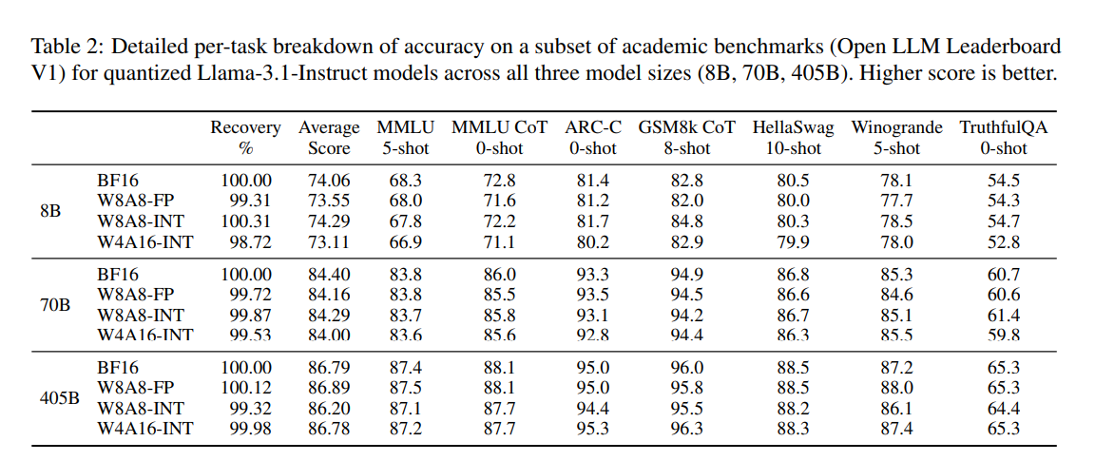
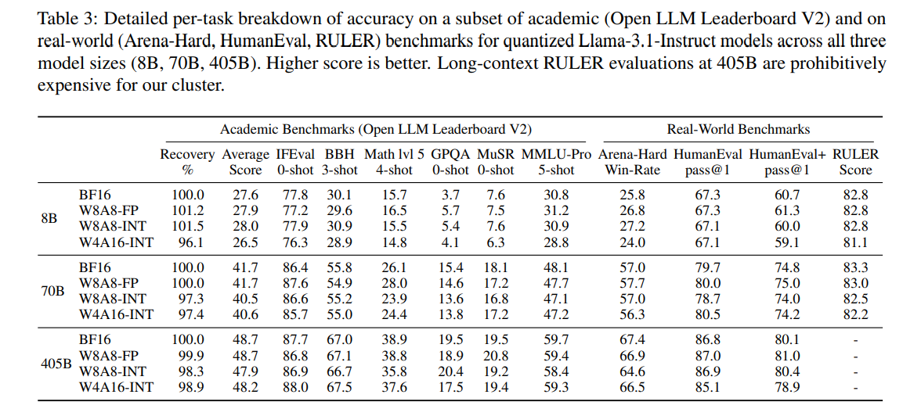
Here we can see the difference between quantized and non-quantized is not much

https://arxiv.org/html/2412.19509v1?utm_source=chatgpt.com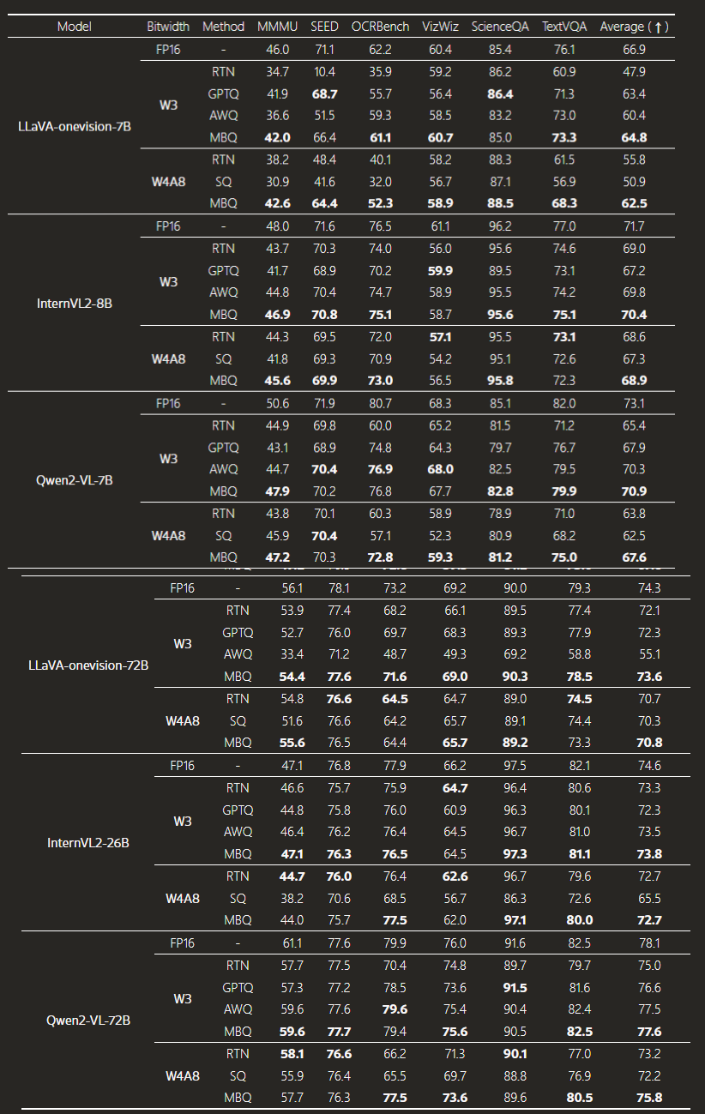

Here, AWQ, the quantization aware training can be used to compare from 16 bit half precision

https://developer.nvidia.com/blog/post-training-quantization-of-llms-with-nvidia-nemo-and-nvidia-tensorrt-model-optimizer/?utm_source=chatgpt.com

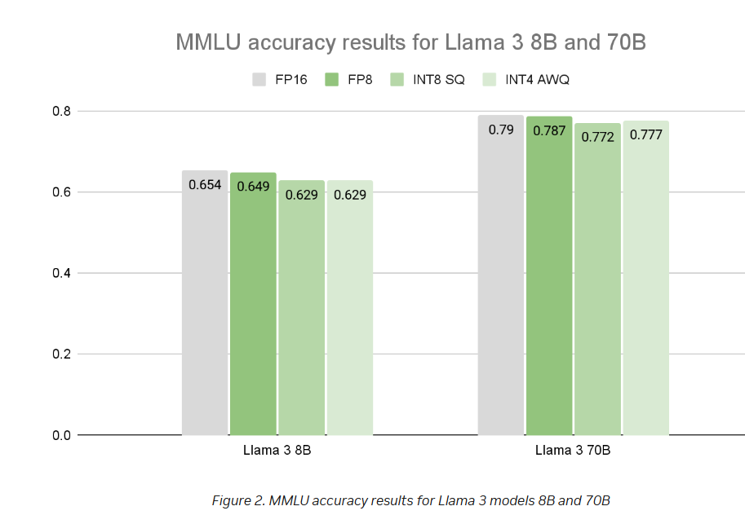
The difference between different quantizations is not much

Gemma 27B
https://arxiv.org/pdf/2503.19786

Model Architecture
- Architecture Type: Decoder-only Transformer (like Vaswani et al., 2017).
- GQA: Uses Grouped-Query Attention (GQA) with post-norm and pre-norm layers using RMSNorm.
- QK-norm: Replaces Gemma 2’s soft-capping with QK-norm, inspired by recent works
- Local/Global Attention:
  - 5:1 ratio of local sliding window self-attention (Beltagy et al., 2020) to global self-attention. (This reduce KV cache)

Context Handling
- Context Length:
  - 128K tokens for most models.
  - 32K tokens for the 1B model.
- RoPE (Rotary Position Embedding):
  - Global attention layers: RoPE base frequency increased from 10K → 1M.
  - Local attention layers: Kept at 10K.

🖼️ Vision Modality
- Vision Encoder:
  - Based on SigLIP (400M parameters).
  - A Vision Transformer (ViT) trained with a variant of CLIP loss.
  - Input: 896 × 896 square images.
  - Shared across 4B, 12B, and 27B models and kept frozen during training.
- Pan & Scan (P&S):
  - Handles non-square or high-res images by splitting them into equal-sized crops, resizing each to 896×896.
  - Applied only at inference time to avoid artifacts like unreadable text or missing small objects.
  - Optional and can be disabled for faster inference.
All models use a 256k-token vocabulary.
Model Size | Vision Encoder | Embedding Params | Non-embedding Params
1B | 0 | 302M | 698M
4B | 417M | 675M | 3,209M
12B | 417M | 1,012M | 10,759M
27B | 417M | 1,416M | 25,600M

# Model Size :
https://medium.com/%40manuelescobar-dev/memory-requirements-for-llm-training-and-inference-97e4ab08091b
https://ksingh7.medium.com/calculate-how-much-gpu-memory-you-need-to-serve-any-llm-67301a844f21
https://huggingface.co/blog/llama31?utm_source=chatgpt.com
https://modal.com/blog/how-much-vram-need-fine-tuning?utm_source=chatgpt.com

LoRA
https://arxiv.org/pdf/2506.11672

What the Paper Does (Main Contributions in Paragraph Form)
The paper introduces D-MoLE (Dynamic Mixture of Curriculum LoRA Experts), a new method for continual learning in multimodal large language models (MLLMs). It tackles the problem of adapting to new tasks without forgetting previous ones—a key challenge in Continual Multimodal Instruction Tuning (CMIT)—while staying within a fixed parameter budget.
To do this, the authors design a dynamic layer-wise expert allocator that intelligently assigns LoRA (Low-Rank Adaptation) experts to different layers based on task needs, rather than applying them uniformly. This helps resolve what they call the task architecture conflict, where different tasks benefit more from different layers.
They also identify a modality imbalance problem—where vision and language parts of the model are updated unequally—and address it with a gradient-based inter-modal curriculum that adaptively balances updates between the language model and vision encoder depending on the task difficulty.
Finally, the method evolves the architecture automatically using training-free zero-cost proxies to identify which layers are most important for each task. This allows it to share knowledge efficiently and scale effectively.
In experiments, D-MoLE significantly outperforms previous state-of-the-art methods in both task adaptation and knowledge retention, showing an average 15% improvement over the best baseline.

https://arxiv.org/pdf/2410.13733
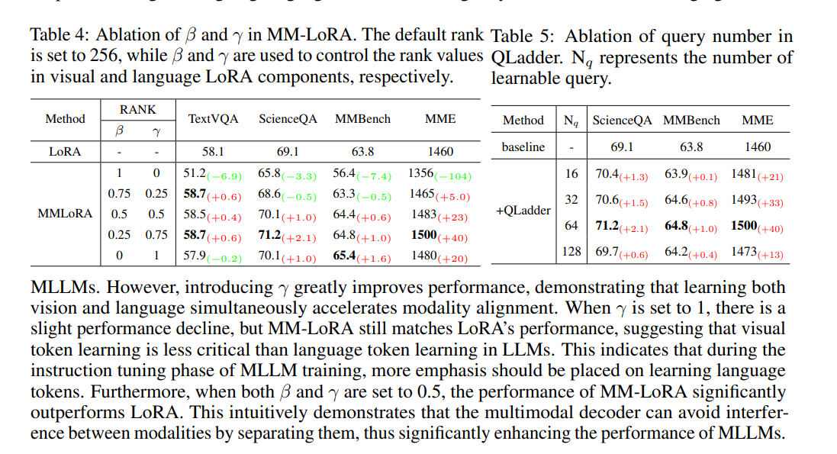
If the rank of the language is higher then vision the results is better

https://arxiv.org/html/2405.18541v2#:~:text=Adapting%20both%20encoders%20leads%20to,the%20best%20results%20on%20average
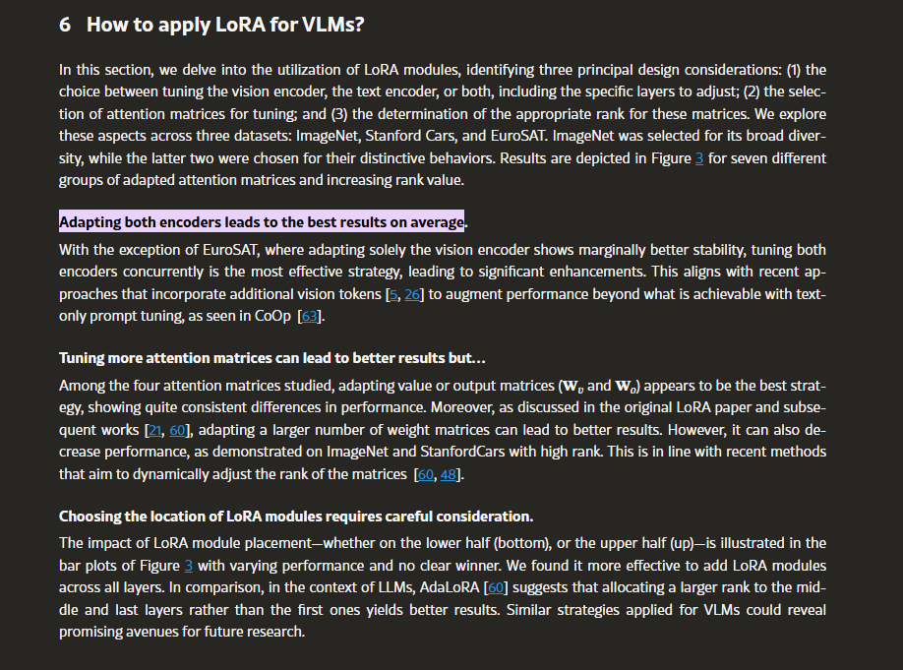

Suggestion:
Since the weight of encoder is frozen during the training phase of Gemma we can keep it fixed
There was not information available regarding the text embedding model
Currenly there is not much information regarding LoRA with multi model LLM above are two new method

APPENDIX
[2411.02355] "Give Me BF16 or Give Me Death"? Accuracy-Performance Trade-Offs in LLM Quantization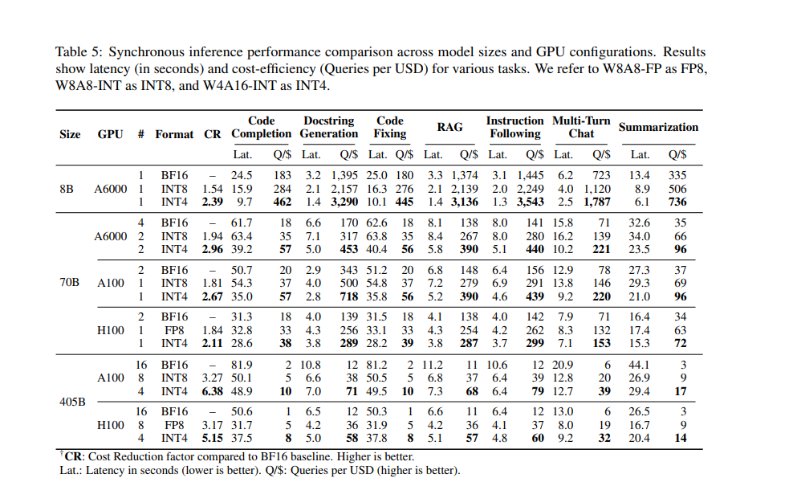
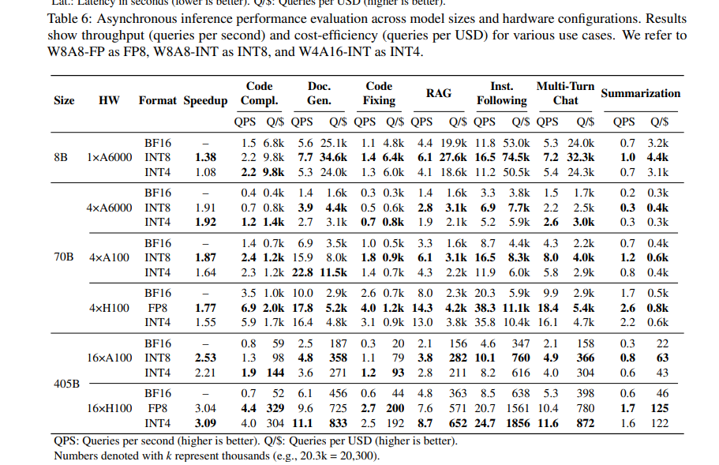
Benchmarking speed across GPU in synchronous and acync calls

