Manual for new combined discipline in the Results Service
by Tim Hatch

General
The Results Service can create a Combined Rankings for either:
- Athletes competing in a competition conforming to the format set out in Chapter [15] of the IFSC Rules; and
- Athletes competing in one or more competitions in the individual Boulder, Lead and Speed disciplines.
- Additionally Resultservice allows to start a combined competition direct from registration without a Seeding list using a random start-order.
Creating a Combined ranking from individual discipline results
A system administration must assign the Combined discipline to the competition at which the combined ranking is to be determined. This assignment is required solely so the Results Service can create a Combined ranking, it is not necessary (or indeed desirable) that competitors are registered in the Combined discipline.
A combined ranking can be created when results exist for all 3 individual disciplines. These results may be from 1 or 2 separate competitions.
Example
The 2017 European Championship was held across two events: Campitello di Fassa (Lead and Speed) and Munich (Boulder). The combined ranking for the European Championship was determined at the last of these two competitions (Munich). Within the Results Service, Campitello di Fassa was assigned Lead and Speed disciplines and Munich was assigned Boulder and Combined disciplines.
Figure 1
Example disciplines/categories allocated to Campitello di Fassa
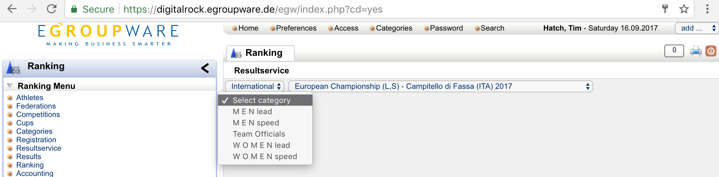

Figure 2
Example disciplines/categories allocated to Munich
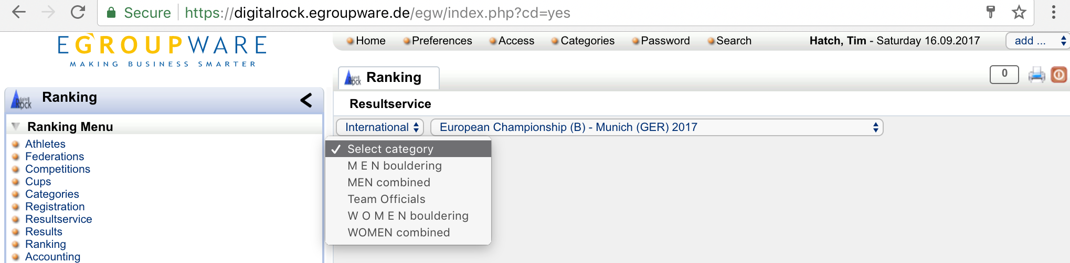

NOTE:
A Combined ranking cannot be created where the Combined discipline has not been assigned.
The Jury President responsible for creating the combined ranking should confirm with the Office that the combined discipline has been added for the relevant categories at the final competition in which a combined ranking id to be calculated.

A Combined ranking can be created once a General Result exists for each of Boulder, Lead and Speed individual disciplines.
NOTE:
A combined ranking can be created before the General Result in any individual discipline has been made Official, however the combined ranking will not automatically update.
I.e. should any individual discipline result subsequently change, the combined ranking will need to be deleted and recreated in full.

In order to create a Combined ranking in any discipline:
a) Select the relevant discipline, e.g. “WOMEN combined”, “female juniors combined”…
b) Select “Startlist / add a new round”. A standard “new round” dialog will open.
c) Where the Combined ranking is to be created from 2 qualifying competitions, select the second qualifying competition.
d) Press “Apply” or “Save”. No other options (e.g. “Quota”) need to be populated.
Figure 3
Creating a combined ranking from existing results
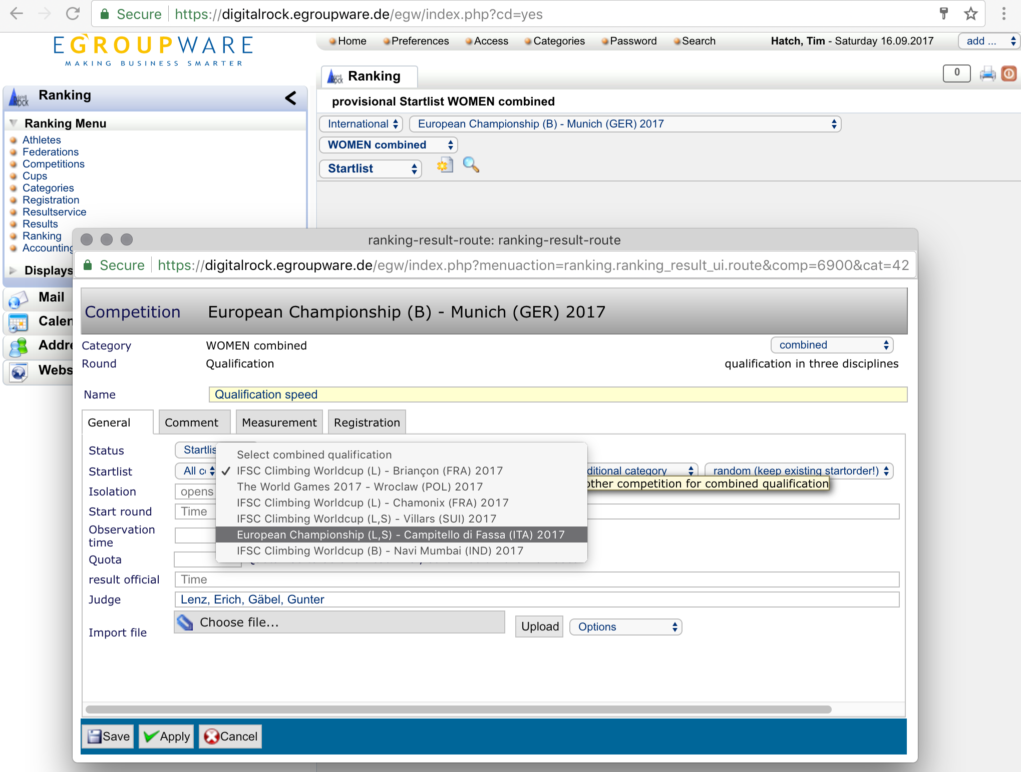

The Results Service will create a “Qualification overall result” and three new rounds: “Qualification boulder”, “Qualification lead” and “Qualification speed”. These three new rounds should be ignored - in this initial implementation, the Results Service cannot distinguish between the creation of a result from an existing competitions and the creation of a start list for a new competition.
The “Qualification overall result” presents the Combined ranking calculated from the results within the three individual disciplines:
NOTE:
1)The combined ranking calculation uses the in-discipline results without modification, i.e. tie-break mechanics applied within each individual discipline are those specified within the IFSC Rules for that discipline. The additional tie-break mechanics contemplated for the Combined discipline are not retrospectively applied.
2)The combined ranking calculation does not apply any tie-break mechanics where two or more athletes have an equal number of Ranking points. At present, such ties must be broken manually.

Combined competitions
Unlike the World Cup and World/Continental Championships, which have floating registration quotas, the proposed format for combined discipline competitions assumes a fixed quota of 20 athletes.
For competitions where the registration quota is the based on a combined ranking calculated from one or more competitions in the individual disciplines, the Results Service allows the start list to be created directly from that combined ranking without any separate registration process.
In order to import athletes from an existing combined ranking into a new combined discipline competition:
a) A quota must be applied to the Official Result for the existing Combined ranking. The defined quota is 20.
b) Within the new Combined competition, select the relevant discipline, e.g. “WOMEN combined”, “female juniors combined”…
c) Within the new Combined competition, select “Startlist / add a new round”. A standard “new round” dialog will open. Select the competition containing the Combined ranking from which the start list is to be drawn. Include the quota for the final round (6).
d) Press “Apply” or “Save”.
Figure 4
Creating a combined discipline competition from existing results
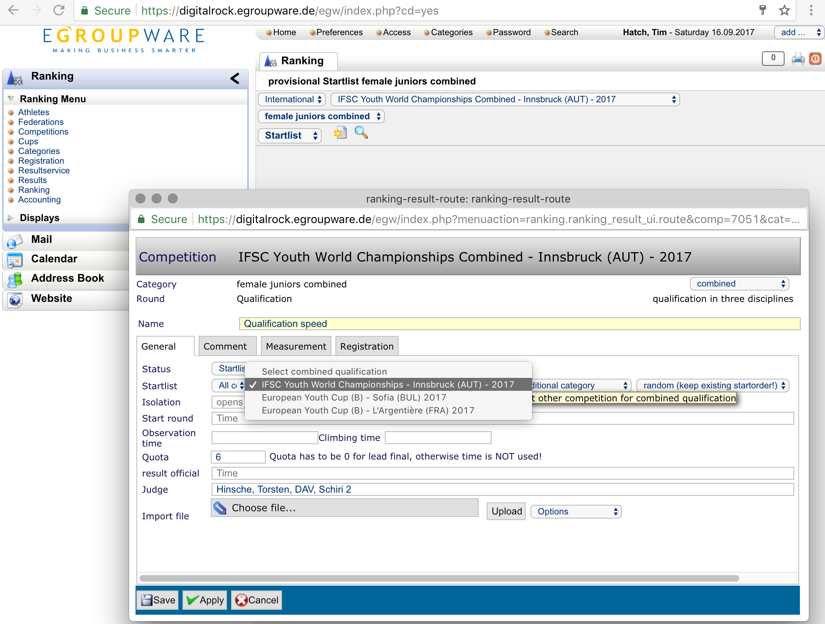
The Results Service will create a “Qualification overall result” and three new rounds: “Qualification boulder”, “Qualification lead” and “Qualification speed”. Each round can be used as normal for the relevant discipline.
WARNING:
The tie-break mechanics within the rules for combined discipline competitions are in evolution. The tie-break mechanisms implemented within the Results Service may not be fully up to date.
Currently (June 2018) the following is implemented:
Speed: Times are stored with up to 3 digits and all 3 digits are used for the ranking, but displayed rounded (.5 up) to 2 digits!
Boulder: Full tie-break is implemented with new 2018 Boulder rules.
Lead: Time is used to break ties in the final.
All tie-breakers for final require that quota is set to 0 for the final round only!

When all three qualification rounds have been completed, selecting any of:
- Startlist (Qualification lead) / add new round;
- Qualification overall result / add new round; or
- General result / add new round
presents a standard dialog for the creation of a new “1/4 final speed” round (Figure 5).
Figure 5
Creating a Speed ¼ Final following completion of the Qualification rounds
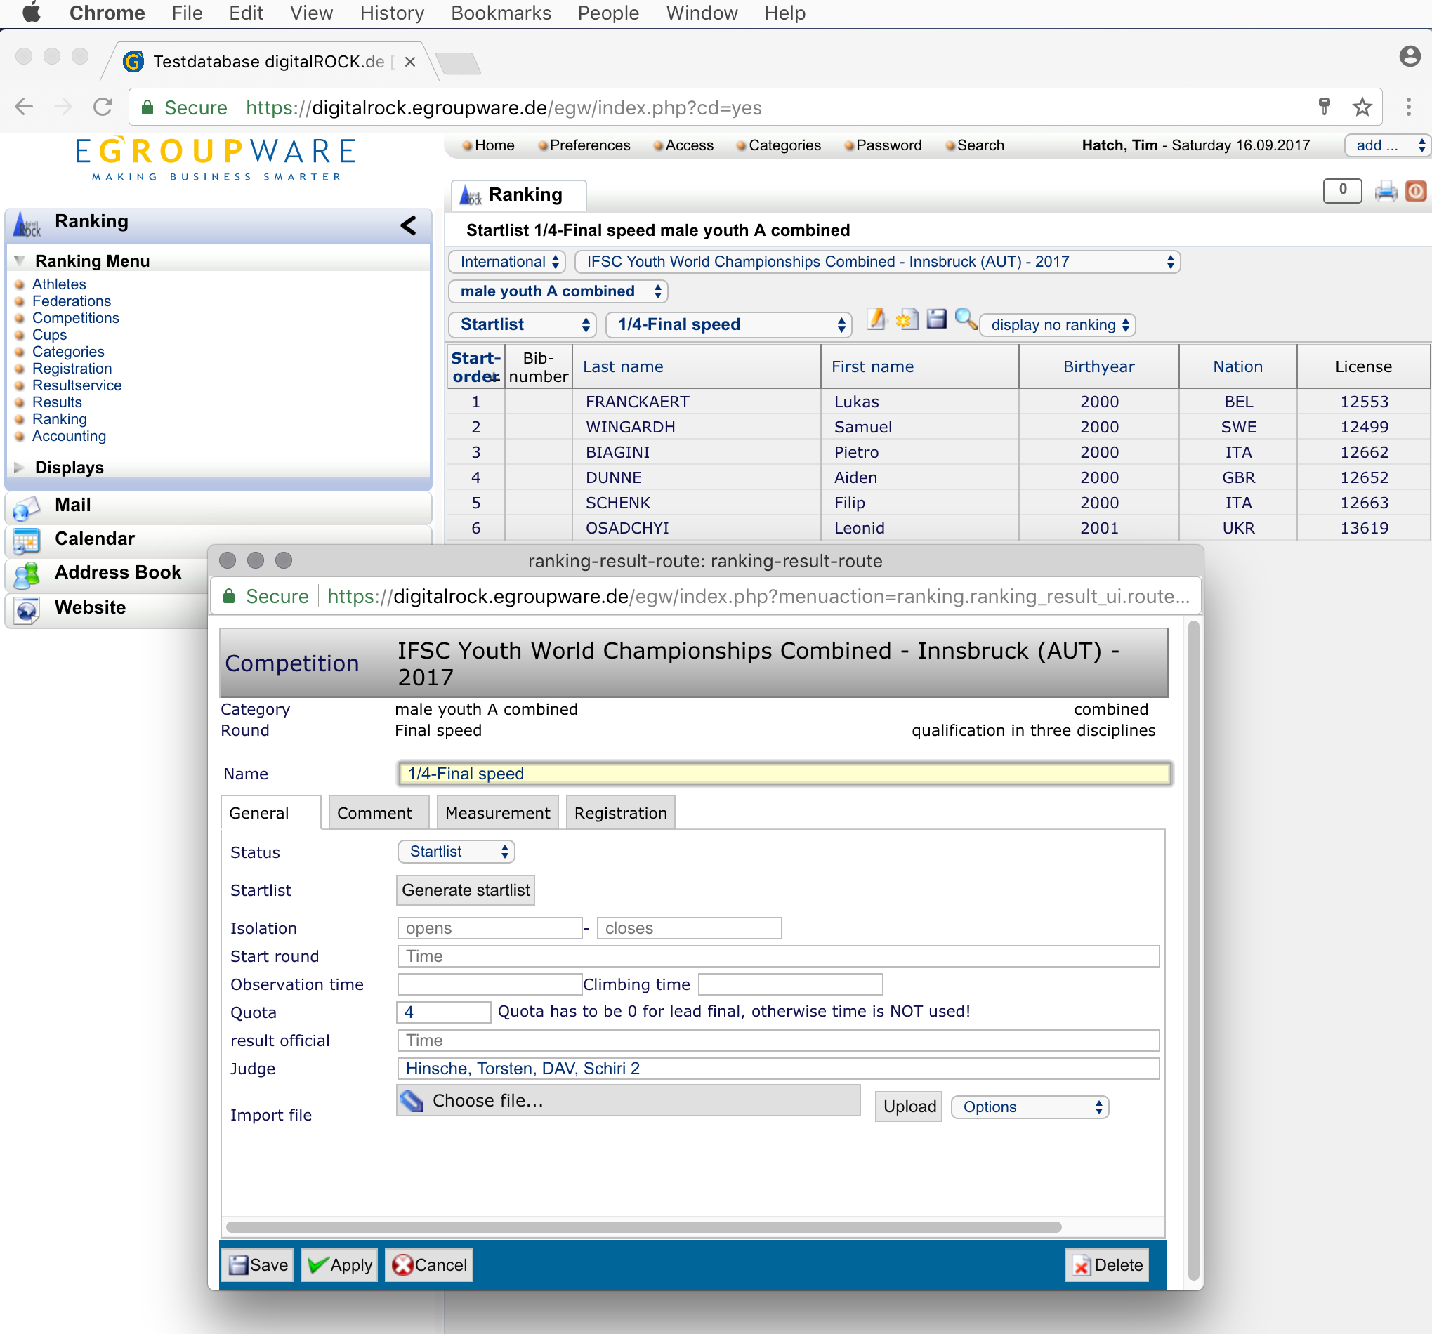
NOTE:
1)The Results Service represents racing pairs by start-order, i.e. Race 1 is between the climbers having start order #1 and #2, Race 2 is between the climbers having start order #3 and #4, etc.
2)The Results Service arranges pairs based on the Combined ranking from Qualification. The current version of the Rules arranges pairs based on the fastest times in Qualification (which follows the general principles for Speed and should result in the 2 fastest climbers being paired in the final). The Results Service pairing can be corrected by downloading a CSV file, editing and re-uploading.
3)The Results Service correctly implement the “Lucky Loser” protocol.

On completion of each stage of the Speed round, the Results Service presents a standard dialog for the creation of the next (Boulder) round.
NOTE:
1)The results for each stage of the Speed final must be made official in order to create the next.
2)There is no need to enter quota values.
3)A single final start list will be produced containing both “Small” and “Big” final pairings. This behaviour differs from that for the individual discipline where separate pairings are created.

On completion of each stage of the Boulder round, the Results Service presents a standard dialog for the creation of the next (Lead) round.

The implementation of the Combined discipline within the Results Service was written based on an unpublished draft of the rules. Further work will be required to update the Results Service to align with the current published rules. Some elements of the rules may not be implemented until confirmed as stable.

