Handout / Introduction

ICC Online Result-Service

This is a basic guideline for the Jury of ICC climbing competitions on how to operate the new Online Result-Service. This service was put in place to provide an instant and up to date result / ranking of a current competition on the ICC website. (And to reduce the amount of effort and time needed to put results into the website / database by passing emails / faxes around and typing single results in.)
You as a judge can use this Result-Service via any given internet connection. The standard should be a connection ‘on site’ at the competition, but it will work with your normal access as well - assuming that you have access rights to operate the system for that particular competition.
For the purpose of training and testing, you always have access to a competition format called ‘XYZ’ which we will use furthermore in this handout.

N.B.: For the time being, this system only works properly with Mozilla Firefox or
Internet Explorer 7.0. Please download and install this browser from
http://www.mozilla-europe.org/en/products/firefox/

First you login to your personalised IFSC website
http://www.ifsc-climbing.org/egroupware/login.php
(for the time being) by typing your username and password.
This leads you to the main page were you choose ‘Resultservice’ on the left Menu-Box.
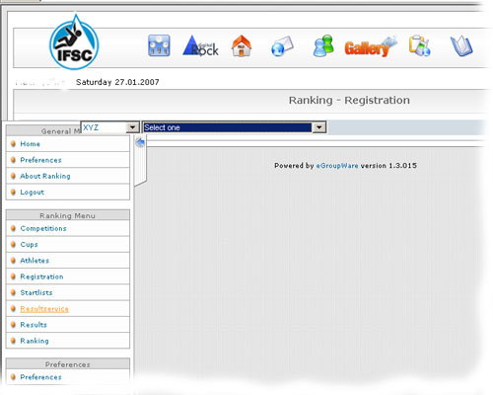

..

Now select your current competition:
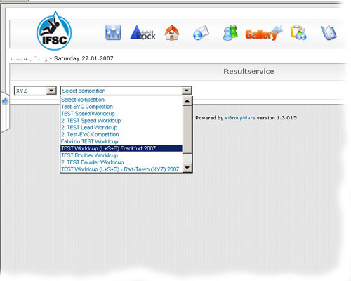

and then the category.
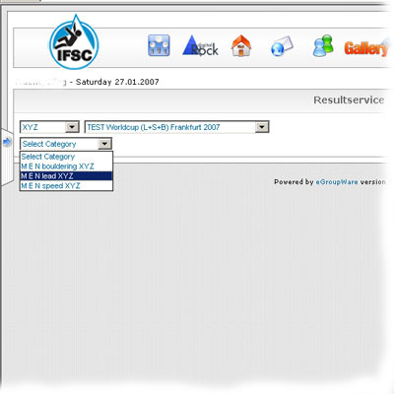

A screen like this is displayed:
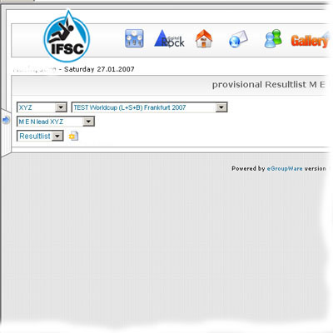

You must now create your first route for this competition (eg Qualification)

by clicking on the
‘Add new route’ icon

The window with the route data / information appears.
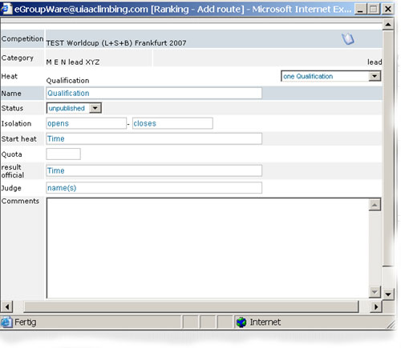
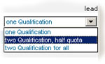
Now you can enter all necessary information for this route like
the name (maybe “¼-Final”),
times and judges’ names,
the quota for qualifiers,
the modus of this round like

The current status as e.g. startlist (to display it on the internet isfc-climbing.org)
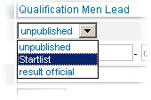

And later when the status is changed to ‘result official’ , the release-time.
When finished, you must click on the ‘Save’ button on the left bottom of the window.

The startlist is produced automatically from the registration of the climbers and according to the procedures in the rules (e.g. WR-reversed order, quotas on split-routes, randomisation of ex-aquos etc.). According to Wim Verhoeven, the startlist of the qulification gets created AFTER the isolation for the qualification is closed, not earlier! The new rules ensure athletes can estimate there start-place, by their position in the ranking. You can remove or register new athletes via the registration.

You’ll find the main window with the current startlist with all pre-registered athletes and the possibility to enter optional starting-numbers and delete competitors that have not shown up after isolation closed (if you generate the startlist before the isolation closed).
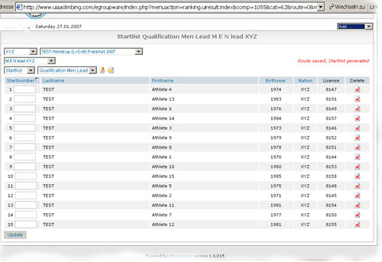
Make sure you click the ‘Update’ button
after the changes to save your data and have the list up to date on the internet (isfc-climbing.org).

Be careful with deleted climbers, they can only be re-entered via registration.

To start entering results, change the dropdownbox to ‘Resultlist’.
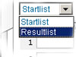
And find the startlist again (now called “resultlist”) with the possibility to
enter heights and supplements (+,-,top) – analog for speed and boulder
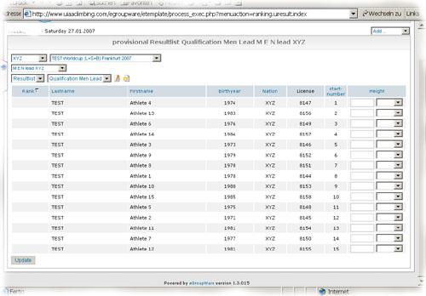

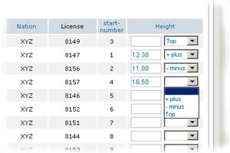

Make sure to save your entries with ‘Update’ .
You can enter the data during the heat and even see a provisional intermediate-results on the internet by updating directly after a competitor has finished her/his attempt.

For easier inserting the results you can switch the resultlist to be ordered by the startnumbers by clicking on the head of culomn startnumber.


After the heat/route is finished and all results are checked, you release the result as official in the route-window.Click on ‘Edit this route’
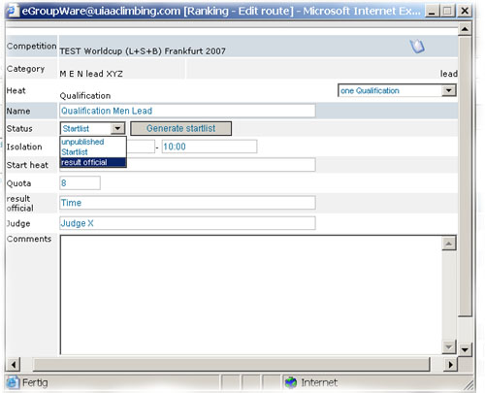
Then enter the release-time and set the status to ‘result official’ . Exit via the ‘Save’ button.

To make changes afterwards (e.g. in the case of a complaint), you must again edit this route and set the status back to ‘Startlist’. (click ‘Save’)
Then you can access the result via ‘Resultlist’ as shown above.

The changes must be updated and the result newly released.

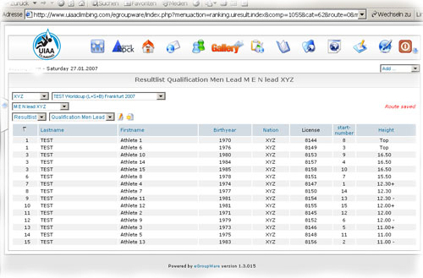
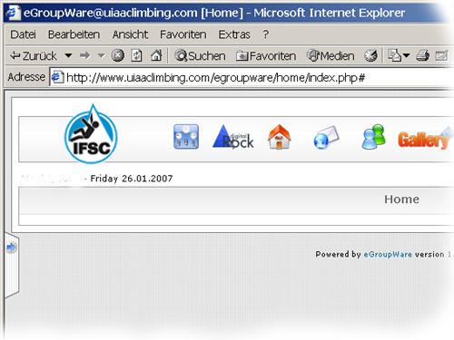

To print lists you simply use the printer function of your browser, but in an adjusted format (no browser –frames, just the plain list with the IFSC-Logo).
You can only print what you have selected in your window.
So if the dropdownbox is set to ‘Startlist’ the displayed startlist will be printed.
You can print provisional result-lists during the heat (with the printed remark ‘provisional’) and the official result after releasing it.

For all succeeding heats / routes you work in the similar way.
Click on ‘Add a new route’
and enter the necessary data. Depending on the settings of the previous heat and the kind of competition, there are some of the settings already done by default.
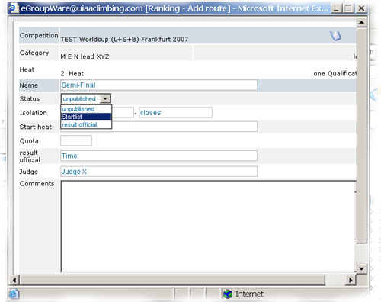

You set the status in the route-window to ‘Startlist’ and exit via ‘Save’.
The new start-list is created according to the quota of the previous heat and the applied rules.
Handle it as described above.
(Print, enter results, release officially etc)

Import the result into the ranking – creating national Team ranking
At the end of the competition (of this categorie) you need to go to the general result and click on ‘edit this route’
As soon as you switch the ‘status’ to ‘result official’ (you can also type in the time, when the general result is official) and click on the button ‘Apply’ (or ‘Save’ and afterwords ‘Edit this Route’) there will be a new button ‘import into ranking’
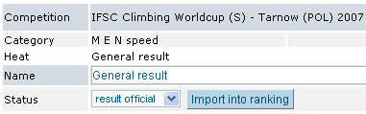
Click on this button and the general result of this categorie is import into the ranking. The national Teamranking will be calculated automaticly when the results of all categories are imported. You will find the national team ranking and can print it through the competitioncalendar
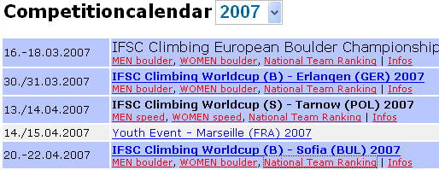
For example the national Teamranking of Sofia:
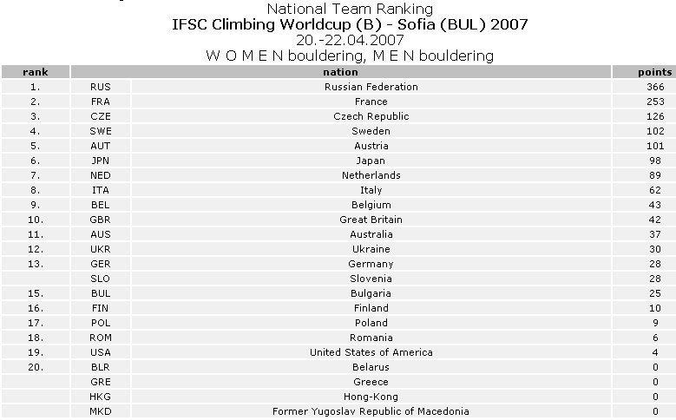

For competitions other than lead, the basic operation is the same.
It differs in some competition-related issues like the selection of the heats modus and the entering of the results.

Speed Competitions
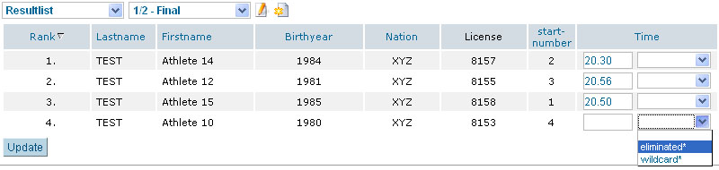
Entering the results will look like

If climbers climb more than one route, you have to enter the sum.
And a General result like
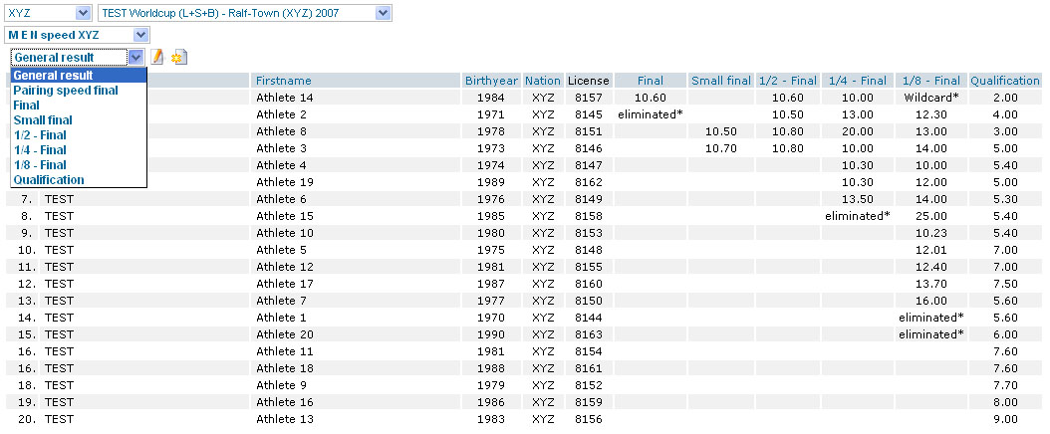

A K.O.-heat with pairings will look as follows in the result-list
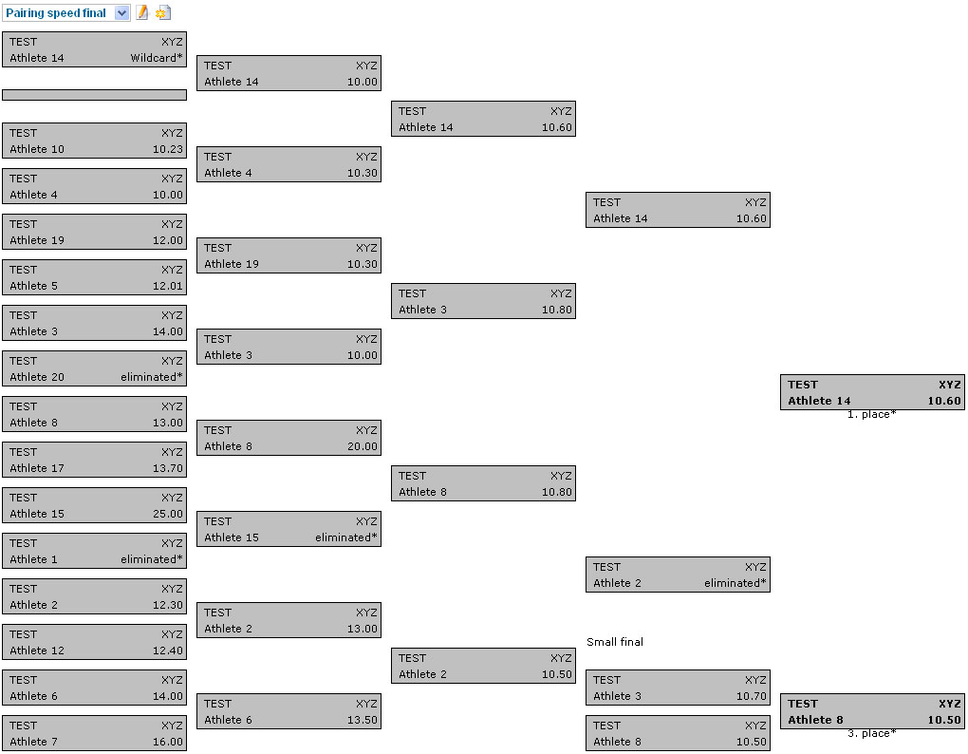

In a process similar to the Lead Competition, you will have to create the heats/routes via ‘Add new route’ (set quotas etc) and enter the results in ‘Resultlist’.
Then release the result (set the status of this route to ‘result official’) and create the succeeding heats/routes. At the end of the competition (or each categorie) set the general result to ‘result official’ and import the result into the ranking.
Bouldering Competitions
Make sure that you set the number of boulders right in the route-window.
(When you ‘Add a new route’ to create qualification and finals)
Entering the results will look like
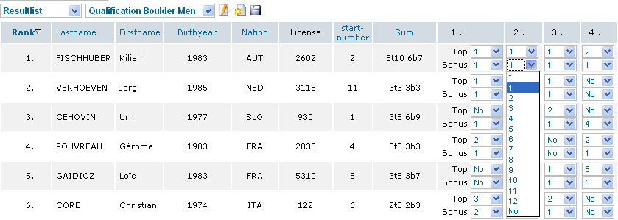
There is a column for each problem and two tick-boxes for each competitor.
The upper one is for the attempts to reach the Top,
the lower to reach the Bonus.
The sum of the competitors’ attempts will the be calculated automatically after clicking on the ‘Update’ button.
Make sure that you release the result (set the status of this route to ‘result official’) and create the succeeding heats/routes. At the end of the competition (or each categorie) set the general result to ‘result official’ and import the result into the ranking.

If you have problems with the internetconnection you can download each start- or resultlist as a csv-file (this can be imported and exported via Excel). Insert the results via Excel and Upload the result afterwords into the resultservice.
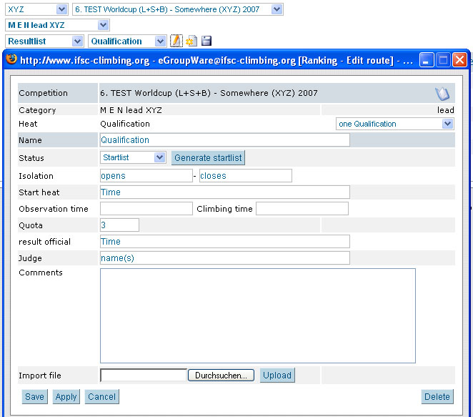
Download the list

If you want to import the resultlist afterwards into the resultservice you should not change any of the fields (e.g. name, id, …) besides the result and place of this heat!!!
The system will prove if everythings correct and let you import the result or tell’s you if somethings wrong with it.

In conclusion,
We would appreciate any feedback on the system.
You are cordially invited to test on http://www.ifsc-climbing.org/egroupware
as much as you can.

(Make sure you stay with the save XYZ setting and not mess up existing results ;-) )

If you have questions that cannot be answered by playing around
or getting some sense out of this quickreview,
or if you find a bug,
feel free to contact us at info@digitalrock.de .

If you have any problems during a competition in particular at the startup of the resultservice please contact us directly through our mobile phone:
Ralf Becker +49 (170) 7815917
Birgit Becker +49 (170) 3147833

