Kuka LBR iiwa – Usage guide

Setup
Up to three computers are needed to work with the robots:
- The “Robot PC”, running on Ubuntu 14.04, located within the table (screen is to the left of the table)
- The “Java PC”, running on Windows, located to the right of the table
- The “Simulink PC”, running on Ubuntu 18.04, located on the right in front of the table (setup can change)
Their passwords are listed at the end of the page.

The following image shows the wiring of the two KUKA Sunrise Cabinet controllers within the table.
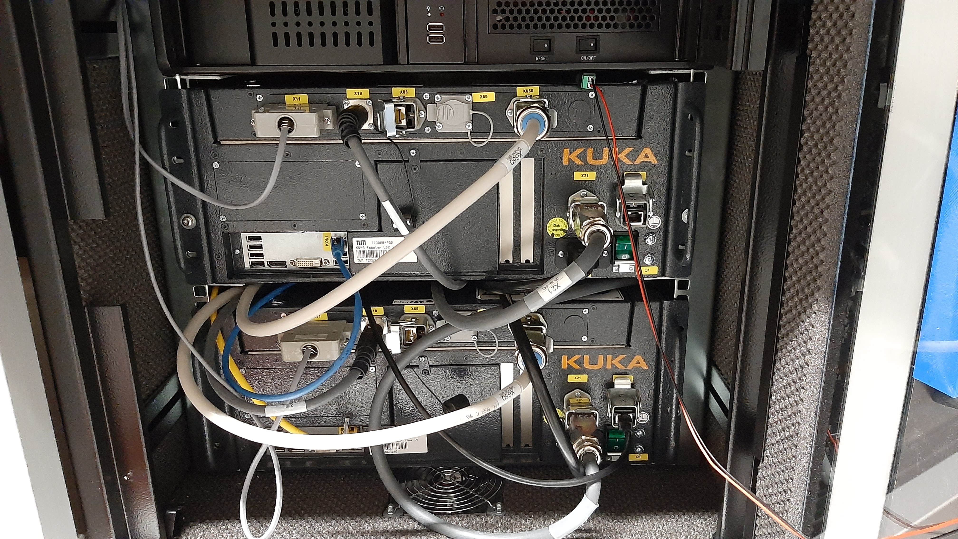
The upper box is connected to the left robot and the lower box is connected to the right robot. The cables have the following purposes:
- Thick dark gray cables: connection to the pads
- Thick light gray cables: connection to the robots
- Black LAN cable: connection to the Java PC (only one robot at a time)
- Blue LAN cable: connection to the Robot PC
Except from the black LAN cable, the cables usually don’t need to be reconnected.

First steps
Before starting to work with the robots, the following steps are always necessary:
- Open the transparent door
- Switch on the robots (green switches) and the Robot PC (on/off switch on top)
- Select Ubuntu 14.04 in the robot PC’s boot menu (must be done manually, not the default Operating System!)
- Take the master emergency stop from its socket. If you know what you are doing, release it.
Now, you can use the pads to control the robots.

TODO: images of the pads

How to use the pads
The pads are basically the interface to controlling the robots. They have to operation modes: manual and automatic. To select the desired mode, turn the key on top and select either manual (T1/T2) or automatic (AUT).
Start an application:
- Set operation mode to AUT
- Choose Application
- Press the green play-button
Manual movement:
- Set operation mode to T1/T2
- Press LBR_iiwa_14_R820 on the top of the screen
- Select Cartesian or Joint Position
- Change joint angles or pose in the world frame

The PCs
Robot-PC
This PC must be running to use the robots. When booting, its operating system must be changed manually to Ubuntu 14.04.

Simulink-PC
This PC can be used to upload Simulink models to the robots and interact with the robots in real-time, e.g. by changing parameters in the Simulink model.
The following steps are required to upload a Simulink model:
- Build the Simulink model
Ensure that the correct IP address of the Robot PC is set in Model Configuration Parameters → Code Generation → Interface → MEX-file arguments
- Connect to the Robot PC:
ssh murola@129.187.231.217
If that does not work, check if the IP address of the Robot PC matches the one above.
Once the ssh connection is established, step 2 does not have be performed again.
- In a new terminal: Copy the Simulink file to the Robot PC:
scp <file_name> murola@129.187.231.217:~/<desired_folder>
To run the uploaded model, do the following:
- On the pads: Start your application (the name is specified on the Java-PC)
- In the terminal where you connected to the robot PC: Start Simulink file
./file_name
- In Simulink: Click “Connect To Target”
- To stop the robots, press CTRL+C in the terminal where you started the Simulink file. Also make sure to press the emergency stop.

Java-PC
This PC can be used to upload new Java applications to the robots with the Sunrise Workbench IDE. Exemplary applications can be found in the already existing project folders. To compile the Java code, click “Synchronize project” on the top left of the screen.

In the StationSetup.cat file, make sure that the IP address matches that of the respective robot (left robot: 192.170.10.2, right robot: 192.170.10.3). Every time something is changed in the StationSetup, the controller must be reinstalled. Therefore, when working with both robots, it is recommended to use a separate project folder for each robot so that you don’t have to change the IP address every time you want to program the other robot.
Select “Deploy to controller” and click “Execute”

Keep in mind that you must replug the black LAN cable when changing the robot to which you upload an application (left robot: upper socket, right robot: lower socket)

Emergency stops
There are three emergency stops. Each pad has one on top that switches of the respective robot. Additionally, there is the yellow master emergency stop which can switch off both robots together.
If someone has to enter the robots’ workspace while they are running, it is imperative that another person outside the workspace holds the master emergency stop and is ready to press it if needed.

Passwords
- Robot PC: “argus”
- Java PC: “ifac”
- Simulink PC: “ncs”

FAQs
- Connection to one of the robots lost after some time, robot stopped moving, but pinging was still possible
→ restarting the respective robot solved the error
- Connecting from the Simulink PC to the Robot PC does not work
→ check the IP address of the Robot PC and enter the correct one when running ssh …
TODOs:
- Take photos of pads
- Look up Ubuntu version of Simulink PC
- Check workflow and terms on Java PC
- Check names written on PCs and add them



