Volcanic Rock Caves
by Stephan Kempe¹

¹Institute of Applied Geosciences, University of Technology Darmstadt, Schnittspahnstr. 9, D-64287 Darmstadt, Germany, Kempe@geo.tu-darmstadt.de
Abstract
Both primary and secondary caves occur in volcanic rocks. Secondary caves are either tectonic (fissure caves) or erosional (sea caves; erosional river caves). Primary caves include: tree and animal casts, hollow tumuli, drained lava tongues, pressure ridge caves, or empty vents, hundreds meter deep. The longest caves form by lateral subterraneous lava transport, termed “pyroducts” (Coan, 1844) (alias lava “tunnels” or “tubes”), integral features of pāhoehoe lava flows. They form by “inflation” at the active, downslope tip of flows or by crusting-over of channels. Internal lava falls cause their downward erosion. The longest lava cave is Kazumura Cave, Hawaii (trunk-length 41 km).
Keywords: Lava caves, pyroducts, primary caves, erosion, vulcanospeleology, pahoehoe, puka.
1. Introduction
Exploration of volcanic rock caves, termed vulcanospeleology by William R. Halliday, the Nestor of the field, did not receive much attention until the 1970’ies. Before, it remained a topic of local caving interest, e.g., in Australia, in the western US, on Tenerife, Sicily and Iceland, or a topic of ecologists looking at biological diversity. One of the reasons for this general lack of attention may have been the question of accessibility but even more so the term “lava tube” may have suggested “tubular caves” of little morphological variety and interest (“you have seen one, you have seen them all”). Even in volcanological textbooks, the important role of “lava tubes” for the lateral transport of lava and the shape and functioning of shield volcanoes has rarely been acknowledged. These textbooks would publish at most one picture of a “lava tube” (very often of Thurston Lava Tube, Hawaii), state that they form by “crusting over of channels” and then move on.
The beginning of lava cave research on Hawaii in the 1970’s and the consecutive acknowledgment of the enormous Hawaiian cave potential spurred activity there and world-wide, leading to the foundation of the Hawaii Speleological Survey in 1989 during the International Congress of Speleology in Budapest, Hungary and the International Commission of Vulcanospeleology in the UIS in 1993. Furthermore, the Vulcanospeleological Symposia, initiated by W.R. Halliday in 1972 (Halliday, 1976) and held every other year (#14th in Australia, August 2010) is attracting many speleologists and other scientists. The proceedings of these symposia form the largest body of professional papers available in this field. They are now accessible at http://www.vulcanospeleology.org/symposia.html. At the International Congresses of Speleology lava cave symposia are also held; the papers of the latest one in Kerrville, Texas, August 2009, are available at http://kong.lib.usf.edu:8881///exlibris/dtl/d3_1/apache_media/222325.pdf. Other sources are the Newsletters of the Hawaii Speleological Survey and the Hawaiian Grotto of the National Speleological Society. US-centered terminology of vulcanospeleology was summarized by Larson & Larson (1993).
In general lava caves, or better caves in lava, can be formed by many different processes. Most of them are primary caves, but secondary caves occur as well. Kant (or one of the editors of his work in 1803) was probably the first to differentiate between primary and secondary caves, albeit on the basis of quite abstruse surmises.
2. Secondary Volcanic Rock Caves
Secondary caves in volcanic rocks, i.e. created long after the lava was deposited, form tectonically, by collapse or by erosion.
Tectonic caves are still poorly documented. Along the “Great Crack”, the SW Rift zone of the Kilauea, several essentially tectonic fissure caves have been explored, including Pit H (183 m deep) and the Wood Valley Pit Crater (90 m deep).
Pit craters form by cold collapse of the roof of small sections of a magma chamber (collapse of the entire roof of a magma chamber leads to the formation of large-scale depressions, called calderas). One recent example is Devil’s Hole on the Island of Hawaii (Hawaii National Park, Chain of Craters Road), that started as a small hole in the ground leading into a conical chamber about 50m deep. Further collapse of ceiling and walls led to an open pit over the course of a few decades. Many other older pits occur in the vicinity. Pit craters have recently obtained more attention because they may be the first cave-like objects detected on Mars. Collapse of hypogene karst caves and the consecutive stooping upward of the cavity can also result in lava caves. An example is the Basalthöhle near Ortenberg, Germany, a chamber in columnar basalts that was intercepted by quarrying for basalt.
Erosional caves in lava may either be formed by waves along coasts or by running water. Wave-cut caves in volcanic rocks are quite common and may be of substantial size. The most famous is Fingal’s Cave of the Island of Staffa, Scotland. Some of the most spectacular examples occur along the cliffs of the Hawaiian Islands specifically on the Na-Pali Coast of Kauai. Sometimes basaltic dykes are eroded by waves leading to long and narrow, fissure-like sea caves such as the > 40 m Sorte Gryde on Bornholm, Denmark. Quite common are also small caves that are produced by the lateral erosion along river valleys that cut down into stacked series of lava flows. The flowing water can then preferentially remove loose a‘a rubble from underneath the solid cores of the a‘a flows that serve as cave roofs. For example, such caves occur along the sides of Wadi Rajil in Jordan near the famous Bronze Age city of Jawa. Water entering primary lava caves can cause internal water erosion such as documented for the Pa‘auhau Civil Defense Cave on Mauna Kea, Hawaii (Kempe et al., 2003). In this cave, several spectacular waterfalls eroded the bottom of the cave, polishing the rocks and gravel, to a surprising extent. It is difficult to understand how water can erode a cave in lava without following an existing lava cave, such as the kilometer-long and 100 m deep Kuka‘iau Cave (Kempe & Werner, 2003) that is formed in a series of pāhoehoe flows and diamict layers in weathered Mauna Kea lavas. It not only pirates the tributaries of a parallel valley but it also forms a series of sumps and chutes where the water moves upward, similar to karstic caves under phreathic conditions. At flood, this cave transports large amounts of water, gravel, rounded blocks and trees and may pond up to 60 m above its sump.
3. Primary Volcanic Rock Caves of Large Extent (Pyroducts)
Tunnels formed by the lateral transport of lava through interior conduits of pāhoehoe lava flows comprise the most important group of primary caves world-wide. Within the tunnel, heat is lost only conductively while surface lava looses heat convectively at the upper and conductively at the lower interface. Tunnel transport is thus the reason why basaltic shield volcanoes have low flank-slopes, often <2° (compare Table 1) and why multiple eruptions can form extensive intracontinental lava plateaus. What appears later on the geological map as an individual “pāhoehoe flow” actually is a low ridge that grew only at the downhill end being supplied by the internal duct that in most cases is not visible to the outside. In fact one can walk across an active tunnel without even noticing it. A‘a flows on the other hand move like glaciers, gliding down-hill with their entire mass, moving like a caterpillar on a bed of rubble that falls down at the front and is overridden. On Hawaii a‘a flows do not develop tunnels.
The first to describe a lava tunnel having inspected it himself was probably Eggert Olafsen (1774-75, § 358, p.130) who visited Iceland 1752 to 1757. He wrote about Surtshellir “….the running lava flowed through this channel like a river…”. Uno von Troil (1779; p. 225) who visited Iceland with Joseph Banks and Daniel Solander in 1772 wrote: “The upper crust sometimes cools and solidifies, even though the molten matter keeps running underneath; in this way large caves form, the walls, floors and ceiling of which are composed of lava and where a lot of dripstones of lava occur” (transl. from German by author). The first to report having seen an active tunnel was Coan (1844) who in 1843 scaled Mauna Loa: “But we soon had ocular demonstration of what was the state beneath us; for in passing along we came to an opening in the superincumbent stratum, of twenty yards long and ten wide, through which we looked, and at the depth of fifty feet, we saw a vast tunnel or subterranean canal, lined with smooth ‘vitrified matter, and forming the channel of a river of fire, which swept down the steep side of the mountain with amazing velocity. The sight of this covered aquaduct – or, if I may be allowed to coin a word, this pyroduct – tiled with mineral fusion, and flowing under our feet at the rate of twenty miles an hour, was truly startling.” Even though Coan used the more general term “tunnel” to start with, he coined a new one: “pyroduct”. This highly specific term should take precedence over younger terms describing the same phenomena. Early geologists like James Dana continued to use “tunnel”; J.W. Powell introduced “volcanic pipes” and Tom Jaggar used “tunnel” as well as “tube”; only after 1940 the term “lava tube” became standard (Lockwood, 2010). For reason of scientific priority, the term pyroduct should be used. Avoiding the word “tube” is also advisable, because it has invoked the picture of pipes in which lava can flow up and down under pressure like in plumbing and it implies a circular cross-section that is only rarely found.
The discovery of extensive lava flows on Venus, Mars and the Moon and even active volcanoes on Io has increased the interest in pyroducts in the last few decades. On Earth the longest surveyed lava tunnel is Kazumura Cave (main trunk length 41 km) (Hawai‘i, Kilauea Volcano) (Allred et al., 1997) and the longest Quaternary pyroduct-fed flow on Earth is that of Undara/Australia (Atkinson & Atkinson, 1995). The author’s group explored and surveyed many other caves on Hawai‘i (e.g., Kempe, 2002) and in Jordan that give opportunity to study formation and evolution of pyroducts from the inside. Many other areas are under investigation as well: The islands of Galapagos, Rapanui, Jeju, Mauritius, Comores, Sicily, Iceland, Canaries, Azores, and in the intracontinental lava fields of Syria, Saudi Arabia, East Africa, Western US, Mexico and Andes. Petrographically, almost all pyroducts documented (yet) occur in tholeiitic and alkali basalts, only the caves in the Mt Susua, Kenya, formed in phonolites (pers. com. C. Wood).
Formation of pyroducts: Even though in many text books they are described as having formed by “crusting over of channels” (e.g., Francis, 1993), there is a totally different mechanism by which lava tunnels can form, and that is by “inflation” (Hon et al., 1994). It is an incremental process starting at the distal tips of pāhoehoe flows where hot lava rapidly covers the ground in a thin sheet. This sheet cools quickly, causing the dissolved gases to form vesicles that diminish the overall density of the lava. This sheet will float on top of the next pulse of advancing melt (the lava flow is “inflated” from below because of buoyancy) before forming the next distal surface sheet. Multiple advances can occur, forming a primary roof composed of several sheets, separated by sheer interfaces (only the first or top sheet will display the subaerially formed typical ropy pāhoehoe structure) (Fig. 1). The “oldest” lava sheet is therefore on top of the stack, contradicting normal stratigraphic rules. Below the primary roof the lava can stay hot and can keep flowing. This is the initial conduit. Inflation caves are characterized by roofs build of one or several, sometimes more than ten continuous sheets of lava. This roof structure can be studied at roof collapses, called “pukas” in Hawai‘i. Many of the long Hawai‘ian caves are inflationary in origin (Kazumura, Keala, Huehue, Ainahou, Keauhou Trail; just to name a few). However, the “crusting-over” of channels can also lead to long caves. Inspection of cross-sections of the roof of the second longest cave on Hawaii, the Kipuka Kanohina System (37 km of interconnected passages), has shown that it consists of welded, irregular fragments of pāhoehoe plates, stabilized by inserted lava fingers (“squeeze balls”) and a 10 to 50 cm thick lining welding the roof from below. Such structure suggests that the roof is formed by agglomeration of floating lithoclasts that are wedged into each other similar to a log-jam on a river. Sometimes roofing-over may also occur by accretion of vertical to sub-vertical thin lava layers growing from the sides inward and having a central vertical parting where the growing lateral shelves meet. The levees of open-surfaced lava channels grow by overbank events of thin lava sheets or by stranded lava floats. Sometimes large sections of the bank break loose and float downstream. These can then jam and form short roofs that are stabilized by spatter. Examples have been documented for the channels of the Puhia Pele eruption of 1801 on the Hualalai.
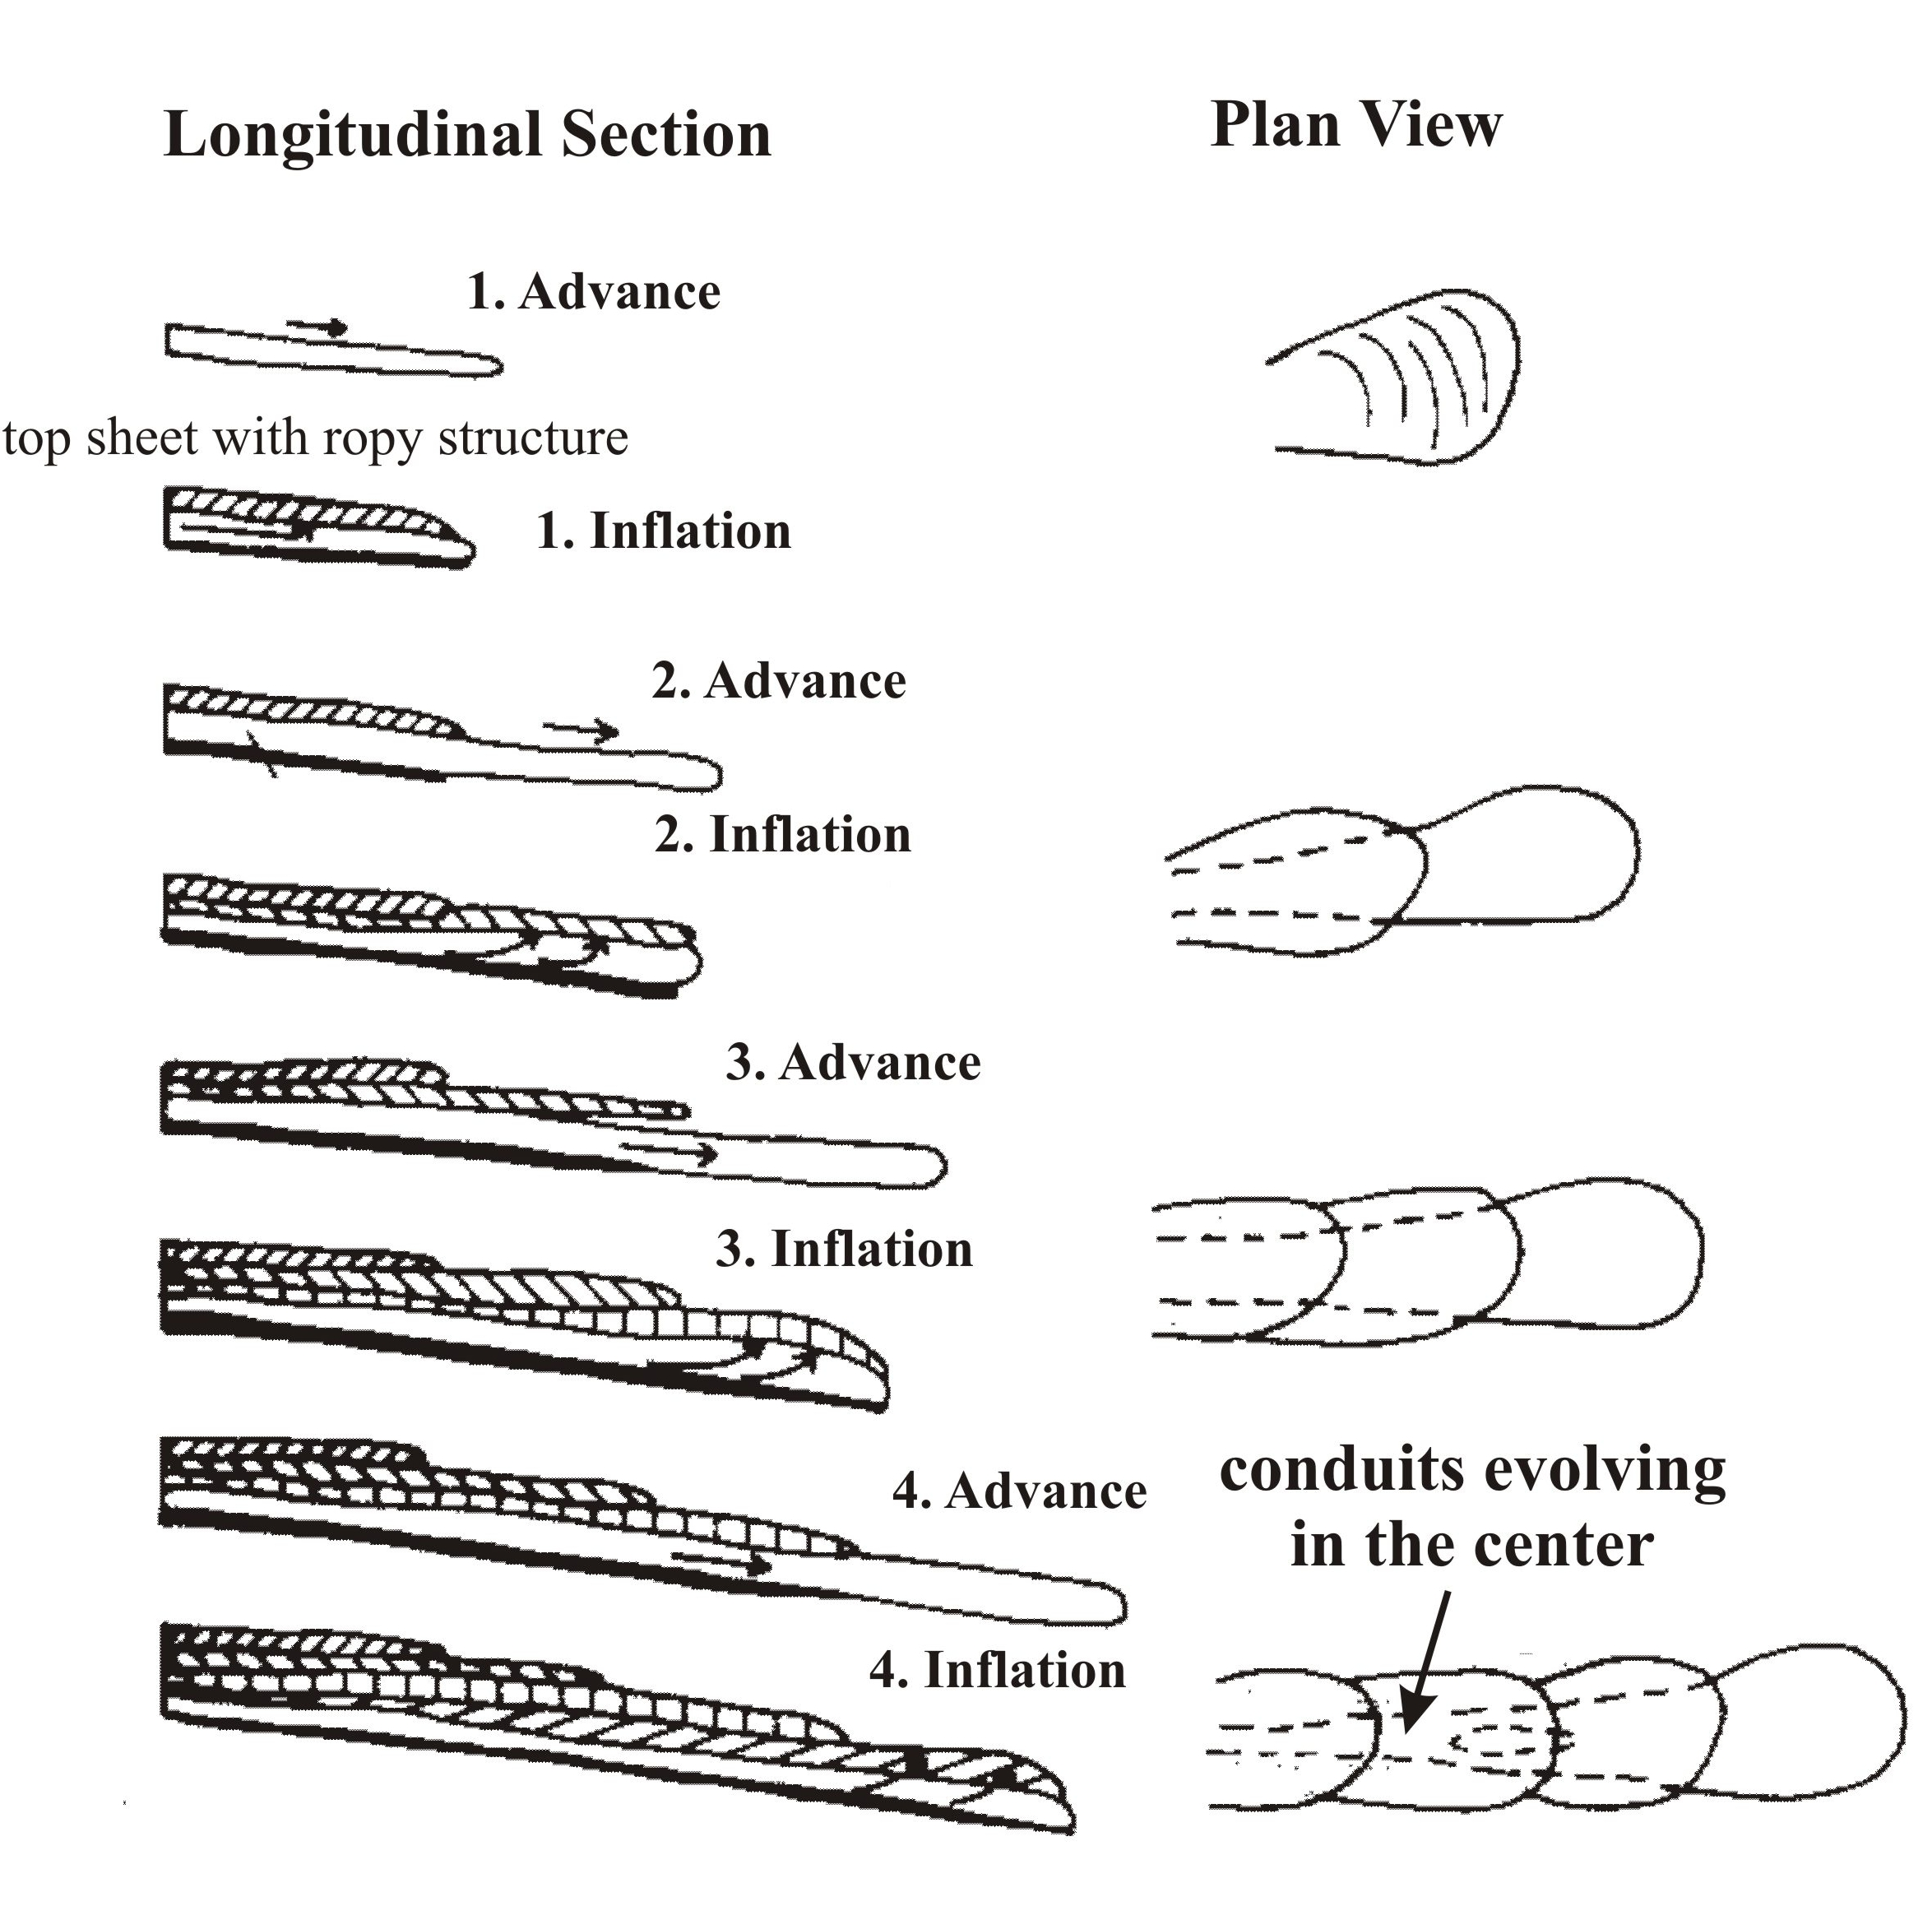

Fig. 1: Sketch illustrating pyroduct (lava tunnel) formation. At the tip of a pāhoehoe flow lava advances quickly in form of a delta of thin, ropy lava. The next pulse of lava lifts the first sheet up (inflation). This process is repeated until a stack of lava sheets (the primary roof) is formed, below which the hottest flow thread becomes the later main conduit.
Internal development: If the area to be covered by the first advance is rather flat, many small, parallel conduits can develop (Fig. 2). Each of them can start to erode down soon after. One of the threads will, however, erode fastest and attract most of the lava. This passage will then drain the other parallel ducts, one by one, often leaving them as small-scale labyrinths high above the final floor. Since these mazes are drained when they are still very hot, their floors are mostly smoother than that of the later main tunnel where the terminal flow can convert to a‘a rubble.
As the erosion continues, the lava flows with an open surface in a self-generated underground canyon cut into older rocks, not associated with the current eruption. This fact can be studied at places, where the thin lining of the side walls has fallen away (e.g., Greeley et al., 1998; Kempe, 2002). Often we find a‘a blocks behind the lining or even ash horizons, both clearly not integral parts of pāhoehoe flows. Downcutting is facilitated by a variety of processes; one of the more spectacular is backcutting of lavafalls (e.g. Allred & Allred, 1997) (Fig. 3). These are quite common in long Hawai‘ian caves, but none were yet found in Jordan. The falling lava acts like a sledge hammer, forcing loose rocks from the floor. These are less dense than the lava itself and float up and are transported on the surface of the river. Thus, other than in a water river, the bed is not protected by bedload and therefore prone to continued erosion. The mobilized blocks are cold and receive a coating of lava forming lavaballs. Some of the lavafalls seem to be stationary forming large plunge-pools and chambers (Allred & Allred, 1997). Due to these erosive mechanisms the cave grows in depth and width in an uphill direction. The passage above the lava falls is quite small in contrast. As one proceeds uphill, the canyon will become larger and larger until one enters the next plunge pool chamber. It is not quite understood how much mechanical erosion and how much melting of the river bed occurs (e.g. Greeley et al., 1998; and citations in Kempe, 2002). Other enlarging processes may occur, such as small phreathic explosions, blowing out sections of the wall or floor as intersected groundwater is vaporized.
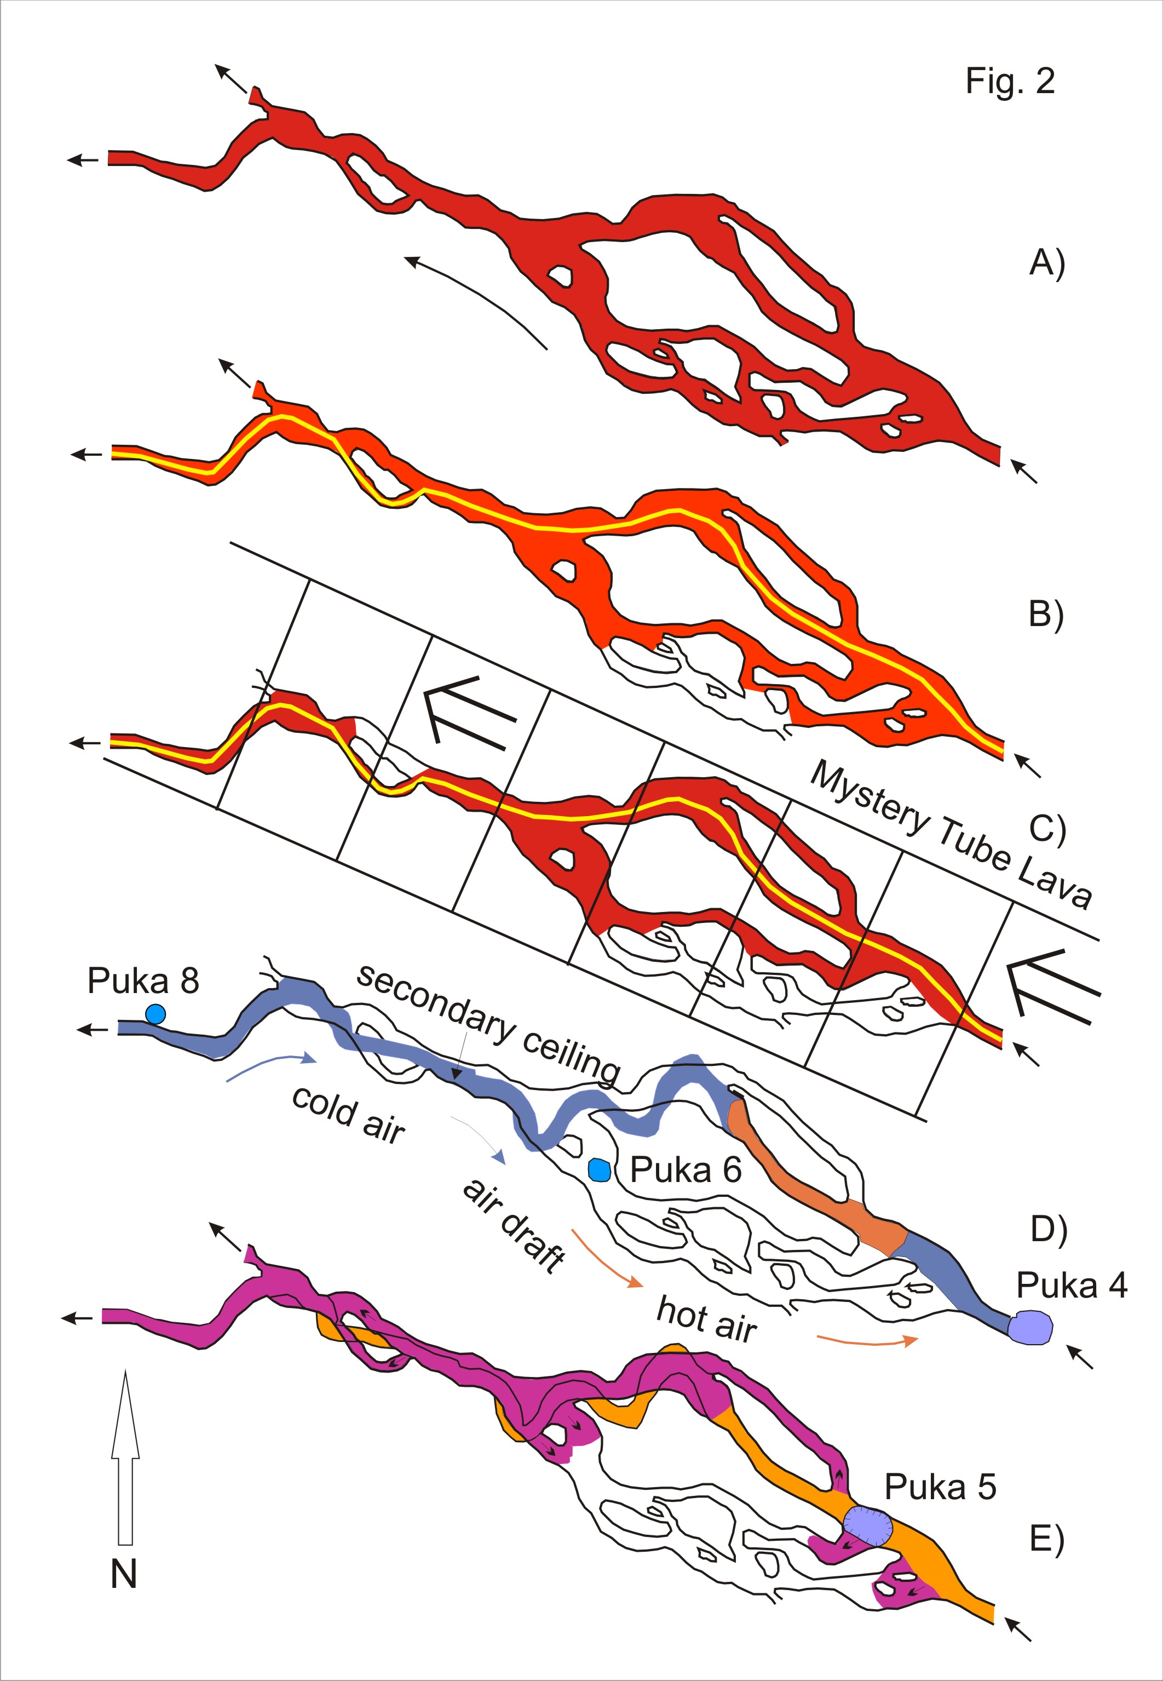

Fig. 2: Detail of the ground plan of the Huehue Cave illustrating how a primary maze of parallel lava threads (A) was drained until the master trunk that cut down fastest remained (E). (A) Initial pattern of lava tunnels, flow was from right to left in up to five parallel conduits. (B) The southern-most conduits were drained first. (C) Further downcutting reduced the number of active conduits to three. At the same time, lava from a parallel flow (Mystery flow) covered the area. (D) Only one tunnel remained (following the thick line in B and C), its bed 2 m below the original surface. The added overburden caused collapse of pukas (labeled 8, 6 and 4) the breakdown of which was removed by the lava river. Now external air began flowing uphill from Puka 8 to 4. As a consequence, a secondary ceiling froze out up- and downhill of Puka 8. (E) Various spill-events reinforced the secondary roof, even spilling into the already drained upper conduits, closing the northern-most one. These spilled lavas were oxidized by the passing surface air and attained various shades of red caused by the crystallization of very fine-grained hematite. The last event was the collapse of Puka 5 while the tube cooled. Its material is still in place.
As the downcutting continues the lava river meanders, undermining walls and destabilizing the roof. Breakdown falling into the flowing lava is also carried away. If the primary ceiling collapses entirely, a skylight or “puka” opens up. If the flow is still active, the rubble can be carried away and we speak of a “hot puka”. If the collapse occurs after the flow terminated, breakdown will remain, sometimes giving easy access to the cave below, sometimes sealing it completely; this is termed a “cold puka”. Through a “hot puka” gases can escape from the tunnel triggering convective cooling. Heat loss is specifically efficient if two pukas open up: cold air will be drawn into the lower one and hot gases will escape from the upper one, freezing out a “secondary ceiling” above the flowing lava in the canyon in between the pukas splitting the passage into two levels on top of each other (Fig. 3). This process can be repeated, forming even more internal ceilings. Later spills from below through breakdown holes or from upstream can reinforce these ceilings. In Ke‘ala Cave, Hawai‘i, one section of secondary ceiling is over 1 km long. Very often the upstream end of the secondary ceiling is sealed. This is caused by lavaballs floating on the lava river that are too buoyant to be dragged below the secondary ceiling. Instead they strand on the upper edge of the secondary ceiling. The accumulated blocks are then welded together by splashed-up lava. Floating blocks can be very large, in Waipouli Makai Cave there is a block about 12 m wide, 8 m long and 5 m thick welded into the ceiling of the cave. The cold, oxygen containing external air that is drawn into the cave can oxidize lava surfaces that are still hot. The iron, contained in the volcanic glass, is oxidized to fine-grained hematite, tinting the surfaces of secondary ceilings in various hues of red. If steam is present also goethite or limonite can be formed, introducing ocher or yellow colors.
Fig. 3: Longitudinal section of an evolving lava tunnel. Top: Erosional enlargement of the underground canyon by backcutting lavafalls. Bottom: Upon static failure and partial collapse of the primary roof a skylight (puka) opens up, allowing cold air to enter the tunnel, freezing an internal secondary roof below which erosional enlargement can continue. Spills from uphill or through holes reinforce the secondary roof.
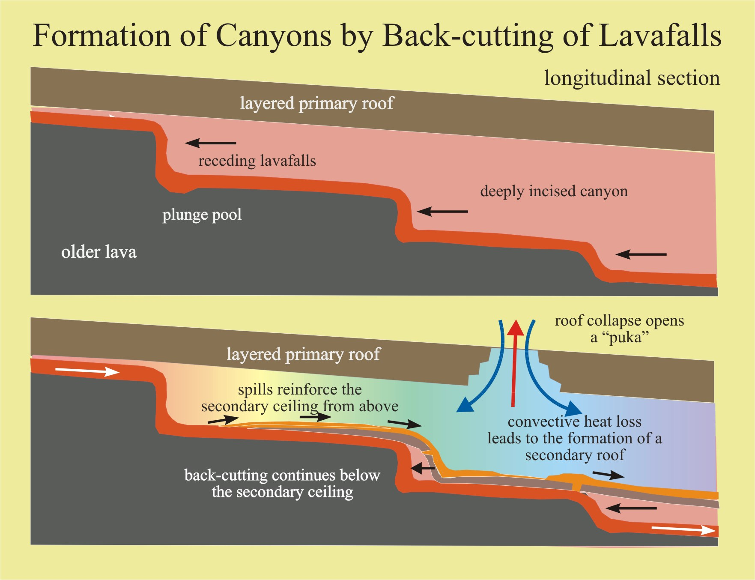
Hot pukas can also serve as temporary rootless vents when the tunnel below is obstructed or even closed entirely. Lava erupting from these pukas can form rapidly cooling, thin, ropy pāhoehoe, re-inforcing the primary roofs from above. The “Puka 17 Flow” out of the lower part of the Huehue tunnel (Fig. 4) is an example. Pukas, cold or hot, can also serve as entrances for lava of later flows, such as at the upper and lower ends of Ke‘ala Cave that are plugged by later invasive lava.
Table 1: Comparison of some morphological indices of some of the Hawai‘ian lava tunnels (for sources of data see Kempe, 2002). (K, A: Kilauea, Ai-la‘au; H, HH Hualālai, Huehue flow of 1801; MK: Mauna Kea; ML Mauna Loa).
Cave | Total length, km | Main trunk length, km | End-to-end bee-line, km | Sinuosity | Vertical distance m | Slope | Volcano
Kazumura Cave | 65.50 | 41.86 | 32.1 | 1.30 | 1101.8 | 1.51° | K, A
Ke‘ala Cave | 8.60 | 7.07 | 5.59 | 1.25 | 186 | 1.51° | K, A
J. Martin/Pukalani System | 6.26 |  |  |  |  |  | K, A
Epperson`s Cave | 1.93 | 1.13 | 0.80 | 1.41 | - | - | K, A
Thurston Lava Tube | 0.490 | 0.490 | 432 | 1.13 | 20.1 | 2.4° | K, A
Ainahou Ranch System | 7.11 | 4.82* | 4.27 | 1.13 | 323 | 3.83° | K, A?
Ke‘auhou Trail System | 3.00 | 2.27 | 1.99 | 1.13 | 213.3 | 5.36° | K, A?
Charcoal System | 1.5 |  | 1.4 |  | 60 | 2.6° | K
Earthquake System | 0.34 |  |  |  | 33 | 4.7° | K
Huehue Tube | 10.8 | 6.17 | 5.13 | 1.2 | 494.6 | 4.58° | H, HH
Clague’s Cave** | 2.73 | 1.39 | 1.18 | 1.15 | 157.1 | 6.49° | H, HH)
Pa‘auhau Civil Defense C. | 1.00 | 0.58 | 0.50 | 1.14 | 49 | 4.87 | MK
Whitney’s Cave | 0.651 | 0.509 | 0.438 | 1.15 | 17.3 | 1.97 | ML
Manjang Gul, Jeju, Korea |  | 4.304 | 3.197 | 1.32 | 32.4 | 0.4 | Jeju
*horizontal; ** upper part of Huehue
All these processes act to form caves of complex patterns, morphologically not representing “tubes” at all. Also the total length of the caves is usually much larger than the simple distance along the main tunnel. Table 1 gives some basic morphometric data, such as sinuosity and slope for some pyroducts.
Fig. 4: Geological map of the Huehue flow (Hualalai Volcano, Hawai‘i) of 1801 according to surveys of the author’s group. Flow was from right to left, vertical distance 500 m. Oldest are the lavas (blue) of the Puhia Pele vent (a series of spectacular spatter cones) that was gas-rich and formed an open channel system (with a few roofed-over sections). After its termination the Huehue flow erupted (numbers label pukas on the Huehue Cave, thick line; lava light yellow-green at left and at Puka 1) accompanied by the Mystery Shield eruption that was active for only a short time (upper right) and covered much of the upper part of the Huehue flow (brown). Zoe’s Puka is a tunnel belonging to the Mystery flow. From Puka 17 a surface flow issued (light green) and the terminal lava from the mystery shield formed several short a‘a flows (dark red-brown at the right).
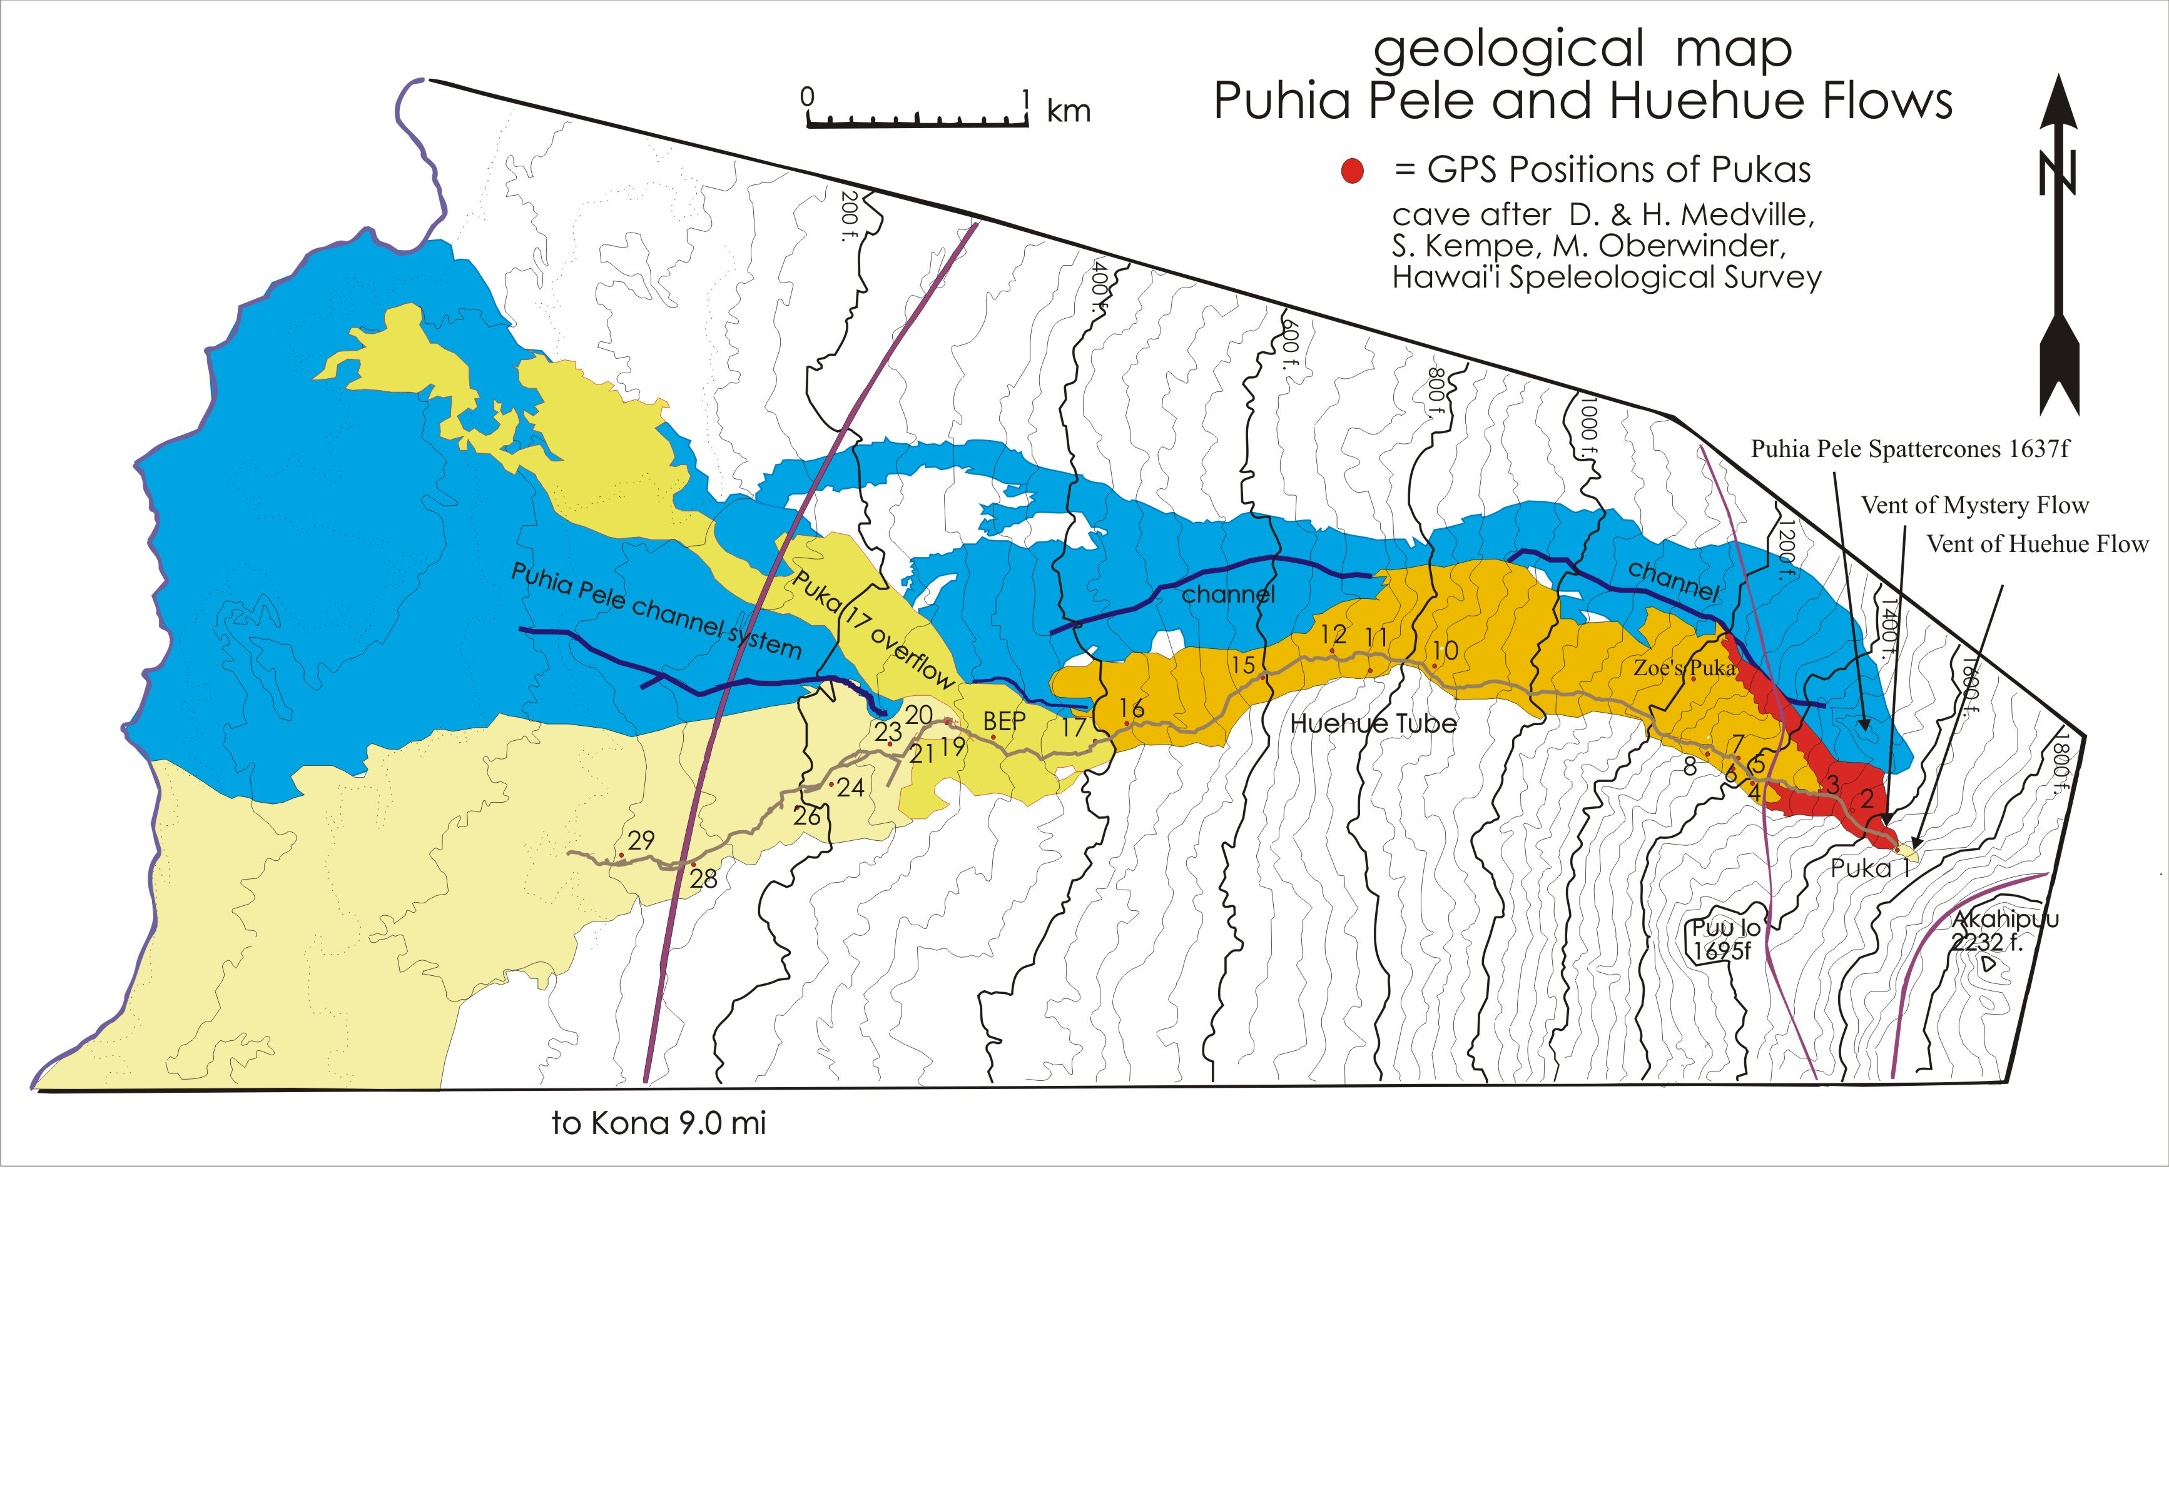
General types of pyroducts: Overall, we can differentiate several general types of lava tunnels. These are: a) single-trunked systems, b) double (or multiple)-trunked systems and c) superimposed-trunked systems
Most of the lava tunnels yet documented in enough detail appear to belong to the single-trunked category. They are fed by one eruption vent and the meso-morphological internal structure can be explained by the processes discussed above. The tunnel size depends on the lava discharge rate and on the length of activity (days, weeks, months and possibly even years), i.e., on the time available for erosion. If the eruption stops or the cave collapses or is blocked, the pyroduct will cool. The next or even - in case of a blocked tunnel - the same eruption will then create a new pyroduct. Normally, it will be situated to either side of the previous flow because that now forms a topographic ridge (flow lobe). Typical examples of single-trunked systems are Kazumura, Ainahou Ranch, Ke‘ala and others of the long Hawai‘ian caves. If lava from the new tunnel should spill through a puka, or break (because of its overburden) into any older, underlying tunnel, then the older tunnel will be filled by lava cooling in the same pattern as at the surface.
Double-trunked systems are comprised of two lava tunnels, active side by side at the same time and fed by two separate eruption points. Such tunnels can interact and cause more complex morphologies than described above. One example is the interaction between the Huehue Flow and the secondary Mystery Flow (Fig. 4; Kempe, 2002). The Huehue flow established its tunnel first, then a second vent (the very inconspicuous, low “Mystery Shield”) erupted lava, forming a small tunnel in parallel. Part of the Mystery lava quickly cooled forming a‘a flows. These superseded the upper part of the Huehue tunnel. Once thick enough, the primary, sheeted roof of Huehue collapsed and left a roof composed of Mystery a‘a lava. The resulting breakdown was removed with the active Huehue lava river. Due to the large, hall-like cavity that formed, a secondary roof froze out over the active flow of Huehue. Later rockfall covering the newly formed “false floor” gives the upper passage the appearance as if the tunnel was formed in a‘a, an impossibility near to a vent issuing very hot basaltic lava.
The least understood and documented category is the superimposed-trunked system. It is defined as a set of lava tunnels superimposing and crossing each other, all being active at the same time. The upper tunnels stop their activity first, so that the lower ones carry on for some time before they also stop operating and become evacuated. There may even be connecting openings between the levels exchanging lava between cross-overs. In such systems at least the lower ducts must have been filled to the ceiling until very late in their development. Such systems could arise when a volcanic vent increases its output volume during an ongoing eruption. Then the already established pyroducts cannot accommodate the increased flow volume and a new level of independently operating tunnels is build on top of the already active ones. The Kipuka Kanohina System on Hawai‘i (Coons, 2009) is the largest example of such a superimposed-trunked system. Sistima Tlacotenco (16 km long), a segmented system of superimposed passages most probably also belongs to this category of conduits.
4. Primary Volcanic Rock Caves of Limited Extent
Primary volcanic rock caves also occur in many different types: Hollow imprints of trees and animals, partings along the central plane of lava sheets, hollow tumuli, drained lava tongues, pressure ridge cavities, volcanic vents and there may be more to be discovered.
Imprints: One of the most astounding caves in any respect is the hollow imprint of a diceratherium in Miocene pillow lavas (Rhino Cave, US Quadrangle Park Lake, Grant Country, Washington, pers. com. C. Holler). Not only is it extremely rare that an animal gets encased in lava, even more unlikely is the fact that the cave is just now opened by erosion, so that it can be entered through ”the rear”. Imprints of trees are, compared to that of animals, more common. A Mikado-like jumble of trees was encased in lava of Mount St. Helens and is now publicly accessible to the joy of kids that can easily crawl through the hollow imprints from one tree to the other. A large, accessible tree trunk is also encountered in Pa‘auhau Civil Defense Cave on Mauna Kea, Hawaii (Kempe et al., 2003). Often tree trunks are still standing, encased with lava that cooled around. When the lava flow is subsiding around them they may be left standing, such as in “Lava Tree State Park”, Hawaii, including an accessible pit-like imprint of the former tree.
Partings: In the process of cooling, gas exsolves from the lava, forming small vesicles. The more time is available, the larger they become. Cooling is fastest from the surface downward and slower from the bottom of the sheet upward: therefore the largest vesicles are mostly found in the lower third of the sheet. Sometimes they become dense enough to cause a parting along which the upper section of the sheet can be separated and bent upward by lateral pressure. These caves are low, but can be quite wide; they are closed on all sides and only accessible if opened in a road cut or by erosion.
Hollow tumuli, peripheral lava rise caves and drained lobes: Tumulus is a morphological term describing a variety of hummocks or small hills rising above the general lava surface (Walker, 1991). Some appear to be pressed up by lateral forces; others may result from lava being injected from below under pressure, resulting in the extrusion of lava from the tumulus. A few of these tumuli are hollow forming dome-like cavities. Some of the largest occur in Kilauea Caldera in the Postal Rift flow of 1919 (e.g. Tumulus E1; Walker, 1991). Other caves follow the perimeter of larger lava rises (e.g., lava rise E5) that deflated in their centers once the lava drained from them. These can be rich in rock-speleothems, specifically cylindrical stalactites. Other caves in the same flow appear to be drained lava flow lobes and lava tongues. All in all about 250 mostly shallow caves have been recorded of various genetic origins in the 1919 caldera flow (pers. com. W.R. Halliday).
Pressure ridge caves: This class of caves is much wider and longer than tumuli caves. In Jordan we know of ten caves of this type, all occurring in the lava field of the Qais/Makais eruption. The longest of these caves is Al-Ameed, with a total horizontal extent of 150 m. It actually consists of two low, 30 (now centrally collapsed) and 15 m wide chambers connected by a low passage. These caves are not related to tumuli nor do they show flow features suggestive of drainage. Rather they seem to be associated with low ridges that are thought to be created by the lateral compression of the upper lava layers, already solidified, caused by the general movement of the lower, still plastic layers, thereby pressed upward forming low, arched domes. On Hawaii Eclipse Cave (own observations) is of similar type, forming a 70 m long, up to 2.5 m high hall, perpendicular to the direction of the flow.
Volcanic vents: Volcanic vents form pit-like or slanted caves, potentially very deep. However, solidified lava and wall collapse normally limit the accessible depth of such caves. Kaukako Crater on Molokai, probably over 350 m deep (100 m above and >250 m below water) is one of the deepest open vents on record. Its diameter narrows down to about 15 to 20 m, ca. 30 m below the water level. The lake is anaerobic below 4 m of depth and was dived by M. and S. Garman to a depth of 140 m, possibly one of the deepest cave dives in anoxic waters. Of similar depth is the Na-One pit on Hualalai, a vent explored to a depth of over 268 m. The current eruption on Kilauea, at the wall of the Halemaumau Crater, has opened up a 40 m wide and 160 m deep pit, at the bottom of which the top of the magma chamber is seen boiling and through which gases, clasts and ash are ejected. Many more vents exist on Hualalai and Kilauea that have not yet been explored due to the high risk of rock fall. On Iceland, the Þríhnúkagígur is 120 m deep (200 m total), funneling out to a width of 49*70 m below its orifice (pers. com. Stefánsson). On Terceira, Azores, the Algar do Carvão, a 90 m deep vent has been made accessible to the public. The vent leads into a large chamber hollowed out by convecting basalt magma in a body of trachyte. Into this class of caves we also must count caves in hollow dikes that have been reported from several places.
5. Rock-Speleothems
The term “speleothem” is composed of the Latin word “spelaeum” (poetical for “cave” after the Greek root “τό σπήλαιον”; to spaelaion = the cave) and the Greek word ό θημών (ho thaemon = the pile, deposit). According to Hill & Forti (1997, p. 13) the term “refers to the mode of occurrence of a mineral and not to its composition”. Thus, lava formations are excluded because they are not composed of “a mineral” but of “rock”. Hill & Forti (1997, p. 217) admit that “there are deposits in caves or in the outside world which, while not speleothems in the strictest sense, nevertheless mimic the forms taken by speleothems”. However, since the term “speleothem” is just indicating a “deposit in a cave” it is logical to use the term “rock-speleothem” for those deposits in lava caves that are strikingly homomorphous in appearance to their cousins, the “mineral-speleothems” (Kempe, 2011).
Among the most common forms of rock-speleothems in lava caves are stalactites and stalagmites, of which each several types can be differentiated. Allred & Allred (1998) have investigated cylindrical stalactites. They appear to be extrusions of the ceiling of residual melt. It is not clear if they are growing like soda straws at their tips or if they are extruded at the ceiling interface. Below these stalactites often stalagmitic driplet spires occur, composed of discrete drips of lava melt. In other cases, where lava cascades into pukas, large curtains, stalagmites and columns can form. Rarely spattering inside a cave is observed; in Manu Nui (pers. com. A. and P. Bosted) apparently water-bearing strata were eroded into and steam explosions threw up spatter that was oxidized surficially showing all colors from black to tan.
6. Conclusions
In spite of the tremendous progress made in lava cave exploration, we still are far from understanding all the features and processes that interact to form caves in volcanic rocks, specifically the large and extensive pyroduct systems. It is clear, that the concept of a “tube”, simply piping lava downhill, is far too simple to explain the observed morphologies. Furthermore, many published lava cave maps are of limited value because they are not linked to a geological map; many of them lack morphological details and cross-sections often do not show structural information of the lava flow itself. Thus, much more process-oriented analysis is needed in order to advance lava cave research.
References:
Allred, K. & Allred, C., 1997: Development and morphology of Kazumura Cave, Hawai‘i. Journal of Cave Karst Studies 59(2): 67-80.
Allred, K., Allred, C., 1998. Tubular lava stalactites and other related segregations. Journal of Cave and Karst Studies 59(2): 131-140.
Allred, K., Allred, C. & Richards, R., 1997: Kazumura Cave Atlas, Island of Hawai‘i. Special Publication Hawai‘i Speleological Survey: 81pp.
Atkinson, V. & Atkinson, A., 1995: Undara Volcano and its lava tubes : a geological wonder of Australia in Undara Volcanic National Park, North Queensland. – Brisbane, 85pp.
Coan, T., 1844: Letter of March 15, 1843 describing the Mauna Loa eruption of 1843. Missionary Herald, 1844.
Coons, D., 2009: The Kipuka Kanohina Cave System, southwestern Hawai‘i. In: Palmer, A., Palmer, M. (Eds.), Caves and Karst of the USA. National Speleological Society, Huntsville, Alabama, pp. 320-321.
Francis, P., 1993: Volcanoes, a Planetary Perspective. Oxford University Press: 443 pp.
Greeley, R., Fagents, S.A., Harris, R.S., Kadel, S.D., & Williams, D.A., 1998: Erosion by flowing lava, field evidence. J. Geophys. Res. 103 (B11): 27,325-27,345.
Halliday, W.R. (ed.) 1976: Proceedings 1st Intern. Symp. of Vulcanospeleology and its Extraterrestrial Applications, White Salmon, Wash. 16. Aug. 1972; Seattle.
Hill, C. & Forti, P., 1997: Cave Minerals of the World, 2nd ed. National Speleological Society, Huntsville, Alabama, 463 pp.
Hon, K., Kauahikaua, J., Denlinger, R. & Mackay, K., 1994: Emplacement and inflation of pāhoehoe sheet flows: observations and measurements of active lava flows on Kilauea Volcano, Hawai‘i. Geol. Soc. Amer. Bull. 106: 351-370.
Kempe, S. 2002: Lavaröhren (Pyroducts) auf Hawai‘i und ihre Genese. In Angewandte Geowissenschaften in Darmstadt, W. Rosendahl & A. Hoppe (Eds.), Schriftenreihe der deutschen Geologischen Gesellschaft 15: 109-127.
Kempe, S., 2011: Morphology of speleothems in primary (lava) and secondary caves. – In (ed.) Frumkin, A., Karst Geomorphology, Elsevier, submitted.
Kempe, S., Bauer, I., & Henschel, H.-V., 2003: The Pa‘auhau Civil Defense Cave on Mauna Kea, Hawai‘i, a lava tube modified by water erosion. – J. of Cave and Karst Studies 65(1): 76-85.
Kempe, S., & Werner, M.S., 2003: The Kuka‘iau Cave, Mauna Kea, Hawai‘i, created by water erosion, a new Hawaiian cave type. – J. of Cave and Karst Studies 65(1): 53-67.
Lockwood, J.P. & Hazlett, R.W., 2010: Volcanoes, a Global Perspective. – John Wiley, 624pp.
Olafsen, E., 1774, 75: Des Vice-Lavmands Eggert Olafsens und des Landphysici Bianre Povelsens Reise durch Island, veranstaltet von der Königlichen Societät der Wissenschaften in Kopenhagen (from the Danish 1st edn. 1772) 2 vol.- Heinecke und Faber, Kopenhagen und Leipzig, 1 map, 51 copperpl., 328+xvi+244 pp.
Troil, U. von, 1779: Briefe welche eine von Herrn Dr. Uno von Troil im Jahr 1772 nach Island angestellte Reise betreffen. Magnus Swederus, Upsala und Leipzig, 342 pp.
Walker, G.P.L., 1991: Structure, and origin by injection of lava under surface crust, of tumuli, "lava rises", "lava rise pits", and "lava-inflation clefts" in Hawaii. Bull. Volcanol., vol.53, p. 546-558.

