|  |
| --- |
| LP.inc |
| DareToSlip |
| **3D-Game(First Person Perspective)** |
| Version #1.0  All work Copyright © 2016 by LP Games.  All rights reserved. |
| **Lovepreet ralh** |
|  |



|  |
| --- |
| March 11th 2016 |

**Table of Contents**

Contents

Version History 3

Game Overview 4

Interface Sketch 4

Menu and Screen Descriptions 4

# Version History

<https://github.com/ralhpreet/DareToSlip3D>

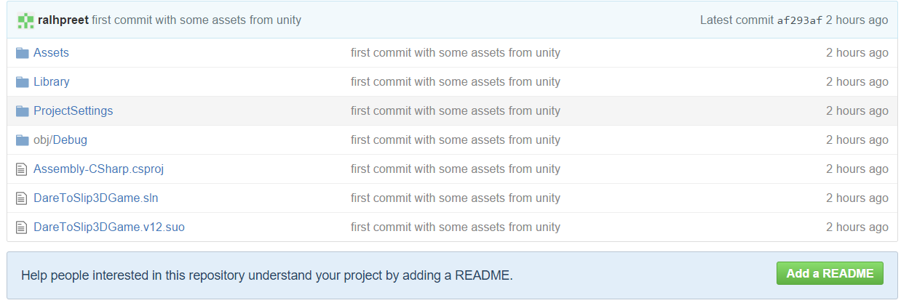

# Game Overview

DareToSlip is a 3D game in which a player have to walk over a 3D platform, and has to reach from one end to the other end going through some hurdles like fire and enemies. He can also collect some bonus(Energy Drinks)

# Interface Sketch

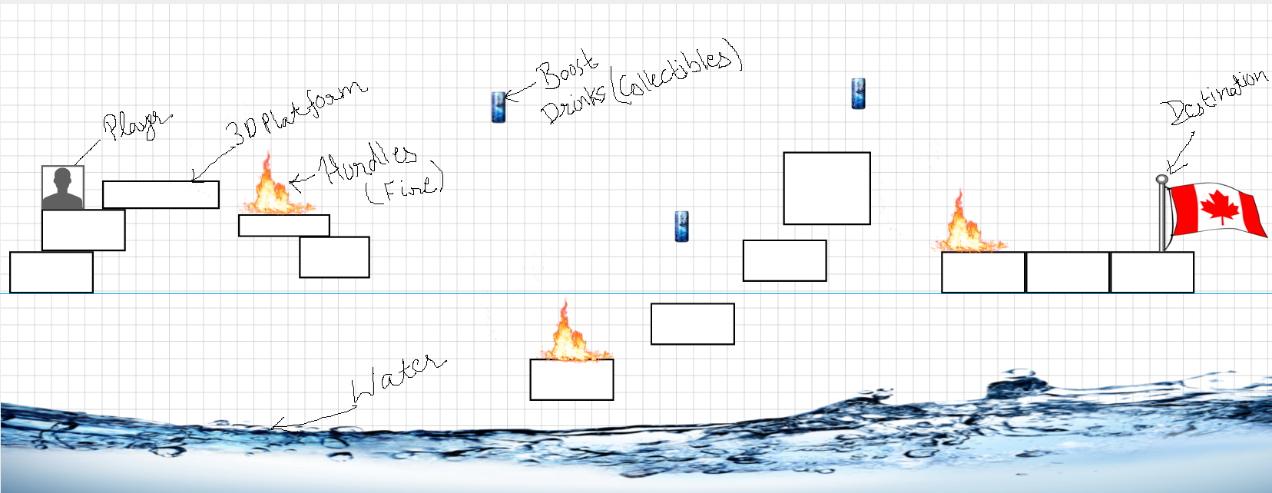

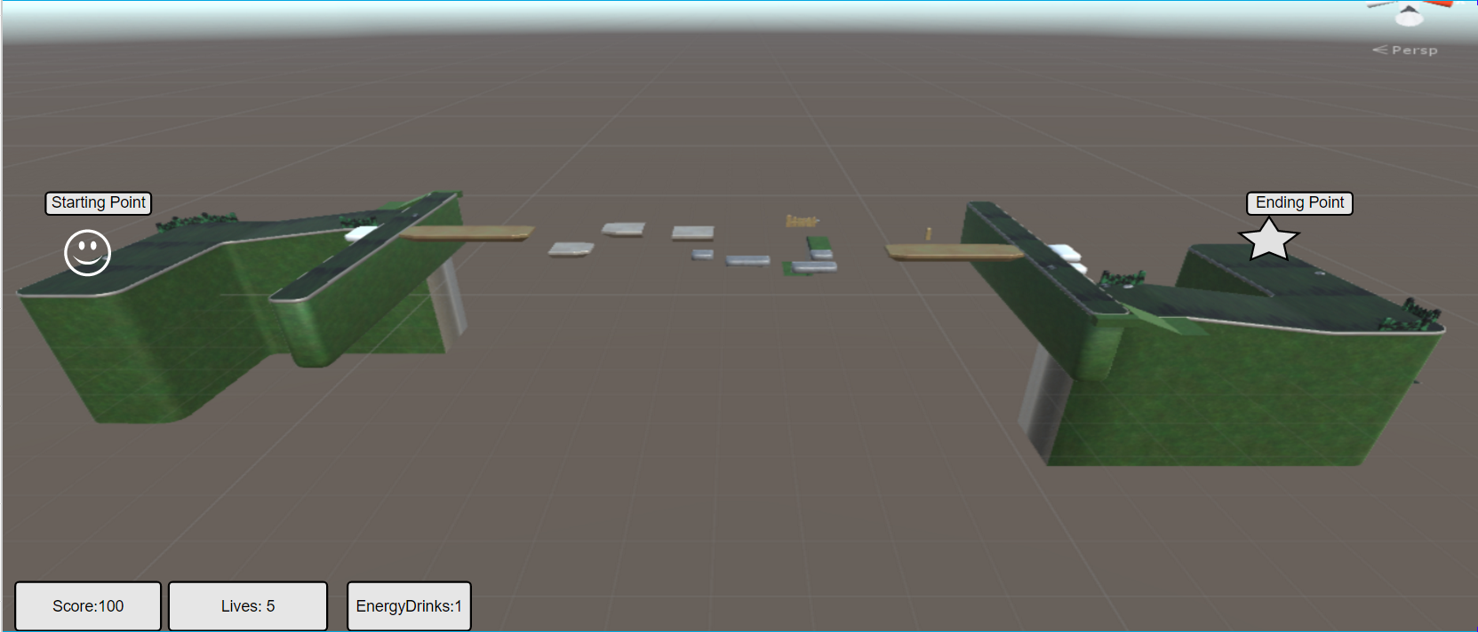

# Menu and Screen Descriptions

Play and Game-Over Screen.

Restart Menu button.

