Sender @ Guest System (Ubuntu):

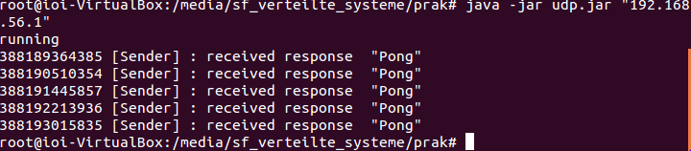

Receiver @ Host System (Windows)

