Begin: 3/11

**4 November 2016**

Begin project, the assignment was received on 3/11/16. Will begin considering ideas soon.

**25 November 2016**

Continued thinking about concepts for the game. I came up with a few ideas.

1. A 2D rogue-like

These games allow the player to control a person which moves around the dungeon, fighting monsters and attempting to go as far into the dungeon as possible. It would be quite easy to fulfil the requirements, and would be interesting. There are several good examples of these games made before, e.g. NetHack

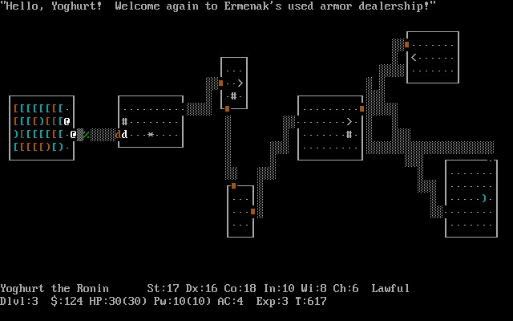

NetHack, a very old rogue-like

1. A programming game

In this, the player need to write code (possibly in a fictional language) to create algorithms to solve puzzles. Zachtronics has made a few of these games (e.g. TIS-100), and this kind of game would be interesting to make and play. However, it does not have as distinct ‘lose’ condition (though this may be discussed).

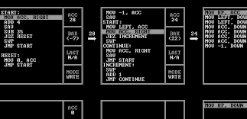

TIS-100, a recent assembly programming game

1. A game similar to ‘gyro’

Gyro is a mobile game which is quite old (2 years), where you control a central circle with different coloured sectors. The player needs to rotate it so incoming balls land in the correct coloured area. I quite enjoyed playing this game before, but it no longer works, so I want to remake it. It is also a simple concept,

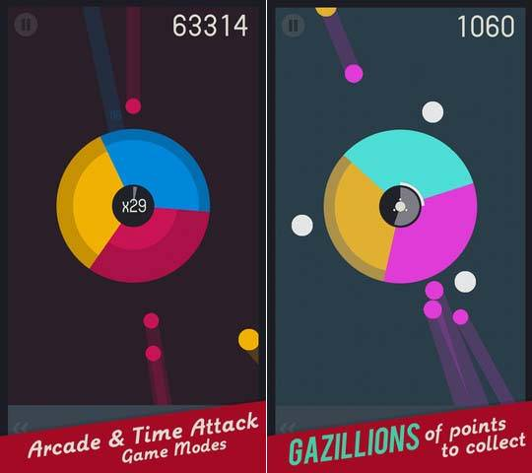

Gyro Gameplay

1. Orbital Mechanics

The main idea behind this game is to use gravity in space to achieve some goal. I have done something similar before (using JavaScript), but the game will need to be much more developed.

**9 December 2016**

I found a game that would likely be better to base off. It is called “jet/lag” (<https://svblm.itch.io/jet-lag>), and has fast-paced gameplay similar to other games I like. As a result, the game would probably be based off this.

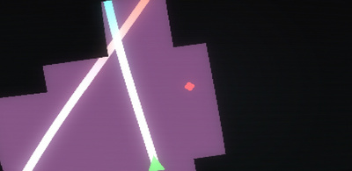

Jet/lag gameplay. It’s hard to show in an image

Another game that would inspire the project is “glitchhiker” (<http://www.glitchhiker.com>).

I further developed the concept from this, and completed the brief description.

**14 December** **2016**

Not much was done around this time. Worked on the Gantt chart.

**23 December 2016**

This is the first week of the holidays. I looked at various frameworks and libraries that could be used for the engine. I plan on using SFML for input/output (inc. display & sound). I previously also have made a vector library (https://github.com/endermaster139/gvector), which I plan on using (unless another math library succeeds it). A entity system will also be needed – EntityX (<https://github.com/endermaster139/gvector>) or anax (<https://github.com/endermaster139/gvector>) will be used.

**6 January 2017**

Since I went to Melbourne for a week, I was unable to do work for the first week. During the second week, I made a (private) git repo for the project.