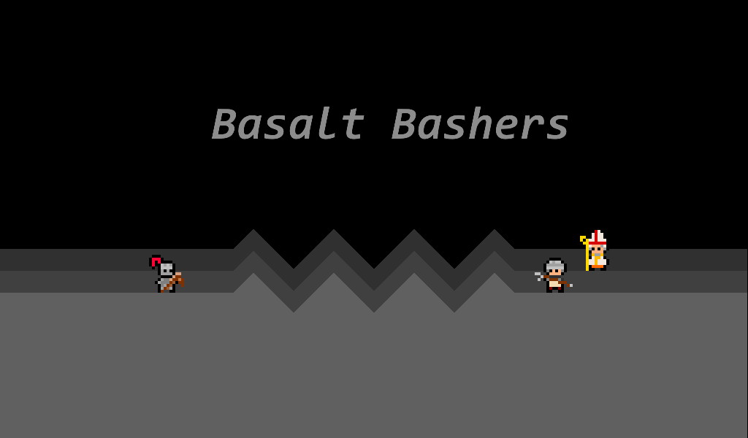

Basalt Bashers - User Manual

# What is Basalt Bashers?

Play the role of a knight, fighting enemies and going ever deeper in an endless cavern. However, you and the enemies are on a grid, and are only able to move like chess pieces! How far can you go?

# Minimum System Requirements

* Windows (sorry Mac users)
* 1 GHz CPU
* 200 MB RAM
* 30 MB Storage

# Installation/Start Guide

1. (optionally) Copy the entire “exe” folder to your computer
2. Run “basalt_bashers.exe” in the “exe” folder

# How to Play

Start the game and press start. Select a difficulty and begin your adventure! Click on green tiles to move. Watch the enemies and make sure you don’t get captured. Reach the exit (a set of stairs) to go to the next level.

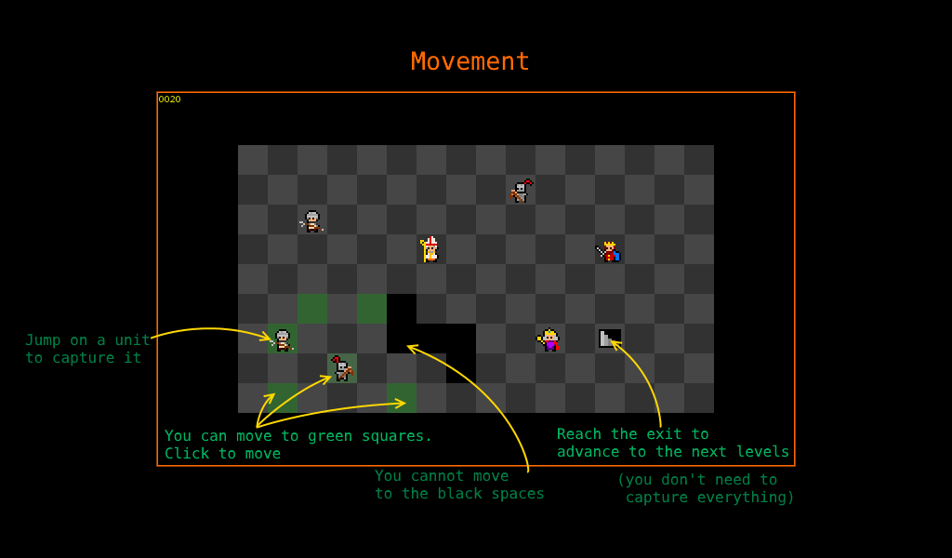

Gain points by capturing enemies (moving to where they are). Harder enemies give you more points. You also gain points by completing a level. You’ll see your score in-game in the top left corner, and at the end when you lose. Share your high scores!

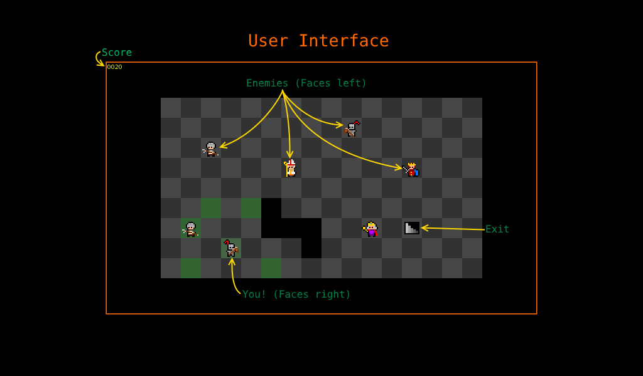

# Common Issues

* **There is no “exe” folder or “basalt_bashers.exe” is missing**

*Solution*: Get a new copy of the game or reinstall, as it is missing files

* **A message similar to this appears** (“flac.dll” may be different)

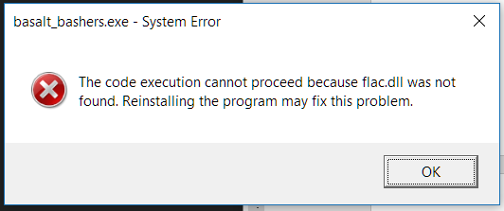

*Solution*: Get a new copy of the game or reinstall, as it is missing files. If the problem persists, install “Microsoft Visual C++ 2017 Redistributable” from the internet

* **Graphics look distorted**

*Solution*: Check that your graphics drivers are at the latest version

* **Keyboard keys do nothing**

*Solution*: This is intentional in most cases. Otherwise, check your keyboard.

Please contact via the details below for other issues.

# Contact Details

Email: [timmy.yao@outlook.com.au](mailto:timmy.yao@outlook.com.au)

Phone: [(02) 9871 7126](javascript:void(0))

Website: <https://ralismark.github.io/>