Practice task and Main task instructions

In a previous experiment you rated people’s faces, judging how much money they returned to another player in a trust game (each one returned from £2 to £12).

In the current experiment, the computer will randomly select one of two faces, and you will win a reward associated with the selected face.

You will see two faces at the same time, one above the other. The computer will randomly choose on face, and you ‘win’ the award associated with the selected face.

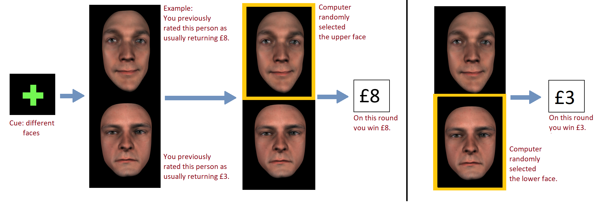

On some occasions, the up-face and down-face will be the same. These cases are indicated with a pink cross at the beginning (like below).

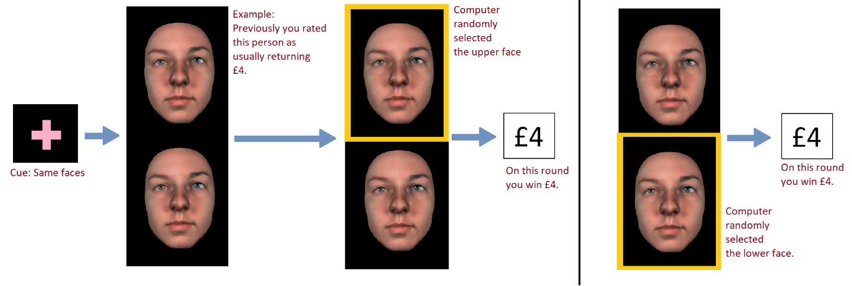

Try to remember how much you ‘win’ from each person. Remember the monetary rewards are based on your previous ratings, so remembering should be straightforward. Moreover, there are only 7 faces to remember overall.