EDF 5401 Practice Final

Russell Almond

2023-12-03

# Physics Playground Background

## The Game

*Physics Playground* is a game for teaching physics. One part of the program is learning supports. There were two kinds of learning supports:

* *Cogntive Supports*: Short videos explaining the physics.
* *Affective Supports*: Motivational messages and diversions designed to help alleviate frustration.

There are matched pretests and posttests which are divided into four parts:

* NearECT — Energy can transfer (ECT), near transfer (similar to the game) items
* FarECT — Energy can transfer (ECT), far transfer (not similar to the game) items
* NearPOT — Properties of torque (POT), near transfer
* FarPOT — Properties of torque (POT), far transfer

More information about the game and the experiment can be found at <https://pluto.coe.fsu.edu/PhysicsDataPlayground/>.

## The support efficacy experiment and key variables

The experiment is a bit complex, with half of the student getting the ECT game levels and posttest in the first half of the experiment and the others in the second half.  
For simplicity we will work with just the ECT-first: Topic1=="ECT".

For these students, there are three condition groups (Condition):

* A – Cognitive Supports Only
* C – Cognitive and Affective Support
* F – No supports (control)

The variables, CognitiveSupports and AffectiveECT are logical variables describing whether or not the cognitive supports and the affective supports were present (during the first half of the study).

The pretest score is labeled ECT and the posttest score is labeled ECTpost.  
There is also a NearECT and NearECTpost (just the near transfer items) and a FarECT and FarECTpost (far transfer items).

## Additional covariates

Age

Self-reported age in years.

Sex, Gender

Self-reported gender

White

Whether or not the subject identified as White.

Gaming

“How often do you play video games?” Ordinal, possible values:  
Never, Once a month or less, Once a week, 3-4 times a week, Every day

Physics

“Have you studied Physics?” Possible answers Yes, No.

POT

Score on the properties of torque physics pretest.

PhysicsScore

POT + ECT

IMI_Enj

Enjoyment subscale of the intrinsic motivation inventory (IMI)

IMI_Eng

Engagement subscale of the IMI

IMI_PC

Player confidence subscale of the IMI

IMI_Effort

Effort subscale of the IMI

IMI_Frust

Frustration subscale of the IMI

IMI_Value

Value of experience subscale IMI

gold, silver, quit

The number of game levels in which the player received a gold trophy (solved the level with an efficient solution), silver trophy (solved the level, but did not meet the qualifications for efficiency), or abandoned the level without solving it.

## Data Loading and cleaning

library(tidyverse)  
library(DescTools)  
library(rgl)  
library(GGally)

Load the data (from the internet)

source("https://pluto.coe.fsu.edu/PhysicsDataPlayground/Data/AllMetadata.R")  
PPIESFall2022 <-   
 read_csv("https://pluto.coe.fsu.edu/PhysicsDataPlayground/Data/PPIESFall2022Full.csv",  
 col_types=colAll)

Extract a subset of the data with just the cases/variables we are working with.

PPIESExtract <- PPIESFall2022 |>  
 filter(Topic1=="ECT") |>  
 select(all_of(c("StudyID", "Condition", "CognitiveSupports", "AffectiveECT",  
 "Age", "Sex", "White", "Gaming", "Physics",   
 "NearECT", "FarECT", "ECT", "NearECTpost", "FarECTpost",  
 "ECTpost", "POT", "PhysicsScore",  
 "IMI_Enj", "IMI_Eng", "IMI_PC", "IMI_Effort", "IMI_Frust",  
 "IMI_Value",  
 "gold", "silver", "quit"))) |>  
 na.omit()  
summary(PPIESExtract)

## StudyID Condition CognitiveSupports AffectiveECT Age   
## Length:119 A:43 Mode :logical Mode :logical Min. :12.00   
## Class :character B: 0 FALSE:35 FALSE:78 1st Qu.:12.00   
## Mode :character C:41 TRUE :84 TRUE :41 Median :13.00   
## D: 0 Mean :13.08   
## E: 0 3rd Qu.:14.00   
## F:35 Max. :16.00   
## Sex White Gaming Physics   
## Male :62 Mode :logical Never :14 Yes:89   
## Female :54 FALSE:29 Once a month or less:22 No :30   
## Other : 0 TRUE :90 Once a week :12   
## Prefer not to say: 0 3-4 times a week :44   
## Nonbinary : 3 Every day :27   
##   
## NearECT FarECT ECT NearECTpost   
## Min. :0.000 Min. :1.000 Min. : 3.000 Min. :0.000   
## 1st Qu.:4.000 1st Qu.:4.000 1st Qu.: 7.000 1st Qu.:5.000   
## Median :5.000 Median :4.000 Median : 9.000 Median :6.000   
## Mean :4.874 Mean :4.412 Mean : 9.286 Mean :5.319   
## 3rd Qu.:6.000 3rd Qu.:5.000 3rd Qu.:11.000 3rd Qu.:6.000   
## Max. :8.000 Max. :7.000 Max. :14.000 Max. :8.000   
## FarECTpost ECTpost POT PhysicsScore   
## Min. :0.000 Min. : 2.00 Min. : 3.000 Min. : 8.00   
## 1st Qu.:4.000 1st Qu.: 9.00 1st Qu.: 6.000 1st Qu.:14.00   
## Median :5.000 Median :10.00 Median : 8.000 Median :17.00   
## Mean :4.689 Mean :10.01 Mean : 7.504 Mean :16.79   
## 3rd Qu.:6.000 3rd Qu.:12.00 3rd Qu.: 9.000 3rd Qu.:20.00   
## Max. :7.000 Max. :15.00 Max. :12.000 Max. :24.00   
## IMI_Enj IMI_Eng IMI_PC IMI_Effort IMI_Frust   
## Min. : 1.0 Min. : 3.00 Min. : 6.00 Min. : 7.00 Min. : 3.0   
## 1st Qu.: 8.5 1st Qu.:14.00 1st Qu.:14.00 1st Qu.:19.00 1st Qu.: 8.0   
## Median :10.0 Median :17.00 Median :17.00 Median :22.00 Median :11.0   
## Mean :10.2 Mean :16.18 Mean :17.51 Mean :22.01 Mean :10.8   
## 3rd Qu.:13.0 3rd Qu.:20.00 3rd Qu.:21.00 3rd Qu.:26.00 3rd Qu.:14.0   
## Max. :14.0 Max. :21.00 Max. :28.00 Max. :28.00 Max. :21.0   
## IMI_Value gold silver quit   
## Min. : 2.000 Min. : 0.000 Min. : 2.000 Min. : 0.000   
## 1st Qu.: 7.000 1st Qu.: 5.000 1st Qu.: 6.000 1st Qu.: 3.500   
## Median : 9.000 Median : 7.000 Median : 8.000 Median : 7.000   
## Mean : 9.059 Mean : 6.924 Mean : 8.563 Mean : 7.487   
## 3rd Qu.:11.000 3rd Qu.: 9.000 3rd Qu.:10.000 3rd Qu.:11.000   
## Max. :14.000 Max. :16.000 Max. :21.000 Max. :25.000

Only three students who identify as nonbinary. Too small to analyze, so take them out.

## Derieved variables

Gain Scores

PPIESExtract <- PPIESExtract |>  
 mutate(ECTgain=ECTpost-ECT,  
 NearECTgain=NearECTpost-NearECT,  
 FarECTgain=FarECTpost-FarECT,  
 LowECT= ECT<median(ECT))

The reason for LowECT will become apparent later.

PPIESExtract <- filter(PPIESExtract,Sex %in% c("Male","Female"))

### Some changes for interpretability

Ages run from 12-16 (middle and high school students). Create an new variable Age1 for subtracts 0, so it is essential years of schooling since elementary school.

Center physics variable to aid in interpretation.

PPIESExtract <- mutate(PPIESExtract,Age1=Age-12,  
 PhysicsCenter=PhysicsScore-mean(PhysicsScore))

It will be convenient (mainly for graphics) to have better labeled condition variable.

PPIESExtract$Supports <-   
 factor(PPIESExtract$CognitiveSupports+PPIESExtract$AffectiveECT,  
 levels=0:2,labels=c("None","COG only","COG+AFF"))

## Enjoyment definition

For the logistic regression, we will define Enjoyed as IMI_Enj >7 (This ranges from 2–14).

PPIESExtract <- mutate(PPIESExtract,Enjoyed=IMI_Enj>8)

Write this out in SPSS format so we can do a parallel analysis there.

haven::write_sav(PPIESExtract,"PPIESExtract.sav")

# ANCOVA

The primary analysis will be an ANCOVA with ECTpost as the dependent variable, ECT as the covariate, and CognitiveSupport and AffectiveECT as the treatment variables. In addition we will explore other possible covariates.

## Exploratory Analysis

ggplot(PPIESExtract,aes(x=ECT,y=ECTpost)) + geom_point(position="jitter") +  
 geom_smooth()

## `geom_smooth()` using method = 'loess' and formula = 'y ~ x'

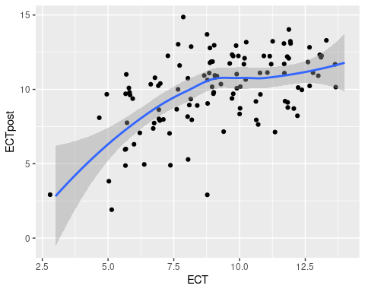

Treatment by condition breakdown

ggplot(PPIESExtract,aes(x=ECT,y=ECTpost,color=Supports)) +  
 geom_point(position="jitter") +  
 geom_smooth()

## `geom_smooth()` using method = 'loess' and formula = 'y ~ x'

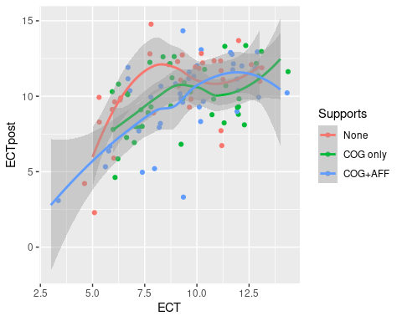

### Demographic Breakdowns

ggplot(PPIESExtract,aes(x=ECT,y=ECTpost,color=Sex)) +   
 geom_point(position="jitter") +  
 geom_smooth()

## `geom_smooth()` using method = 'loess' and formula = 'y ~ x'

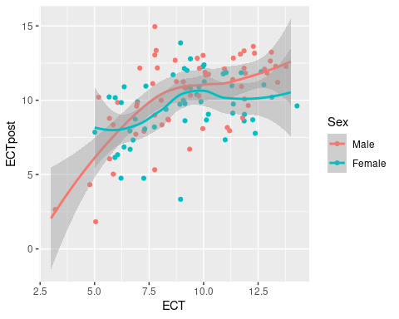

ggplot(PPIESExtract,aes(x=ECT,y=ECTpost,color=factor(Age))) +   
 geom_point(position="jitter") +  
 geom_smooth()

## `geom_smooth()` using method = 'loess' and formula = 'y ~ x'

## Warning in simpleLoess(y, x, w, span, degree = degree, parametric = parametric,  
## : pseudoinverse used at 6.975

## Warning in simpleLoess(y, x, w, span, degree = degree, parametric = parametric,  
## : neighborhood radius 3.025

## Warning in simpleLoess(y, x, w, span, degree = degree, parametric = parametric,  
## : reciprocal condition number 4.961e-17

## Warning in simpleLoess(y, x, w, span, degree = degree, parametric = parametric,  
## : There are other near singularities as well. 4

## Warning in predLoess(object$y, object$x, newx = if (is.null(newdata)) object$x  
## else if (is.data.frame(newdata))  
## as.matrix(model.frame(delete.response(terms(object)), : pseudoinverse used at  
## 6.975

## Warning in predLoess(object$y, object$x, newx = if (is.null(newdata)) object$x  
## else if (is.data.frame(newdata))  
## as.matrix(model.frame(delete.response(terms(object)), : neighborhood radius  
## 3.025

## Warning in predLoess(object$y, object$x, newx = if (is.null(newdata)) object$x  
## else if (is.data.frame(newdata))  
## as.matrix(model.frame(delete.response(terms(object)), : reciprocal condition  
## number 4.961e-17

## Warning in predLoess(object$y, object$x, newx = if (is.null(newdata)) object$x  
## else if (is.data.frame(newdata))  
## as.matrix(model.frame(delete.response(terms(object)), : There are other near  
## singularities as well. 4

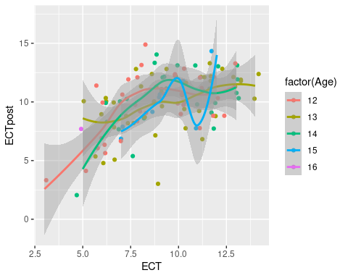

ggplot(PPIESExtract,aes(x=ECT,y=ECTpost,color=White)) +   
 geom_point(position="jitter") +  
 geom_smooth()

## `geom_smooth()` using method = 'loess' and formula = 'y ~ x'

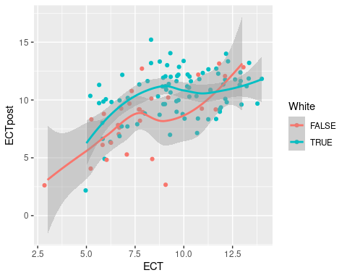

ggplot(PPIESExtract,aes(x=ECT,y=ECTpost,color=Gaming)) +   
 geom_point(position="jitter") +  
 geom_smooth()

## `geom_smooth()` using method = 'loess' and formula = 'y ~ x'

## Warning in simpleLoess(y, x, w, span, degree = degree, parametric = parametric,  
## : pseudoinverse used at 7

## Warning in simpleLoess(y, x, w, span, degree = degree, parametric = parametric,  
## : neighborhood radius 2

## Warning in simpleLoess(y, x, w, span, degree = degree, parametric = parametric,  
## : reciprocal condition number 4.0584e-17

## Warning in predLoess(object$y, object$x, newx = if (is.null(newdata)) object$x  
## else if (is.data.frame(newdata))  
## as.matrix(model.frame(delete.response(terms(object)), : pseudoinverse used at 7

## Warning in predLoess(object$y, object$x, newx = if (is.null(newdata)) object$x  
## else if (is.data.frame(newdata))  
## as.matrix(model.frame(delete.response(terms(object)), : neighborhood radius 2

## Warning in predLoess(object$y, object$x, newx = if (is.null(newdata)) object$x  
## else if (is.data.frame(newdata))  
## as.matrix(model.frame(delete.response(terms(object)), : reciprocal condition  
## number 4.0584e-17

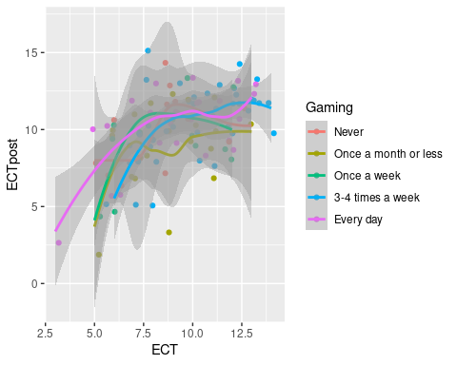

ggplot(PPIESExtract,aes(x=ECT,y=ECTpost,color=Physics)) +   
 geom_point(position="jitter") +  
 geom_smooth()

## `geom_smooth()` using method = 'loess' and formula = 'y ~ x'

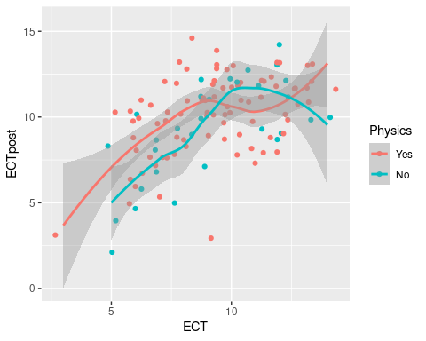

Look at the correlation between the trophy variables and ECT with a scatterplot matrix.

select(PPIESExtract,all_of(c("ECTpost","ECT","gold","silver","quit"))) |>  
 ggpairs()

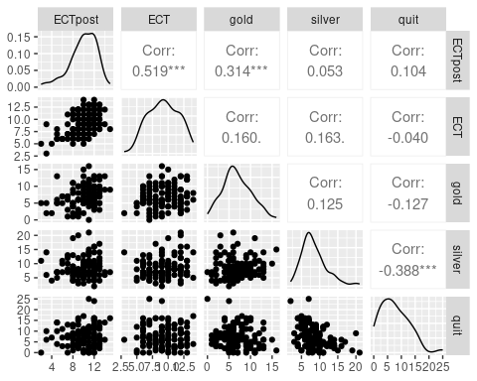

### Treatment Effect

A = Cognitive Only C = Cogntivie + Affective F = Control (no supports)

ggplot(PPIESExtract,aes(x=Supports,y=ECTgain)) + geom_boxplot()

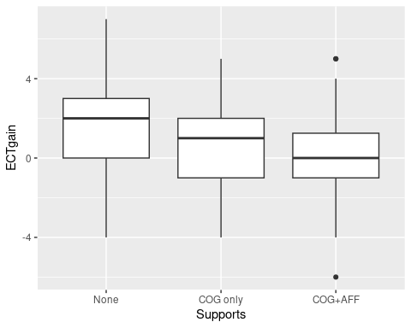 ## Baseline Model

ECTbase <- lm(ECTpost ~ ECT + Supports,data=PPIESExtract)  
summary(ECTbase)

##   
## Call:  
## lm(formula = ECTpost ~ ECT + Supports, data = PPIESExtract)  
##   
## Residuals:  
## Min 1Q Median 3Q Max   
## -6.487 -1.195 0.259 1.436 5.113   
##   
## Coefficients:  
## Estimate Std. Error t value Pr(>|t|)   
## (Intercept) 5.45418 0.83271 6.550 1.81e-09 ***  
## ECT 0.55409 0.08309 6.668 1.02e-09 ***  
## SupportsCOG only -0.76882 0.49428 -1.555 0.1227   
## SupportsCOG+AFF -0.95423 0.50343 -1.895 0.0606 .   
## ---  
## Signif. codes: 0 '***' 0.001 '**' 0.01 '*' 0.05 '.' 0.1 ' ' 1  
##   
## Residual standard error: 2.133 on 112 degrees of freedom  
## Multiple R-squared: 0.2939, Adjusted R-squared: 0.275   
## F-statistic: 15.54 on 3 and 112 DF, p-value: 1.618e-08

## ATI Model

ECTATI <- lm(ECTpost ~ ECT * Supports,data=PPIESExtract)  
summary(ECTATI)

##   
## Call:  
## lm(formula = ECTpost ~ ECT * Supports, data = PPIESExtract)  
##   
## Residuals:  
## Min 1Q Median 3Q Max   
## -6.4208 -1.1708 0.3345 1.3457 5.1432   
##   
## Coefficients:  
## Estimate Std. Error t value Pr(>|t|)   
## (Intercept) 5.1758 1.4036 3.687 0.000354 ***  
## ECT 0.5851 0.1509 3.877 0.000180 ***  
## SupportsCOG only 1.0668 1.9435 0.549 0.584183   
## SupportsCOG+AFF -1.9916 1.9590 -1.017 0.311555   
## ECT:SupportsCOG only -0.1993 0.2065 -0.965 0.336647   
## ECT:SupportsCOG+AFF 0.1078 0.2057 0.524 0.601226   
## ---  
## Signif. codes: 0 '***' 0.001 '**' 0.01 '*' 0.05 '.' 0.1 ' ' 1  
##   
## Residual standard error: 2.129 on 110 degrees of freedom  
## Multiple R-squared: 0.3093, Adjusted R-squared: 0.2779   
## F-statistic: 9.852 on 5 and 110 DF, p-value: 8.382e-08

anova(ECTbase,ECTATI)

## Analysis of Variance Table  
##   
## Model 1: ECTpost ~ ECT + Supports  
## Model 2: ECTpost ~ ECT * Supports  
## Res.Df RSS Df Sum of Sq F Pr(>F)  
## 1 112 509.71   
## 2 110 498.58 2 11.124 1.2271 0.2971

## Diagnostic plots

oldpar <- par(mfrow=c(2,2)) # Put all of the plot together  
plot(ECTbase)

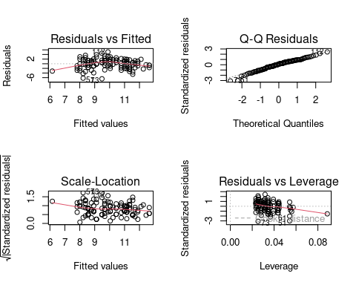

par(oldpar) # Restore the graphics window

## Influential points

dfb <- dfbetas(ECTbase)  
summary(dfb)

## (Intercept) ECT SupportsCOG only   
## Min. :-0.6918712 Min. :-0.1977376 Min. :-0.3265859   
## 1st Qu.:-0.0230543 1st Qu.:-0.0572469 1st Qu.:-0.0352084   
## Median : 0.0034389 Median : 0.0003176 Median :-0.0012389   
## Mean :-0.0005849 Mean : 0.0004359 Mean : 0.0002644   
## 3rd Qu.: 0.0517385 3rd Qu.: 0.0240710 3rd Qu.: 0.0142047   
## Max. : 0.2821892 Max. : 0.4952094 Max. : 0.3950561   
## SupportsCOG+AFF   
## Min. :-0.3489227   
## 1st Qu.:-0.0377298   
## Median : 0.0001959   
## Mean : 0.0000221   
## 3rd Qu.: 0.0370026   
## Max. : 0.3699555

Flagging value is {r} 2/sqrt(nrow(dfb))

## Calculate a logical value rows higer than flagged value.  
flags <- apply(dfb,1,function(r) any(r>2/sqrt(nrow(dfb))))  
PPIESExtract$StudyID[flags]

## [1] "C0066" "A0594" "F1337" "F1450" "F1562" "F2024" "C2192" "F3069" "C3395"  
## [10] "A3520" "C3676" "F3733"

dfb[flags,]

## (Intercept) ECT SupportsCOG only SupportsCOG+AFF  
## 4 0.03654101 -0.04082561 0.001963686 0.237167321  
## 25 -0.16751897 0.18716130 -0.157136503 -0.015609607  
## 45 0.18985529 -0.13588964 -0.108406731 -0.101518909  
## 51 -0.69187121 0.49520945 0.395056137 0.369955513  
## 54 -0.01193039 -0.13772952 0.234406729 0.235126049  
## 61 -0.45887962 0.32844483 0.262018721 0.245370876  
## 67 -0.16829815 0.18803184 -0.009044211 -0.162849806  
## 85 -0.01542288 -0.17804828 0.303026650 0.303956542  
## 99 0.15304974 -0.17099549 0.008224774 0.202169254  
## 104 0.08266226 -0.09235477 0.193952491 0.007702563  
## 109 -0.36950320 0.41282907 -0.019856814 -0.207837518  
## 112 0.28218916 -0.09564341 -0.326585876 -0.317185830

### Remove flagged values

ECTnoinf <- lm(ECTpost ~ ECT + Supports, data=PPIESExtract,  
 subset = !flags)  
summary(ECTnoinf)

##   
## Call:  
## lm(formula = ECTpost ~ ECT + Supports, data = PPIESExtract, subset = !flags)  
##   
## Residuals:  
## Min 1Q Median 3Q Max   
## -6.4911 -1.0138 0.1497 1.2870 3.3210   
##   
## Coefficients:  
## Estimate Std. Error t value Pr(>|t|)   
## (Intercept) 6.59967 0.78814 8.374 3.55e-13 ***  
## ECT 0.47733 0.07664 6.228 1.12e-08 ***  
## SupportsCOG only -1.21658 0.43406 -2.803 0.00609 **   
## SupportsCOG+AFF -1.40449 0.44773 -3.137 0.00224 **   
## ---  
## Signif. codes: 0 '***' 0.001 '**' 0.01 '*' 0.05 '.' 0.1 ' ' 1  
##   
## Residual standard error: 1.751 on 100 degrees of freedom  
## Multiple R-squared: 0.3228, Adjusted R-squared: 0.3025   
## F-statistic: 15.89 on 3 and 100 DF, p-value: 1.596e-08

rbind(base=coef(ECTbase),  
 noinf=coef(ECTnoinf))

## (Intercept) ECT SupportsCOG only SupportsCOG+AFF  
## base 5.454182 0.5540946 -0.7688248 -0.9542281  
## noinf 6.599668 0.4773266 -1.2165801 -1.4044902

## Exploring more models

ECTminmod <- ECTpost ~ ECT + Supports  
ECTmaxmod <- ECTpost ~ ECT + Supports + Age + Sex + White + Gaming +  
 Physics + POT + gold + silver + quit  
ECTstep <- step(ECTbase,list(lower=ECTminmod,upper=ECTmaxmod),trace=2)

## Start: AIC=179.71  
## ECTpost ~ ECT + Supports  
##   
## Df Sum of Sq RSS AIC  
## + gold 1 38.091 471.61 172.70  
## + POT 1 27.882 481.82 175.18  
## + White 1 26.161 483.54 175.60  
## + Physics 1 18.944 490.76 177.31  
## + quit 1 12.241 497.46 178.89  
## + Sex 1 10.103 499.60 179.39  
## <none> 509.71 179.71  
## + silver 1 0.415 509.29 181.61  
## + Age 1 0.022 509.68 181.70  
## + Gaming 4 22.859 486.85 182.38  
##   
## Step: AIC=172.7  
## ECTpost ~ ECT + Supports + gold  
##   
## Df Sum of Sq RSS AIC  
## + quit 1 18.219 453.40 170.13  
## + POT 1 17.647 453.97 170.28  
## + Physics 1 15.385 456.23 170.85  
## + White 1 12.700 458.91 171.53  
## <none> 471.61 172.70  
## + Sex 1 5.590 466.03 173.31  
## + silver 1 1.347 470.27 174.37  
## + Age 1 1.036 470.58 174.44  
## + Gaming 4 23.170 448.45 174.85  
## - gold 1 38.091 509.71 179.71  
##   
## Step: AIC=170.13  
## ECTpost ~ ECT + Supports + gold + quit  
##   
## Df Sum of Sq RSS AIC  
## + POT 1 18.818 434.58 167.21  
## + White 1 16.188 437.21 167.91  
## + Physics 1 15.880 437.52 167.99  
## + Gaming 4 36.055 417.34 168.52  
## + Sex 1 10.055 443.34 169.53  
## <none> 453.40 170.13  
## + Age 1 0.573 452.82 171.98  
## + silver 1 0.271 453.13 172.06  
## - quit 1 18.219 471.61 172.70  
## - gold 1 44.069 497.46 178.89  
##   
## Step: AIC=167.21  
## ECTpost ~ ECT + Supports + gold + quit + POT  
##   
## Df Sum of Sq RSS AIC  
## + White 1 18.395 416.18 164.19  
## + Physics 1 15.375 419.20 165.03  
## + Gaming 4 30.277 404.30 166.83  
## <none> 434.58 167.21  
## + Sex 1 5.782 428.80 167.66  
## + Age 1 0.238 434.34 169.15  
## + silver 1 0.123 434.45 169.18  
## - POT 1 18.818 453.40 170.13  
## - quit 1 19.390 453.97 170.28  
## - gold 1 32.919 467.50 173.68  
##   
## Step: AIC=164.19  
## ECTpost ~ ECT + Supports + gold + quit + POT + White  
##   
## Df Sum of Sq RSS AIC  
## + Gaming 4 32.595 383.59 162.73  
## + Physics 1 11.473 404.71 162.95  
## <none> 416.18 164.19  
## + Sex 1 5.577 410.61 164.63  
## + silver 1 0.727 415.46 165.99  
## + Age 1 0.412 415.77 166.08  
## - White 1 18.395 434.58 167.21  
## - gold 1 19.178 435.36 167.42  
## - POT 1 21.024 437.21 167.91  
## - quit 1 23.312 439.50 168.52  
##   
## Step: AIC=162.73  
## ECTpost ~ ECT + Supports + gold + quit + POT + White + Gaming  
##   
## Df Sum of Sq RSS AIC  
## + Physics 1 10.713 372.88 161.45  
## <none> 383.59 162.73  
## + silver 1 2.090 381.50 164.10  
## - Gaming 4 32.595 416.18 164.19  
## + Age 1 0.268 383.32 164.65  
## - POT 1 13.282 396.87 164.68  
## + Sex 1 0.043 383.55 164.72  
## - gold 1 20.042 403.63 166.64  
## - White 1 20.712 404.30 166.83  
## - quit 1 37.136 420.72 171.45  
##   
## Step: AIC=161.45  
## ECTpost ~ ECT + Supports + gold + quit + POT + White + Gaming +   
## Physics  
##   
## Df Sum of Sq RSS AIC  
## <none> 372.88 161.45  
## - Physics 1 10.713 383.59 162.73  
## - Gaming 4 31.835 404.71 162.95  
## + silver 1 0.964 371.91 163.15  
## + Age 1 0.934 371.94 163.16  
## - POT 1 12.321 385.20 163.22  
## + Sex 1 0.029 372.85 163.44  
## - White 1 17.092 389.97 164.65  
## - gold 1 19.459 392.33 165.35  
## - quit 1 36.969 409.84 170.41

summary(ECTstep)

##   
## Call:  
## lm(formula = ECTpost ~ ECT + Supports + gold + quit + POT + White +   
## Gaming + Physics, data = PPIESExtract)  
##   
## Residuals:  
## Min 1Q Median 3Q Max   
## -4.5265 -1.3610 0.4432 1.3402 3.3360   
##   
## Coefficients:  
## Estimate Std. Error t value Pr(>|t|)   
## (Intercept) 3.25129 1.03860 3.130 0.00227 **   
## ECT 0.37062 0.08926 4.152 6.81e-05 ***  
## SupportsCOG only -0.42316 0.45531 -0.929 0.35486   
## SupportsCOG+AFF -0.99902 0.46812 -2.134 0.03521 *   
## gold 0.14001 0.06039 2.318 0.02240 *   
## quit 0.11807 0.03695 3.196 0.00185 **   
## POT 0.19227 0.10422 1.845 0.06794 .   
## WhiteTRUE 1.04390 0.48042 2.173 0.03208 *   
## GamingOnce a month or less -1.09580 0.67756 -1.617 0.10887   
## GamingOnce a week -0.75415 0.75671 -0.997 0.32128   
## Gaming3-4 times a week 0.16173 0.63180 0.256 0.79847   
## GamingEvery day 0.44679 0.64883 0.689 0.49262   
## PhysicsNo -0.71581 0.41611 -1.720 0.08839 .   
## ---  
## Signif. codes: 0 '***' 0.001 '**' 0.01 '*' 0.05 '.' 0.1 ' ' 1  
##   
## Residual standard error: 1.903 on 103 degrees of freedom  
## Multiple R-squared: 0.4835, Adjusted R-squared: 0.4233   
## F-statistic: 8.033 on 12 and 103 DF, p-value: 1.97e-10

## Splitting into High and Low initial ECT values

Added the median split variable so that we could fit separate slopes to high and low ECT values.

ECThighlow <- lm(ECTpost ~ ECT*LowECT + Supports*LowECT,data=PPIESExtract)  
summary(ECThighlow)

##   
## Call:  
## lm(formula = ECTpost ~ ECT * LowECT + Supports * LowECT, data = PPIESExtract)  
##   
## Residuals:  
## Min 1Q Median 3Q Max   
## -7.4465 -1.2895 0.3619 1.3619 4.0063   
##   
## Coefficients:  
## Estimate Std. Error t value Pr(>|t|)   
## (Intercept) 9.3072 1.7640 5.276 6.85e-07 ***  
## ECT 0.1917 0.1616 1.186 0.238112   
## LowECTTRUE -9.4533 2.5684 -3.681 0.000365 ***  
## SupportsCOG only -0.8725 0.6002 -1.454 0.148968   
## SupportsCOG+AFF -0.5857 0.5950 -0.984 0.327193   
## ECT:LowECTTRUE 1.2645 0.3298 3.834 0.000213 ***  
## LowECTTRUE:SupportsCOG only -0.3410 0.9924 -0.344 0.731836   
## LowECTTRUE:SupportsCOG+AFF -1.4674 1.0127 -1.449 0.150226   
## ---  
## Signif. codes: 0 '***' 0.001 '**' 0.01 '*' 0.05 '.' 0.1 ' ' 1  
##   
## Residual standard error: 2.021 on 108 degrees of freedom  
## Multiple R-squared: 0.3891, Adjusted R-squared: 0.3495   
## F-statistic: 9.825 on 7 and 108 DF, p-value: 1.97e-09

anova(ECTbase,ECThighlow)

## Analysis of Variance Table  
##   
## Model 1: ECTpost ~ ECT + Supports  
## Model 2: ECTpost ~ ECT * LowECT + Supports * LowECT  
## Res.Df RSS Df Sum of Sq F Pr(>F)   
## 1 112 509.71   
## 2 108 441.02 4 68.685 4.205 0.003337 **  
## ---  
## Signif. codes: 0 '***' 0.001 '**' 0.01 '*' 0.05 '.' 0.1 ' ' 1

# Logistic Regression

The research question is what is the relationship between game enjoyment and physics ability (as measured by the pretest), PhysicsScore

The IMI_Enj variables is the sum of two 7-option Likert scale items, so 8 is neutral on both variables. So define enjoyment as IMI_Enj > 8.

Also, look at the role of gender.

## Exploratory analysis

ggplot(PPIESExtract,aes(x=PhysicsScore,y=as.numeric(Enjoyed))) +  
 geom_point(position=position_jitter(width=.5,height=.1)) +  
 geom_smooth()

## `geom_smooth()` using method = 'loess' and formula = 'y ~ x'

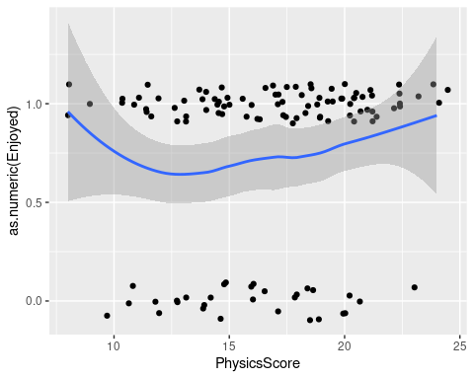

Enjoyment by Gender

table(PPIESExtract$Enjoyed,PPIESExtract$Sex)

##   
## Male Female Other Prefer not to say Nonbinary  
## FALSE 10 20 0 0 0  
## TRUE 52 34 0 0 0

All three variables together

ggplot(PPIESExtract,aes(x=PhysicsScore,y=as.numeric(Enjoyed),color=Sex)) +  
 geom_point(position=position_jitter(width=.5,height=.1)) +  
 geom_smooth()

## `geom_smooth()` using method = 'loess' and formula = 'y ~ x'

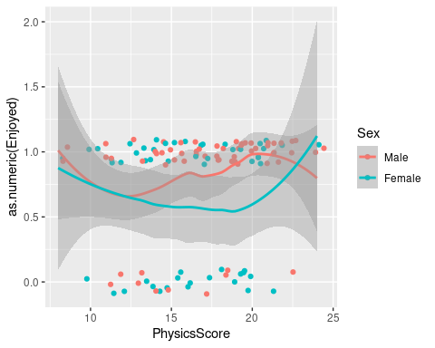

## Base Model

ENJphys <- glm(Enjoyed ~ PhysicsCenter, data=PPIESExtract,  
 family=binomial())  
summary(ENJphys)

##   
## Call:  
## glm(formula = Enjoyed ~ PhysicsCenter, family = binomial(), data = PPIESExtract)  
##   
## Coefficients:  
## Estimate Std. Error z value Pr(>|z|)   
## (Intercept) 1.07145 0.21543 4.973 6.58e-07 ***  
## PhysicsCenter 0.07384 0.05670 1.302 0.193   
## ---  
## Signif. codes: 0 '***' 0.001 '**' 0.01 '*' 0.05 '.' 0.1 ' ' 1  
##   
## (Dispersion parameter for binomial family taken to be 1)  
##   
## Null deviance: 132.61 on 115 degrees of freedom  
## Residual deviance: 130.90 on 114 degrees of freedom  
## AIC: 134.9  
##   
## Number of Fisher Scoring iterations: 4

Prediction at mean physics ability

round(psych::logistic(coef(ENJphys)[1]),2)

## (Intercept)   
## 0.74

## Model with gender

ENJphysG <- glm(Enjoyed ~ PhysicsCenter + Sex, data=PPIESExtract,  
 family=binomial())  
summary(ENJphysG)

##   
## Call:  
## glm(formula = Enjoyed ~ PhysicsCenter + Sex, family = binomial(),   
## data = PPIESExtract)  
##   
## Coefficients:  
## Estimate Std. Error z value Pr(>|z|)   
## (Intercept) 1.63383 0.34640 4.717 2.4e-06 ***  
## PhysicsCenter 0.05651 0.05889 0.960 0.3373   
## SexFemale -1.06317 0.44989 -2.363 0.0181 *   
## ---  
## Signif. codes: 0 '***' 0.001 '**' 0.01 '*' 0.05 '.' 0.1 ' ' 1  
##   
## (Dispersion parameter for binomial family taken to be 1)  
##   
## Null deviance: 132.61 on 115 degrees of freedom  
## Residual deviance: 125.05 on 113 degrees of freedom  
## AIC: 131.05  
##   
## Number of Fisher Scoring iterations: 4

Prediction at mean physics ability

round(psych::logistic(coef(ENJphysG)[1]+c(Male=0,Female=1)*coef(ENJphysG)[3]),2)

## Male Female   
## 0.84 0.64

## Model with gender interaction

ENJphysXG <- glm(Enjoyed ~ PhysicsCenter * Sex, data=PPIESExtract,  
 family=binomial())  
summary(ENJphysXG)

##   
## Call:  
## glm(formula = Enjoyed ~ PhysicsCenter * Sex, family = binomial(),   
## data = PPIESExtract)  
##   
## Coefficients:  
## Estimate Std. Error z value Pr(>|z|)   
## (Intercept) 1.68015 0.36404 4.615 3.93e-06 ***  
## PhysicsCenter 0.15656 0.09366 1.672 0.0946 .   
## SexFemale -1.15787 0.46245 -2.504 0.0123 *   
## PhysicsCenter:SexFemale -0.17080 0.12123 -1.409 0.1589   
## ---  
## Signif. codes: 0 '***' 0.001 '**' 0.01 '*' 0.05 '.' 0.1 ' ' 1  
##   
## (Dispersion parameter for binomial family taken to be 1)  
##   
## Null deviance: 132.61 on 115 degrees of freedom  
## Residual deviance: 123.02 on 112 degrees of freedom  
## AIC: 131.02  
##   
## Number of Fisher Scoring iterations: 4

Prediction at mean physics ability

round(psych::logistic(coef(ENJphysXG)[1]+c(Male=0,Female=1)*coef(ENJphysXG)[3]),2)

## Male Female   
## 0.84 0.63

## Analysis of Deviance

Like Analysis of Variance, only with Deviance & chi-squared.

anova(ENJphys,ENJphysG,ENJphysXG)

## Analysis of Deviance Table  
##   
## Model 1: Enjoyed ~ PhysicsCenter  
## Model 2: Enjoyed ~ PhysicsCenter + Sex  
## Model 3: Enjoyed ~ PhysicsCenter * Sex  
## Resid. Df Resid. Dev Df Deviance  
## 1 114 130.90   
## 2 113 125.05 1 5.8513  
## 3 112 123.02 1 2.0272

The differences in deviance are chi-squared valued.

Here is a chi-square table.

chi2.1.table <- rbind(prob=c(.5,.75,.9,.95,.99),  
 X2=qchisq(c(.5,.75,.9,.95,.99),1))  
round(chi2.1.table,2)

## [,1] [,2] [,3] [,4] [,5]  
## prob 0.50 0.75 0.90 0.95 0.99  
## X2 0.45 1.32 2.71 3.84 6.63