Lab 6 : Setting Up Animations and Game Mechanics
Follow these step-by-step instructions to complete the lab tasks.

In order to download the project you will have to clone this git repository :
https://github.com/amcnabbbaltar/420_541_Lab5

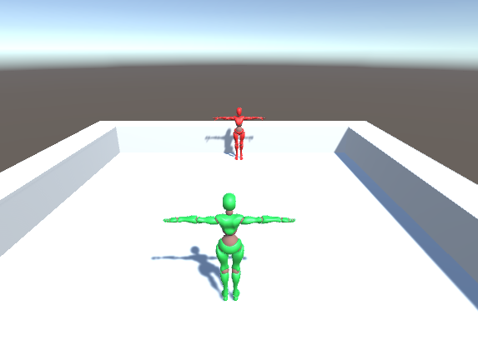

Task 1 : Stop the player from moving during the roll according to the input.

- When we do the roll we can move the player which is not the behaviour we want to have.
- We will fix that
  - Open the PlayerMovement Script
  - Find the OnAnimatorMove()

And add an if that encompass its code.
This wil only allow movement through animation if the root motion boolean is set to true.

private void OnAnimatorMove()
{
// If root motion is enabled, apply the animation's motion directly to the controller
if (animator.applyRootMotion)
{
Vector3 velocity = animator.deltaPosition;
velocity.y = playerVelocity.y * Time.deltaTime; // Preserve vertical movement (gravity, jump)
controller.Move(velocity);
}

}

- Now we want to enable and disable the root motion only for this animation.
- Open up by double clicking on the PlayerAnimator in the folder Character/Animation.
  - 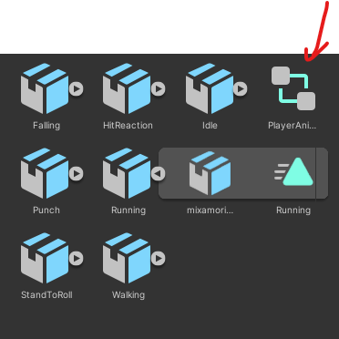
- Select the Stand to roll Animation 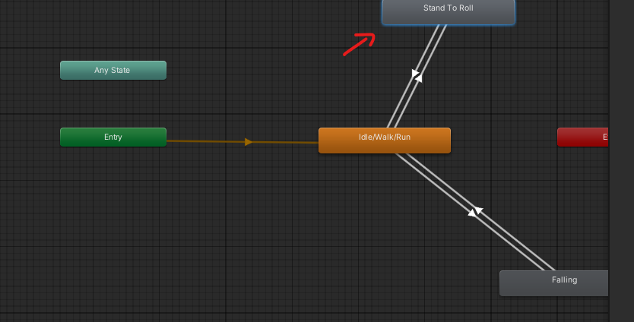
- In the inspector click on the add behaviour button and create a script called RootMotionController
- 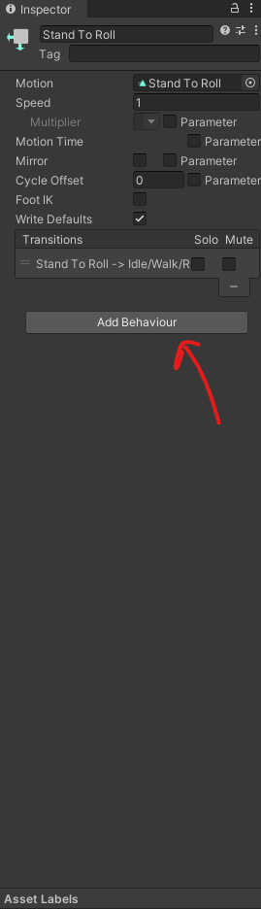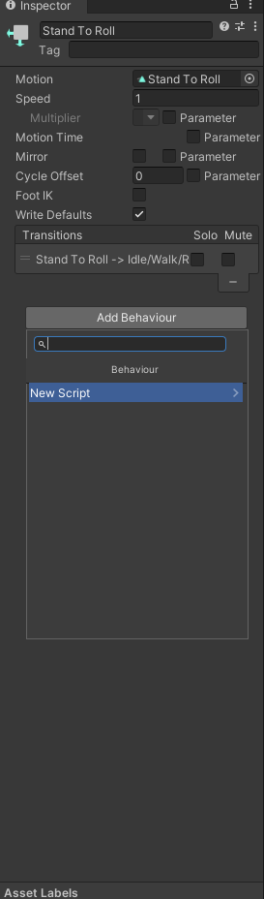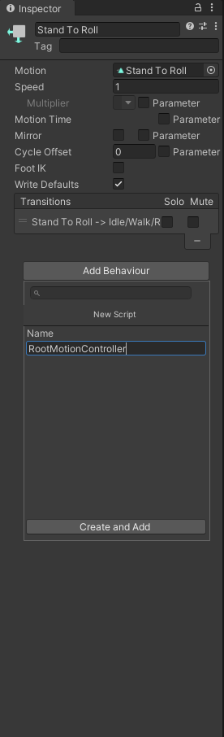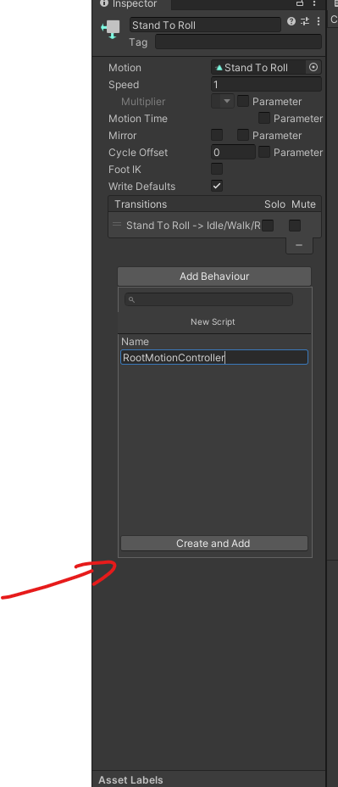
- Then click on create and add.
- Move the newly created script in your Scripts folder
- 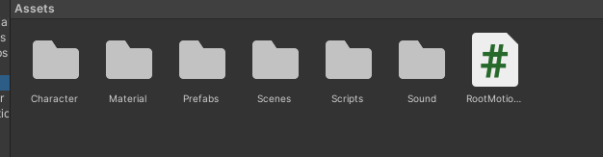
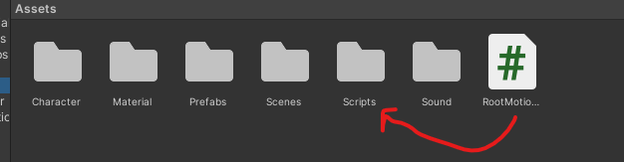

- Open up the script it should look like this 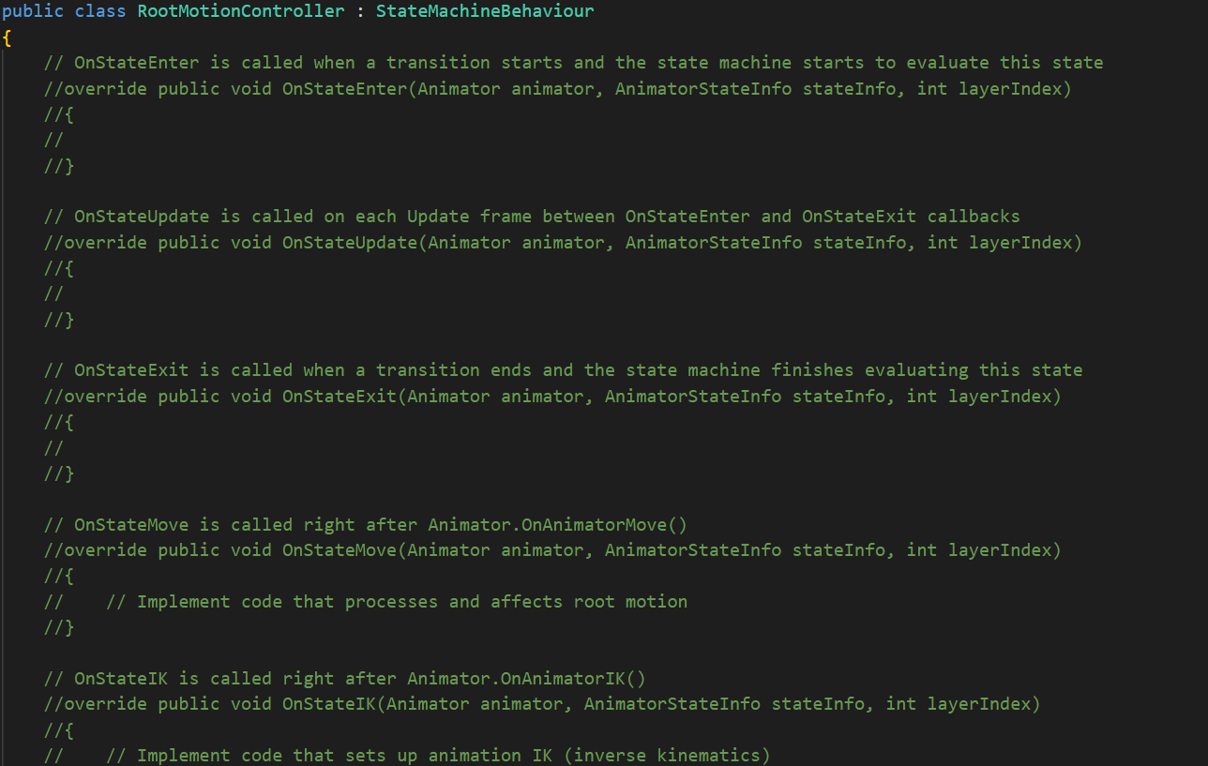
This special type of MonoBehaviours allow you to do some code when you start an animation, when you stop playing an animation and during the animation with different Method
- OnStateEnter() - > At the start of your animation
- OnStateUpdate()-> During the animation as an Update Loop
- OnStateExit()->At the end of an animation
- OnStateMove() -> During animation root motion
- OnStateIK() -> During Animation IK Calculations

In this case we only want to enable the RootMotion at the beginning and end of the animation
So we will modify the OnStateEnter() and the OnStateExit()

Modify the RootMotionController as such
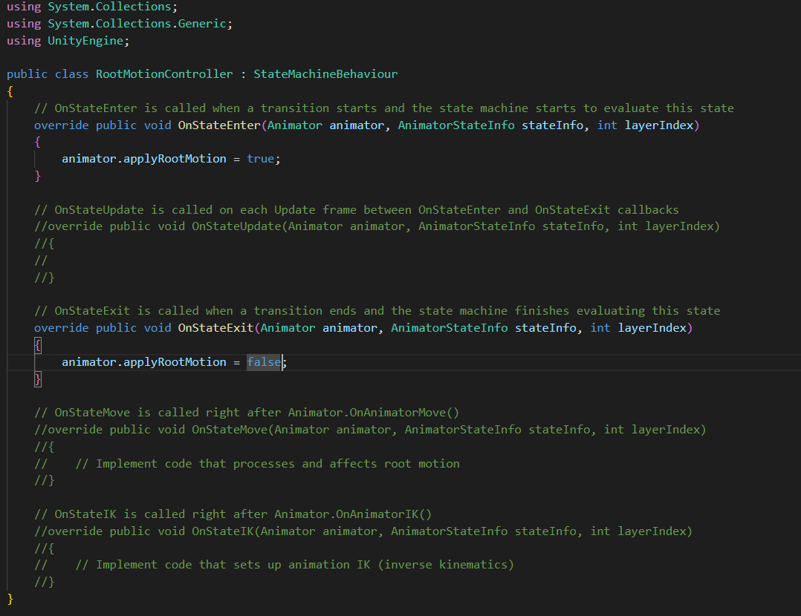

Task 3: Setup the Punch and Hit Reaction Animation
- Set Up Animations:
  - Select each animation file.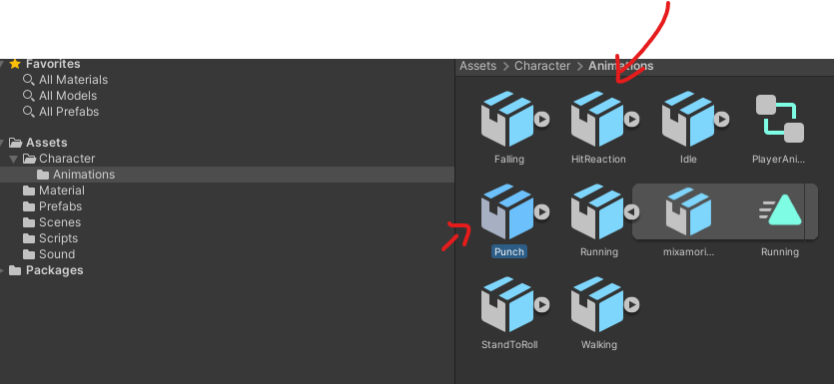
  - In the Inspector, go to the Rig tab and set Animation Type to Humanoid.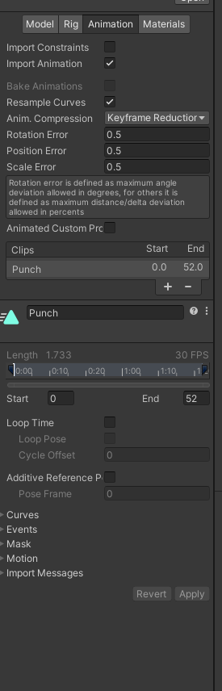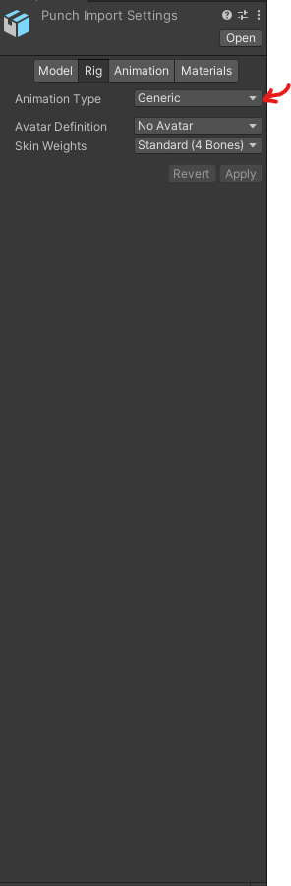
  - Set Avatar Definition to Copy From Other Avatar.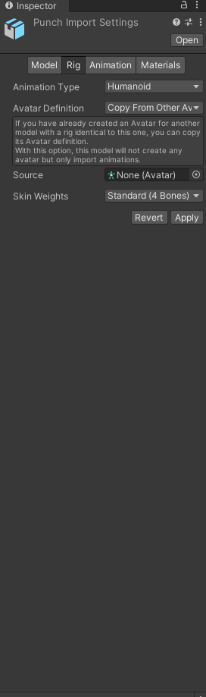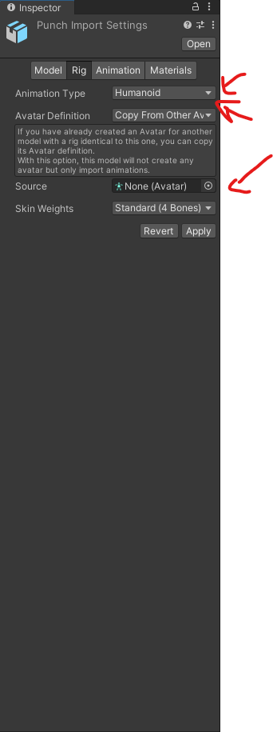
  - Select the enemy avatar or create one if not existing.Click Apply.

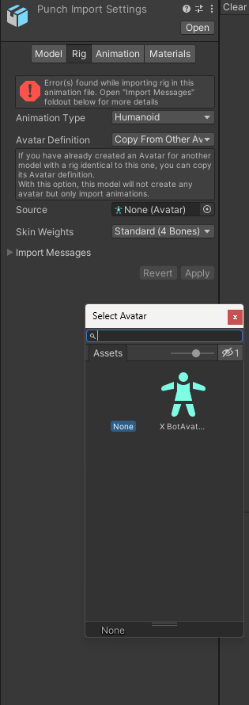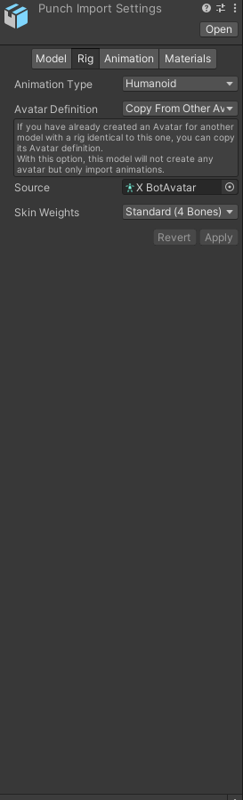
Do the same thing for the HitReaction Animation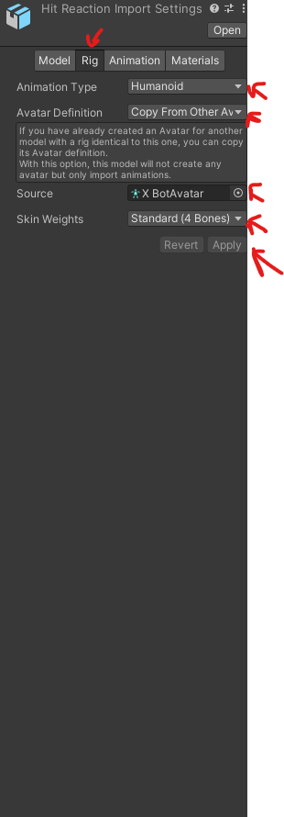

Reajust the initial rotation in the Punch animation :
Modify the offset to put -45 degrees in it.
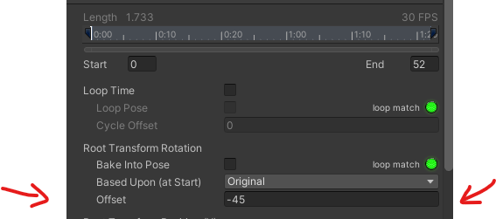

Task 2: Create an Animator for the Enemy
- Create Animator Controller:
  - Right-click in the Project window and select Create > Animator Controller.
  - Name it EnemyAnimator.

- Assign Animator to Enemy:
  - Select your enemy GameObject in the Hierarchy.
  - In the Inspector, click Add Component and choose Animator.
  - Drag and drop the EnemyAnimator onto the Controller field of the Animator component.
- Open Animator Window:
  - Select EnemyAnimator.
  - Go to Window > Animator to open the Animator window.

- Add Idle Animation:
  - Drag the idle animation clip from the Project window into the Animator.
  - Set it as the Default State by right-clicking and selecting Set as Layer Default State.
  - 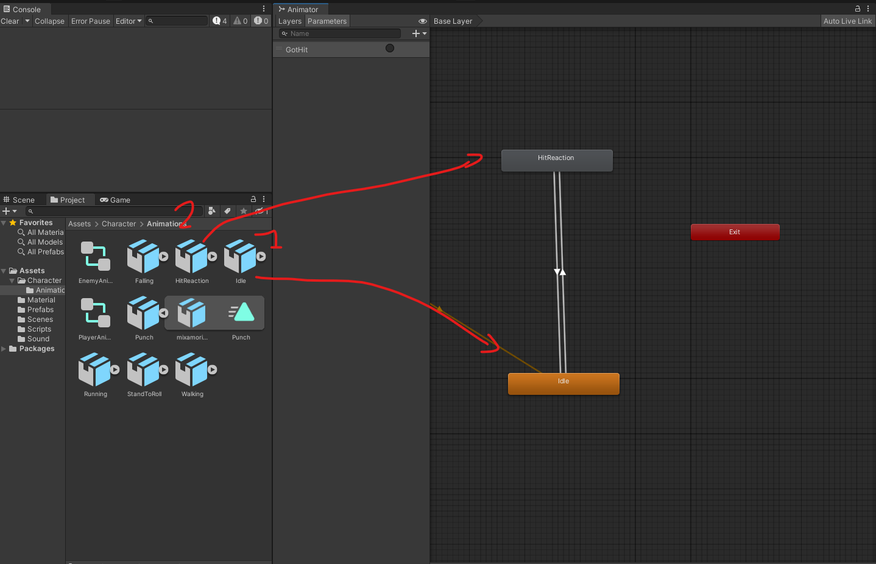
- Add Hit Reaction Animation:
  - Drag the hit reaction animation clip into the Animator.
- Create Transition with Trigger:
  - Select the transition from Idle to Hit Reaction.
  - In the Inspector, under Conditions, add a new Trigger parameter (e.g., GotHit).
  - Set the condition for the transition to the GotHit trigger.
  - 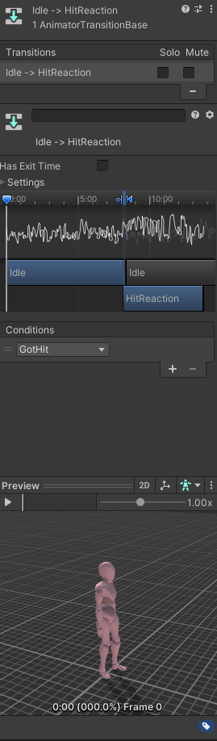

- Set Transition Back to Idle:
  - Create a transition from Hit Reaction back to Idle.
  - Ensure there are no conditions for this transition.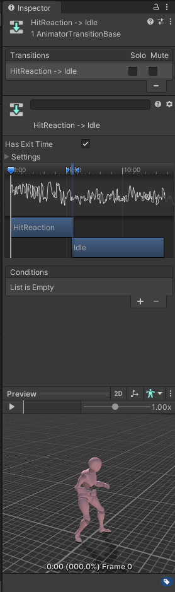

Task 4: Modify the Player Animator to Add the Attack ( Punch ) Animations

- Open Player Animator Controller:
  - Select your player's Animator Controller (e.g., PlayerAnimator).
  - Open the Animator window.
- Add Attack Animations:
  - Drag the attack animation clips into the Animator.
- Create Parameters:
  - In the Animator window, click the Parameters tab.
  - Add a Trigger parameter for the attack (e.g., doPunch)
- Set Up Transitions:
  - Create transitions from the appropriate states (e.g., from Idle/walk/run) to the attack animation.
  - Set the condition for each transition to its corresponding trigger.
- Transition Back to Idle or Movement:
  - Create transitions from each attack animation back to Idle/walk/run or Movement.
  - Ensure there are no conditions for these transitions.
- Modify the PlayerAnimationManager to add your Trigger :
using System.Collections;
using System.Collections.Generic;
using UnityEngine;
public class PlayerAnimationManager : MonoBehaviour
{
private Animator animator;
private PlayerMovement movement;
public void Start()
{
animator = GetComponent<Animator>();
movement = GetComponent<PlayerMovement>();
}
public void LateUpdate()
{
if (animator == null || movement == null)
{
Return;
}
animator.SetFloat("CharacterSpeed", movement.GetMoveSpeed());
animator.SetBool("IsFalling",!movement.isGrounded);
if (Input.GetButtonUp("Fire1"))
{
animator.SetTrigger("doRoll");
}
if (Input.GetButtonUp("Fire2"))
{
animator.SetTrigger("doPunch");
}
}

}

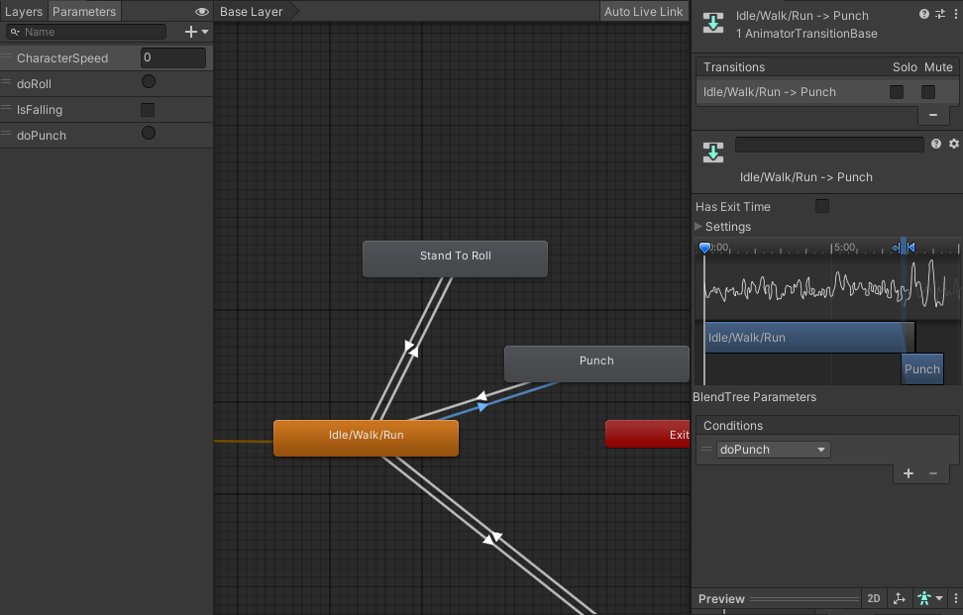

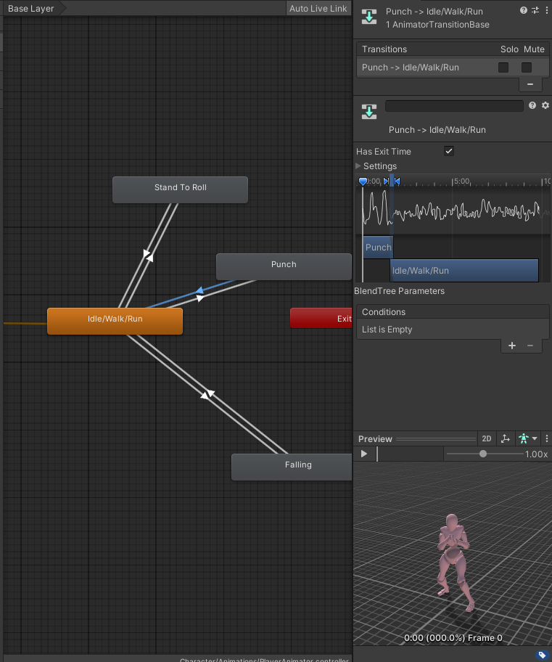

Task 6: Add to the Colliders to the fists

Access the Character's Bone Hierarchy
- Expand the Character's Hierarchy:
  - In the Hierarchy window, expand your character's GameObject by clicking the arrow next to its name.
  - Continue expanding the child objects until you reach the hand bones.
- Locate the Hand Bones:
  - Typically, the path to the hand bones is:
    - CharacterName
      - Hips
        - Spine
          - Chest
            - UpperChest (if available)
              - LeftShoulder / RightShoulder
              - LeftArm / RightArm
              - Left ForeArm/RightForearm
              - LeftHand/RigthHand,

Step 4: Add Colliders to the Hands 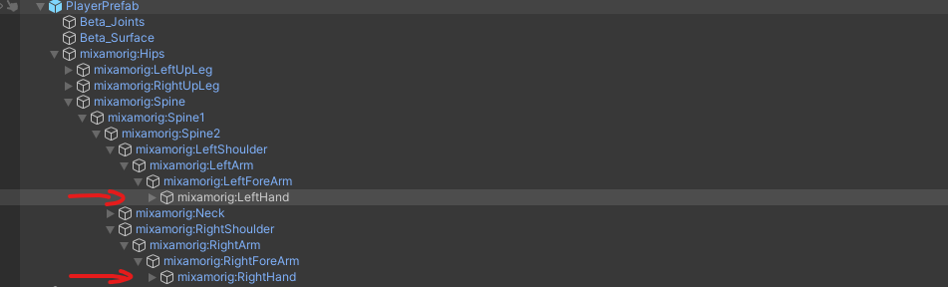

For the Right Hand:

- Select the RightHand Bone:
  - Click on the RightHand GameObject in the Hierarchy.
  - Note : If you want to add a weapon to a Character you would add it as a child of the RightHand object
- Add a Collider Component:
  - In the Inspector, click on Add Component.
  - Type Capsule Collider in the search bar and select it.
- Adjust the Collider:
  - Center: Adjust the Center values to align the collider with the hand mesh.
  - Radius and Height: Modify the Radius and Height to encompass the hand.
  - Direction: Set the Direction (X, Y, or Z) based on the orientation of the hand bone.
- Make sure it is a Trigger
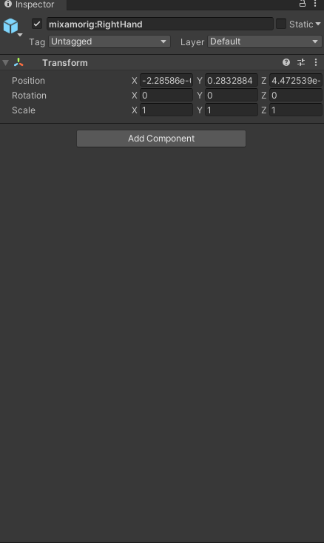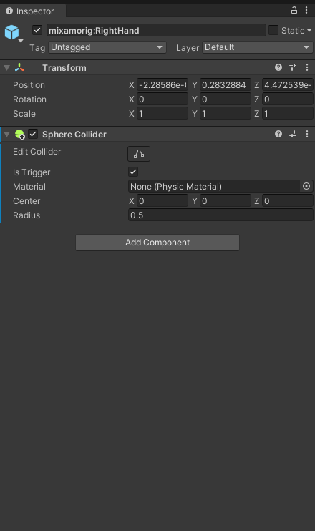

For the Left H
- Select the LeftHand Bone:
  - Click on the LeftHand GameObject in the Hierarchy.
- Add a Collider Component:
  - Repeat the same steps as for the right hand.
- Adjust the Collider:
  - Configure the collider to fit the left hand, similar to how you did for the right hand.

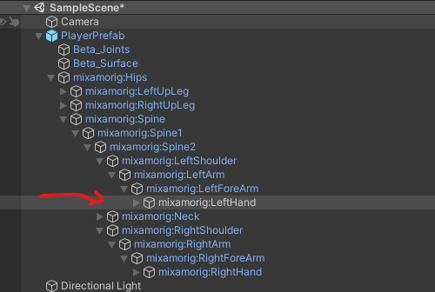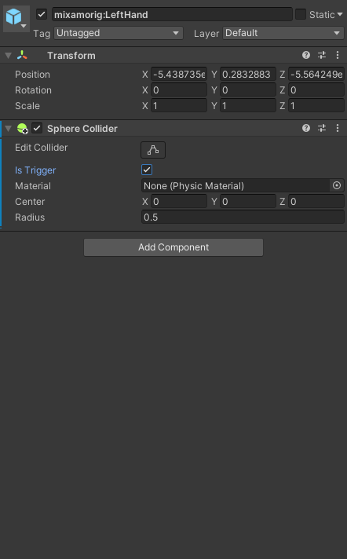

4.3 Implement the Hit Detection Logic
Open the script and write the following code:

using UnityEngine;

public class HitDetector : MonoBehaviour
{
private void OnTriggerEnter(Collider other)
{
if (other.CompareTag("Enemy"))
{
EnemyController enemyController = other.GetComponent<EnemyController>();
if (enemyController != null)
{
enemyController.GotHit();
}
}
}

Add this script to both fists
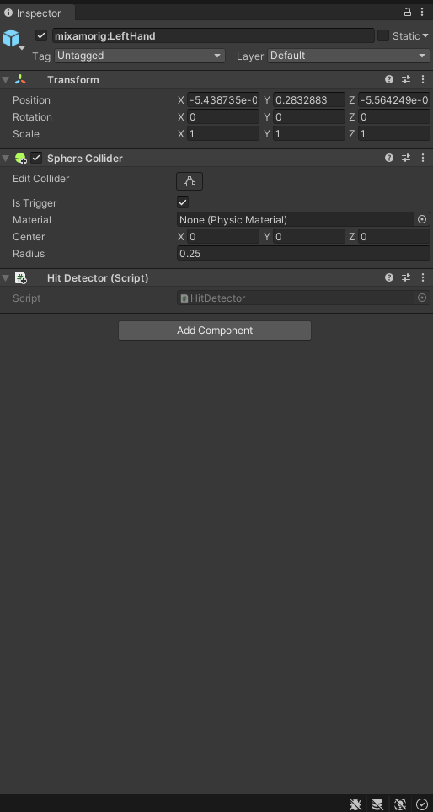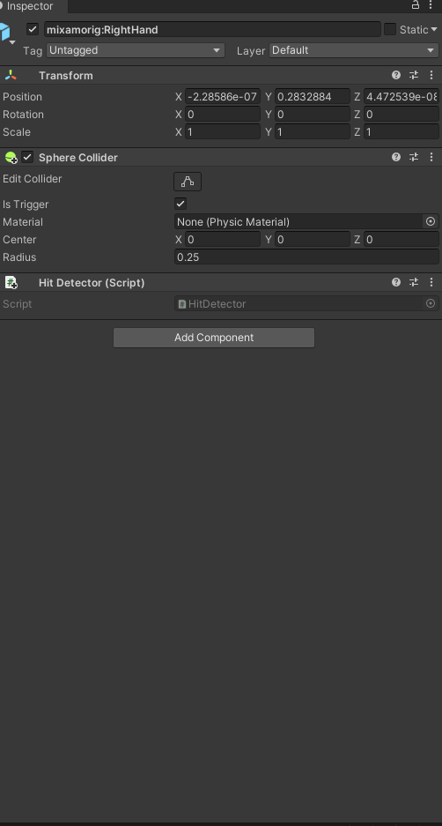

Step 5: Synchronizing Hit Detection with Animations

5.1 Disabling the Collider by Default
Create a HitboxManagerScript script, modify the Start method to disable the colliders initially:

public Collider[] attackColliders;
void Start()
{
foreach( Collider attackCollider in attackColliders)
{
attackCollider.enabled = false; // Disable collider at start
}

}

5.2 Creating Functions to Enable/Disable the Collider
Add the following methods to the script:
public void EnableHitbox()
{
foreach( Collider attackCollider in attackColliders)
{
attackCollider.enabled = true;
}
}

public void DisableHitbox()
{
foreach( Collider attackCollider in attackColliders)
{
attackCollider.enabled = false;
}
}

The full script should look like this :
using System.Collections;
using System.Collections.Generic;
using UnityEngine;

public class HitBoxManager : MonoBehaviour
{
// Start is called before the first frame update
public Collider[] attackColliders;
void Start()
{
foreach( Collider attackCollider in attackColliders)
{
attackCollider.enabled = false; // Disable collider at start
}

}

public void EnableHitbox()
{
foreach( Collider attackCollider in attackColliders)
{
attackCollider.enabled = true;
}
}

public void DisableHitbox()
{
foreach( Collider attackCollider in attackColliders)
{
attackCollider.enabled = false;
}
}
}

Now we need to add the two hands colliders
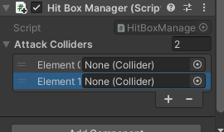

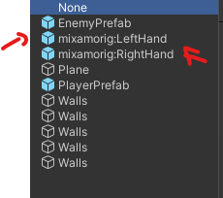

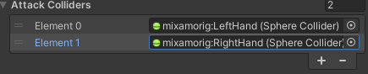

5.3 Adding Animation Events
- Select the Punch animation in the project Hierachy
- In the animation Tab go down to the section called Events
- .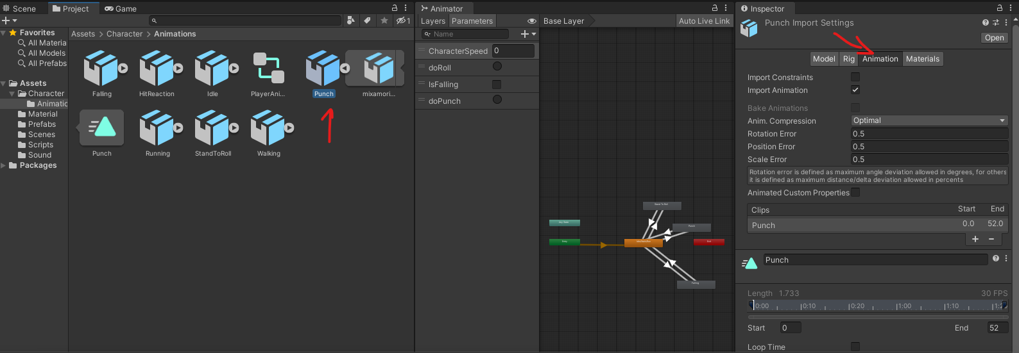
- 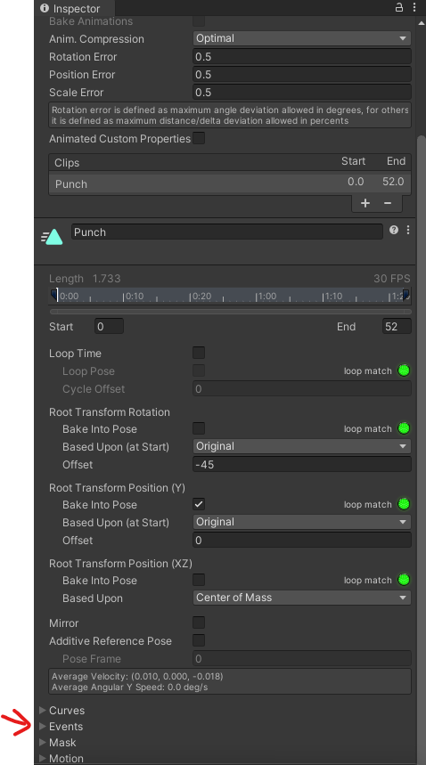
- Click the Add Event button (looks like a white marker).
- In the Inspector, set the function to EnableHitbox.
- 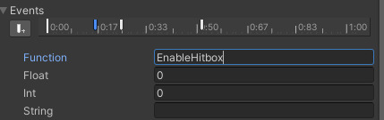
- Move to the frame where the attack should stop dealing damage.
- Add another event and set the function to DisableHitbox.
- 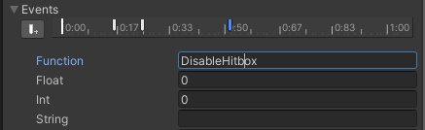

Task 7: Add a Particle System Component to the Enemy GameObject
- Select Enemy GameObject:
  - In the Hierarchy, select your enemy GameObject.
- Add Particle System:
  - In the Inspector, click Add Component.
  - Choose Particle System.
- Configure Particle System:
  - Adjust the particle system settings as desired (e.g., shape, emission rate, lifetime).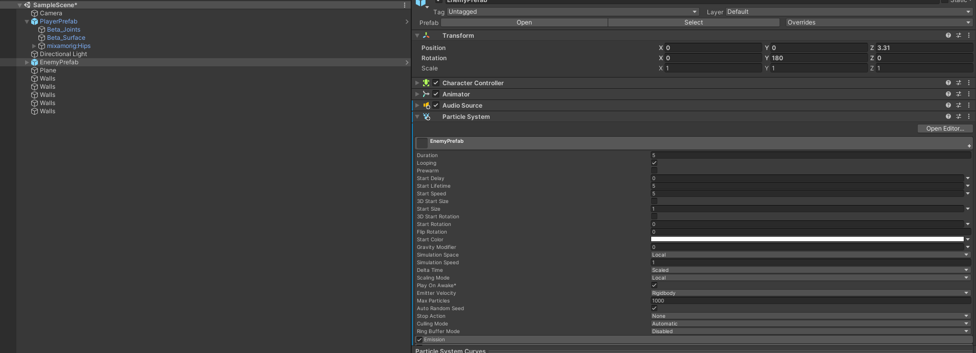
  - Uncheck Play On Awake to prevent it from playing automatically.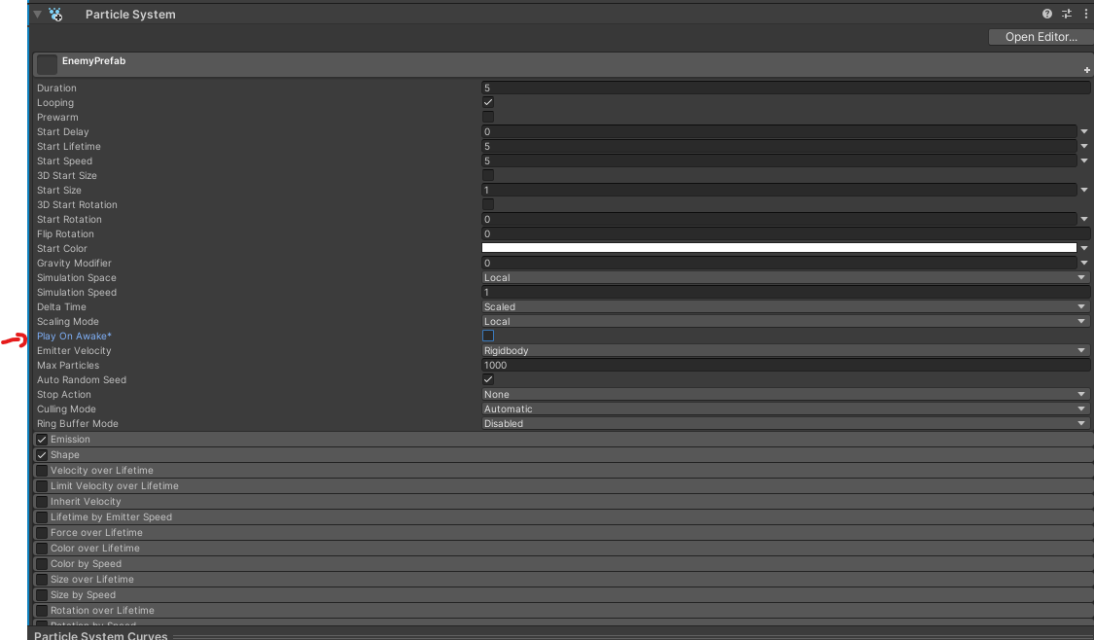
  - Set the renderer to cubes and assign it a material
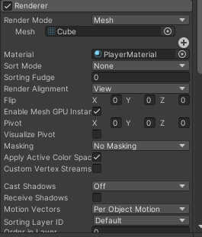\

Task 7: When the Enemy Gets Hit, Play the Reaction Animation, Particle System, and Sound
- Create Hit Sound:
  - Import the hit sound effect into the Project window.
- Add Audio Source to Enemy:
  - Select the enemy GameObject.
  - Click Add Component and choose Audio Source.
  - Uncheck Play On Awake.
- Create Enemy Script:
  - In the Project window, create a new C# script named EnemyController.
- Edit the Enemy Script:

using UnityEngine;

public class EnemyController : MonoBehaviour
{
private Animator animator;
private ParticleSystem hitParticles;
private AudioSource audioSource;

void Start()
{
animator = GetComponent<Animator>();
hitParticles = GetComponent<ParticleSystem>();
audioSource = GetComponent<AudioSource>();
}

public void GotHit()
{
animator.SetTrigger("GotHit");
hitParticles.Play();
audioSource.Play();
GameManager.Instance.IncrementScore();
}
}

- Assign Hit Sound:
  - In the Inspector, assign the hit sound to the Audio Source component.
  - 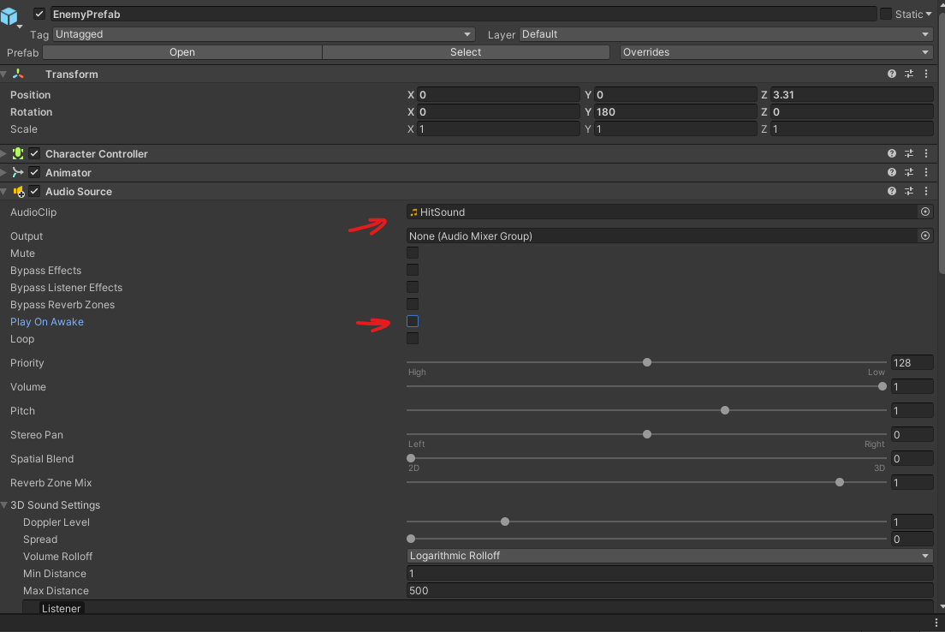
- Set Up Animator Trigger:
  - Ensure the GotHit trigger is set up in the enemy's Animator Controller.

Task 8: When the Enemy Gets Hit, Increment the Score in the Game Manager Singleton
- Create GameManager Singleton:
  - In the Project window, create a new C# script named GameManager.
- Edit the GameManager Script:
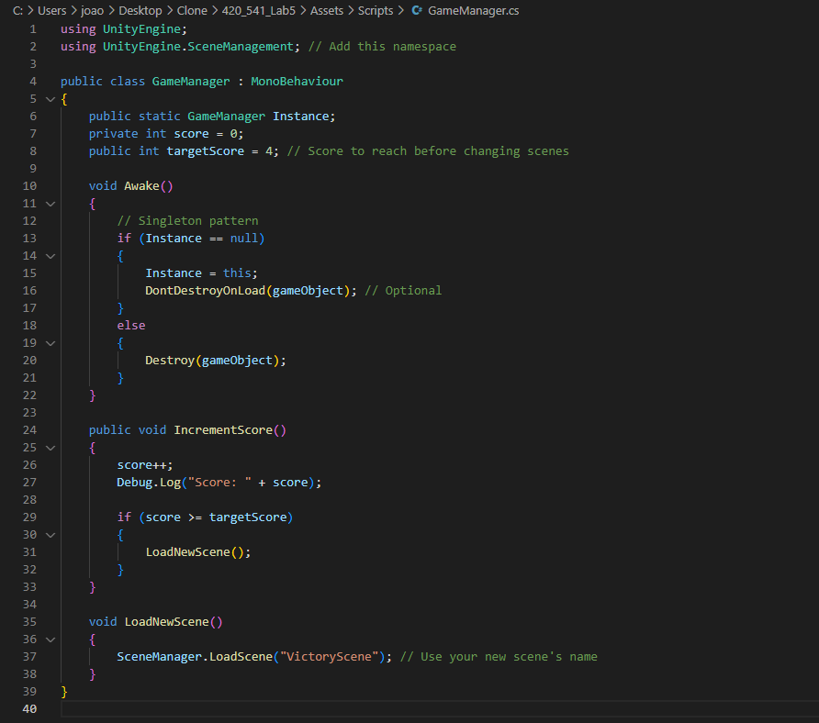
The dont destroy on load will make sure the game manager stays active between scene loading.

- Add GameManager to Scene:
  - Create an empty GameObject in the Hierarchy.
  - Name it GameManager.
  - Attach the GameManager script to it.

- Ensure Enemy Calls IncrementScore():
  - Confirm that the GetHit() method in EnemyController calls GameManager.Instance.IncrementScore();.

Task 7: Add Animation Event to Play Sounds When You Punch

- Create a script on the player called PlayerAudioManager 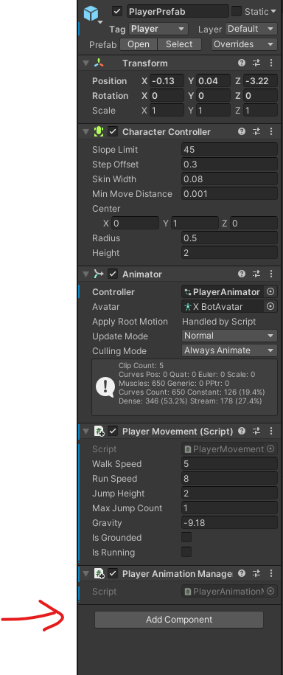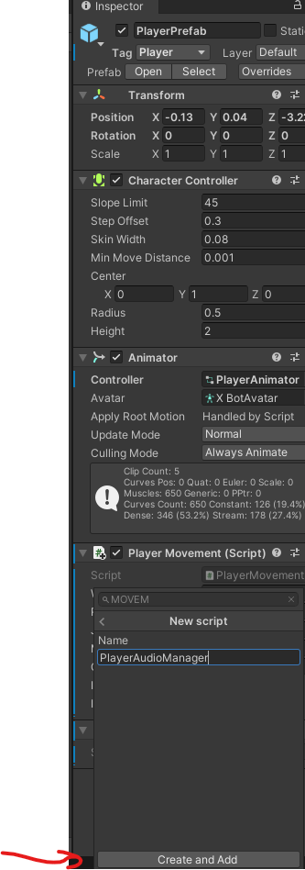
- Create Audio Source:
  - Select the player GameObject.
  - In the Inspector, click Add Component and choose Audio Source.
  - Uncheck Play On Awake.
  - 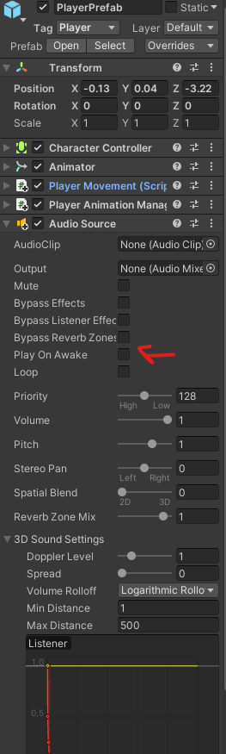
- Add Audio Clip Reference:
  - In the script, add a reference to the Audio Source:
  - By click the little circle and then selecting the PunchSound

  - 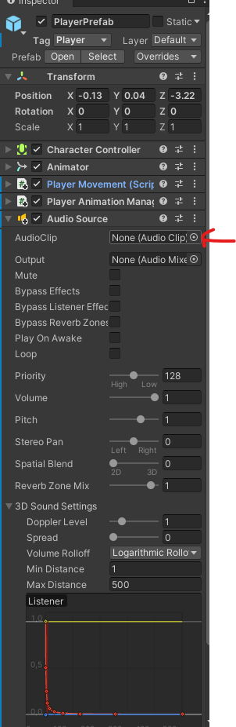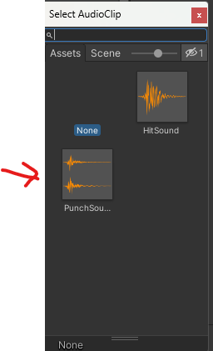

Now lets code the PlayerAudioManager:
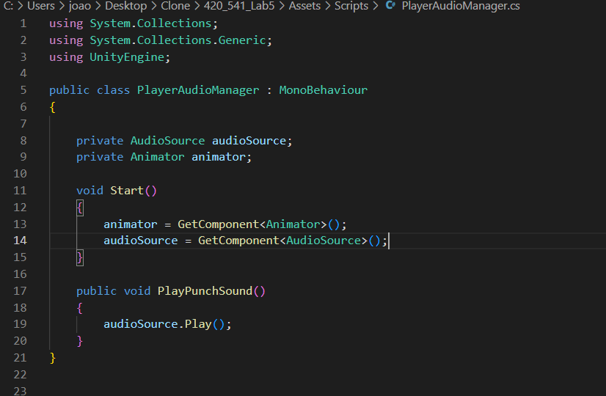
- Add Animation Events to Attack Animations:
  - Select the punch attack animation clip.
  - 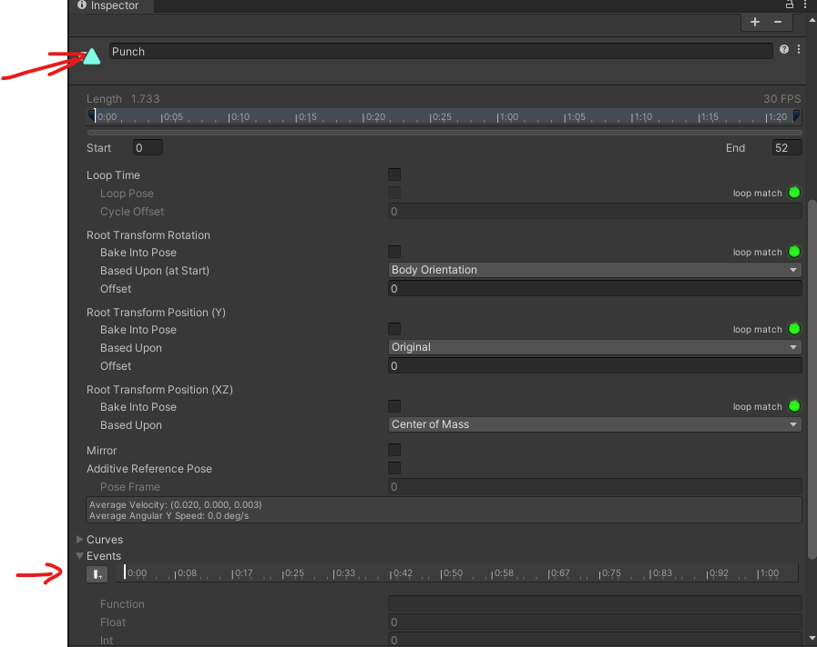

  - Open the Animation window.
  - Move the playhead to the frame where the punch occurs.
  - Click Add Event.
  - In the event, type PlayPunchSound.
  - 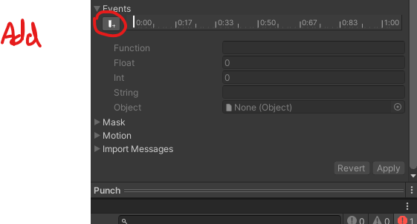

Task 9: Create a New Scene and Save It
- Create New Scene:
  - Go to File > New Scene.
- Set Up Scene (Optional):
  - Add any GameObjects or settings needed for the new scene.
- Save the Scene:
  - Go to File > Save As.
  - Name the scene (e.g., VictoryScene.unity) and save it in your Scenes folder.
  - 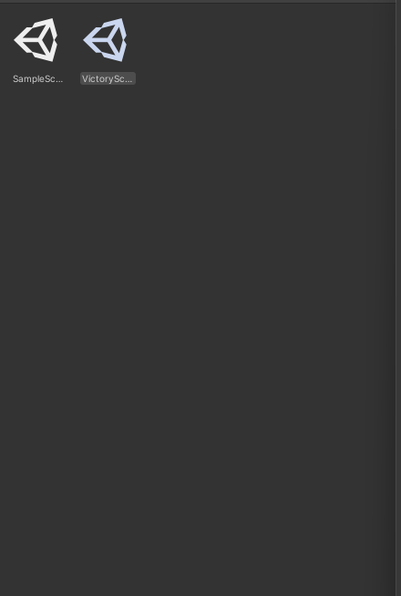

Task 11: Add Your New Scene to the Build Settings
- Open Build Settings:
  - Go to File > Build Settings.
  - 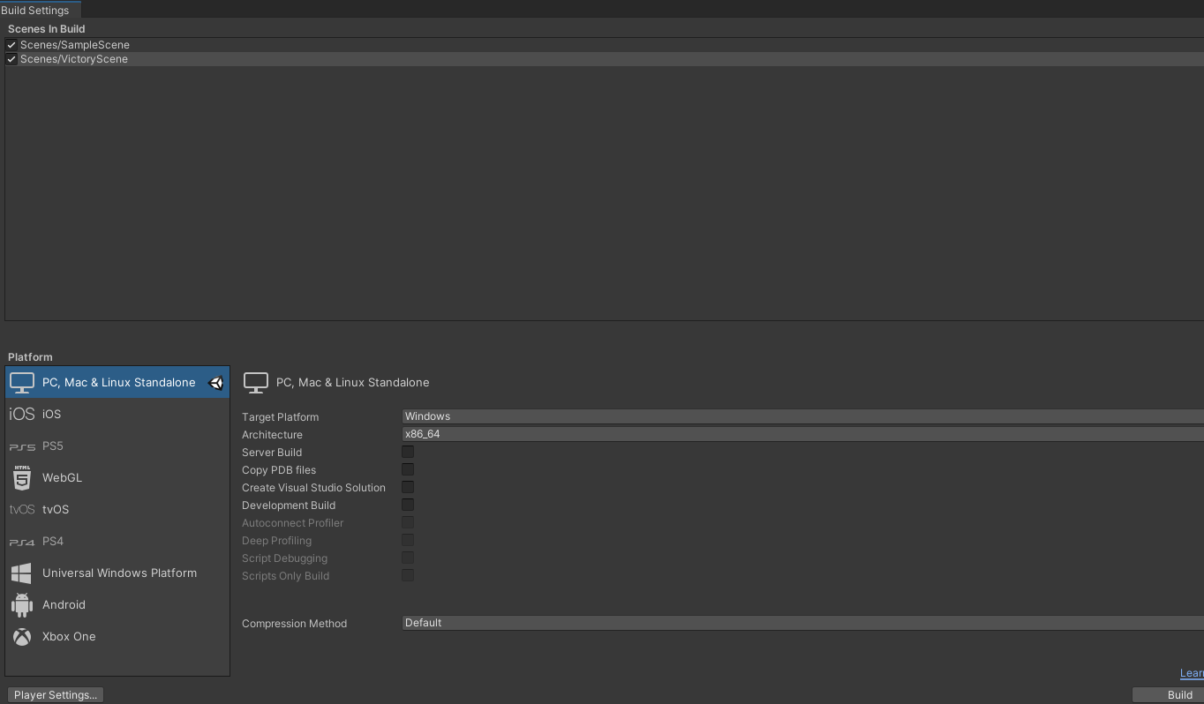
- Add Open Scenes:
  - With your new scene open, click Add Open Scenes.
  - Ensure both your main game scene and the new scene are listed in the Scenes In Build.
- Verify Scene Order:
  - Check that the scenes are in the correct order or adjust as needed.

Git: https://github.com/ralphban/GameProgLab5

