Overview

Hi,

React.js is good starting point for having a crack at the front end is by and experiencing designs first hand. I’ve created the following document to help you out getting started and setting you up into the dev world below.

Even though what you will learn is mainly web based applications, the fundamental concepts learned here will give you some understanding of what you need to know before heading to game development.

If at any stage you get stuck or have any questions, feel free to reach out. Just note, for the majority of what is to follow, I’m going to assume you know little to nothing about most of the stuff. But I’ll try to walk you through it as best I can.

First you will need to install two tools,

* [Visual Studio Code - Code Editing. Redefined](https://code.visualstudio.com/)
* and [Node.js — Run JavaScript Everywhere](https://nodejs.org/en)

If you are not familiar with Visual studio, there are some quick install and basic layout tutorials on YouTube you can search for. Most of them cover the basics.

Node.js on the other hand is basically just a building package you will need to be able to use React.js on your system.

Let’s jump in

1. Head to the following link in your browser: [ralphbotes/react-dev-starter-template](https://github.com/ralphbotes/react-dev-starter-template)
2. If you are not familiar, Github is the go to cloud platform where most developers use to “SAVE” their code. When you are starting out, its good to leave it for later as it may be overwhelming at first. So to spare you we will go the easy route. But feel free to watch some videos on YouTube about GitHub at a later stage to learn how to use it. It’s a “Code SAVER” (pun intended).
3. On open you should see a Green “Code” code button. Click it then select the “Download Zip” option and proceed t download and save the ZIP to your downloads folder. 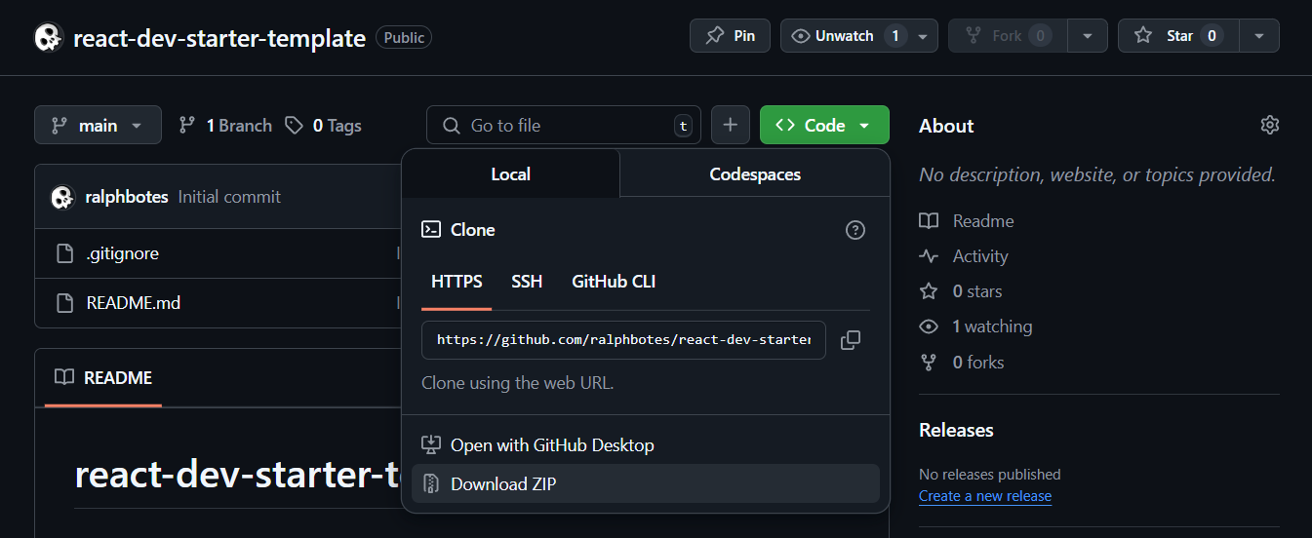
4. After it downloaded, head over to your downloaded file, right click on it and select the “Extract All…” option. Then select “Extract” again on the popup.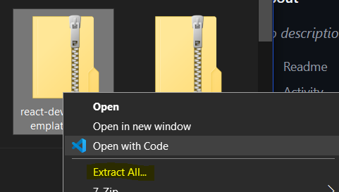
5. Take the new extracted file and move it to another location on your system so you do not delete it by accident later on. It’s usually a good idea to have a dedicated folder for projects, example C:/Projects.
6. Now open Visual Studio Code.
7. In your toolbar, select “File” then select the “Open Folder” option. 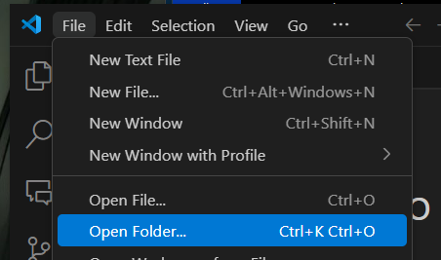
8. Go to where your folder is saved on your system, select it and select the “Select Folder” button at the bottom right of the popup.
9. Now open a new Terminal. A screenshot of a computer

   AI-generated content may be incorrect.
10. Type ***npm install*** and press enter. A black screen with white text

    AI-generated content may be incorrect.
11. If you get a warning like this one at any stage of working with npm: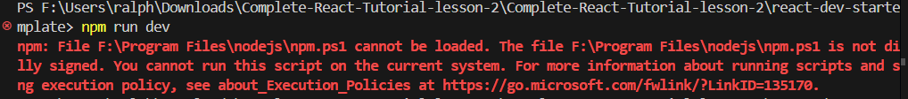
12. Run the following command in the terminal to overwrite it ***Set-ExecutionPolicy -Scope Process -ExecutionPolicy Bypass***
13. If asked for permitions like so:A computer screen with text

    AI-generated content may be incorrect.
14. Press ***A*** and then enter to accept all.
15. If you had the above issue, retry entering ***npm install*** again and it should go through no issues. Then wait for it to finish. It may take some time so be patient. Go have a wizz.
16. After the install completed, run the following command: ***npm start***
17. Again, this may take some time, your browser should open on the following url when startup has succeeded: ***http://localhost:3000/***
18. This is your web app and here you will be able to play around on. Whenever you want to start a new project again, you can just follow these exact same steps, and you’ll get a new clean web app to play with.
19. To stop your web app, simply go back to the terminal, select it and click ***Crtl + C*** on your keyboard.