Student Workshop on Modern Laser Technology

DAMOP2005
Lincoln, NE

17 May 2005
1:00 to 5:00 pm in Ferguson Hall
City Campus

Authors: Uiterwaal Batelaan

HANDOUT
1. Propagation of pulses in a dispersive medium

The discussion below is in part an adaptation of Chapter 9 in Anthony Siegman’s book “Lasers” [1]. A pulse propagating (in one dimension) in the positive direction initially (at position ) has a spectrum (Fourier transform) 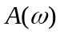, centered around a carrier frequency 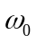:

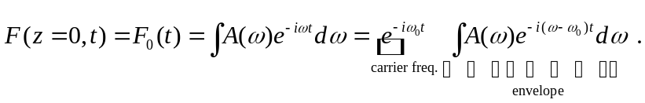

An example of a Fourier transform is given in Flash movie A1 [2]. The pulse propagates in a dispersive medium in which the wavelength is a function of the angular frequency:

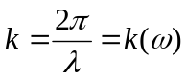.

This relationship is assumed to be valid independent of the pulse intensity. In other words, the medium affects the pulse, but the pulse intensity is assumed not to affect the medium’s properties. A more complicated situation arises when the pulse intensity does alter the medium’s properties; when this happens in optics, we speak of nonlinear optics. For the moment, we only consider linear optics; this is the case usually encountered when pulse intensities are not too strong. Propagation from to causes each frequency component of the pulse to change its phase according to

The pulse spectrum is modified while the pulse propagates. This implies that the pulse itself changes shape, because it is the inverse Fourier transform of the spectrum. A few typical and important cases of dispersion and the resulting pulse propagation are discussed below. They are also exemplified in Flash movies B1 and B2.

0. No dispersion

The first case we look at is

.

In this case, we have distortion-free propagation:

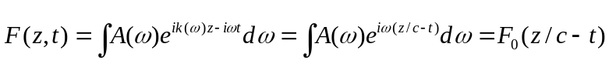

A typical example is a light pulse in vacuum. The speed 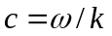 is called the phase velocity, and can be written as 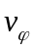. An alternative view of the same propagation is

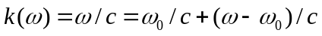

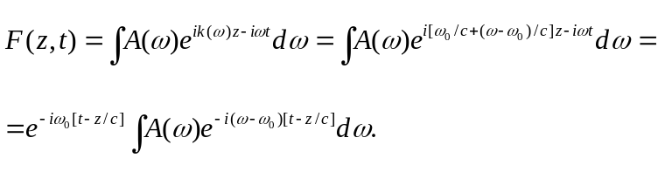

1. First-order term: group velocity

In a more general case, we expand the wavenumber as

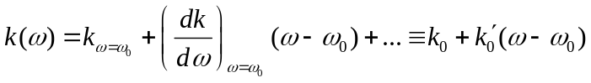,

so up to first order in 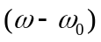. The pulse now propagates according to

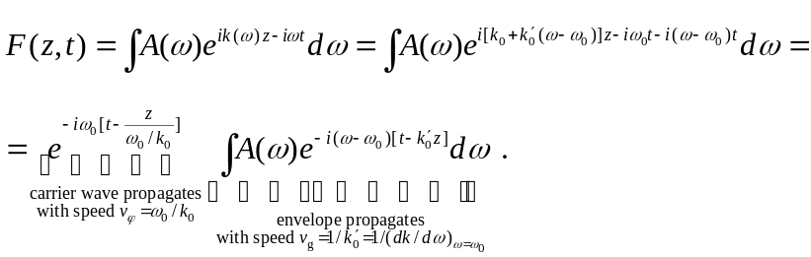

The velocity 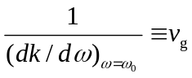 is called the group velocity. It determines the speed with which the envelope propagates. This behavior is visualized in Flash movie A2. Note: For the dispersion-free case, we have 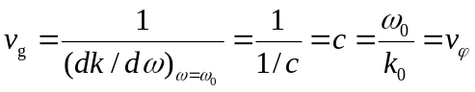 so the carrier and the envelope travel at the same speed.

2. Second-order term: group velocity dispersion

In an even more general case, we can expand the wavenumber up to second order in :

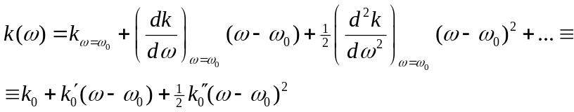

In this case, we find for the propagating pulse

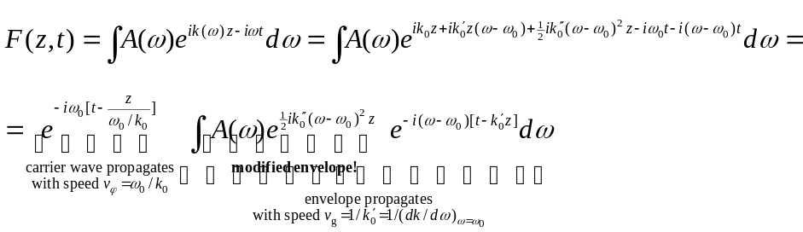

The envelope is modified! To get a good understanding of what happens here, it is useful to investigate a Gaussian pulse with a complex-valued envelope:

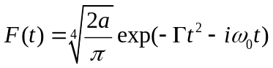 with .

The complex-valued parameter is called the complex beam parameter. The corresponding frequency spectrum is (Fourier transform):
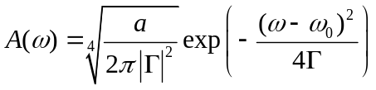.

The parameters and are interpreted as follows:

pulse duration: 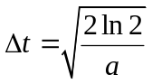
chirp:
for 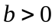: positive chirp, red 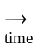 blue
for 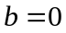: no chirp
for 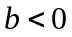: negative chirp, blue red
bandwidth: 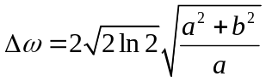 is constant (linear process)

The effect of the second-order term is to modify the complex-beam parameter:

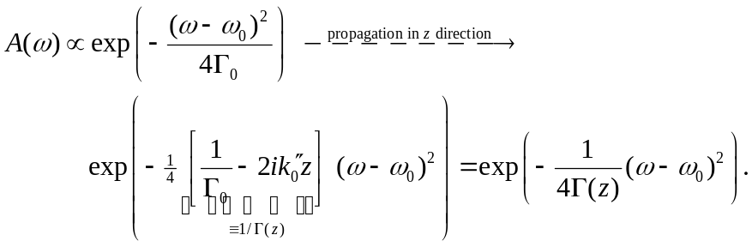

When , the imaginary part of vanishes, and there is no chirp. This happens when 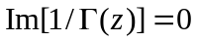. To find out where an unchirped pulse occurs, we therefore look at

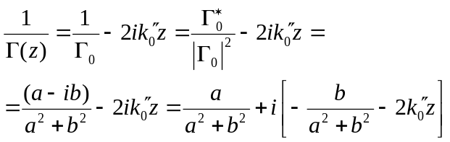

The position with zero chirp is thus 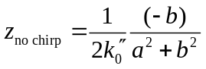. It is positive when (the initial chirp) and 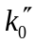 (the so-called group velocity dispersion, or GVD) of the medium are of unlike sign. The typical case 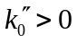 is called normal dispersion; the case 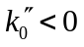 is called anomalous dispersion. For a material with normal dispersion, the imaginary component of 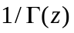 will become negative for 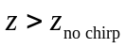. This implies 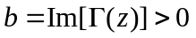: the chirp will become positive.

As the pulse propagates, its duration changes with the chirp. The time-bandwidth product is

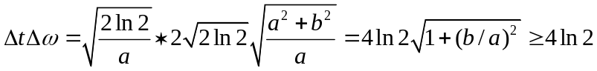.

Now the bandwidth is fixed (linear, absorption-free process), so we have for the pulse duration:

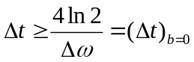.

We see that for a given bandwidth the shortest pulse occurs when there is no chirp. One often calls a chirp-free pulse a transform-limited pulse. For a given pulse energy, this pulse has the highest peak intensity. These effects are illustrated in Flash movie B3.
2. A dispersive medium

In the previous section we described how a pulse propagates through a medium with a known dispersion relation. How do you calculate the dispersion relation, or equivalently, the index of refraction for a medium? A useful model that describes the types of media that we are interested in within the context of this Tutorial can be modeled with a multi-level atom. We will here summarize the initial part of the approach to slowing presented in Peter Milonni’s book [3]; “Fast Light, Slow Light and Left-Handed Light.” Consider the level diagram of Figure 1.
1
2
3
Ω_{c}
Ω_{p}
Figure 1. Three-level scheme to obtain negative slope for the index of refraction. We can essentially model a two-level system by turning the “coupling” field off; Ω_{c}=0.
The Hamiltonian for the three-level system of Fig. 1 is

, (2.1)

where 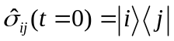, μ is the transition dipole moment and E_{i} is the energy of the state 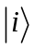. As in the previous section, the electric field, E(t), is considered to be classical. The evolution of the operators 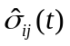 is given by the Heisenberg equation of motion

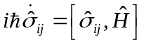. (2.2)

By combining Eqs. (2.1) and (2.2) the evolution equations can be obtained. The combined electric field (coupling, ‘c’, and probe field, ‘p’) are given by

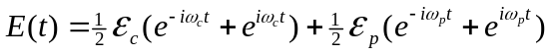. (2.3)
The electric field amplitudes are related to the Rabi frequencies indicated in Fig. 1 by
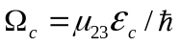. Making the usual rotating wave approximation, assuming that the probe field is weak, choosing the coupling field on resonance, and introducing decay rates 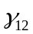 and 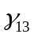, the steady state solution for the system can be found. The expectation value 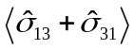 determines the induced dipole moment and thus also the refractive index as experienced by the probe field. The result is that the real part of the index of refraction is given by

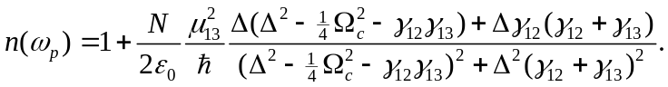 (2.4)

The imaginary part of the index of refraction is given by

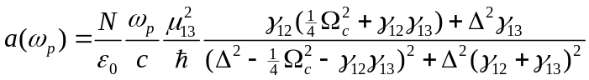. (2.5)

The behavior of these functions is indicated in Flash movie A3. Two important features can be obtained with the sketched model. When the coupling laser is turned on the index of refraction can be made positive, which allows the group velocity to be reduced (remember 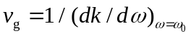). The coupling laser also allows for a strong reduction of the absorption, which is part of the description of electromagnetically induced transparency (EIT).

3. Connection between dispersion of ultrashort pulses and the propagation of slow light.

To see a connection between the dispersion of short pulses and the propagation of slow light, we can compare the propagation of a laser pulse through a medium on resonance and very far off resonance. On resonance we will find the slow light behavior, while very far off resonance we will find ultrashort pulse dispersion. As described in Sec. 1, we inspect the dispersion to understand pulse propagation. In Sec. 2, a model giving useful dispersion curves are given. Let us inspect these dispersion curves (see Flash movie A3). For the usual dispersion curve associated with a two-level system, the slope of the index of refraction is negative at resonance, while the off-resonant tails have a positive slope. Furthermore, the second derivative as a function of frequency is zero at resonance, while the tails have a non-zero curvature. What are the typical frequency and time scales for resonance and the light pulse? For an atomic resonance the lifetime is typically of the order of 10 ns and the related natural linewidth is 100 MHz. The bandwidth of EIT (not discussed above) is of the order of 100 kHz, and turns out to be narrower than the linewidth. This means that for slowing of light often pulses of several microseconds are used, so that their frequency width does not exceed this bandwidth. The carrier frequency of the light pulse is chosen on a particular atomic resonance and the pulse propagates through a vapor of that atom. In this way we can use the steep slope (modified by a laser coupling the excited state to a third level). If the frequency width were too large the pulse would be absorbed by the medium. For the propagation of ultrashort pulses through air or a liquid, the carrier frequency of the pulse is typically very far off resonance. For a 30 fs pulse the bandwidth is about 30 THz. Usually, the important resonances in the medium are found at much shorter wavelengths (higher frequencies) than the range where for instance a pulsed Ti:sapphire laser works (about 800 nm). This means that the ultrafast pulse experiences a positive linear dispersion, and, more important for our present discussion, a positive quadratic dispersion. This will cause normal dispersion; the pulse will develop a positive chirp. To deliver an intense pulse on target the initial pulse has to be given a negative initial chirp to compensate for this effect (Flash movies B2 and B3). For slow light we thus use a pulse with a bandwidth of less than 10^{–6} nm and linear dispersion, while for ultrafast pulse propagation bandwidths of more than 10 nm and quadratic dispersion are important. It is perhaps amusing to note that such different experimental techniques are described theoretically in such a similar fashion.

References
[1] Anthony Siegman, Lasers, University Science Books (Sausalito, CA), Chapter 9, 1986.
[2] The Flash movies are accessible at http://www.unl.edu/amop/Laser_tutorial_files/shell.html
[3] Peter Milonni, Fast Light, Slow Light and Left-Handed Light. Institute of Physics Publishing (Bristol and Philadelphia), Chapter 5, 2005.

We assume the wavenumber is positive so pulses travel in the +z direction.

