## 新增监控节点信息

http请求：<http://IP>:端口/monitor/snmp/nodecreate

输入：

json={

" ip":"1",//ip

" groupName":"1",//组名

“defaultInterval”:1,//默认采集时间,int类型，单位秒

“cpuInterval”:3,//cpu采集间隔时间,int类型，单位秒

“memoryInterval”: 3,//内存采集间隔时间,int类型，单位秒

“networkInterval”: 3,//网络采集间隔时间,int类型，单位秒

“diskInterval”:2, //硬盘采集间隔时间,int类型，单位秒

“monitorProcess”: "1", //监控进程名称，不同进程间用逗号分隔,没有为空,

“enabled”:true,//是否启用，boolea类型

“creator”:”admin”,//操作人

“templateId”:222//snmp模板id,int类型

}

输出：

{"errorCode":0,"errorMessage":"SUCCESS",

"data":””,"pageNo":0,"pageSize":0,"totalPage":0,"total":0}

请求实例如下图：

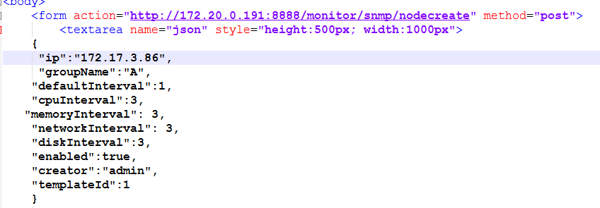

## 二、获取单个监控节点信息

http请求：<http://IP>:端口/monitor/snmp/nodeget

输入：

nodeId=333//监控节点ID

输出：

{"errorCode":0,"errorMessage":"SUCCESS",

"data":

{"nodeId":17809,//监控点击ID

"template":{"templateId":1,"templateName":"name","templateType":1,"communityRead":"1","communityWrite":"1","userName":"1","contextName":"1","authProtocol":"1","encryProtocol":"1","port":1,"timeout":111,"retrys":1,"enabled":true},//模板内容

"ip":”172.17.3.86”,//IP地址

"hostName":"optserver.mpay.com2",//主机名

"deviceType":"防火墙",//机器类型

"osType":"win12",//操作系统

"groupName":"1",//组名

"defaultInterval":1,//默认采集时间

"cpuInterval":3,//cpu采集时间

"memoryInterval":3,//内存采集时间

"networkInterval":3,//网络采集时间

"diskInterval":2,//磁盘采集时间

"enabled":true,"//是否可用

“createDate":” 1459230191000,//操作时间,时间毫秒,需要页面自己转

"creator":"admin",//操作人

"status":0,// 0：正常,1：宕机

"templateId":1//模板ID

},"pageNo":0,"pageSize":0,"totalPage":0,"total":0}

请求实例如下图：：

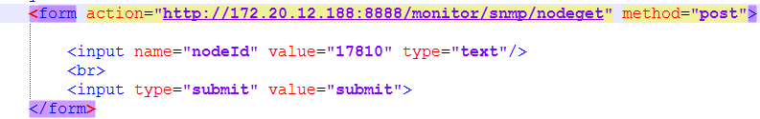

## 分页查询监控节点信息

http请求：<http://IP>:端口/monitor/snmp/ nodesearch

输入：

json={

"ip":"17",//IP或者节点名

"groupName":"1",//组名

"enabled":true,//是否可用

"deviceType":"PLC"//设备类型

}

pageNo=1

pageSize=20

输出：

{"errorCode":0,"errorMessage":"SUCCESS","data":[{"nodeId":17809,"template":{"templateId":1,"templateName":"name","templateType":1,"communityRead":"1","communityWrite":"1","userName":"1","contextName":"1","authProtocol":"1","encryProtocol":"1","port":1,"timeout":111,"retrys":1,"enabled":true} ,"ip":"172.17.3.86","hostName":"optserver.mpay.com2","deviceType":"防火墙","osType":"win12","groupName":"1","defaultInterval":1,"cpuInterval":3,"memoryInterval":3,"networkInterval":3,"diskInterval":2,"enabled":true,"createDate":1459221591000,"creator":"admin","status":0,"templateId":1}],"pageNo":1,"pageSize":10,"totalPage":1,"total":1}//内容解释同获取单个监控节点信息

请求实例如下图：

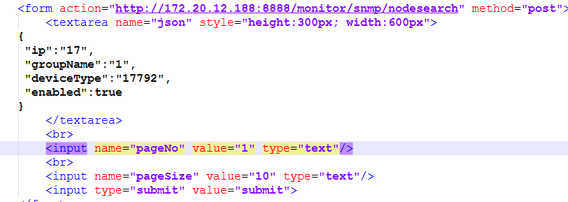

## 修改监控节点

http请求：<http://IP>:端口/monitor/snmp/ nodeupdate

输入：

json={

“nodeId”:”222”,//监控节点ID

" ip":"172.17.3.86",//ip

" groupName":"1",//组名

“defaultInterval”:1,//默认采集时间,int类型，单位秒

“cpuInterval”:3,//cpu采集间隔时间,int类型，单位秒

“memoryInterval”: 3,//内存采集间隔时间,int类型，单位秒

“networkInterval”: 3,//网络采集间隔时间,int类型，单位秒

“diskInterval”:2, //硬盘采集间隔时间,int类型，单位秒

“monitorProcess”: "1", //监控进程名称，不同进程间用逗号分隔,没有为空,

“enabled”:true,//是否启用，boolea类型

“creator”:”admin”,//操作人

“templateId”:222//snmp模板id,int类型

}

输出：

{"errorCode":0,"errorMessage":"SUCCESS",

"data":””,"pageNo":0,"pageSize":0,"totalPage":0,"total":0}

请求实例如下图：

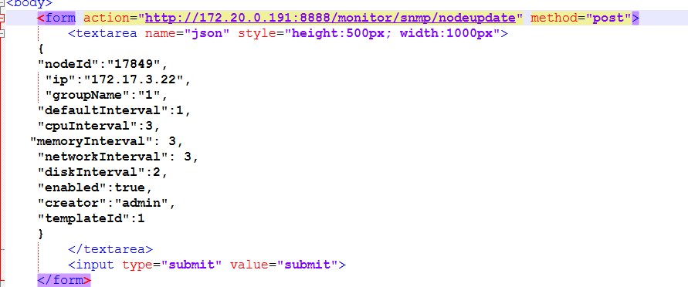

## 删除监控节点

http请求：http://IP:端口/monitor/snmp/ nodedelete

输入：

nodeId=333//监控节点ID

输出：

{"errorCode":0,"errorMessage":"SUCCESS",

"data":””,"pageNo":0,"pageSize":0,"totalPage":0,"total":0}

请求实例如下图：

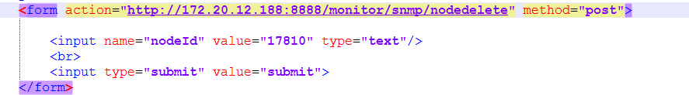

## 新增snmp配置模板

http请求：<http://IP>:端口/monitor/snmp/templatecreate

输入：

json={

"templateName":"li", //模板名称,不能为空

"templateType":1, //模板类型 1:v1/v2,3:v3,int类型，不能为空

"communityRead":"public", //读团体字,没有为空

"communityWrite":"public", //写团体字,没有为空

"userName":"li", //用户名称,不能为空

"contextName":"98942", //上下文名称,没有为空

"authProtocol":"98942", //认证协议, 没有为空

"authPassword":"", //认证密码, 没有为空

"encryProtocol":"98942", //加密协议, 没有为空

"encryPassword":"", //加密密码, 没有为空

"port":123, //端口，int类型，不能为空

"timeout":2, //超时时间(ms), int类型不能为空

"retrys":3, //重试次数, int类型,不能为空

"enabled":true //是否启用 1:是 0:否,Boolean类型, 不能为空(目前不做选择，默认为启用)

}

输出：

{"errorCode":0,"errorMessage":"SUCCESS",

"data":””,"pageNo":0,"pageSize":0,"totalPage":0,"total":0}

请求实例如下图：

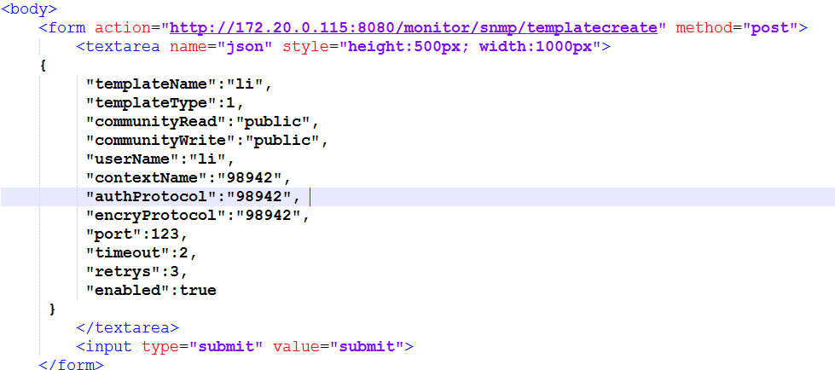

## 分页获取snmp配置模板列表

http请求：<http://IP>:端口/monitor/snmp/templatelistget

输入：

json={

"templateName":"", //模板名称，没有为空

"templateType":0 //模板类型 1:v1/v2,3:v3,int类型,没选为0

}

pageNo=1 //不能为空

pageSize=20 //不能为空

输出：

{"errorCode":0,"errorMessage":"SUCCESS",

"data":[{"templateId":1,"templateName":"name","templateType":1,"communityRead":"1","communityWrite":"1","userName":"1","contextName":"1","authProtocol":"1","encryProtocol":"1","port":1,"timeout":111,"retrys":1,"enabled":true},

{"templateId":2,"templateName":"sada","templateType":1,"communityRead":"1","communityWrite":"1","userName":"1","contextName":"1","authProtocol":"1","encryProtocol":"1","port":1,"timeout":1,"retrys":1,"enabled":true},{"templateId":3,"templateName":"li","templateType":1,"communityRead":"public","communityWrite":"public","userName":"li","contextName":"98942","authProtocol":"98942","encryProtocol":"98942","port":123,"timeout":2,"retrys":3,"enabled":true}],"pageNo":1,"pageSize":20,"totalPage":1,"total":3} 各字段解释同六接口描述所示

请求实例如下图：

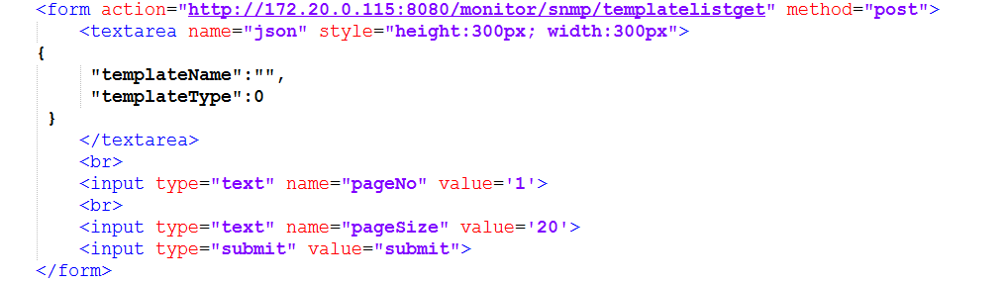

## 获取单个snmp模板配置信息

http请求：<http://IP>:端口/monitor/snmp/templateget

输入：

templateId=2 //模板id

输出：

{"errorCode":0,"errorMessage":"SUCCESS",

"data":{"templateId":2,"templateName":"sada","templateType":1,"communityRead":"1","communityWrite":"1","userName":"1","contextName":"1","authProtocol":"1","encryProtocol":"1","port":1,"timeout":1,"retrys":1,"enabled":true},"pageNo":0,"pageSize":0,"totalPage":0,"total":0}各字段解释同六接口描述所示

请求实例如下图：

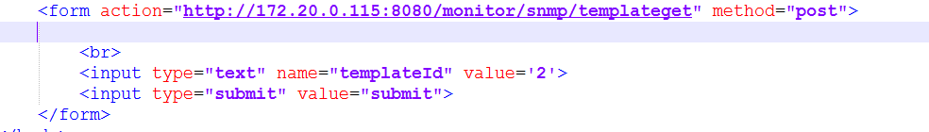

## 删除单个snmp模板配置信息

http请求：<http://IP>:端口/monitor/snmp/ templatedelete

输入：

templateId=1 //模板id

输出：

{"errorCode":1,"errorMessage":"snmp配置模板[name]与监控节点[test3K,test5]已绑定,请先解除关系;","data":"","pageNo":0,"pageSize":0,"totalPage":0,"total":0}

请求实例如下图：

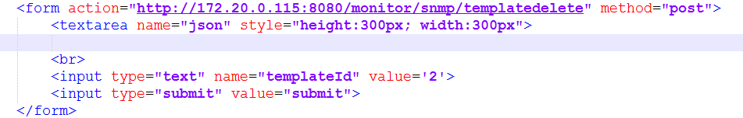

## 更新单个snmp模板配置信息

http请求：<http://IP>:端口/monitor/snmp/templateupdate

输入：

json={

"templateId":1, //模板名称,不能为空

"templateName":"name", //模板名称,不能为空

"templateType":1, //模板类型 1:v1/v2,3:v3,int类型，不能为空

"communityRead":"public", //读团体字,没有为空

"communityWrite":"public", //写团体字,没有为空

"userName":"li", //用户名称,不能为空

"contextName":"", //上下文名称,没有为空

"authProtocol":"", //认证协议, 没有为空

"authPassword":"", //认证密码, 没有为空

"encryProtocol":"", //加密协议, 没有为空

"encryPassword":"", //加密密码, 没有为空

"port":123, //端口，int类型，不能为空

"timeout":2, //超时时间(ms), int类型不能为空

"retrys":3, //重试次数, int类型,不能为空

"enabled":true //是否启用 1:是 0:否,Boolean类型, 不能为空(目前不做选择，默认为启用)

}

输出：

{"errorCode":0,"errorMessage":"SUCCESS","data":"","pageNo":0,"pageSize":0,"totalPage":0,"total":0}

请求实例如下图：

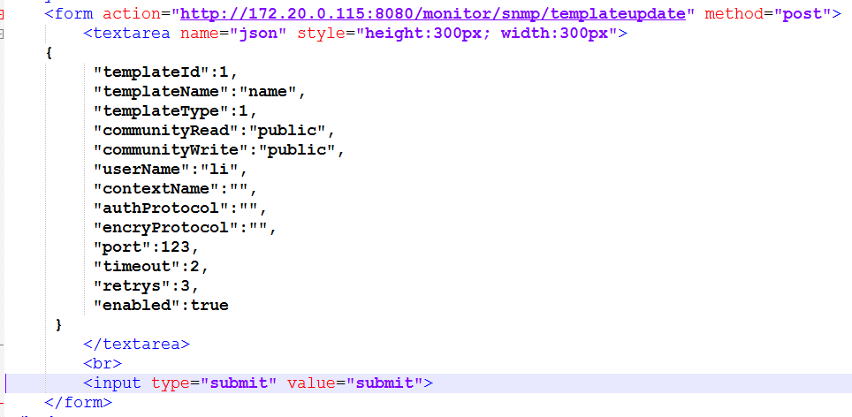

## 批量删除snmp模板配置信息

http请求：<http://IP>:端口/monitor/snmp/templatedeletebatch

输入：

templateIds=”1,3” //模板id,多个id用逗号分隔

输出：0:成功,1:失败,2:部分成功部分失败

{"errorCode":2,"errorMessage":"snmp配置模板[name]与监控节点[test3K,test5]已绑定,请先解除关系;","data":"","pageNo":0,"pageSize":0,"totalPage":0,"total":0}

请求实例如下图：

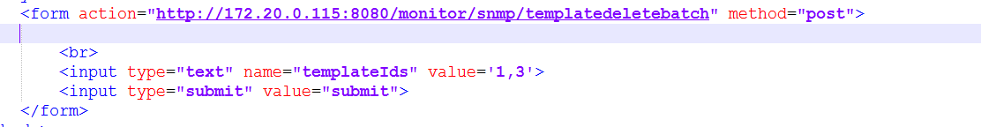

## 获取服务器基本信息

http请求：<http://IP>:端口/monitor/snmp/summary

输入：

ip=172.17.3.86

输出：

{"errorCode":0,"errorMessage":"SUCCESS",

"data":{"sysName":"optserver.mpay.com",//机器名

"sysDescr":"Linux optserver.mpay.com 2.6.39-400.17.1.el6uek.x86_64 #1 SMP Fri Feb 22 18:16:18 PST 2013 x86_64",//系统描述

"sysUpTime":"5时17分19秒,"//系统启动时间

sysStatus":"RUNNING",//系统状态

"totalPhysicalMemory":4069376,//总物理内存

"usedPhysicalMemory":2874112,//使用物理内存

"totalSawpMemory":8136960,//总交换区大小

"usedSawpMemory":5219008,//使用交换区大小

cpuUsages":[1,2],//cpu占用率，每个元素代表一个核

"totalStorage":97744220,//总磁盘容量

"usedStorage":18000942,//已用磁盘容量

"storageDetail":[{"total":495844,"partition":"/boot","used":56270},{"total":44614752,"partition":"/home","used":374392},{"total":1027484,"partition":"/dev/shm","used":0},{"total":51606140,"partition":"/","used":17570280}]},//各分区名称、总容量、已用容量

"pageNo":0,"pageSize":0,"totalPage":0,"total":0}

## 获取TCP链接基本信息

http请求：http://IP:端口/monitor/snmp/tcpconninfo

输入：

ip=172.17.3.86

输出：

{"errorCode":0,"errorMessage":"SUCCESS"

,"data":{

"tcpStatisticData": //tcp状态统计信息

{"timeWait":0,"synSent":0,"finWait2":0,"synReceived":0,"finWait1":0,"deleteTCB":0,"established":0,"closed":0,"closeWait":0,"listen":7,"lastAck":0,"closing":0},

"time":1460011641569,

"tcpConnMsg":[

{"tcpConnRemAddress":"0.0.0.0", //远程地址

"tcpConnLocalAddress":"0.0.0.0", //本地地址

"tcpConnState":"listen", //状态

"tcpConnRemPort":0, //远程端口

"tcpConnLocalPort":22}, //本地端口

{"tcpConnRemAddress":"0.0.0.0","tcpConnLocalAddress":"0.0.0.0","tcpConnState":"listen","tcpConnRemPort":0,"tcpConnLocalPort":111},{"tcpConnRemAddress":"0.0.0.0","tcpConnLocalAddress":"0.0.0.0","tcpConnState":"listen","tcpConnRemPort":0,"tcpConnLocalPort":6379},{"tcpConnRemAddress":"0.0.0.0","tcpConnLocalAddress":"0.0.0.0","tcpConnState":"listen","tcpConnRemPort":0,"tcpConnLocalPort":48127},{"tcpConnRemAddress":"0.0.0.0","tcpConnLocalAddress":"127.0.0.1","tcpConnState":"listen","tcpConnRemPort":0,"tcpConnLocalPort":25},{"tcpConnRemAddress":"0.0.0.0","tcpConnLocalAddress":"127.0.0.1","tcpConnState":"listen","tcpConnRemPort":0,"tcpConnLocalPort":199},{"tcpConnRemAddress":"0.0.0.0","tcpConnLocalAddress":"172.17.3.86","tcpConnState":"listen","tcpConnRemPort":0,"tcpConnLocalPort":11211}],

"ip":"172.17.3.86"},

"pageNo":0,"pageSize":0,"totalPage":0,"total":0}

## 获取服务进程统计信息

http请求：http://IP:端口/monitor/snmp/serviceprocessinfo

输入：

ip=172.17.6.180

输出：

{"errorCode":0,"errorMessage":"SUCCESS",

"data":{

"servProInfoMap":{

"mingetty": //进程名称

{"processNum":6, //进程数

"cpuUsage":"0.0", //cpu总使用率,展示时乘以100,格式化为小数点后两位+百分号，如0.23%,

"memorySpace":"3.3799999", //内存总占用空间,展示时格式化为小数点后两位+单位,如3.38MB,

"running":0,"runnable":6,"notRunnable":0,"invalid":0 //状态

} ,"rsyslogd":{"processNum":1,"cpuUsage":"0.00","memorySpace":"7.89","running":0,"runnable":1,"notRunnable":0,"invalid":0},"snmpd":{"processNum":1,"cpuUsage":"0.54","memorySpace":"11.44","running":1,"runnable":0,"notRunnable":0,"invalid":0},"httpd":{"processNum":9,"cpuUsage":"0.01","memorySpace":"80.42","running":0,"runnable":9,"notRunnable":0,"invalid":0},"puppet":{"processNum":1,"cpuUsage":"0.07","memorySpace":"152.74","running":0,"runnable":1,"notRunnable":0,"invalid":0},"kacpi_hotplug":{"processNum":1,"cpuUsage":"0.00","memorySpace":"0.00","running":0,"runnable":1,"notRunnable":0,"invalid":0},"ntpdate":{"processNum":1,"cpuUsage":"0.00","memorySpace":"1.38","running":0,"runnable":1,"notRunnable":0,"invalid":0},"ata_sff/3":{"processNum":1,"cpuUsage":"0.00","memorySpace":"0.00","running":0,"runnable":1,"notRunnable":0,"invalid":0},"crypto/1":{"processNum":1,"cpuUsage":"0.00","memorySpace":"0.00","running":0,"runnable":1,"notRunnable":0,"invalid":0}}},"pageNo":0,"pageSize":0,"totalPage":0,"total":0}

## 获取网络接口信息

http请求：http://IP:端口/monitor/snmp/network

输入：

ip=172.17.6.180

输出：

{"errorCode":0,"errorMessage":"SUCCESS","data":

[{"mtu":16436,//最大传输单元(不需显示)

"index":1,//序号

"ipAddr":"127.0.0.1",//ip地址

"outKps":6.8541665,//发送速率(Kb/s),需要格式化最多保留一位小数

"operStatus":1,//状态：1-Up；2-Down

"speed":10000000,//速率，需除以1000000，显示为整数，单位M

"inKps":6.8541665,//接收速率(Kb/s),需要格式化最多保留一位小数

"outOctets":1793280916,// 不需显示

"type":"softwareLoopback",//类型

"inErrors":0,//接收错包数

"inOctets":1793280916,// 不需显示

"name":"lo",//名称"macAddr":"",//MAC地址

"inDiscards":0,// 接收丢包数"outDiscards":0,//发送丢包数

"outErrors":0//发送错包数},

{"mtu":1500,"index":2,"ipAddr":"172.17.3.86","outKps":1387.6068,"operStatus":1,"speed":1000000000,"inKps":477.5599,"outOctets":1779114173,"type":"ethernetCsmacd","inErrors":0,"inOctets":-1948593067,"name":"eth0","macAddr":"52:54:00:d6:16:74","inDiscards":2316485,"outDiscards":0,"outErrors":0}],"pageNo":0,"pageSize":0,"totalPage":0,"total":0}

## 获取CPU历史数据

http请求：http://IP:端口/monitor/snmp/cpuhistdata

输入： ip= 172.17.3.86

lastSeconds = 30

输出:

{"errorCode":0,"errorMessage":"SUCCESS","data":

[{"time":1460921886041, //历史数据时间点

"usages":[19,1] //cpu占用率，每核为一个元素

}],

"pageNo":0,"pageSize":0,"totalPage":0,"total":0}

{"errorCode":0,"errorMessage":"SUCCESS","data":[{"time":1460921886041,"usages":[19,1]}],"pageNo":0,"pageSize":0,"totalPage":0,"total":0}

## 获取内存历史数据

http请求：http://IP:端口/monitor/snmp/memoryhistdata

输入： ip= 172.17.3.86

lastSeconds = 30

输出:

{"errorCode":0,"errorMessage":"SUCCESS","data":

[{"time":1460689334911, //历史数据时间点

"totalMemory":2054968, //总内存

"usedMemory":1980436 //已用内存

}],

"pageNo":0,"pageSize":0,"totalPage":0,"total":0}

{"errorCode":0,"errorMessage":"SUCCESS","data":[{"time":1460689334911,"totalMemory":2054968,"usedMemory":1980436}],"pageNo":0,"pageSize":0,"totalPage":0,"total":0}

## 获取磁盘容量信息历史数据

http请求：http://IP:端口/monitor/snmp/diskhistdata

输入： ip= 172.17.3.86

lastSeconds = 30

输出:

{"errorCode":0,"errorMessage":"SUCCESS","data":

[{"time":1461022331809, //历史数据时间点

"total":97744220,// 总容量

"used":18074090,// 已用容量

"details":[

{"name":"/boot",//分区名

"total":495844,// 分区总容量

"used":56270},//分区已用容量

{"name":"/home","total":44614752,"used":374592},

{"name":"/dev/shm","total":1027484,"used":0}]

,"pageNo":0,"pageSize":0,"totalPage":0,"total":0}

{"errorCode":0,"errorMessage":"SUCCESS","data":[{"time":1461022331809,"total":97744220,"used":18074090,"details":[{"name":"/boot","total":495844,"used":56270},{"name":"/home","total":44614752,"used":374592},{"name":"/dev/shm","total":1027484,"used":0}],"pageNo":0,"pageSize":0,"totalPage":0,"total":0}

## 获取网络接口信息历史数据

http请求：http://IP:端口/monitor/snmp/networkhistdata

输入： ip= 172.17.3.86

lastSeconds = 30

index=1

输出:

{"errorCode":0,"errorMessage":"SUCCESS","data":

[{"time":1461612217778, //历史数据时间点

"inKps":0, // 接收速率

"outKps":0 //发送速率

},{"time":1461612307920,"inKps":0.0,"outKps":0.0}],"pageNo":0,"pageSize":0,"totalPage":0,"total":0}

{"errorCode":0,"errorMessage":"SUCCESS","data":[{"time":1461612217778,"inKps":0.0,"outKps":0.0},{"time":1461612307920,"inKps":0.0,"outKps":0.0}],"pageNo":0,"pageSize":0,"totalPage":0,"total":0}

{"errorCode":0,"errorMessage":"SUCCESS","data":

[{"time":1461022356821, "dataList":[{"index":1, "inKps":6.8541665,

"outKps":6.8541665 },{"index":1,"inKps":6.8541665,"outKps":6.8541665}]},{"index":1,"inKps":0.0,"outKps":0.0}]}],"pageNo":0,"pageSize":0,"totalPage":0,"total":0}

## 获取系统状态信息历史数据

http请求：http://IP:端口/monitor/snmp/systemstatushistdata

输入： ip=172.17.3.86

lastSeconds = 30

输出:

{"errorCode":0,"errorMessage":"SUCCESS","data":

[{"time":1461025060819, //历史数据时间点

"sysName":"optserver.mpay.com",//系统名称

"status":"\"RUNNING\""//服务器状态

}],

"pageNo":0,"pageSize":0,"totalPage":0,"total":0}

{"errorCode":0,"errorMessage":"SUCCESS","data":[{"time":1461025060819,"sysName":"optserver.mpay.com","status":"\"RUNNING\""}],"pageNo":0,"pageSize":0,"totalPage":0,"total":0}

1. 2016-04-18：新增与更新snmp模板两接口各新增两字段，蓝色字体标记；
2. 2016-04-19:分页查询监控节点信息补充状态信息，具体说明请参考二号接口蓝色字体；
3. 2016-04-26:接口一与接口四新增monitorProcess字段，具体说明请参考接口蓝色字体;
4. 2016-04-27:接口19新增一个查询参数index，具体见接口蓝色字体部分；