[ ] ARCHIVED STUDENTS

• When the students is want to transfer to another university, it should be have a button of archived on the action to deactivate that student from list and it supposed to be not recognize his face on the face recognition.

The date on the table is the timestamp of the date when they are deactivated.

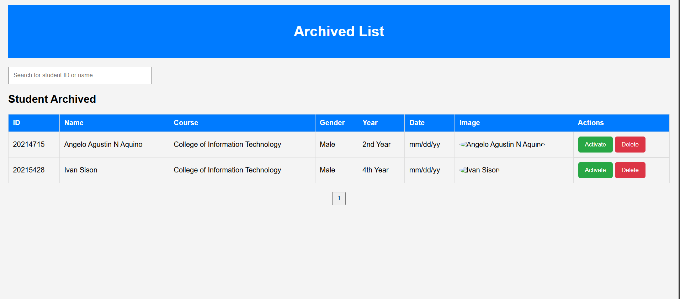

[ ] Gmail notification for creating account

• Kapag yung admin gumawa ng account para sa staff kailangan mag sesend yung email at password ng staff sa kanilang email.

[ ] Validations of the contact numbers in registration form and in the profile

• Put a validation on the contact numbers that it should be maximum in 11 characters then if its not there’s alert message, then if the numbers are not 11 character it should not be going to the next page

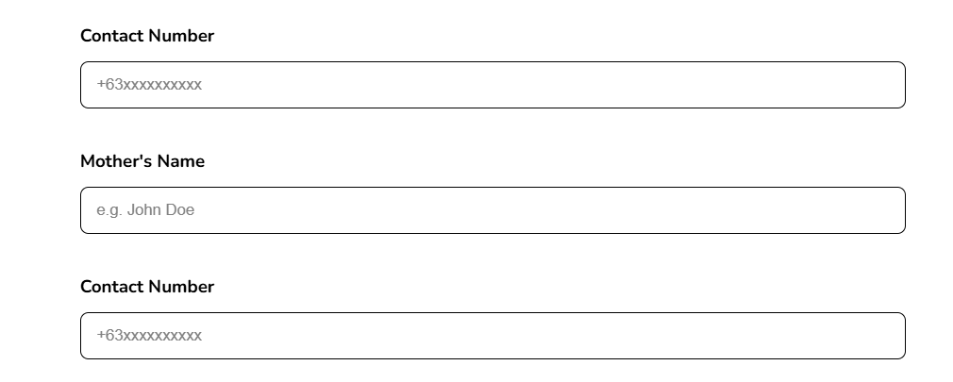

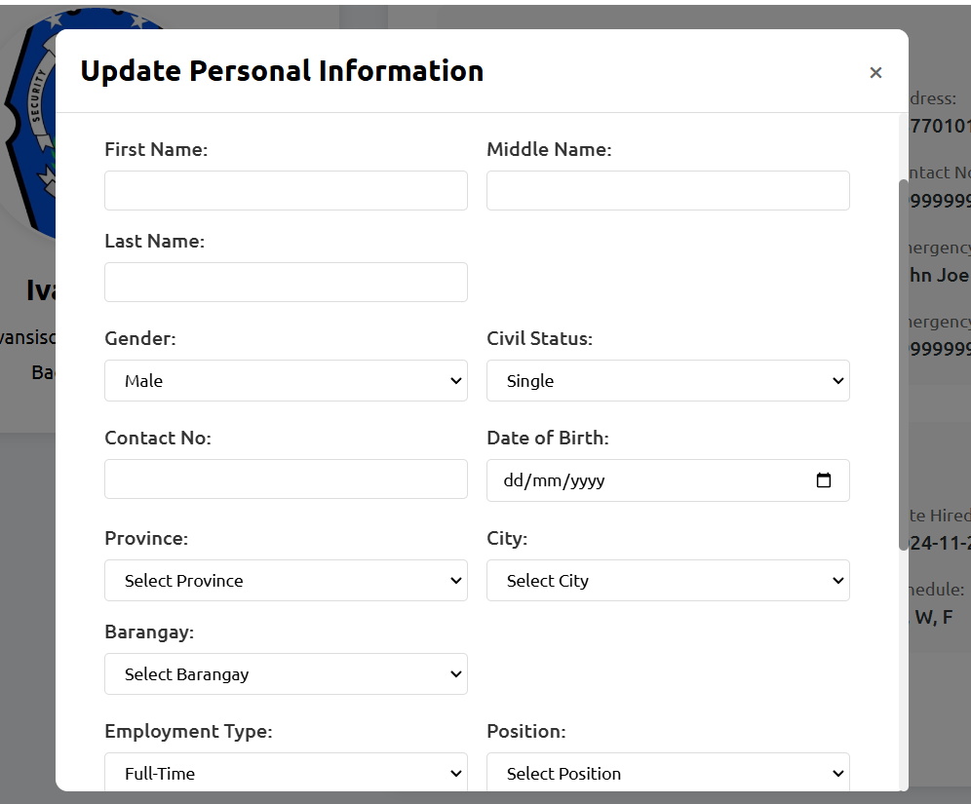

[ ] Validations of the ID number in registration form of the students

• The maximum of the character of id number of the stusent is 8 characters.

[ ] Edit the all generate pdf into like this.

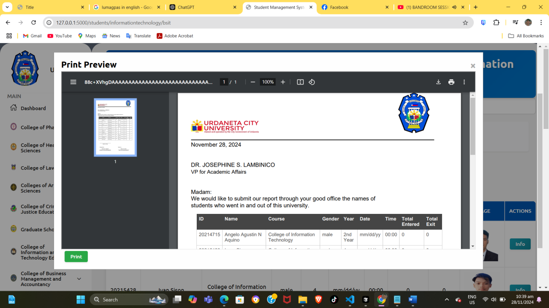

[ ] Then on the prepared by it should be get the name of the user who print the list.



[ ] Pagination on the index page

• The maximum of every page is 10 data of the students

