Bugs:

* dark mode nawala after mag punta sa home ng selpon then bumalik
* sa message nawawala yung pics pag scroll or pag inscroll up
* state on name pag mag ppm yung icon name
* show password state not working
* icons ng user di nag uupdate kada nalipat ng mga message
* announcement nakakapag upload ng file pero di nakakapag chat which is correct, i hide nalang natin siguro

To add:

* Logo in apk
* App name
* Filter for cuss words
* every sem mag auuto log out

Features add:

* Face recognition for validation if false direct to pin
* Location details once logged in -
* Delete function on messages ( so mag add tayo boolean each sent na message show = true and if delete yung show = false )
* Search keyword sa messages
* Viewing of medias and files section in chat option
* Push notification for users dm
* Side nav add filtering for year level and course
* Optional Today’s post (like my day)
* Terms and Condi page

Revision:

* Login page add logo
* Student profile instead of uid we add student id
* sa message page naman dapat create message tapos groupchat create group chat
* limit file upload
* side nav add filtering for year level each course
* Tabs must be logo ( instead of text use logo )
* on student and instructor creation add upload image
* on creation of instructor when organization exist create announcement data

Bugs:

Nawawala yung recent announcement pag nag swipe

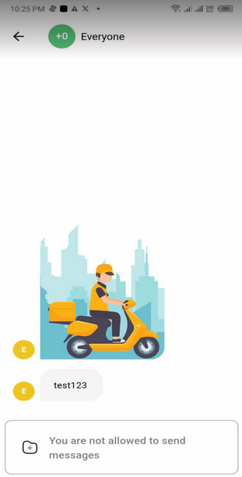

Nagiging rgb yung mga default profile

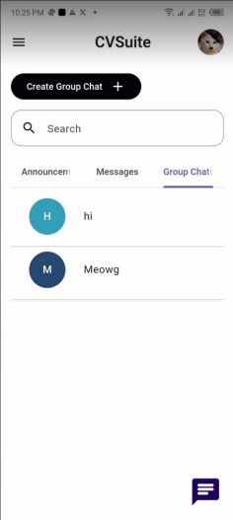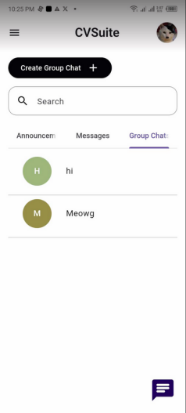

Di ma show yung profile mo na picture sa iba

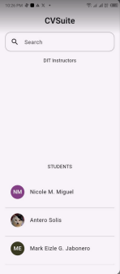

AS YUNG profile dapat NM

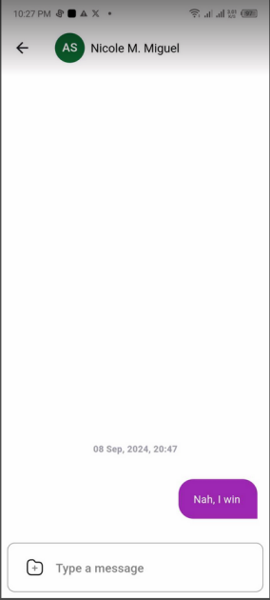

Yung profile sa msg tab  
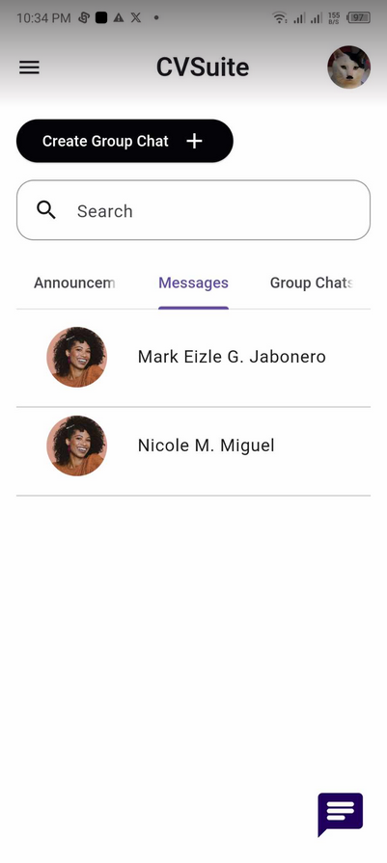

Nabalik yung light mode pag nag re open   
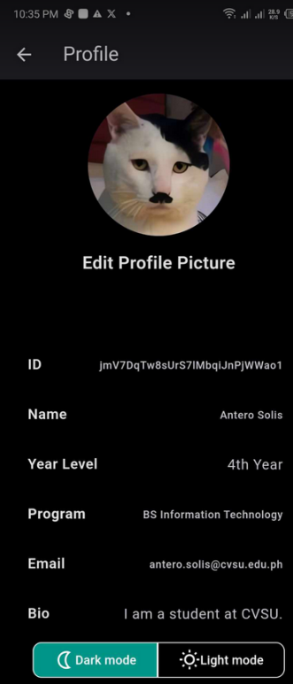

Recommend:

Light and Dark button to easy switch no need go to settings   
 