**Republic of the Philippines**

**Cebu Eastern College, Incorporated**

Leon Kilat Street, Cebu City, 6000 Philippines

# College of Information Technology

Landline No.: (032) 256 2526

Email: cebueasterncollege1915@yahoo.com

Official Page: [https://www.facebook.com/cec1915easternians](https://www.facebook.com/CEC1915EASTERNIANS)

**Integrated Online Platform for Academic Management and Communication at Cebu Eastern College (CEC)**

A Research Paper Presented To:

**The Faculty of College of Information Technology**

Cebu Eastern College, Inc., Cebu City, Philippines

In Partial Fulfillment of the Requirement for the Course

## (Name of Research Course)

Researchers:

Loquellano, Ralph Jenrey T.

Alquisola, Mark Anthony E.

Magdasal, Kyle Jheric T.

Gabutan, Daisy D.

**Academic Year 2023-2024**

## APPROVAL SHEET

This research paper entitled **“(TITLE)”**, prepared and submitted by **(NAME OF MEMBERS)** in partial fulfillment for the requirements of **(NAME OF RESEARCH COURSE)**, School Year 2023-2024 is hereby recommended for acceptance and approval for the final oral defense after being examined.

**Prof. Juvelyn G. Sato**

Research Adviser

**PANEL OF EXAMINERS**

**Dr. Arlene C. Okora**

Academic Head (Chair Panelist)

**Prof. Mr.**

Panelist Member Panelist Member

**Mr. Mr.**

Panelist Member Panelist Member

**Approved by the Committee for Thesis Writing Proposal on (Date) with a Grade of ____**

Page 2 of 91

Republic of the Philippines

**Cebu Eastern College, Incorporated**

Leon Kilat Street, Cebu City, 6000 Philippines

# College of Teacher Education

Landline No.: (032) 256 2526

Email: cebueasterncollege1915@yahoo.com

Official Page: [https://www.facebook.com/cec1915easternians](https://www.facebook.com/CEC1915EASTERNIANS)

**Rating Sheet for the Capstone Final Defense**

**The submitted manuscript shall be scored according to the following:**

**(INSERT Table of CRITERIA)**

## DEDICATION

This project is intended for those who supported us in every step throughout this journey. To our families who had the most patience, who encouraged us and showed their love, thank you for having faith in us and for driving our dreams. Being the guiding force, we could not have achieved this goal without your constant presence

Also, this work is being dedicated to the teachers, administrators and students of Cebu Eastern College. This platform has been designed with the hope that it will benefit the school community and improve communication and management of academic activities. It is our desire that this will be useful in enhancing growth, efficiency and collaboration for the future.

In the end, this dedication applies to our mentors and peers who would share with us their knowledge, use their creativity and work hard to make a positive change in the world. It is our hope that this project would illustrate the values of creativity and advancement of education.

## ACKNOWLEDGEMENT

It is with utmost gratefulness that we acknowledge those who had a part in the success of the capstone project that is, Integrated Online Platform for Academic Management and Communication at Cebu Eastern College (CEC).

First of all, there is great worth extending to those who acted as our mentors and advisors as their support was significant throughout the entire undertaking of the development of this project. The input they offered and the feedback they gave us were both sufficient as well as inspiring to ensure we went over and above in all aspects.

We would also like to appreciate Cebu Eastern College for allowing us to carry out a project which has a positive impact to the society and in this case the academic environment. The views of students, teachers, and administrators were important in developing a solution that reaches the needs of the education institution.

We would like to thank our families and friends for believing in us and never faltering especially in difficult times. Their patience and understanding made it easier for us to concentrate and be determined throughout the tough times.

In conclusion, we thank team members of our project. We would like to thank the people who participated in this project for their creativity and efforts since different experiences from the members contributed towards realizing our dream project.

To all who contributed to this journey, we are most grateful.

## ABSTRACT

This capstone project integrates the performance of an Integrated Online Platform for Academic Management and Communication at CEC. All kinds of academic as well as admin tasks are set for various user types including, Students, Instructors, Admins, and Super Admins. It defines a multi-platform approach which comprises a mobile app for students and instructors and a web portal for admin users. Major features include logins, manage accounts, post announcements, messaging including group chats and private messaging. The Super Admin should be able to manage all the other administrative accounts while the departmental admins should only provision in management risks allowing a more organized and manageable level of academic management. It is predicted that this system will improve communication, lessen manual management, and allow users to easily and efficiently use, the databases and tools available to them. With the aid of the new platform, the efforts of CEC are to assist in the development of the academic processes, enhancing interaction, and strengthening the academic community.

## TABLE OF CONTENTS

**CHAPTERS Page**

**No.**

RESEARCH

TITLE.………….…….………….…….………….…….………….…….…………………………….1

APPROVAL

SHEET.………….…….………….…….………….…….………….………….………………………2

DEDICATION.………….…….………….…….………….…….………….………….……………..3

ACKNOWLEDGEMENT.………….…….………….…….………….…….………….………….….4

ABSTRACT………….………….………….………….………….……..……….………….……….…5

TABLE OF CONTENTS……….………….………….………….………….……..……….…………6

LIST OF GRAPHS/TABLES ….………….………….………….………….……..……….………….……………7

LIST OF

FIGURES….………….………….………….………….……..…………………..………….……………8

1. **CHAPTER I: INTRODUCTION** 
   1. Related Software.………….………….………….………….…………………….…….………..13
   2. Purpose and Description of the Project……….………….………….…………………….………15 1.3 Objectives of the Study………….………….…………………………..…….………….……………16
   3. Significance of the Study ……….………………………………………..……………………………..18
   4. Flow of the Study ………………………………………………………………………………………….20
   5. Scopes and Delimitation………….…….………….……..…….………..……………………………21
   6. Definition of Terms……………………………………………………………………………………….23

1. **CHAPTER II: REVIEW OF RELATED LITERATURE** 
   1. Related Literature……………………………………………………………….…………..25
   2. Comparative Matrix……………………………………………………………….…………..28

1. **CHAPTER III: METHODOLOGY** 
   1. Research Environment….……….……….……….……….…….…….…….…….…..…33
   2. Software Engineering Methodology….……….……….……….…….…….…….…….…..…30
   3. Planning Phase.……….……….……….……….…….…….…….…….…..…35
   4. Business Model Canvas.……….……….……….……….…….…….…….…….…..…36
   5. Program Workflow.……….……….……….……….…….…….…….…….…..…37
   6. Validation Board.……….……….……….……….…….…….…….…….…..…38
   7. Gantt Chart.……….……….……….……….…….…….…….…….…..…39
   8. Functional Decomposition Diagram.……….……….……….…….…….…….…….…..40
   9. Analysis-Design Phase.……….……….……….……….…….…….…….…….…..…41
   10. Use-Case Diagrams.……….……….……….……….…….…….…….…….…..…42
   11. Storyboard: Web Development.……….……….……….…….…….…….…….…..…47
   12. Database Design……….……….……….…….…….…….…….…..…51
   13. Entity Relationship Diagram.……….……….……….……….…….…….…….…….…..…44
   14. Data Dictionary.……….……….……….……….…….…….…….…….…..…45
   15. Network Design.……….……….……….……….…….…….…….…….…..…54
   16. Network Model.……….……….……….……….…….…….…….…….…..…55
   17. Network Topology.……….……….……….……….…….…….…….…….…..…56
   18. Development/Construction/Build Phase.……….……….……….……….…..…
   19. Technology Stack Diagram.……….……….……….……….…….…….…….…….…..…58
   20. Hardware Specification.……….……….……….……….…….…….…….…….…..…59
   21. Program Specification.……….……….……….……….…….…….…….…….…..…60
   22. List of Modules.……….……….……….……….…….…….…….…….…….
   23. List of Screen per Modules.……….……….……….……….…….…….…….…….…..…61
   24. Technical Background……….……….……….……….…….…….…….…….…..…63

1. **CONCLUSION**……….……….……….……….…….…….…….…….…..…65
2. **RECOMMENDATION**….……….……….……….…….…….…….…….…..………………66
3. **REFERENCES**….……….……….……….…….…….…….…….…..……………………….67

**VI. APPENDICES**

Appendix A: Curriculum Vitae ………………………………………………………………….68

Appendix B: Letter of Approval …………………………………………………………………74

Appendix C: Survey Questionnaire …………………………………………………………….75

Appendix D: Test Data ……………………………………………………………………………

Appendix E: Documentation …………………………………………………………………….

## LIST OF GRAPHS/TABLES

**TABLE DESCRIPTION PAGE**

**NO.**

1 Comparative Matrix 27

2. Validation Board 37

3. Data Dictionary 44-45

4. Database Design 57-59

5. Program Specification 68

## LIST OF FIGURES

**FIGURE DESCRIPTION PAGE**

**NO.**

1. Planning Phase 33
2. Business Model Canvas 35
3. Program Workflow 36
4. Gantt Chart 38
5. Functional Decomposition Diagram 39
6. Analysis Design Phase 40
7. Use Case Diagram 42
8. Entity Relationship Diagram 43
9. Network Design 61
10. Network Model 62
11. Network Topology 63
12. Development Phase 64
13. Technology Stack Diagram 66
14. Minimum Hardware Specification 67

## Related Software

Effective communication between students and instructors is crucial for fostering a productive

educational environment. This project aims to bridge the gap in student-instructor management by

facilitating proper communication channels. The primary objectives include enabling group chats and

private chats with filtered and monitored content to prevent explicit and prohibited activities. Additionally, announcements will be organized by department or directed to all users when

appropriate.

### Related Software Applications

Microsoft Teams is an all-in-one collaborative platform that aims to improve communication and

collaboration among students and teachers. It has different functionalities like group chats, private

chats, and channels meant for various departments. Microsoft Teams also ensures compliance with

institutional policies by providing strong content filtering and monitoring systems. In this case

announcements can be sent to specific groups or blanket the whole organization making it perfect for

educational environments.

Slack is a popular messaging tool used for team communication. It enables the creation of different departmental channels as well as private messages and group discussions. Content moderation tools

across various third-party platforms have been integrated into slack to ensure that proper means of

communication are adhered to. Additionally, it allows for targeted announcements concerning specific

groups or all users enhancing its suitability in an educational setup.

An educational platform created to enhance teacher-learner communication is Google Classroom. It

simplifies organization of announcements, assignments and discussions. While primarily concerned

with coursework, Google Classroom also allows for individual conversations and whole class notices. It has seamless integration with other Google Workspace tools, ensuring strong filtering content and

monitoring features that guarantee a safe environment for communication.

## Purpose and Description of the Project

The purpose of the Integrated Online Platform for Academic Management and Communication at Cebu Eastern College (CEC) is to establish a centralized digital environment that enhances both the quality and efficiency of education. By offering a unified platform, this project seeks to streamline communication and collaboration among students, instructors, and administrators, aiming to create a more cohesive academic community. Through this platform, CEC can provide real-time updates, accessible resources, and tools that foster a more dynamic educational experience.

Furthermore, the platform addresses the need for improved academic management by digitizing essential tasks, such announcements, engage in group chats and private messaging, and receive help from an integrated chatbot. This accessibility allows students to engage with their education in a more organized and timely manner, minimizing administrative obstacles and ensuring they have the resources needed to succeed. For faculty and staff, this system optimizes administrative tasks, reducing manual processes and allowing them to focus on delivering quality education.

### Description of the project

The Integrated Online Platform for Academic Management and Communication at Cebu Eastern College (CEC) is designed to address the diverse needs of the institution by providing a centralized solution for essential academic and administrative functions. This platform serves as a digital bridge that connects students, instructors, and administrative staff, making it easier for each group to interact and access the information they need. By incorporating modern technologies, the platform streamlines processes that are often manual and time-consuming, ultimately enhancing the overall efficiency of the college’s operations.

One of the core components of the platform is its comprehensive communication tools, which include integrated messaging and notification systems. These tools allow for seamless communication between students, teachers, and administrative staff. Through features such as messaging and announcements, users can receive important updates, engage in group discussions, and stay informed about academic requirements and events. By reducing communication gaps, this system ensures that all members of the CEC community remain connected and well-informed.

## Objectives of the Study

A structured and phased approach will be followed by CEC in developing the project to achieve

all objectives effectively. To begin with, core features and functionalities of the project will be defined,

centering on improving education quality and efficiency. This includes designing a user-friendly

interface that integrates academic resources like learning materials and announcements. Moreover,

there is also going to be a built-in messaging system which incorporates both private and group chats

to facilitate communication. In addition, these messaging elements should have content filtering tools

that can help maintain appropriate levels of conversation on the online education platform to prevent

obscene or restricted activities that are detrimental to learning among students.

The next stage will focus on creating tools for increasing student engagement and support. Through this application, students would be able to access academic materials and even promote

collaborative work through group chat. Additionally, a chatbot will come in handy in addressing

recurring problems thus reducing the amount of work associated with regular inquiries incurred by

the administration. This makes it easier for students to interact with the administration as well as

allowing lecturers to manage course content, make announcements and communicate with individual

students or groups.

The project has also integrated simple analytics on the current number of users categorized

as instructor, student and administrator. This information is very important for enhancing educational

activities and making administrative decisions to continuously improve the quality of education.

Finally, the project will concentrate on establishing a secure platform for communication. These

advanced features are inclusive of word filters that have been made to conform to institution policies

and guidelines. Through this environment, everyone can learn and grow personally. All these steps

are necessary to attain the overarching objectives of upgrading education quality and operational

efficiency through a one-stop digital resource.

## SIGNIFICANCE OF THE STUDY

Individually, students benefit from this platform through having easier access to academic

information and resources. It is a one-stop-shop for all announcements. Customizable profiles

guarantee unique user experiences, which can be light or dark themed. Collaboration among students

is encouraged using group chat functionalities that provide peer support and enhance feelings of

community. Additionally, the presence of chatbot system provides quick responses to FAQs thereby

offering instant help while reducing contacting administrative offices for simple problems. In summary,

there are better channels of communication between the administration and the students; improved

means by which information can be accessed and more active involvement in the learning process.

Platform administrators have the power to control everything that happens in it. They can

make announcements or import student and teacher data, post a text for chatbot or update its content. The system is equipped with statistics on courses, students and instructors - a valuable aid to data-

driven decision making. Furthermore, they may create chats by teachers (for subjects) as well as

students (for sections or personal interest), which enhances active communication within the

academia.

The project also incorporates advanced features like word filtering for maintaining right communication standards. Then questions from the user are managed by administrator, who makes

answers that commonly recur for example: where is registrar’s office? can I see my tutor? This

collection of tools helps directors cope with administration issues of an institution, encourage academic

performance and make learning environment better.

Through improved communication and course management mechanisms, the project offers

instructors immense benefits. They can make announcements or chat with students as a group

through it, hence making information flow faster and creating an interactive learning environment. Instructors can use the system to centrally manage course materials therefore making it easier to

update learners on essential matters. Therefore, this not only improves instruction but also enriches

the overall students’ experience in learning. The latter include streamlined communication, enhanced

resource management as well as good tracking and backing of student development.

## FLOW OF THE STUDY

The flow explains the management system of a platform that has different roles: Super Admin, Admin, Student, and Instructor. The first step is Super Admin creating accounts for other users and

assigning departments to them. Also, he can remove or delete them at any time. On web panel,

admins can manage accounts, check active users and create ads or manage them. It also provides CRUD operations on Chatbot questions and answers as well as room creation like private chat rooms

which send messages through the platform.

Students and Instructors login through the mobile platform where they can view announcements, edit

profile details as well as ask Chatbot some questions or join a group chat. Additionally, they may

create a private room and message each other privately. The final responsibility is left with admins

who control group chats, enable chatbots to operate within it and filter content for a good

communication between students and instructors in the platform.

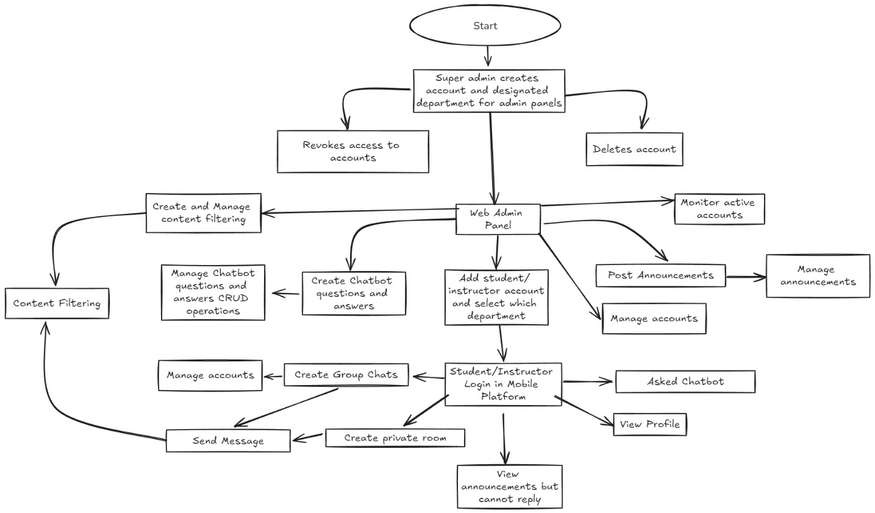

## Scopes and Delimitation

**Scope of the Project**

CEC’s Integrated Online Platform for Academic Management and Communication is an all-inclusive digital system designed to centralize a range of academic and communication functionalities within a single platform. Key features include comprehensive management of instructor and student information, and efficient communication tools that connect students, teachers, and administrators through messaging, announcements, and group chats.

The platform includes several functionalities aimed at enhancing user experience and administrative efficiency. For instance, the login process requires CEC emails with password protection and a one-time password (OTP) recovery option to ensure secure access. The home interface provides designated areas for announcements, group chats, and organizational communications. Users can edit profile information such as profile pictures and display modes, although fields like full name, student ID, year level, and email are non-editable. Instructors can create group chats for their subjects, and students can create chats for their sections or at their discretion. Additionally, the platform features a sidebar filter for finding teachers and students, as well as a chatbot popup for instant assistance.

On the administrative side, there is a dedicated web interface with enhanced features. Administrators have capabilities to announce to all users or specific groups, import student and teacher information, and manage user access. Further functionalities include creating and managing chatbot questions and answers, filtering inappropriate language, and viewing statistics on courses, students, and instructors through the admin dashboard. The system allows administrators to add, edit, and delete student and instructor records, along with multiple detailed tables for user information. Announcements can be made at institutional, program, or departmental levels, and the chatbot can be programmed to provide information on instructor and registrar availability.

**Delimitations of the Project**

The platform’s primary limitations are its focus on internal academic processes and communication within Cebu Eastern College (CEC). It is specifically designed to address the needs of students, instructors, and administrators within the institution and does not extend to external stakeholders or integrate with third-party systems.

Additionally, while the platform fulfills most academic and communication requirements, it may not fully support certain departments or programs that have specialized needs unique to CEC. These delimitations mean that the system is not intended as a universal solution for all departments but rather focuses on the core academic and administrative functions that benefit the majority of users within CEC. Despite these limitations, the platform aims to create a more organized and efficient educational environment for the CEC community.

## Definition of Terms

**Chatbot:** A chatbot is a computer program or an artificial intelligence system designed to simulate conversation with human users, typically through text-based interfaces. (Techopedia, 2022)

**Integration:** Integration refers to the process of combining different components, systems, or software applications to work together seamlessly. It enables data exchange and functionality across various platforms. (TechTarget, 2022)

**Platform:** A platform is a foundation or framework that provides a set of tools, services, and resources for building and deploying applications, services, or products. It can refer to software, hardware, or cloud-based environments. (Investopedia, 2022)

**Stakeholders:** Stakeholders are individuals or groups who have an interest or influence in a project, organization, or business. They can include investors, employees, customers, suppliers, and the community. (Business Dictionary, 2022)

**One Time PIN (OTP):** An OTP is a unique code generated for a single transaction or login session. It provides an additional layer of security by verifying the user’s identity. (Techopedia, 2022)

**Academic Resource:** An academic resource refers to any material, tool, or service used for educational purposes. It can include textbooks, research papers, online libraries, and learning platforms. (Merriam-Webster, 2022)

**Word Filtering:** Word filtering involves automatically detecting and blocking or censoring specific words or phrases in digital content, such as social media posts or chat messages. It is commonly used to prevent offensive or inappropriate language. (Techopedia, 2022)

**Student:** A student is an individual enrolled in an educational institution, such as a school, college, or university, pursuing formal education and learning. (Cambridge Dictionary, 2022)

**Instructor:** An instructor is a teacher, educator, or trainer who imparts knowledge, conducts classes, and guides students in their learning process. (Merriam-Webster, 2022)

**Administrator:** An administrator is a person responsible for managing and overseeing the operations, policies, and resources of an organization, system, or network. (Oxford Languages,

2022)

## Review Related Literature

Integrated Online Platforms in Academic Management

The importance of integrated online platforms in the management and communication processes of educational institutions has become more pronounced. They act as central points for managing student information, course enrollments, communication and announcements thereby facilitating smooth interaction among students, lecturers and administrators. According to Zi-Yu Liu, Natalya Lomovtseva, Elena Korobeynikova (2020) “Analysis of distance learning systems, testing of students and consultation with teachers allow saying that such platforms help to make education more accessible and convenient.”

Role-Based Access Control (RBAC) in Educational Systems

Integrated academic management systems require role-based access control (RBAC) as a necessary security measure. This helps in preventing users from gaining access to information and tools that do not relate to their tasks, thereby maintaining data integrity and security. According to Liu Dongdong, Xu Shiliang, Zhang Yan, TAN Fuxiao, NIU Lei, ZHAO Jia (2017). “Based on the refinement of system privilege and user role, this paper puts forward the security management model of “user classification, role authorization, Unified management ”, which is more suited to the structure of multi-level applications by controlling the data range accessible to users, and ultimately achieves the purpose of strengthening the security of the system.”

User Experience (UX) in Educational Mobile and Web Applications

To ensure that an educational platform is engaging and can be used by different types of users, user experience design is important. Research by Kiranjeet Kaur, Khairul Shafee Kalid, Savita K Sugathan (2021). “The use of mobile application facilitates an interactive and innovative learning experience for students. “While there are many studies emphasizing on the use of mobile application but less focuses on the student’s experience in using those applications.” Educational platforms which have the possibility to change between light and dark mode as well as other customizable UIs are suggested as being appreciably enhancing user’s satisfaction. Additionally, a secure yet personalized user experience can be achieved when non-editable profile information fields like full name and student ID are present in conjunction with editable ones such as profile pictures.

Real-Time Communication and Collaboration Tools

For modern education platforms, real-time communication tools of group chat and announcement are necessary. In this way, the students and teachers are always in contact with each other despite their geographical separation. According to Kathleen M Swigger, Robert Brazile, Suzanne Byron, Alan Livingston, Victor Lopez, Josie Reynes (1999) “These activities focus on teaching students how to organize and systematize their explorations for information and to share this information with members of a group.” However, it could be observed that incorporating rooms specifically for announcements, group chats and organizational activities within an academic platform can help to consolidate communication while enhancing an inclusive learning environment.

Data Management and Security

The effective data management is the basis for the success of using an all-inclusive academic platform. Systems should have capacity to deal with huge volumes of information such as students’ and lecturers’ records, and must be equipped with strong importing, editing and deleting features. Milan Petkovic, Willem Jonker (2007) says “ The technology is nonintrusive, transparent and hidden in the background. In the ambient intelligence vision, the devices collect, process and share all kinds of information, including user behavior, in order to act in an intelligent and adaptive way.” It also shows that platforms that have inclusive dashboards that track data about courses, students, and instructors provide valuable insights for administrators thereby enabling them to make informed decisions based on facts. Also, security measures like password protection, OTP based password recovery and limited email domain logins (e.g. CEC emails only) are necessary to protect sensitive information from unauthorized access. These security protocols play a crucial role in maintaining the sanctity of the educational system’s operations by ensuring that certain parts of features or content can only be accessed by authorized individuals.

**Comparative Matrix**

|  |  |  |  |
| --- | --- | --- | --- |
| Functionality | Our App | Microsoft Teams | Slack |
| Group Chat & Private Chat | ✔ | ✔ | ✔ |
| Chat Content Filtering & Monitoring | ✔ | ✖ | ✖ |
| Announcements | ✔ | ✖ | ✖ |
| Chatbot | ✔ | ✔ | ✔ |
| Student/Instructor Management | ✔ | ✖ | ✖ |
| Customization Options | ✔ | ✔ | ✔ |

## Software Engineering Methodology

This project employs the Agile methodology, an iterative approach to software development that allows for flexibility in response to changing requirements, prioritizing continuous improvement and user satisfaction. Agile’s adaptability is ideal for developing a platform that serves academic and communication needs, as it enables iterative feedback and refinement of the system’s features.

The Agile process divides development into sprints, each with clearly defined objectives that align with the project’s goals. Sprints include planning sessions, daily stand-ups to maintain team alignment, and sprint reviews to assess progress and identify improvement areas. This method ensures consistent delivery of functional increments of the platform, gradually building a system that addresses the needs of students, instructors, and administrators effectively.

### Development Product Backlog

The product backlog consists of user stories and features in order of priority that need to be developed.

These are some initial user stories for filling the product backlog:

**User Stories:**

1. **As a Student, I want to:**
   * + Login with my CEC email and password.
     + Edit my profile picture and display settings.
     + Join and create group chats.
     + View announcements in designated rooms.
2. **As an Instructor, I want to:**
   * + Create group chats for my subjects.
     + Manage group chat members.
     + Post announcements in designated rooms.
3. **As an Admin, I want to:**
   * + Create accounts for students and instructors.
     + Manage announcements for my department.
     + Add questions to the chatbot.
4. **As a Super Admin, I want to:**
   * Manage all admin accounts.

Every sprint will have specific, measurable goals designed to fit into the project objectives. The

following are examples of objectives for the initial sprints:

Goals for Sprint 1:

* + User authentication (login with CEC email and password) should be implemented.
  + A basic structure that includes user account types such as Students, Instructors, Admins, Super Admins should be set up.
  + The Home Screen should include non-editable profile information fields and an initial layout

created.

Goals for Sprint 2

* + Develop profile editing features (profile picture, light mode & dark mode).
  + Provide functionality for creating and managing group chats by students and instructors.
  + Create designated rooms for announcements and group chats.

Goals for Sprint 3

* + Implement announcement management system exclusively meant for departmental admins.
  + Create a chatbot that can answer frequently asked questions effectively.
  + Make provision for adding queries to the chatbot by the administrators themselves.

Each sprint kicks off with a planning session where tasks required to achieve these goals are

defined; followed by daily standups, development/testing; then finished by sprint review to

evaluate progress and determine areas of improvement.

## Research Environment

Study Background

This capstone project titled "Integrated Online Platform in Academic Management and Communication

at CEC" will be done within the Central Educational Center (CEC). This is a medium-sized institution

that has a diverse student population and several academic departments organized hierarchically. The

research environment for this study is ideal because the college requires an improved system of

communication as well as academic management.

Participants

The four main types of account holders for the integrated online platform are:

Students: These include undergraduate and graduate students who are enrolled in various programs

at CEC. They will use it to get announcements, join group chats, edit their profiles and talk to course

mates or instructors.

Instructors: Teachers who teach courses and manage classroom activities. They will create subject-

related group chats with students and inform them about departmental messages.

Admins: Each admin is responsible for managing student accounts, instructor accounts, posting announcements, etc. Each department has its own admin who manages students’ course registrations.

Super Admins: These are administrators who have the responsibility to handle all other admin accounts

within the departments. They oversee the whole system and make top-ranking decisions, ensuring

that it operates smoothly.

Technological Infrastructure

This study will utilize CEC’s current technological infrastructure like a steady internet connection, web

and mobile application servers, and secure databases for storing sensitive data. It can be accessed

via web browsers on desktop computers or through mobile applications specifically tailored for Android

and iOS devices.

## Planning Phase

**Business Model Canvas**

**Program Workflow**

USER

LOG IN



Can view

/notify

School

Announcement



Can view

and message Group

Chat



Can view

and

chat

private

message



Can

search User



Can

ask chatbot



Can

Edit Profile Picture



|  |  |  |  |
| --- | --- | --- | --- |
| ADMIN | |  | | --- | | LOG IN | | Can  view and add  Announcement      Can  view and manage students      Can  view and manage students    Can  manage chatbot    Can  view dashboard stats |

**Validation Board**

|  |  |  |  |  |
| --- | --- | --- | --- | --- |
| **Category** | Assumption/Hypothesis | **Experiment** | Result/Metric | Next Steps |
| **Customer Segment** | Students will find the platform useful for  accessing academic resources and communication. | Conduct surveys and interviews with students.  Offer a beta version of the platform for feedback. | % of positive feedback and willingness to use the platform. | Refine features based on  feedback and address concerns. |
| Problem | Current communication between students and  instructors is inefficient and fragmented. | Analyze current communication tools and  conduct focus groups to  understand pain points. | List of current inefficiencies and pain points. | Address identified pain  points in the platform design. |
| **Solution** | An integrated platform will solve the  communication issues  and improve academic management. | Develop a prototype and  conduct usability testing sessions with students,  instructors, and admins. | User satisfaction scores,  completion rates of tasks. | Iterate on the prototype  based on  usability testing results. |

**Gantt Chart**

**Functional Decomposition Diagram**

### Analysis-Design Phase

### Use-Case Diagrams

## Entity Relationship Diagram

**Data Dictionary**

**Users**

|  |  |  |  |  |
| --- | --- | --- | --- | --- |
| **Field Name** | **Data Type** | **Field Size** | **Description** | **Example** |
| UserID | int | 255 | Primary key for identifying users | 1001 |
| FirstName | String | 255 | User's first  name | John |
| MiddleName | String | 255 | User's middle  name | A. |
| LastName | String | 255 | User's last name | Doe |
| Email | String | 255 | User's email address | john.doe@cec.com |
| Password | String | 255 | User's password | ******** |
| ProfilePicture | String | 255 | URL or path to user's profile picture | /images/john.jpg |
| UserType | String | 50 | Type of user  (Student,  Instructor,  Admin, etc.) | Student |
| YearLevel | String | 50 | Academic year level of the student | 2nd Year |
| Program | String | 255 | Program or course of the user | BSIT |
| Department | String | 255 | Department name the user belongs to | BSIT |

**Departments**

|  |  |  |  |  |
| --- | --- | --- | --- | --- |
| **Field Name** | **Data Type** | **Field Size** | **Description** | **Example** |
| DepartmentID | int | **255** | Primary key for identifying departments | 10 |
| DepartmentName | String | 255 | Name of the department | BSIT |

**Chats**

|  |  |  |  |  |
| --- | --- | --- | --- | --- |
| **Field Name** | **Data Type** | **Field Size** | **Description** | **Example** |
| roomID | int | 4 | Primary key for identifying chats | 5001 |
| chatName | String | 255 | Name of the chat | CS Group Chat |
| type | String | 50 | Type of chat  (Group or Private) | Group |
| Messages | List | - | List of  messages within the chat | ["Hello", "Hi"] |
| CreatedBy | String | 255 | User who created the chat | john.doe@cec.com |
| Users | List | - | List of users in the chat | ["john.doe@cec.com",  "jane.smith@cec.com"] |

Chatbot

|  |  |  |  |  |
| --- | --- | --- | --- | --- |
| Field Name | Data Type | Field Size | Description | Example |
| questions | String | 1024 | Questions handled by the chatbot | What are the office hours? |
| quickReplies | String | 512 | Quick replies available for the questions | ["9AM-5PM",  "Closed"] |

## Storyboard: Web Development

### 1. User Login (Student)

**Scene 1:** The user opens the mobile app and is presented with a login screen.

Visual: The login screen shows input fields for the CEC email and password.

Action: The student enters their CEC email and password, then taps the "Login" button.

System Response: The app validates the credentials and loads the home screen.

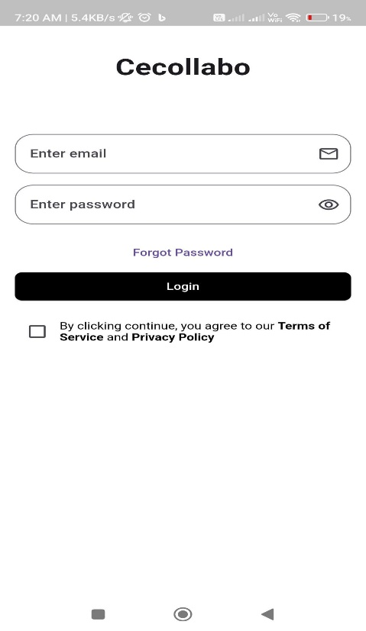

**Scene 2:** The user sees an option for "Forgot Password." Visual: A "Forgot Password?" link below the login fields.

Action: The user taps on "Forgot Password" and is prompted to enter their CEC email to receive an OTP.

System Response: An OTP is sent to the user's email, and the app displays an OTP input screen.

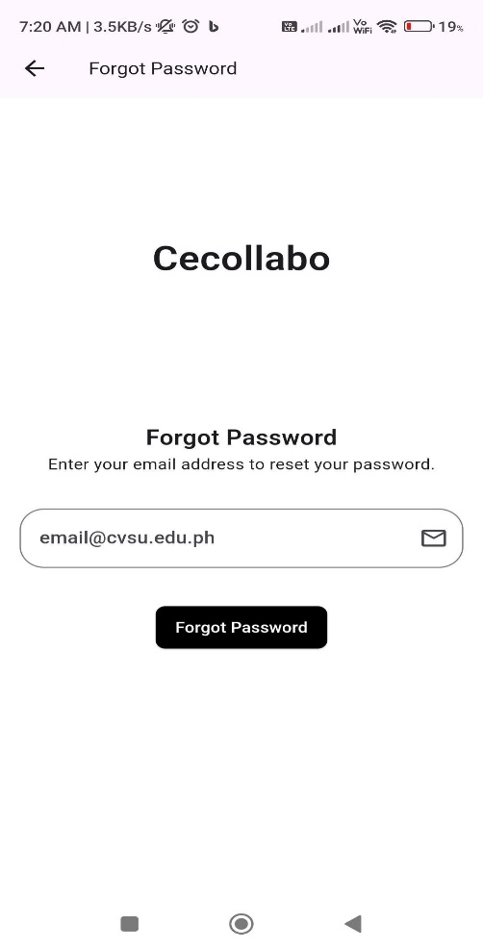

### 2. Home Screen Navigation

**Scene 3:** The user arrives at the home screen after logging in.

Visual: The home screen displays designated rooms for announcements, group chats, and

organizational groups.

Action: The user taps on the "Announcements" room.

System Response: The app navigates to a list of announcements.

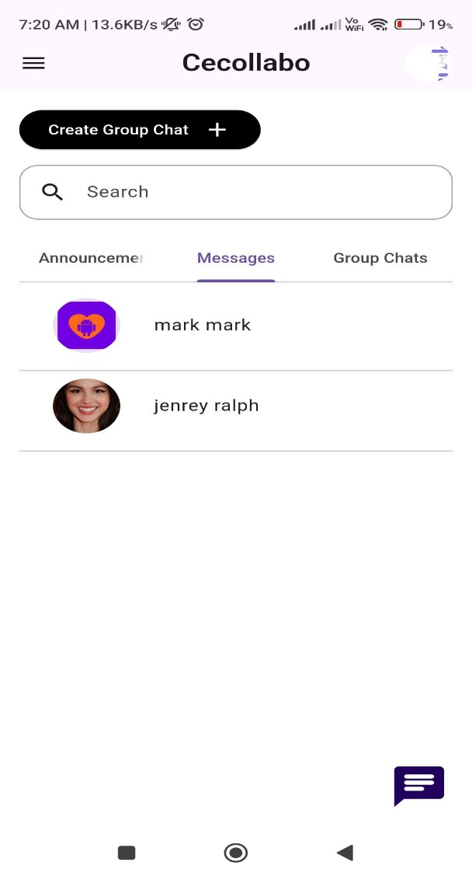

**Scene 4:** The user views their profile information.

Visual: Profile section showing full name, student ID, year level, program, and email (non-editable

fields) along with options to edit the profile picture and switch between light and dark modes.

Action: The user changes their profile picture and switches to dark mode.

System Response: The app saves the changes and updates the display.

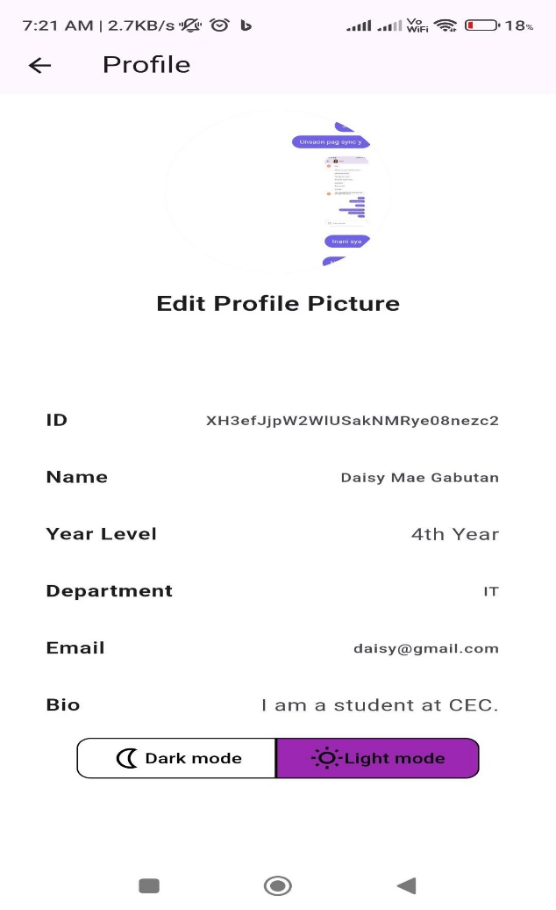

### 3. Chat Functionality

**Scene 5:** The user navigates to a group chat room.

Visual: A list of group chat rooms created by teachers and students.

Action: The user taps on a group chat room to view messages.

System Response: The app opens the chat room, displaying the chat history and options to send a

new message.

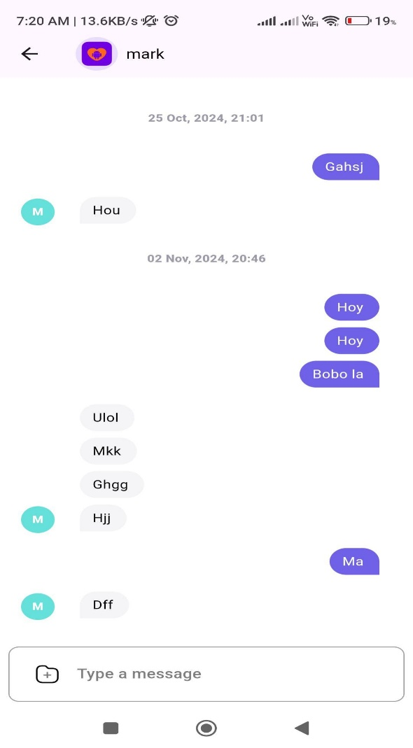

**Scene 6:** A teacher creates a new group chat.

Visual: The teacher selects a “Create Group Chat” option and enters details like group name and

members.

Action: The teacher adds students to the group and sets the group name.

System Response: The app creates the group chat, and the group appears in the chat list for all

members.

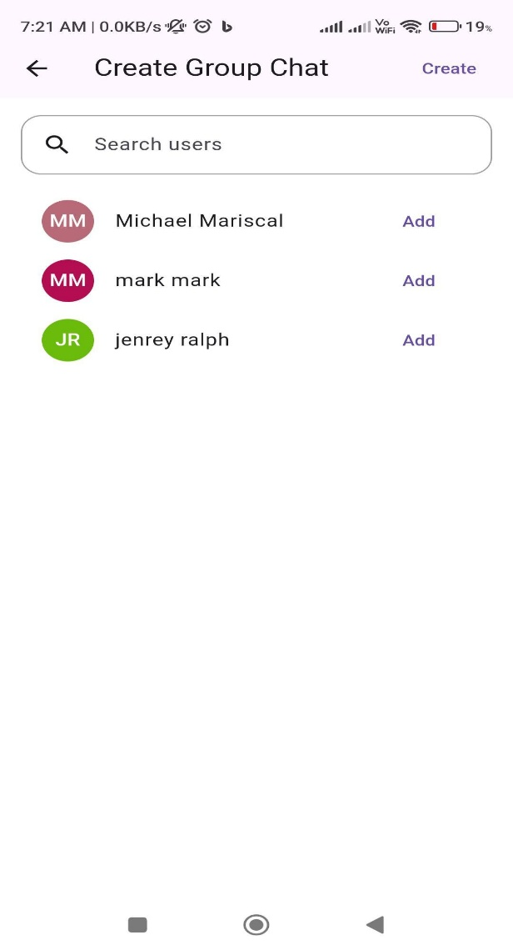

**Scene 7:** A student edits a group chat.

Visual: The student opens the group chat settings and sees options to rename the group and

remove members.

Action: The student renames the group and removes a member.

System Response: The changes are saved and reflected in the group chat.

### 4. Admin Web Interface

**Scene 8:** An admin logs in to the web interface.

Visual: The admin login page with fields for email and password.

Action: The admin enters their credentials and logs in.

System Response: The web interface loads the dashboard.

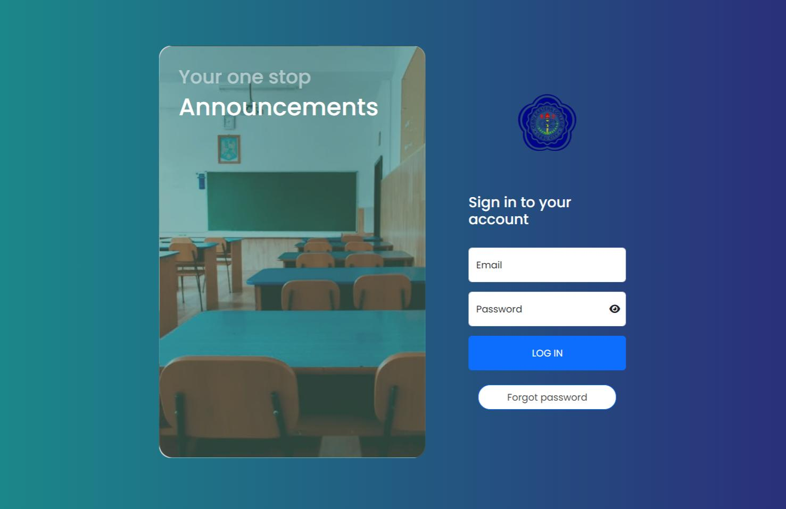

**Scene 9:** Managing announcements.

Visual: The admin navigates to the "Announcements" section of the dashboard.

Action: The admin creates a new announcement and selects the department it is related to. System Response: The announcement is published and appears in the mobile app for the relevant

users.

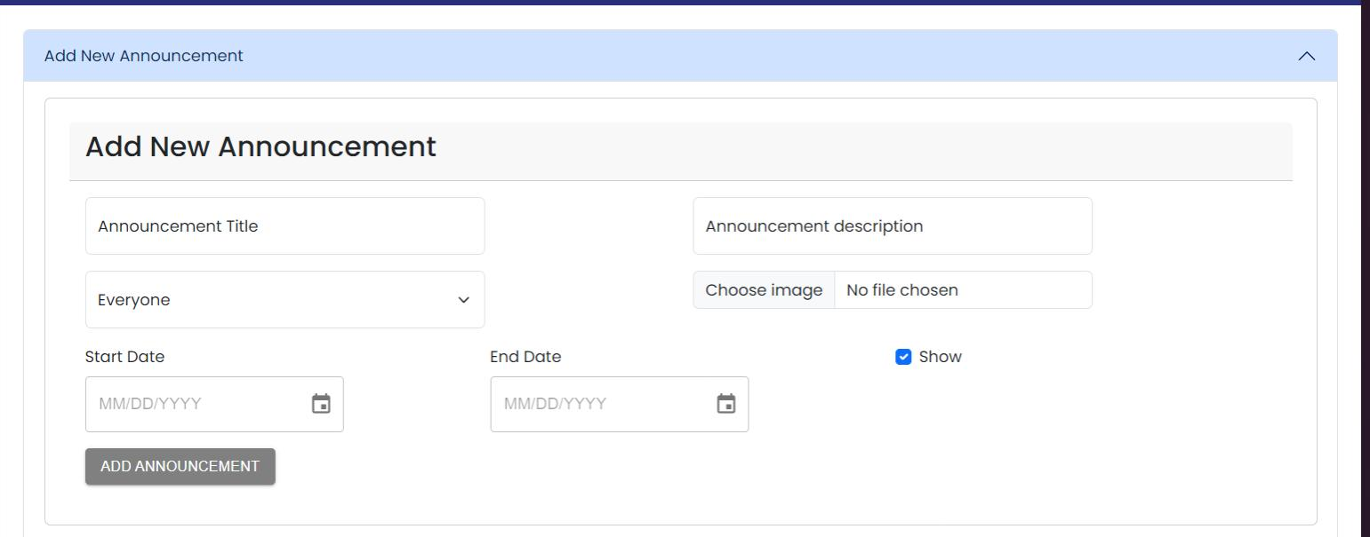

**Scene 10:** Managing Users.

Visual: The admin accesses the "Users" section, where they can view and manage student and

instructor accounts.

Action: The admin adds a list of new students, edits an existing student's information, and deletes a

user.

System Response: The system updates the user database accordingly.

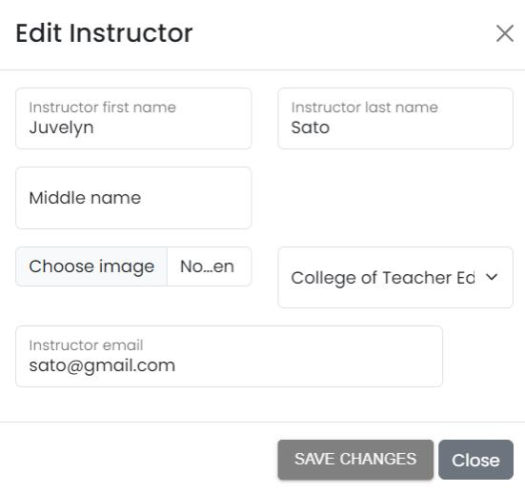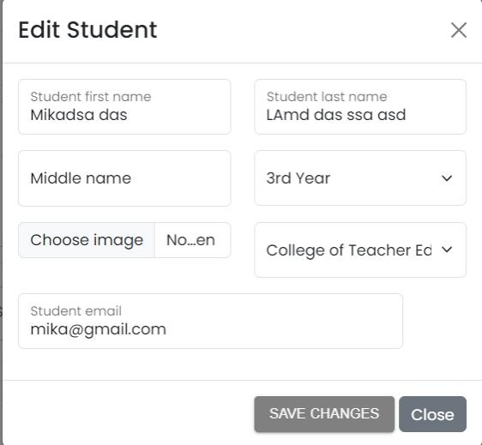

### 5. Super Admin Actions

**Scene 11:** A Super Admin manages admin accounts.

Visual: The Super Admin accesses the "Admin Management" section.

Action: The Super Admin creates a new admin account, assigns a department, and sets permissions. System Response: The new admin account is created and can access the relevant department's

functions.

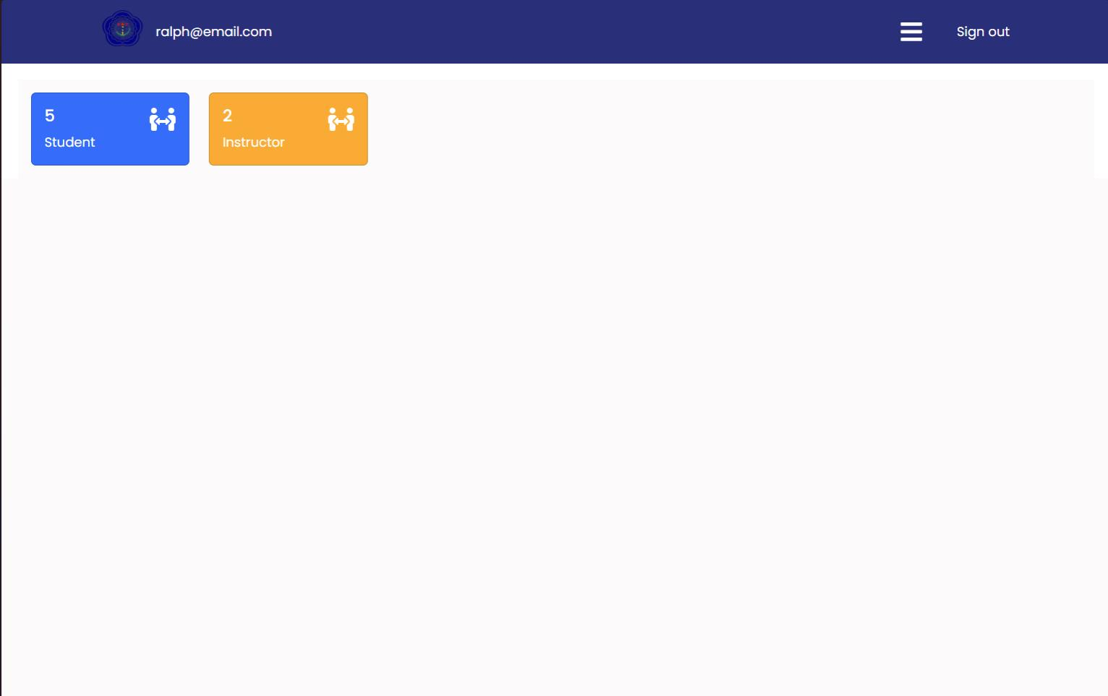

6. Chatbot Interaction

**Scene 12:** A student uses the chatbot for FAQs.

Visual: A chatbot pop-up appears on the home screen.

Action: The student types a question into the chatbot.

System Response: The chatbot provides a relevant answer based on pre-programmed FAQs.

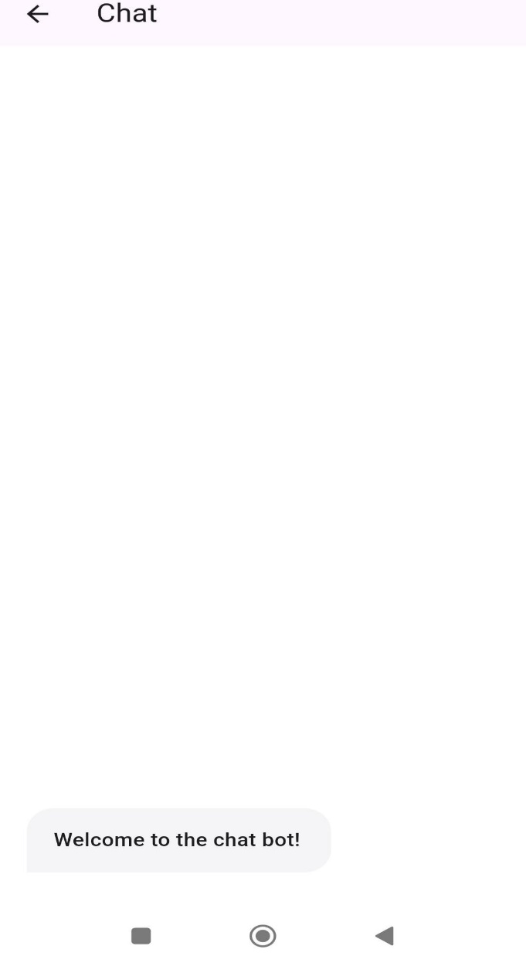

**Database Design**

**Users Collection**

|  |  |  |  |
| --- | --- | --- | --- |
| Collection/Path | Field | Type | Description |
| /users/{userId} | fullName | string | The full name of the user. |
|  | email | string | The CEC email of the user. |
|  | role | string | Role of the user:  student,  instructor, admin, superAdmin. |
|  | id | string | School Id |
|  | yearLevel | string | Year level (only for students). |
|  | program | string | Program of study (only for students). |
|  | profilePicture | string (URL) | URL to the user's profile picture. |
|  | mode | string | User's preferred mode: light, dark. |
|  | department | string | Department  (only for instructors and admins). |
|  | createdAt | timestamp | Timestamp of when the user was created. |
|  | updatedAt | timestamp | Timestamp of the last update to the user's information. |

**Rooms Collection**

|  |  |  |  |
| --- | --- | --- | --- |
| Collection/Path | Field | Type | Description |
| /rooms/{roomId} | name | string | Name of the group. |
|  | members | array (user IDs) | Array of user IDs representing the group members. |
|  | createdBy | user ID | ID of the user who created the group. |
|  | createdAt | timestamp | Timestamp of when the group was created. |
|  | type | string | Type of group: admin, user, announcement |
|  | messages | String, object | Contains messages and info |

**Room Message Sub Collection**

|  |  |  |  |
| --- | --- | --- | --- |
| Subcollection/Path | Field | Type | Description |
| /rooms/{roomId}/messages/{messageId} | text | string | The content of the message. |
|  | senderId | user ID | ID of the user who sent the message. |
|  | createdAt | timestamp | Timestamp of when the message was sent. |
|  | messageType | string | Type of message: text, image, file. |
|  | fileUrl | string (URL) | URL to the file or image (optional, for files/images). |
|  | imageUrl | string (URL) | URL to the file or image  (optional, for files/images). |

**Chatbot Collections**

|  |  |  |  |
| --- | --- | --- | --- |
| Collection/Path | Field | Type | Description |
| /chatbot/questions/{questionId} | question | string | The primary question that the |
|  |  |  | chatbot will respond to. |
|  | answer | string | The answer provided by the chatbot (optional if quick replies are present). |
|  | quickReplies | array | Array of quick reply objects, each containing a text and potentially nested quick replies. |
|  | createdBy | user ID | ID of the admin who created the question. |
|  | department | string | Department associated with the question (optional). |
|  | createdAt | timestamp | Timestamp of when the question was created. |
|  | updatedAt | timestamp | Timestamp of the last update to the question. |

## Network Design

## Network Model

## Network Topology

**Development Phase**

## Technology Stack Diagram

**Minimum Hardware Specification**

**Web Platform**

**CPU**: 2 to 4 Cores

**RAM**: 2 GB to 4 GB

**Browser:** Chrome, Edge, Mozilla, Firefox

**Mobile Platform**

CPU: 2 to 4 Cores

RAM: 2 to 4 GB

Android API: 21+

IOS: 8+

## Program Specifications

**Program Name**: CECOLLABO

**Purpose**: To provide users (students, instructors, and administrators) with accessibility to digital communication, easy collaboration and fast announcement dissemination.

**Stakeholders:** Instructors, Students, Administrators

**Scope:** Announcement, Chat bot, Realtime Messaging.

**List of Screen Per Modules**

|  |  |  |  |  |
| --- | --- | --- | --- | --- |
| Module | Screen | Visual | Action | System Response |
| 1. User Login (Student) | 1.1 Login Screen | Input fields for  CEC email and password. | The user enters their credentials and taps the  "Login" button. | App validates the credentials and loads the home screen. |
| 1.2 Forgot Password | "Forgot Password?" link below the login fields. | The user taps  "Forgot  Password" and enters their CEC email. | An OTP is sent to the user's email,  and an OTP input screen is displayed. |  |
| 2. Home Screen Navigation | 2.1 Home Screen Navigation | Home screen with options for  announcements, group chats, and  organizational groups. | The user taps the  "Announcements" room. | The app navigates to a  list of announcements. |
| 2.2 User Profile | Profile section showing full  name, student  ID, year level, program, email, etc. | The user changes the  profile picture  and switches to dark mode. | The app saves the changes and updates the profile display. |  |
| 3. Chat  Functionality | 3.1 Group Chat  List | List of group chat rooms. | The user taps a group chat room. | The app opens the chat room, displaying the  chat history and options to send a new message. |
| 3.2 Teacher  Creates Group Chat | "Create Group  Chat" option for teachers. | The teacher creates a new group chat,  names it, and adds members. | The app creates the group chat,  and it appears in the list for all members. |  |
| 3.3 Edit Group Chat | Group chat settings with options to  rename the  group and remove members. | The student renames the group and  removes a member. | Changes are saved and  reflected in the group chat. |  |
| 4. Admin Web Interface | 4.1 Admin Login Page | Admin login page with fields for email and password. | Admin enters credentials and logs in. | The web  interface loads the admin dashboard. |
| 4.2  Announcements Management | Admin dashboard showing the  "Announcements" section. | The admin creates a new  announcement  for a  department. | The announcement is published and  appears in the  mobile app for the relevant users. |  |
| 4.3 User Management | Admin dashboard section for  managing users  (students and instructors). | Admin adds students, edits  student details, or deletes a user. | The system updates the user database accordingly. |  |
| 5. Super Admin Actions | 5.1 Admin Management | "Admin Management" section in the  Super Admin interface. | The Super Admin creates a new  admin, assigns a department, and sets permissions. | A new admin account is  created and  gains access to relevant  department functions. |
| 6. Chatbot  Interaction | 6.1 Chatbot PopUp | Chatbot pop-up on the home screen. | The student types a question into the chatbot. | The chatbot responds with a relevant answer based on preprogrammed FAQs. |

## Technical Background

The application utilizes a variety of modern technologies to ensure cross-platform compatibility, high performance, and an enhanced user experience. Below is an overview of the different technologies employed in the application:

### Front-End Technologies

**React.js :** A JavaScript library for building user interfaces, particularly single-page applications where data can change dynamically without requiring a page reload.

**HTML:**

Description: The standard markup language used to create web pages.

Use Case: Used in conjunction with React.js to structure the content on the web pages.

**CSS:**

Description: A stylesheet language used for describing the presentation of a document written in HTML.

Use Case: Employed to style the web components, ensuring they are visually appealing and responsive.

**Bootstrap:**

Description: A front-end framework for developing responsive and mobile-first websites.

Use Case: Utilized to quickly design and customize responsive web components for the Admin and Super Admin interfaces.

**Mobile Technologies**

### Flutter

Description: An open-source UI software development kit created by Google for building natively compiled applications for mobile, web, and desktop from a single codebase.

Use Case: Used to develop the mobile app for both Android and iOS platforms, providing a consistent user experience and interface across devices.

### Dart

Description: A client-optimized programming language for fast apps on any platform, which is primarily used in Flutter.

### Platform-Specific Technologies

Android

Description: An open-source mobile operating system based on the Linux kernel, developed by Google.

### iOS

Description: A mobile operating system created and developed by Apple Inc. exclusively for its hardware.

**Backend Technologies**

Node.js

Description: A JavaScript runtime built on Chrome's V8 JavaScript engine, used for building scalable network applications. It's event-driven and non-blocking, making it ideal for data-intensive real-time applications.

Express.js

Description: A minimal and flexible Node.js web application framework that provides a robust set of features for web and mobile applications. It simplifies the process of creating server-side functionality like REST APIs and middleware.

**CONCLUSION**

Cebu Eastern College (CEC) is now effectively managing communication and academic works using the “Integrated Online Platform for Academic Management and Communication”. The platform provides features such as the announcement board, group chats, private messages, and a chatbot, thus allowing students and teachers as well as administrators to interact in a singular space and resolve information and communication gaps.

The project not only created an attractive interface and design of the mobile application and web-based administrator panel for each user level, but also solved typical problems such as disorganized communications and monotonous work. This means that all people including students and administrators will be able to use required functionality with minimum efforts.

The platform has been developed bearing the intention of security and scalability. The intention is to provide a technology that can be enhanced in the long term to cater for more users and be able to secure their user data. There have been significant inputs and feedback and refinements across the development journey that allowed us to build a platform that addresses the existing issues within the CEC and is flexible to grow with future demands.

All in all, this is a reasonable advancement of the CEC as it adds a functional and efficient platform for performance of the administrative and academic functions. In the long-term perspective, further integration of the tools for the data analysis and for the individual learning strategies may prove beneficial. This illustrates to a great extent how technology can enhance and foster educational opportunities in the CEC environment which is beneficial to all members of the CEC community

**RECOMMENDATION**

User Training and Support: It is advisable to provide training sessions for students as well as instructors and users themselves, so that all users are able to exploit the platform to the fullest, emphasizing especially the need for comprehensive training sessions. These may include training programs, a guidebook, and a helpdesk among others.

Regular Updates and Maintenance: To achieve this, an updating and maintenance plan will need to be put in place in order to avoid or get rid of any weaknesses in the platform. This consists of correcting any errors, implementing additional improvements proposed by the users, and guaranteeing that the platform is updated to par with current developments in the field.

Feedback Mechanism: A systematic feedback mechanism has to be established so that users are able to communicate their experiences and recommendations for enhancements. In this case, periodical surveys or feedback forms are able to be very beneficial for further development.

Adherence to these suggestions will enable Cebu Eastern College to utilize the Integrated Online Platform most suitably, and ensure it will be relevant to further changes in educational requirements.

**REFERENCES**

Kuh, G. D., Kinzie, J., Schuh, J. H., & Whitt, E. J. (2010). *Student Success in College: Creating Conditions That Matter. John Wiley & Sons*

Roblyer, M. D., & Ekhaml, L. (2000). "How Interactive Are YOUR Distance Courses? A Rubric for Assessing Interaction in Distance Learning." *Online Journal of Distance Learning Administration, 3(2).*

Walker, R., Voce, J., & Jenkins, M. (2016). "Charting the Development of Technology-Enhanced Learning Developments across the UK Higher Education Sector: A Longitudinal Perspective (2001–2012)." *Interactive Learning Environments*, 24(3), 438–456.

Stallings, W., & Brown, L. (2017). *Computer Security: Principles and Practice*. Pearson Education.

Ferraiolo, D. F., & Kuhn, D. R. (1992). "Role-Based Access Controls." *15th National Computer Security Conference*.

Sandhu, R. S., Coyne, E. J., Feinstein, H. L., & Youman, C. E. (1996). "Role-Based Access Control Models." *IEEE Computer*, 29(2), 38–47.

Burke, M., & Settles, B. (2011). "Learning to Discover Social Circles in Ego Networks." *Proceedings of the Conference on Artificial Intelligence*

Singh, M., & Aggarwal, I. (2018). *Real-Time Notifications in Web Applications: Architectures and Techniques*. Springer.

Hrastinski, S. (2008). "Asynchronous and Synchronous E-Learning." *Educause Quarterly*, 31(4), 51–55.

Ku, H. Y., Tseng, H. W., & Akarasriworn, C. (2013). "Collaboration Factors, Framework, and Technologies in Online Group Work." *International Review of Research in Open and Distributed Learning*, 14(5), 41–53.

Kwon, S., Kang, M., & Bae, M. (2018). "Educational Chatbot Design for Better Understanding of Courses and Assessment." *Education and Information Technologies*, 23(4), 1555–1565.

Jia, J. (2004). "The Study of the Application of a Chatbot System for Language Learning." *Proceedings of the Society for Information Technology & Teacher Education International Conference*, 1201–1207.

Murugesan, S., & Deshpande, Y. (2001). "Meeting the Challenges of Web Application Development: The Web Engineering Approach." *Proceedings of the International Conference on Software Engineering*, 687–689.

Park, Y., & Lee, Y. (2008). "Understanding the Acceptance of Multimedia Messaging Services: An Extension of the Technology Acceptance Model." *Journal of Human-Computer Interaction*, 24(1), 88–112.

APPENDIX A: CURRICULUM VITAE

## CURRICULUM VITAE

### Ralph Jenrey T. Loquellano

loquellanoralphjenrey@gmail.com

 (+63)9057331813

<https://rjportfolio-v2.vercel.app/>

### WORK EXPERIENCE

Calcmenu Philippines June 20, 2024 –

Present

Software Developer Intern

Work from home

Integrate AI models into chatbot interface



Develop REST-APIs with basic JWT and CSRF authentications / T-SQL



Fine tuning AI and using vectors database to retrieve related data.



Created angularV18 website for managing chatbot.



CI/CD using Azure DevOps



FluxFusionDev December 5, 2024 –

Present

Full-Stack Developer (Freelance)

Remote

Develop React JS applications with backends Django, NodeJS, PHP, Firebase, MongoDB



Develop Android applications using Flutter.



Develop a backend for multi level marketing using PHP and MySQL



Develop React Native applications



Develop Next JS Application



Deployed applications using Vercel, Render, VPS hosting (Ubuntu)



Tech Mahindra June 2022 – December 2022

Technical Support Representative

Cebu City, Philippines

Assisted customers in resolving a wide array of technical issues.



Provided technical guidance to optimize operational processes.



### EDUCATION

Bachelor of Science in Information Technology

Cebu City, Philippines

### CERTIFICATIONS, SKILLS & INTERESTS

Certifications: FreeCodeCamp Response Web Design, FreeCodeCamp Data Structures and Alogorithm



Skills: React Js, Node Js, PHP, Angular, Flutter, Firebase, MongoDB, MySQL, Next JS, Bootstrap, Material, CSS, Javascript, TypeScript.



**DAISY DEREMAS GABUTAN**

dgabutan9@gmail.com

 (+63)9286266546

### WORK EXPERIENCE

Web Developer City Hall July 20, 2024 – Present

UI/UX designer

Front-end components

Coding Interface

Debugging



Collaborating Teams



### EDUCATION

Cebu Eastern College

Bachelor of Science in Information Technology

SKILLS & INTERESTS

* Responsive design



* JavaScript frameworks
* API integration
* Cross-browser testing
* Version control
* UI/UX collaboration
* Code optimization

### KYLE JHERIC T. MAGDASAL

kyle.magdasal@gmail.com

 (+63)9297865508

### WORK EXPERIENCE

4rmtech Cebu City July 24, 2024 –

Present

Mobile Phone Repairs



Laptop Maintenance and Repair



Technical Assistance

Customer Service

Quality Assurance

### EDUCATION

Cebu Eastern College April 24, 2025

Bachelor of Science in Information Technology

Cebu City, Philippines

SKILLS & INTERESTS

- Mobile Phone Repair (Screen and Battery Replacement)



- Laptop Repair (Basic Component Replacement)



- Hardware Diagnostics



- Operating System Installation



- Component Replacement (RAM, SSD)



- Use of Basic Tools (screwdrivers, multimeters)



- Device Disassembly and Reassembly



### MARK ANTHONY ALQUISOLA

markanthonyestrera804@gmail.com

 (+63)9150324616

### WORK EXPERIENCE

Concentrix July 27, 2024 – Present

Built and maintained apps



Worked with teams

Used coding languages

Fixed bugs

Reviewed code



Added APIs



Used Agile methods



Improved app speed



### EDUCATION

Cebu Eastern College

Bachelor of Science in Information Technology

### SKILLS & INTERESTS

Python



Java



SQL



Ms Teams



Excel



APPENDIX B: LETTER OF APPROVAL

**OATH OF CONFIRMATION**

As a student presently enrolled in Capstone 2 at Cebu Eastern College, I hereby acknowledge that I have fully comprehended and accepted the principles, expectations, and guidelines laid out in the Capstone Project Manual established by Cebu Eastern College.

This document stands as confirmation that the said policies were thoroughly reviewed and clearly articulated in a dedicated session led by both the faculty and the Dean of Cebu Eastern College.

With this affirmation, I pledge my commitment to upholding these regulations and ensuring that the Capstone Project adheres to the highest standards of academic integrity and institutional policies.

CONFORME: CONFORME:

_______________________ _______________________

(Signature of Student over printed name) (Signature of Parent/Guardian)

NOTED: NOTED:

_______________________ _______________________

(Signature of Adviser over printed name) Dean **Survey Questionnaire**

Dear Valued Participants (Student),

We are excited to be in the testing phase of our study titled **“Integrated Online**

**Platform for Academic Management and Communication at Cebu Eastern**

**College (CEC).”** Your feedback is crucial in evaluating the effectiveness of this system, and we sincerely appreciate your participation.

By sharing your insights, you will help us refine the platform and enhance our services, particularly regarding security and communication features. Your input is vital for us to create a more user-friendly experience for everyone involved. Your feedback is important in improving this platform. The survey is brief, and your responses will remain confidential.

Thank you for your support, and may we all be blessed in this journey!

Warm regards,

The Researchers.

**Instructions for Responding to the Questionnaire:**

Check the corresponding box that corresponds to how best you agree to the statement provided.

* 1 = Strongly Disagree
* 2 = Disagree
* 3 = Neutral
* 4 = Agree
* 5 = Strongly Agree

|  |  |  |  |  |  |
| --- | --- | --- | --- | --- | --- |
|  | 1 | 2 | 3 | 4 | 5 |
| How effective do you find the current communication methods in your academic environment? |  |  |  |  |  |
| How comfortable are you with using digital communication tools for school-related discussions? |  |  |  |  |  |
| How useful do you find private messaging for communicating with instructors and peers? |  |  |  |  |  |
| How useful do you find announcements for staying informed about academic events and deadlines? |  |  |  |  |  |
| How effective do you think social media is for communicating important information in an academic setting? |  |  |  |  |  |
| How satisfied are you with the overall communication tools provided by your school? (1-5 scale) |  |  |  |  |  |

**Instructions for Responding to Open-Ended Questions:**

For the following questions, please provide your thoughts and insights in the space provided. There are no right or wrong answers—your honest feedback is valuable to us.

* What are the main advantages of using mobile announcements over traditional methods?

* What disadvantages, if any, do you associate with receiving announcements through mobile apps?

* What features would enhance the effectiveness of communication and announcements in your school?

**Survey Questionnaire**

Dear Valued Participants (Admin),

We are excited to be in the testing phase of our study titled **“Integrated Online**

**Platform for Academic Management and Communication at Cebu Eastern**

**College (CEC).”** Your feedback is crucial in evaluating the effectiveness of this system, and we sincerely appreciate your participation.

By sharing your insights, you will help us refine the platform and enhance our services, particularly regarding security and communication features. Your input is vital for us to create a more user-friendly experience for everyone involved. Your feedback is important in improving this platform. The survey is brief, and your responses will remain confidential.

Thank you for your support, and may we all be blessed in this journey!

Warm regards,

The Researchers.

**Instructions for Responding to the Questionnaire:**

Check the corresponding box that corresponds to how best you agree to the statement provided.

* 1 = Strongly Disagree
* 2 = Disagree
* 3 = Neutral
* 4 = Agree
* 5 = Strongly Agree

|  |  |  |  |  |  |
| --- | --- | --- | --- | --- | --- |
|  | 1 | 2 | 3 | 4 | 5 |
| How effective do you find the current announcement system in reaching students? |  |  |  |  |  |
| How do you perceive the overall impact of announcements on student engagement? |  |  |  |  |  |
| How satisfied are you with the response rate to your announcements? |  |  |  |  |  |
| How well do announcements integrate with other communication tools used in the school? |  |  |  |  |  |
| How effective do you find social media as a tool for communicating announcements? |  |  |  |  |  |
| How satisfied are you with the overall communication tools provided by your school? (1-5 scale) |  |  |  |  |  |

**Instructions for Responding to Open-Ended Questions:**

For the following questions, please provide your thoughts and insights in the space provided. There are no right or wrong answers—your honest feedback is valuable to us.

* What challenges do you face when using the current system for announcements? Like (Facebook/ Messenger).

* Any additional comments or suggestions regarding the announcement process in your school?

* What features would enhance the effectiveness of communication and announcements in your school?