Address: 4720 Centre Avenue, Pittsburgh PA 15213

E-mail: ralph.kim93@gmail.com

Phone: 678-372-3227

Portfolio: http://www.ralphkim.com

VR Developer

RALPH KIM

November 13, 2016

Magic Leap

Dear Hiring Professional,

I heard about this position from a recruiter at the Technical Opportunities Conference at Carnegie Mellon. I am confident in my skillset to meet the responsibilities of the position, and I believe that my combination of arts and technical background would make a great fit for the company.

For almost every project, I learned new technologies and have become adept at doing so. For StatueVision, I learned to use the Leap SDK and write shader code; for a crowd-sourced madlibs game TwitchLibs, I learned how to communicate through Twitch IRC; I created UnitySphinx by adapting the PocketSphinx speech recognition library. In addition, I also have extensive experience in creating content for new hardware including the Leap, Oculus Rift, the Vive, and the Google Tango to name a few.

Having performed the duties of a technical artist, visual artist, and programmer across a variety of projects, I am capable of understanding the language and concerns of both the artists and engineers. I am great at bridging the between members in a multi-disciplinary production team.

Please feel free to contact me at ralph.kim93@gmail.com or 678-372-3227. I look forward to discussing my potential candidacy for this position. My portfolio can be found on my website at http://www.ralphkim.com. Thank you very much for your time.

Sincerely,

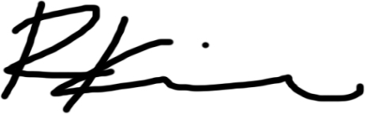

Ralph (Junghyun) Kim