Address: 4720 Centre Avenue, Pittsburgh PA 15213

E-mail: ralph.kim93@gmail.com

Phone: 678-372-3227

Portfolio: http://www.ralphkim.com

VR Developer

RALPH KIM

November 13, 2016

ILMxLAB

Dear Hiring Professional,

I heard about this position from a former Disney employee, Vivek Sangubhotla. I am confident in my skillset to meet the responsibilities of the position, and I believe that my combination of arts and technical background would make a great fit for the company.

I have implemented games in Unity through every stage of development. In these projects, I have designed solutions for gameplay mechanics, player controls, animation, and multi-platform UI.

As personal projects, I have created tools with consideration towards reusability across multiple projects. One such example is a template project in Unity for multiplayer VR experience. Another is a flexible plugin that implements PocketSphinx speech recognition into Unity.

I have worked as a freelancer on projects under contract with fast turnaround times. This has required me to plan tight schedules and follow deadlines for deliverables.

Having performed the duties of a technical artist, visual artist, and programmer across a variety of projects, I am capable of understanding the language and concerns of both the artists and engineers.

Please feel free to contact me at ralph.kim93@gmail.com or 678-372-3227. I look forward to discussing my potential candidacy for this position. My portfolio can be found on my website at http://www.ralphkim.com. Thank you very much for your time.

Sincerely,

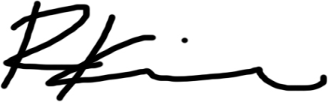

Ralph (Junghyun) Kim