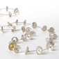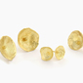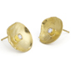

CODE | DESCRIPTION | PRICE
 | DAISY RANGE
DSN1 | Long articulated daisy neckpiece | $675
DSN3 | Double daisy neckpiece | $500
DSP1 | Small 18ct yellow gold daisy pendant + diamond | $475
DSP2 | Small 18ct white gold daisy pendant + diamond | $475
DSP3 | 18ct gold daisy pendant | $350
DSP4 | Single daisy choker | $140
DDP1 | Large double daisy pendant | $245
DDP2 | Medium double daisy pendant | $225
DDP3 | Small double daisy pendant | $175
DSB1 | Long articulated daisy bracelet | $350
DSB3 | Double daisy bracelet | $315
DDR1 | XXL Double daisy ring | $190
DDR2 | XL Double daisy ring | $150
DDR3 | Double daisy ring | $120
DDR4 | Double daisy leaf ring | $120
DSR1 | Large daisy ring | $145
DSR2 | Medium daisy ring | $135
DSR3 | Small daisy ring | $110
DSR4 | Small 18ct gold daisy ring | $425
DDE1 | Double daisy earrings | $90
DDE2 | Double daisy studs | $85
DSE1 | daisy earrings | $85
DSE2 | Large daisy studs | $90
DSE3 | Daisy studs | $75
DSE3 OX | Oxidised daisy studs | $75
DSE4 | 18ct gold daisy studs | $370
DSE5 | Medium 18ct gold daisy studs | $320
DSE6 | Small18ct gold daisy studs | $260
DSE7 | Xs 18ct gold daisy studs | $220
DSDE1 | 18ct gold daisy studs + diamonds – available in white gold | $860
DSDE2 | Medium 18ct gold daisy studs + diamonds – available in white gold | $550
DSDE3 | Small 18ct gold daisy studs + diamonds – available in white gold | $500
DSDE4 | Xs 18ct gold daisy studs + diamonds – available in white gold | $375
DSDE5 | Xs silver daisy studs + diamonds | $380
DSBP1 | Daisy brooch with stalk | $90
DSC | Daisy cufflinks | $80

- WHOLE SALE PRICE LIST

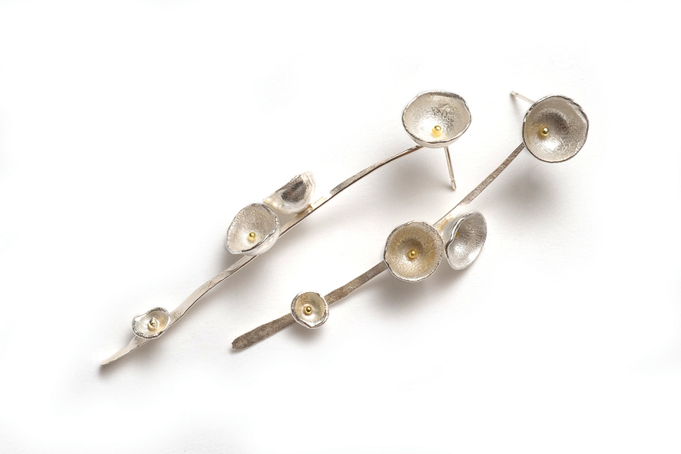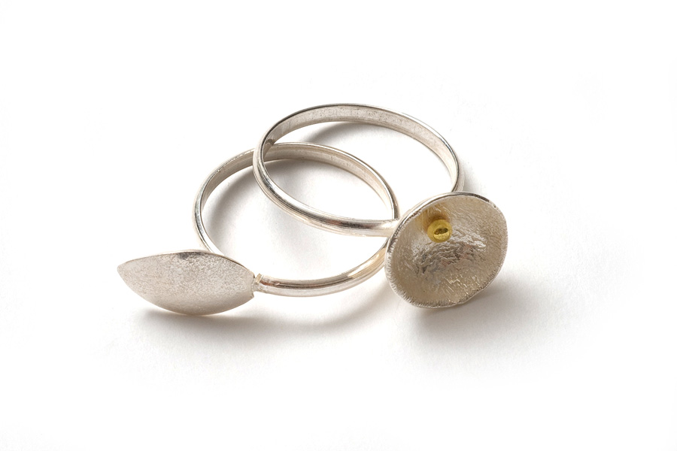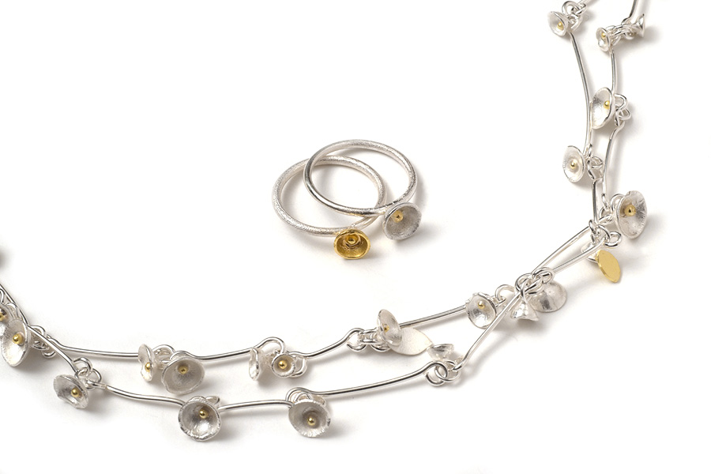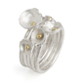

 | ACORN CUP RANGE
ACN1 | Medium acorn cup cluster neckpiece | $725
ACN2 | Small acorn cup cluster neckpiece | $450
ACN3 | 5 Strand Xs acorn cup choker | $250
ACN4 | 3 Strand Xs acorn cup choker | $180
ACB1 | Medium acorn cup cluster bracelet | $350
ACB2 | Short Medium acorn cup cluster bracelet | $165
ACB3 | Small acorn cup cluster bracelet | $300
ACB4 | Short small acorn cup cluster bracelet | $130
ACR1 | Acorn cup leaf ring | $110
ACR2 | Acorn cup leaf ring + stamen | $120
ACR3 | 5 18ct Gold Acorn Cup Rings + Diamonds | $2700
ACR4 | Small 5 18ct Gold Acorn Cup Rings + Diamonds | $2300
ACR5 | 3 18ct Gold Acorn Cup Rings + Diamonds | $2050
ACR6 | Small 3 18ct Gold Acorn Cup Rings + Diamonds | $1800
ACR7 | 5 silver acorn cup rings with diamonds | $1600
ACR8 | 5 Acorn Cup Rings | $250
ACR9 | 3 Acorn Cup Rings | $150
ACR10 | Acorn cup cluster ring | $160
ACR11 | Small acorn cup cluster ring + 18ct gold cup | $180
ACR12 | Acorn cup cluster ring, with leaf | $150
ACE1 | Acorn cup earrings | $75
ACE2 | Medium acorn cup cluster earrings | $140
ACE3 | Small acorn cup cluster earrings | $120
ACE4 | Medium acorn cup cluster leaf earrings | $145
ACE5 | Small acorn cup cluster leaf earrings | $125
ACE6 | Medium Acorn Cup Studs- Also available in oxidised silver. | $70
ACE7 | Small Acorn Cup Studs -Also available in oxidised silver. | $68
ACE8 | Extra Small Acorn Cup Studs- Also available in oxidised silver. | $64
ACE9 | XXS Acorn Cup Studs -Also available in oxidised silver. | $60
ACE10 | Large Acorn cup cluster studs | $105
ACE11 | Medium Acorn cup cluster studs | $95
ACE12 | Small Acorn cup cluster studs | $85
ACE13 | Large Acorn cup leaf studs | $85
ACE14 | Medium Acorn cup leaf studs | $80
ACE15 | Small Acorn cup leaf studs | $75
ACBR1 | Large Acorn cup cluster brooch | $120
ACBR2 | Medium Acorn cup cluster brooch | $90
ACBR3 | Small Acorn cup cluster brooch | $75

Shimara Carlow Studio MG6 Mercator Building Abbotsford Convent 1 St Heliers St Abbotsford Vic 3067 0458 380 530 shimara@shimara.com www.shimara.com

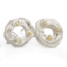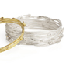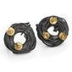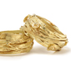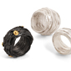

 | SILVER ACORN CUP WRAP RANGE
SACWN1 | 18ct gold wrap choker + acorn cups | $1600
SACWN2 | Small oxidised silver wrap choker + 18ct gold acorn cups | $615
SACWN3 | Small silver wrap choker + acorn cups | $295
SACWB1 | 18ct gold wrap bangle + acorn cups | $1400
SACWB2 | Silver wrap bangle + 18ct gold acorn cups | $575
SACWB3 | Silver wrap bangle + acorn cups | $285
SACWB4 | Small oxidised silver wrap bangle + 18ct gold acorn cups | $425
SACWB5 | Small silver wrap bangle + acorn cups | $170
SACWR1 | 18ct gold wrap ring + acorn cups | $1000
SACWR2 | Large oxidised silver wrap ring + 18ct gold acorn cups | $220
SACWR3 | Oxidised silver wrap ring + 18ct gold acorn cups | $190
SACWR4 | Silver wrap ring + 18ct gold acorn cups | $190
SACWR5 | Large silver wrap ring + acorn cups | $175
SACWR6 | Silver wrap ring + acorn cups | $160
SACWE1 | 18ct gold wrap studs + acorn cups | $475
SACWE2 | Silver wrap studs + 18ct gold acorn cups | $155
SACWE3 | Silver wrap studs + acorn cups | $80
SACWE4 | Oxidised silver wrap studs + 18ct gold acorn cups | $155

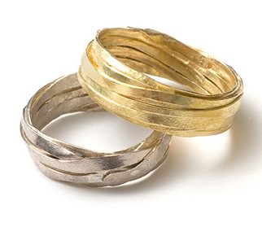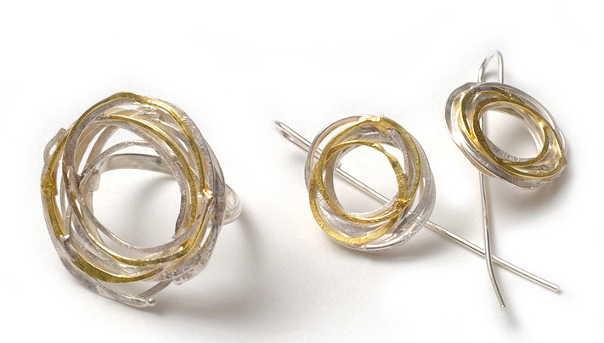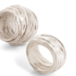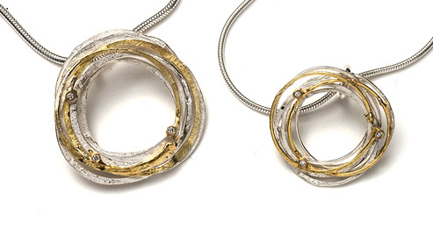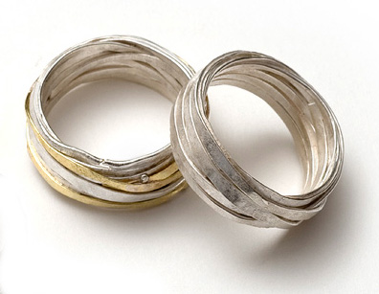
 | SILVER WRAP RANGE
SGWP1 | Large silver and gold wrap pendant + 3 diamonds | $465
SGWP2 | Medium silver + gold wrap pendant + 3 diamonds | $415
SGWP3 | Small silver + gold wrap pendant + diamonds | $335
SGWP4 | Medium silver + gold wrap pendant | $275
SGWP5 | Small silver + gold wrap pendant | $245
SWP1 | Medium silver wrap pendant | $165
SWP2 | Small silver wrap pendant | $135
SWP3 | Medium hammered silver wrap pendant | $145
SWP4 | Small hammered silver wrap pendant | $114
SWB1 | Silver wrap cuff | $395
SWB2 | Gold + silver wrap bangle | $235
SGWR1 | Small silver + gold wrap ring + 3 diamonds | $265
SGWR2 | Medium silver + gold wrap ring | $195
SGWR3 | Medium silver wrap ring | $205
SGWR4 | Small silver wrap ring | $195
SGWR5 | Medium hammered silver wrap ring | $185
SGWR6 | Small hammered silver wrap ring | $150
GWR1 | 1mm 18ct gold wrap ring | $1200
GWR2 | 18ct gold wrap ring – also available in white gold | $925

Shimara Carlow Studio MG6 Mercator Building Abbotsford Convent 1 St Heliers St Abbotsford Vic 3067 0458 380 530 shimara@shimara.com www.shimara.com

 | SILVER WRAP RANGE
GWR3 | .6mm 18ct gold wrap ring - also available in white gold | $825
GWR4 | .8mm 18ct gold wrap ring - also available in white gold | $650
SWR1 | 1mm Xl silver + gold wrap ring | $180
SWR2 | 1mm Large silver + gold wrap ring | $160
SWR3 | Silver + gold wrap ring | $140
SWR4 | .8mm Silver + gold wrap ring. | $130
SWR5 | 1mm Xl silver wrap ring | $140
SWR6 | 1mm Large silver wrap ring | $120
SWR7 | Large silver wrap ring | $110
SWR8 | Silver wrap ring | $105
SWR9 | Small silver wrap ring | $100
SWR10 | .8mm silver wrap ring | $95
SGWE1 | Silver + gold wrap earrings + diamonds | $295
SGWE2 | Silver +gold wrap earrings | $170
SGWE3 | Silver wrap earrings | $90
SGWE4 | Hammered silver wrap earrings | $85
SGWE5 | Silver + gold wrap studs + diamonds | $285
SGWE6 | Silver + gold wrap studs | $160
SGWE7 | Silver wrap studs | $85
SGWE8 | Hammered silver wrap studs | $80

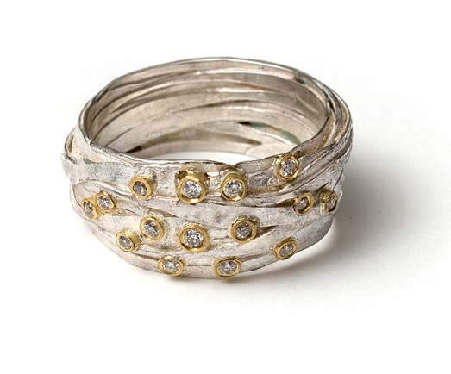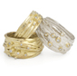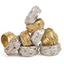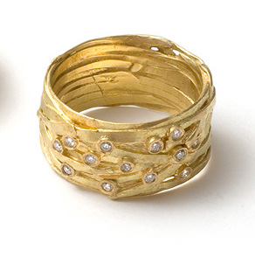

 | WRAP RINGS WITH STONES
WGSR1 | 18ct gold wrap ring + 15 diamonds | $1800
WGSR2 | 18ct gold wrap ring + 12 diamonds | $1570
WGSR3 | Large 18ct gold wrap ring + tall tube + 9 mixed diamonds | $2240
WGSR4 | 18ct gold wrap ring in tall settings with 9 mixed diamonds | $1630
WGSR5 | 18ct gold wrap ring + tall tube + 7 mixed diamonds | $1610
WGSR6 | 18ct gold wrap ring + 7 small mixed diamonds | $950
WGSR7 | 18ct gold wrap ring + 6 diamonds | $1160
WGSR8 | 18ct gold wrap ring + 6 pink sapphire | $1000
WGSR9 | 18ct gold wrap ring + 6 aqua marine | $1000
WSR1 | Large silver wrap ring + 15 diamonds | $970
WSR2 | Silver wrap ring + 15 diamonds | $850
WSR3 | Large silver wrap ring + 9 mixed diamonds | $1150
WSR4 | Silver wrap ring + 9 mixed diamonds | $950
WSR5 | Silver wrap ring + tall gold tube + 7 mixed diamonds | $810
WSR6 | Silver wrap ring + tall gold tube + 7 sm mixed diamonds | $570
WSR7 | Silver wrap ring, gold tube + 5 diamonds 2.4mm | $720
WSR8 | Silver wrap ring, gold tube + 5 diamonds 2.2mm | $600
WSR9 | Silver wrap ring, gold tube + 5 pink sapphire 2.2mm | $385
WSR10 | Silver wrap ring, gold tube + 5 aquamarine 2.2mm | $385

Shimara Carlow Studio MG6 Mercator Building Abbotsford Convent 1 St Heliers St Abbotsford Vic 3067 0458 380 530 shimara@shimara.com www.shimara.com
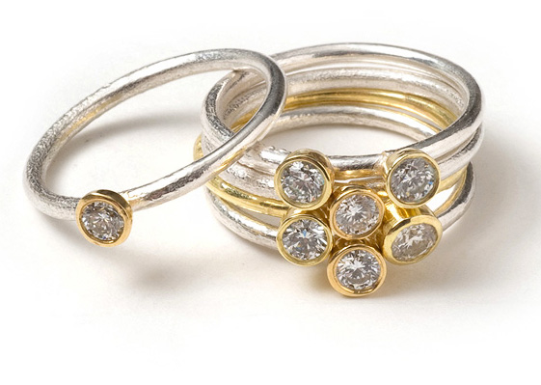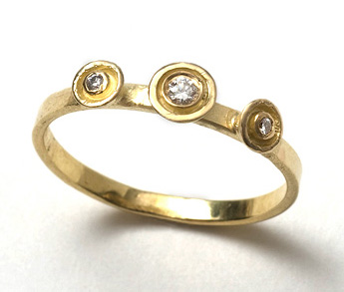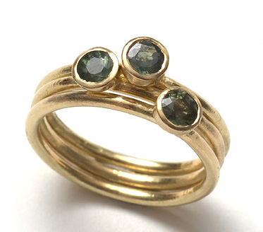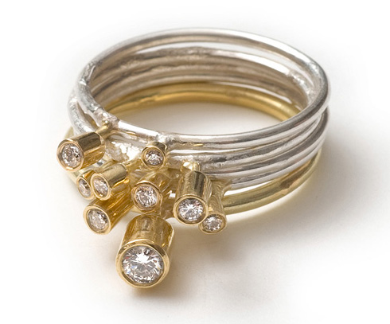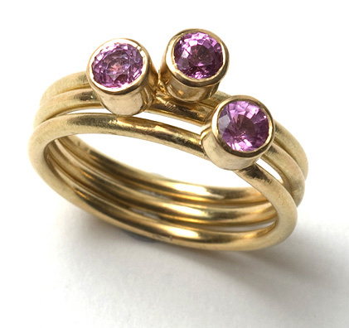

 | RING SETS WITH STONES
SRS1 | 6 18ct gold gum nut rings with pink sapphire and greet tourmaline | $2125
SRS2 | 3 18ct gold gum nut rings with diamonds | $2150
SRS3 | 5 silver + 18ct gold gum nut rings + 7 diamonds | $2250
SRS4 | 5 tall silver + 18ct gold gum nut rings + mixed diamonds | $1325
SRS5 | 5 silver + 18ct gold cup rings + diamonds | $1425
SRS6 | 5 small silver + 18ct gold cup rings + diamonds | $1225
SRS7 | 5 silver cup rings + diamonds | $630
SRS8 | 5 small silver cup rings + diamonds | $490
SRS9 | 3 18ct gold bands with 3 diamonds | $620
SRS10 | 3 silver cup rings + aqua marine | $265
SRS11 | 18ct gold tall gum nut solitaire ring | $850
SRS12 | 18ct gold square wedding ring, to match above | $460
SRS13 | 18ct gold d section men’s wedding ring | $725
SES1 | 18ct yellow gold gum nut studs + diamonds | $650
SES2 | 18ct white gold gum nut studs + diamonds | $650

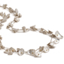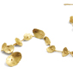

 | HONESTY RANGE
HN1 | 18ct gold honesty neckpiece | $6000
HN2 | Large honesty neckpiece + 18ct gold | $2600
HN3 | Large long honesty neckpiece | $925
HN4 | Large honesty neckpiece | $825
HN5 | Large short honesty neckpiece | $475
HN6 | Medium long honesty neckpiece | $725
HN7 | Medium honesty neckpiece | $625
HN8 | Small long honesty neckpiece | $625
HN9 | Small honesty neckpiece | $450
HP1 | 18ct gold honesty pendant | $350
HP2 | Large honesty pendant | $180
HP3 | Medium honesty pendant | $160
HP4 | Small honesty pendant | $140
HB1 | 18ct gold honesty bracelet | $2500
HB2 | Large honesty bracelet + 18ct gold | $670
HB3 | Large long honesty bracelet | $425
HB4 | Large articulated honesty bracelet | $195
HB5 | Medium long honesty bracelet | $325
HB6 | Medium honesty bracelet | $185
HB7 | Small long honesty bracelet | $225
HB8 | Small honesty bracelet | $175
HR1 | Medium 18ct gold honesty ring | $425
HR2 | Small 18ct gold honesty ring | $375

Shimara Carlow Studio MG6 Mercator Building Abbotsford Convent 1 St Heliers St Abbotsford Vic 3067 0458 380 530 shimara@shimara.com www.shimara.com

 | HONESTY RANGE
HR3 | XX Large honesty ring | $210
HR4 | Extra Large honesty ring | $190
HR5 | Large honesty ring | $170
HR6 | Medium honesty ring | $135
HR7 | Small honesty ring | $110
HE1 | Large honesty earrings | $95
HE2 | Medium honesty earrings | $85
HE3 | Small honesty earrings | $75
HE4 | Extra Small honesty earrings | $65
HE5 | Medium 18ct gold honesty studs | $335
HE6 | Small 18ct gold honesty studs | $240
HE7 | Large honesty studs | $80
HE8 | Medium honesty studs | $75
HE9 | Small honesty studs | $65
HE10 | Extra Small honesty studs | $60
HBR1 | Extra Large honesty brooch | $170
HBR2 | Large honesty brooch | $110
HBR3 | Medium honesty brooch | $90

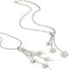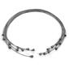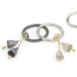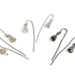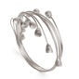

 | GUM NUT RANGE
GNN1 | Silver bell gum nut wrap choker + 18ct gold | $430
GNN2 | Oxidised silver bell gum nut wrap choker + 18ct gold | $430
GNN3 | Silver bell gum nut wrap choker | $375
GNP1 | 5 pod gum nut pendant + 18ct gold | $245
GNP2 | 3 Pod Gum Nut Pendant + 18ct Gold | $210
GNP3 | 3 Pod Gum Nut Pendant | $190
GNP4 | 3 bell Gum Nut Pendant + 18ct Gold | $200
GNP5 | Oxidised 3 bell Gum Nut Pendant + 18ct Gold | $200
GNP6 | 3 bell Gum Nut Pendant | $155
GNB1 | Silver Bell Gum Nut Wrap Bangle with 18ct gold | $375
GNB2 | Oxidised Silver Bell Gum Nut Wrap Bangle with 18ct gold | $375
GNB3 | Silver Bell Gum Nut Wrap Bangle | $310
GNR1 | 2 Bell Gum Nut Ring + 18ct Gold detail | $120
GNR2 | Oxidised 2 Bell Gum Nut Ring + 18ct Gold detail | $120
GNR3 | 2 Bell Gum Nut Ring | $110
GNR4 | Large Bell Gum Nut Ring + 18ct Gold detail | $120
GNR5 | Oxidised Large Bell Gum Nut Ring + 18ct Gold detail | $120
GNR6 | Large Bell Gum Nut Ring | $110
GNR7 | 3 Bell Gum Nut Rings + 18ct Gold detail | $200

Shimara Carlow Studio MG6 Mercator Building Abbotsford Convent 1 St Heliers St Abbotsford Vic 3067 0458 380 530 shimara@shimara.com www.shimara.com

GNR8 | Oxidised 3 Bell Gum Nut Rings + 18ct Gold detail | $200
GNE1 | Medium Pod Gum Nut Earrings with 18ct gold | $105
GNE2 | Medium Bell Gum Nut Earrings with 18ct gold | $105
GNE3 | Bell Gum Nut Earrings with 18ct gold | $85
GNE4 | Oxidised Bell Gum Nut Earrings with 18ct gold | $85
GNE5 | Bell Gum Nut Earrings | $75
GN1 | 3 Medium silver pod gum nut brooch + 18ct gold | $165
GN2 | 3 Small silver pod gum nut brooch + 18ct gold | $105
GN3 | 3 Small silver pod gum nut brooch | $85

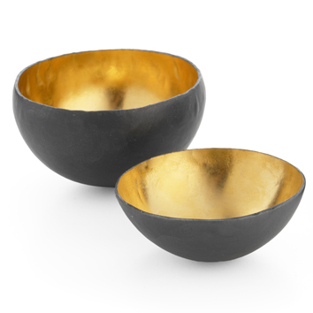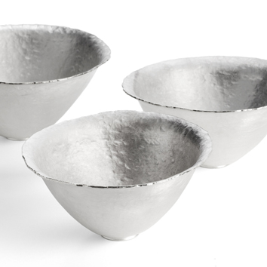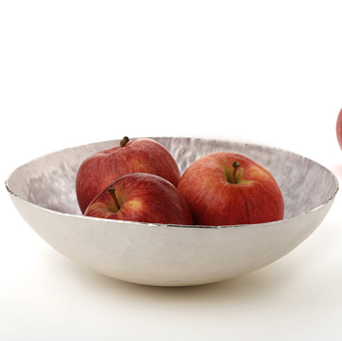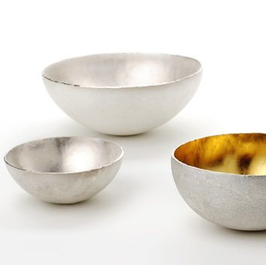

 | BOWLS
FSD1 | Large fine silver dish | $2700
FSB1 | Large fine silver bowl | $1720
FSB2 | Medium fine silver bowl | $1000
FSB3 | Small fine silver bowl | $490
FSB4 | Extra small fine silver bowl | $320
FSGB1 | Medium fine silver bowl + gold plate | $1100
FSGB2 | Small fine silver bowl + gold plate | $530
FSGB3 | Oxidised small fine silver bowl + gold plate | $530
FSGB4 | Extra small fine silver bowl + gold plate | $360
FSGB5 | Oxidised extra small fine silver bowl + gold plate | $360
FSCB1 | Fine silver conserve pot with gum nut spoon + gold plate | $1215
FSMB1 | Fine silver mustard pot with gum nut spoon + gold plate | $645

Shimara Carlow Studio MG6 Mercator Building Abbotsford Convent 1 St Heliers St Abbotsford Vic 3067 0458 380 530 shimara@shimara.com www.shimara.com

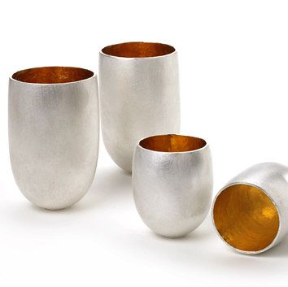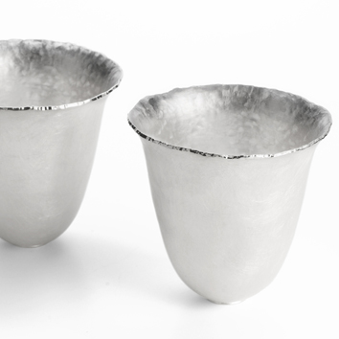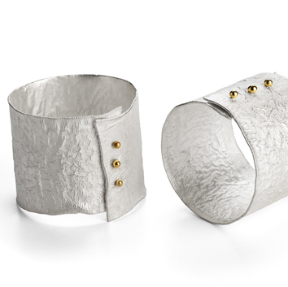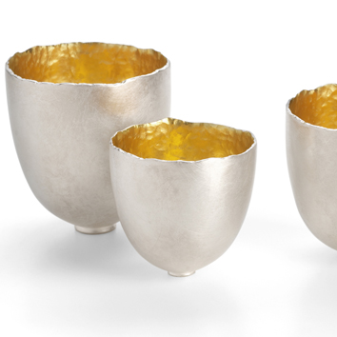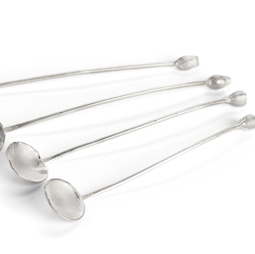

 | SILVERSMITHING
FST1 | Large fine silver fluted tumbler | $1000
FST2 | Fine silver fluted tumbler | $800
FSTG1 | Tall fine silver tumbler + gold plate | $890
FSSG1 | Large fine silver Saki cup + gold plate | $695
FSSG2 | Medium fine silver Saki cup + gold plate | $575
FSSG3 | Small fine silver Saki cup + gold plate | $490
FSSG4 | Extra Small fine silver Saki cup + gold plate | $405
FSSG5 | Tall fine silver shot + gold plate | $540
FSSG6 | Pod fine silver shot + gold plate | $540
FSS1 | Tall fine silver shot | $500
FSS2 | Pod fine silver shot | $500
FSS3 | Small egg shell shot | $290
SNR1 | Reticulated napkin ring + 18ct gold | $200
SS1 | Caddy spoon with gum nut handle + 18ct gold | $225
SS2 | Long oval spoon with gum nut handle + 18ct gold | $175
SSS1 | Silver gum nut salt spoon with oval bowl | $75
SSS2 | Silver gum nut salt spoon | $75

TERMS AND CONDITIONS

Initial order $400 pro forma, thereafter 30 days.
Please allow 6-8 weeks delivery.
Please note silversmithing items may take longer.
All orders are sent registered mail, insured p + p cost $12.50.
Claims for damages or shortages must be made verbally on receipt, and in writing within 5 working days.
All good remain the property of Shimara Carlow until paid in full.

All Items are made from sterling silver unless otherwise stated. All gold is 18ct gold; all gold plate is 23 1/2ct gold

Shimara Carlow Studio MG6 Mercator Building Abbotsford Convent 1 St Heliers St Abbotsford Vic 3067 0458 380 530 shimara@shimara.com www.shimara.com

