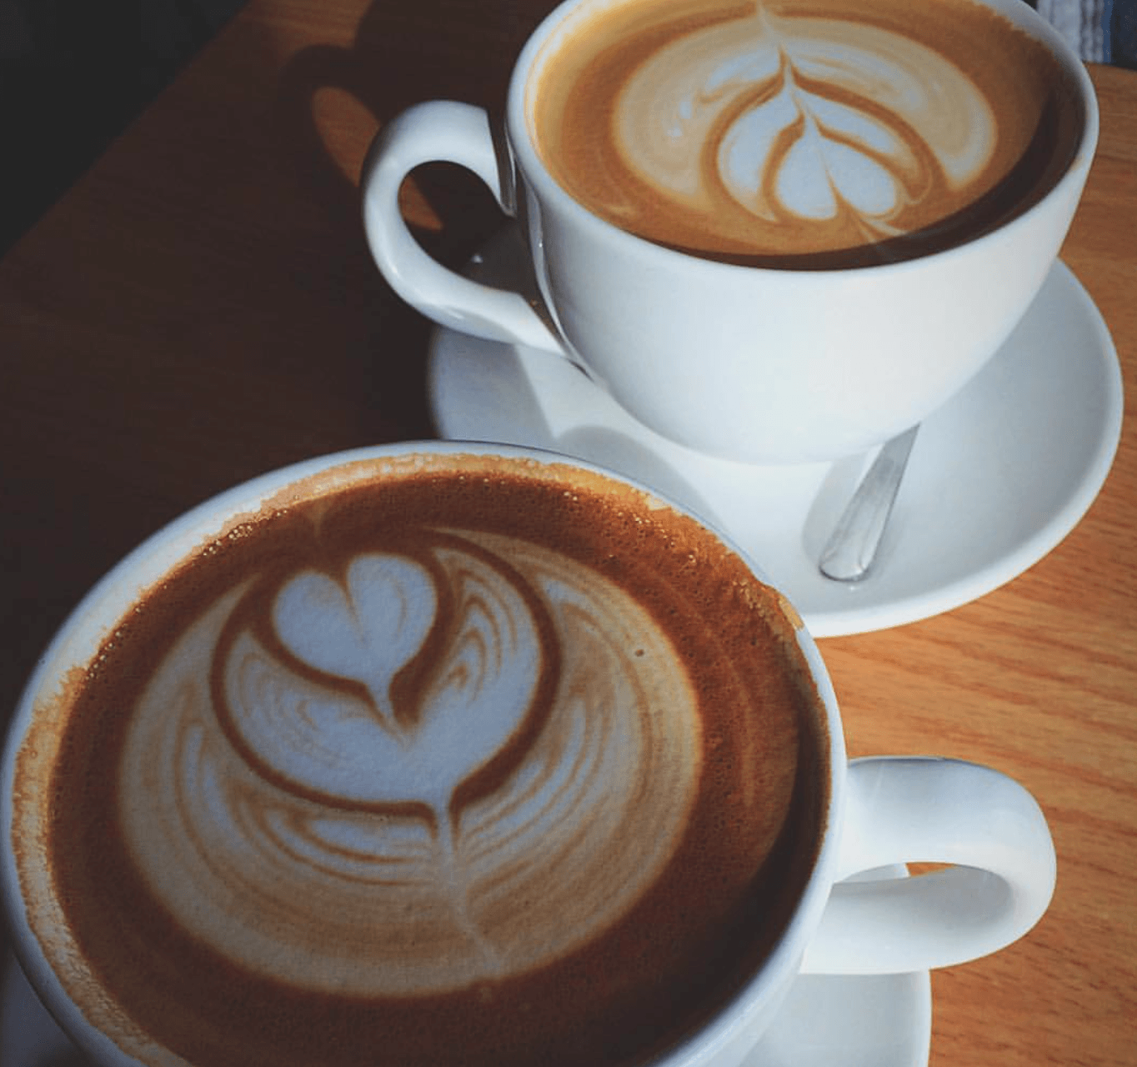

**Café Style**



**WORD GUESS**