**FURever Home**

**Software Requirements Specification**

**Version <1.0>**

**Revision History**

|  |  |  |  |
| --- | --- | --- | --- |
| **Date** | **Version** | **Description** | **Author** |
| <26/MAR/18> | <1.0> | Initial Release | Brian D. Ruthrauff |
|  |  |  |  |
|  |  |  |  |
|  |  |  |  |

**Table of Contents**

[1.          Introduction](http://sce.uhcl.edu/helm/rationalunifiedprocess/webtmpl/templates/req/rup_srsuc.htm#1.                  Introduction)

[1.1      Purpose](http://sce.uhcl.edu/helm/rationalunifiedprocess/webtmpl/templates/req/rup_srsuc.htm#1.1               Purpose)

[1.2      Scope](http://sce.uhcl.edu/helm/rationalunifiedprocess/webtmpl/templates/req/rup_srsuc.htm#1.2               Scope)

[1.3      Definitions, Acronyms and Abbreviations](http://sce.uhcl.edu/helm/rationalunifiedprocess/webtmpl/templates/req/rup_srsuc.htm#1.3               Definitions, Acronyms and Abbreviations)

[1.4      References](http://sce.uhcl.edu/helm/rationalunifiedprocess/webtmpl/templates/req/rup_srsuc.htm#1.4               References)

[1.5      Overview](http://sce.uhcl.edu/helm/rationalunifiedprocess/webtmpl/templates/req/rup_srsuc.htm#1.5               Overview)

[2.          Overall Description](http://sce.uhcl.edu/helm/rationalunifiedprocess/webtmpl/templates/req/rup_srsuc.htm#2.                  Overall Description)

[2.1      Product Functions](http://sce.uhcl.edu/helm/rationalunifiedprocess/webtmpl/templates/req/rup_srsuc.htm#2.1               Use-Case Model Survey)

[2.2      Assumptions and Dependencies](http://sce.uhcl.edu/helm/rationalunifiedprocess/webtmpl/templates/req/rup_srsuc.htm#2.2               Assumptions and Dependencies)

[3.          Specific Requirements](http://sce.uhcl.edu/helm/rationalunifiedprocess/webtmpl/templates/req/rup_srsuc.htm#3.                  Specific Requirements)

[3.1      Use-Case Reports](http://sce.uhcl.edu/helm/rationalunifiedprocess/webtmpl/templates/req/rup_srsuc.htm#3.1               Use-Case Reports)

[3.2      Supplementary Requirements](http://sce.uhcl.edu/helm/rationalunifiedprocess/webtmpl/templates/req/rup_srsuc.htm#3.2               Supplementary Requirements)

[4.          Supporting Information](http://sce.uhcl.edu/helm/rationalunifiedprocess/webtmpl/templates/req/rup_srsuc.htm#4.                  Supporting Information)

**Software Requirements Specification**

**1.**                  **Introduction**

**1.1**               **Purpose**

Describe the function, use, and administration of the FURever Home website. Provide constraints of the design process and minimum requirements for use.

**1.2**               **Scope**

FURever Home is a website for allowing Animal Shelters and Homes to list animals they have available for adoption to users that are looking to adopts pets. This document covers the use administration and design of the website.

**1.3**               **Definitions, Acronyms and Abbreviations**

User: a user is someone visiting the site and looking to adopt a pet

Shelter or Home: are used interchangeably to describe an organization or person that has animals that need to be adopted.

**1.4**               **References**

High Level Design Document

Configuration Management Plan

Sprint Plan

**1.5**               **Overview**

Document will not provide technical details on how to implement the specified features except where needed. Assume all features are to be included in the final product except any feature listed as not essential for this release.

**2.**                  **Overall Description**

**2.1**               **Product Functions**

1. Users can filter the list of pets by pet attributes
2. Users can save the filter settings
3. Users can save lists of favorite pets
4. Users can share direct links to pets with other users and other websites
5. Users can view basic information about the pets
6. Shelters can establish publicly viewable profile pages with contact information
7. Shelters can add, remove and edit pets
8. (not essential) Shelters have a way to see which of their pets are being liked by users
9. (not essential) Users can write comments about the pets
10. (not essential) Users can filter pet list based on distance from a location

**2.2**               **Assumptions and Dependencies**

Storage space on the server is severely limited so image hosting will need to be handled by linking to off site images for anything beyond basic pet template photos used for place holders.

The site will be hosted on Microsoft Azure

**3.**                  **Specific Requirements**

**3.1**               **Use-Case Reports**

Refer to High level design document for the project for more specifics on how the product functions listed in 2.1 will be implemented.

**3.2**               **Supplementary Requirements**

Currently the website depends on an outside method of storing images of the pets that FURever Home can then link to for the purpose of displaying images of the pets that are up for adoption.

**4.**                  **Supporting Information**

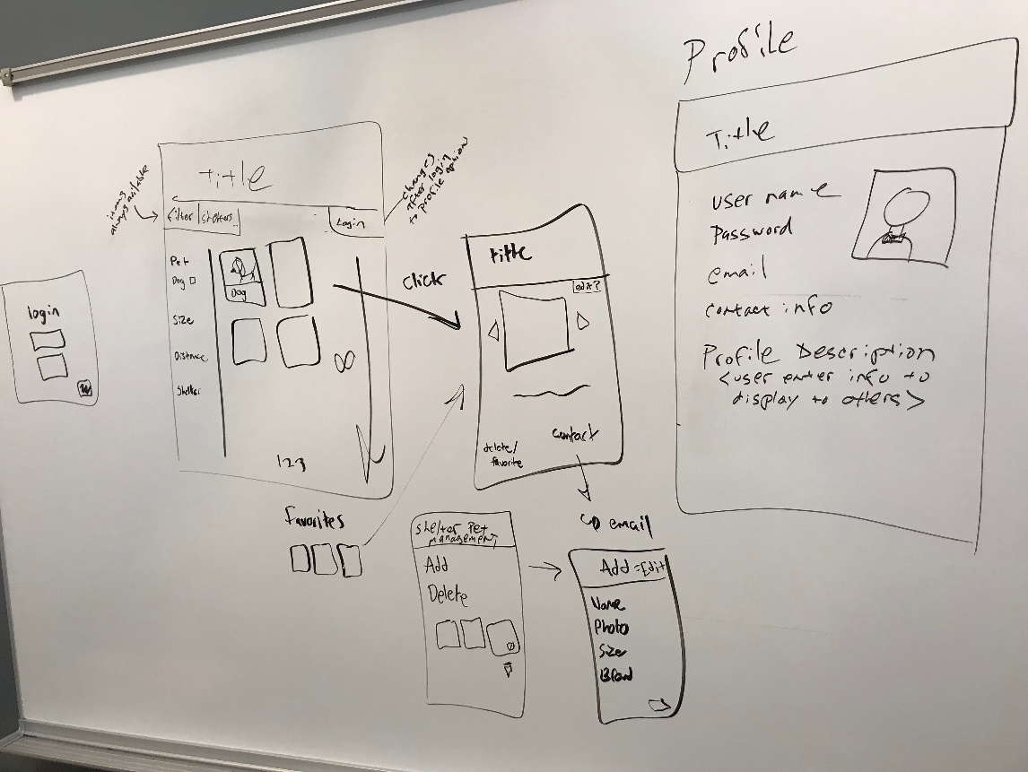

Figure : sample website design

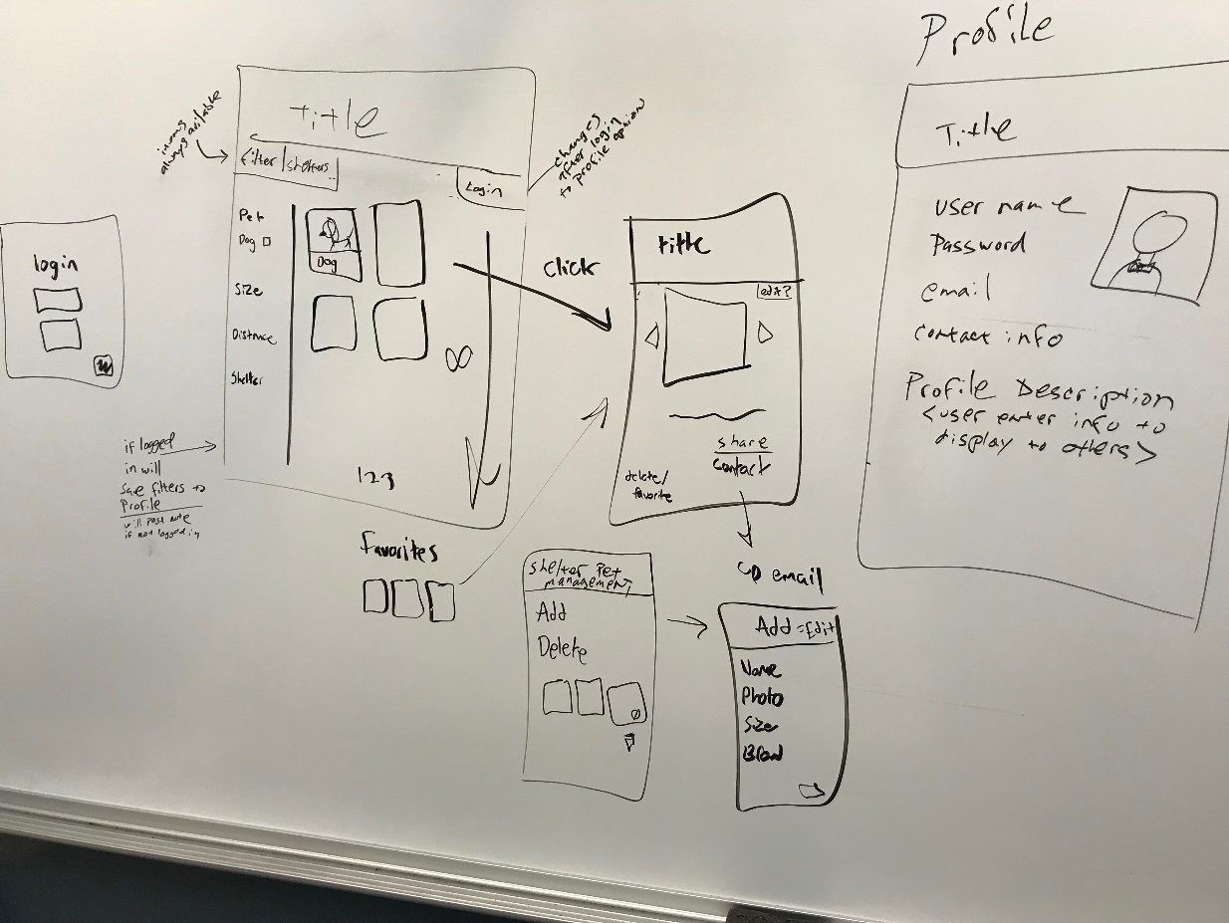

Figure : sample website design